Towage and Tugs
Introduction- What is a tug

Since early times small vessels have assisted manoeuvring other often larger vessels.

A tug is a boat that manoeuvres vessels by pushing or towing them or gives them the power to move when they have none.

Early tugs were wooden and to start with clinker built vessels with simple steam boilers and side mounted paddle wheels, this gave them a very shallow draught and superb manoeuvrability. By the early 1800’s, river and harbour boats were being fitted with steam engines. In March 1802, William Symington of Scotland fitted his patented steam engine on his paddlewheel boat and she became the first official tug. The Charlotte Dundas made her voyage into history. The use of the term “tug” possibly came from a vessel named “tug” and built and operated in Dumbarton in 1817.

Early steam tugs often had a dual role of carrying passengers invariably on sightseeing trips. Their tow hooks were often situated in the after part of the vessel clear of the passenger areas but suitable for straight tows.

The need for tugs in Fowey was great because the river is narrow, has high sides and twists and bends including a right angle. There is also a lot of fresh water coming down the river. This creates very fast currents as well as a big rise and fall in the water level. Tugs helped much larger vessels to enter and leave Fowey Harbour faster and more safely in these very difficult conditions. Tugs were also used to tow vessels in and out of Par harbour and from some distance off the harbour.

The steam engine quickly became the most efficient and widely used way to propel boats and tugs were amongst the first vessels with steam propulsion, providing freedom from the restraint of the wind. The early steam engines were difficult to keep fuelled requiring large quantities of coal but working in a harbour they could be fuelled and watered regularly. Wooden construction was replaced by iron and then by steel and the paddles would be replaced by screws and other forms of directional devices. Early steam tugs oiled the metaphorical wheels of trade by freeing sailing ships to make or leave port in unfavourable winds or by towing them between ports when there was insufficient wind.

There is no record of the first vessel to tow or of the vessel being towed in Fowey but indications are that men in rowing boats assisted the sailing vessels before tugs came into there being. The “Treffry” was probably the first purpose built tug engaged. Further up the river at Lostwithiel horses were used as in the canals.

To improve efficiency and manoeuvrability, ship designers began experimenting with other forms of propulsion. Screw propellers were adopted by tugs in the 1870’s. Their metal blades provided much more power than paddlewheels. Paddle wheels were still in use in many naval harbours into the 1980’s competing with modern designs .Iron and steel hulls were becoming more common. The size and ability of tugboats began to support these new propellers. There is no record of paddle tugs being used in Fowey and all were single screw tugs until the late 1900’s when two smaller tugs were twin propelled. Early steering was by blocks and tackles replaced by chains and then steam pistons and finally by hydraulics.

When seagoing ships became powered, tugs assisted these large, unwieldy vessels to manoeuvre in ports in all sorts of weather and varying tidal conditions. Tugs had really become the work horses in harbours. Their role became more one of manoeuvring and turning than towing in from or to sea.

When the diesel engine became usable in ships, things were forever changed. Diesel was lighter and cheaper to run and tugs needed fewer crew. There were no boilers to maintain and taking coal and water became a thing of the past. Steam engine powered tugs were around until the late 1950’s.

A tug's power is typically stated by its engine's horsepower and its overall bollard pull. Bollard pull is a value that allows the comparison of the pulling force of watercraft, particularly tugboats. A mooring bollard may be used as a point of attachment for measuring the force, or pull of the craft. The term is primarily (but not only) used for measuring the strength of tugs

Tugs by the very nature of the job they do today need to be highly manoeuvrable, and various propulsion systems have been developed to increase manoeuvrability and increase safety. The earliest tugs were fitted with paddle wheels, but these were soon replaced by propeller-driven tugs. Kort nozzles have been added to increase thrust per kW/hp or bollard pull. This was followed by the nozzle-rudder, which omitted the need for a conventional rudder. The cycloidal propeller was developed and was occasionally used in tugs because of its manoeuvrability in the early 1930’s. Later it was also linked to safety due to the development of the Voith Water Tractor, a tugboat configuration which could not be pulled over by its tow.

In the late 1950s, the Z-drive or azimuth thruster, was developed. Although sometimes referred to as the Schottel system, many brands exist. These propulsion systems are used on tugs designed for numerous tasks. Conventional propeller/rudder configurations are more efficient for straight tows such as in estuaries or port-to-port towing.

The Kort nozzle is a sturdy cylindrical structure around a special propeller having minimum clearance between the propeller blades and the inner wall of the Kort nozzle. The thrust:power ratio is enhanced because the water approaches the propeller in a linear configuration and exits the nozzle the same way.

The nozzle fitted to Penleath (ex Badia) with a steering rudder behind. One of the earliest fitted to a tug by Watkins in the Ramsgate yard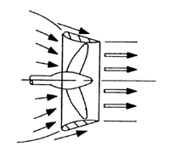

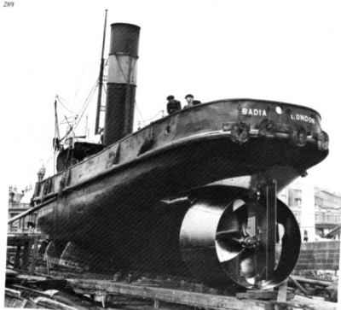

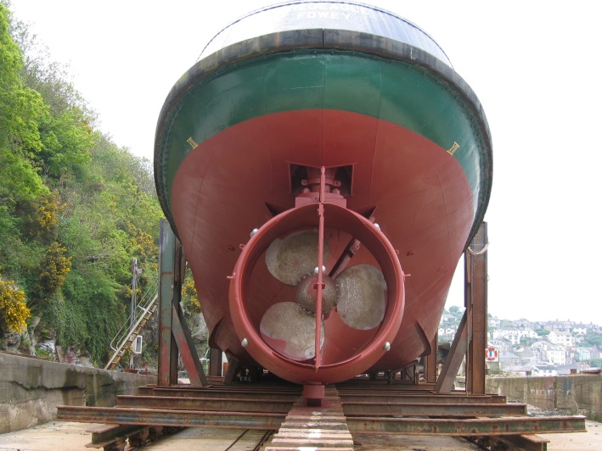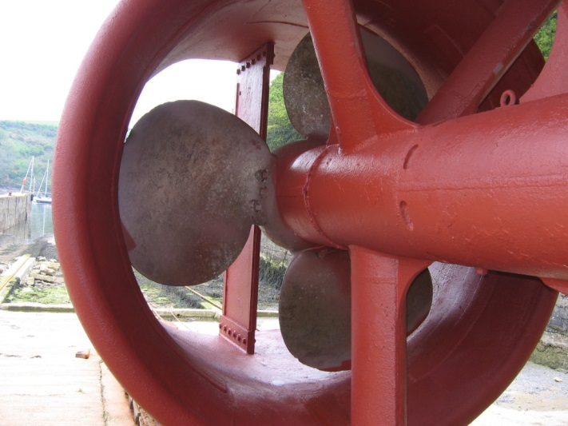

The Tregeagle’s Kort steering nozzle and variable pitch propeller

The Voith Schneider propeller (VSP), also known as a cycloidal drive is a specialised marine propulsion system. It was developed by Voith from an idea by the Austrian engineer Ernst Schneider. It is highly manoeuvrable, being able to change the direction of its thrust almost instantaneously. It is widely used on tugs. From a circular plate, rotating around a vertical axis, a circular array of vertical blades (in the shape of hydrofoils) protrudes out of the bottom of the ship. Each blade can rotate itself around a vertical axis. It combines propulsion and steering in a single unit. The internal gear changes the angle of attack of the blades in sync with the rotation of the plate, so that each blade can provide thrust in any direction. On the Voith Schneider Propeller, a rotor casing which ends flush with the ship's bottom is fitted with a number of axially parallel blades and rotates about a vertical axis.

The tug Cannis has this type of propulsion units.

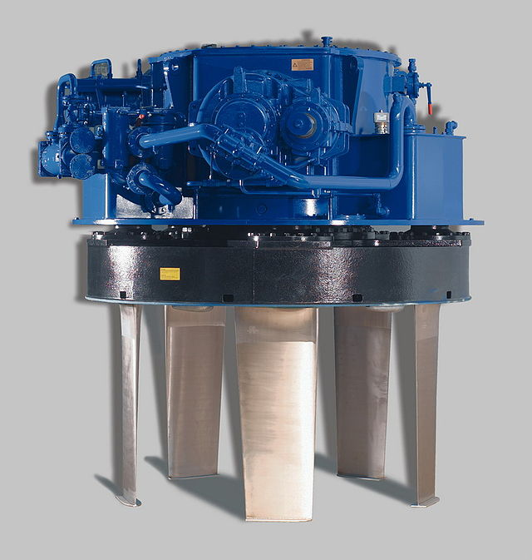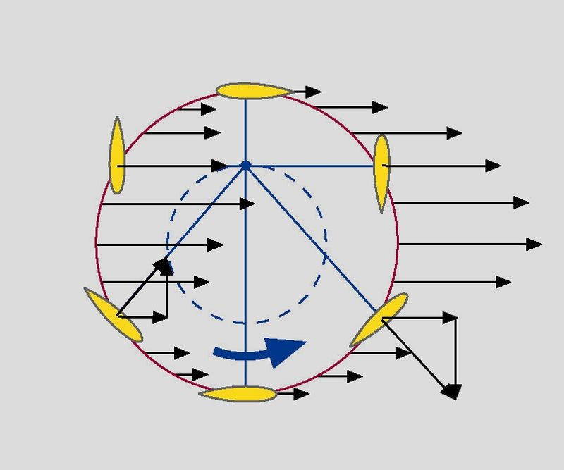

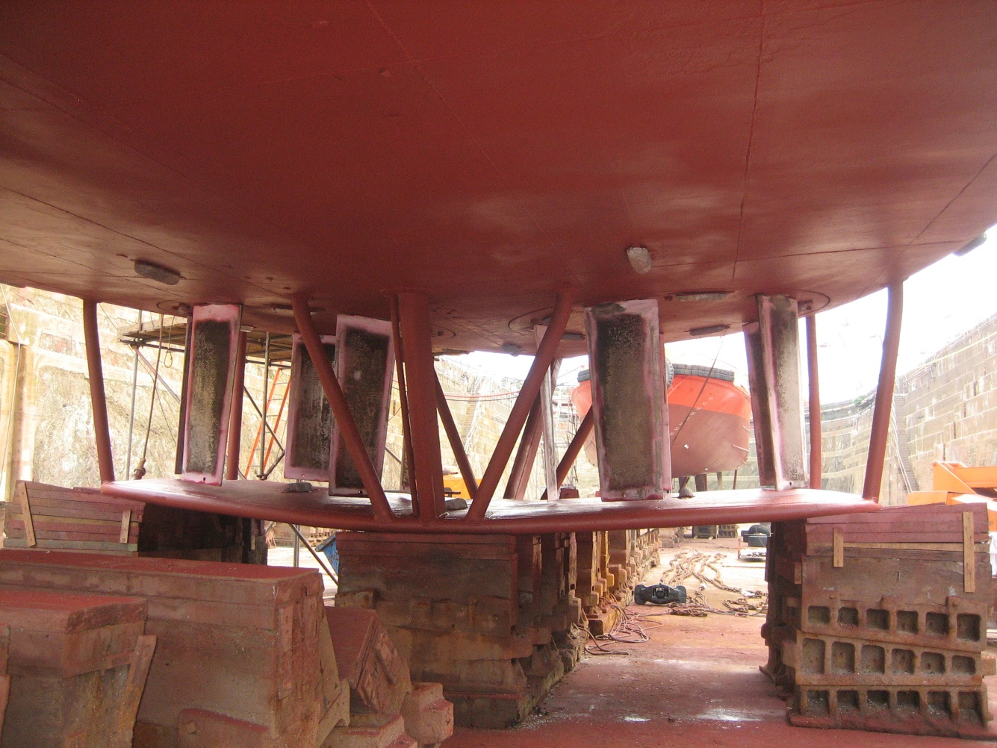

The “Morgawr’s” Voith drives and the protective frame and docking pad.
The present “Cannis” has a similar arrangement.

The SCHOTTEL Rudder propeller.

The SCHOTTEL Rudder propeller is recognised worldwide as the classic marine propulsion system. Developed and built in 1950 by Josef Becker, founder of the present-day SCHOTTEL Group, it quickly conquered the world of modern shipbuilding. The name of SCHOTTEL has become a synonym for azimuthing rudder propellers.

The principal characteristics of the SRP derive from the combination of propulsion and azimuth steering. There is consequently no need for a rudder, and the engine power is optimally converted into thrust. The 360° rotation of the Rudder propeller means that the full input power is available for manoeuvring.

It is used in tugs of all classes, in ports or on the open sea. The SRP is the ideal propulsion solution for many vessels where the focus is on optimal implementation of the available power.

The Advantages of this system are:-
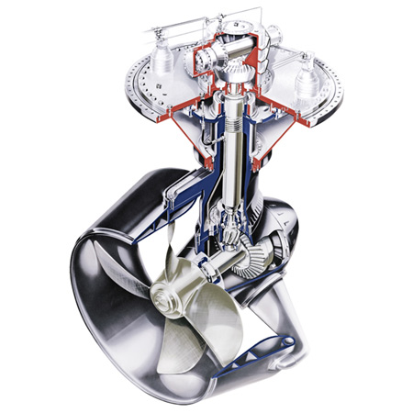

Maximum manoeuvrability
Optimum efficiency
Economical operation
Space-saving installation
Simple maintenance
High reliability
Optimized in terms of cavitation and vibration
Dependable design
Fixed or controllable-pitch propeller
Z or L drive

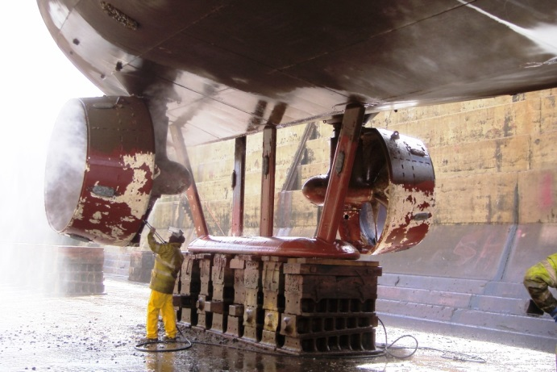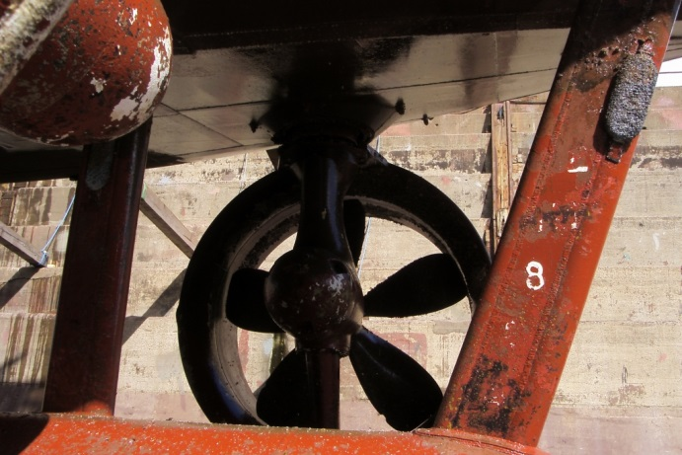

“Cormilan’s” Schottel drives turn inwards for dry-docking

