Schooner A.B. SHERMAN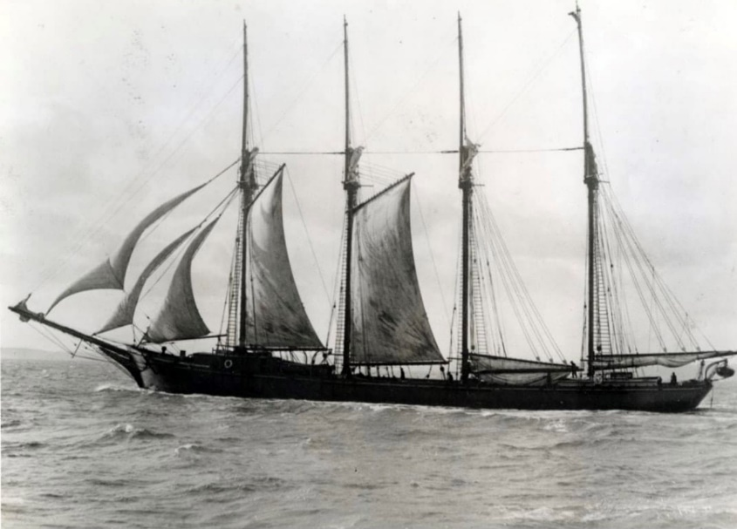
 | Vessel Name | Official Number | Signal letters | Rig /Type |  | Where built |  | Builder |  | Year built |  |  | Year end |  | reg tons
 | A.B.SHERMAN | 131989 | KJWF | schooner Motor sail |  |  | Boston mass. |  | R. Crosbie & Son., East Boston, MA |  | 1883 |  |  | 1928 |  | 581
OWNERS/ MANAGERS/REGISTRATION DETAILS |  |  |  |  | Notes |  |  |  |  |  |  | MASTERS
registered in Fowey June 26, 1917: A. B. Sherman, schooner, gross 611 tons owned by Jonathan May & Sons, Philadelphia attacked with gunfire by enemy submarine off Scilly islands, towed into Plymouth where she stayed until 1919; no casualties. (Submarine probably German U-62)seized in 1917.21st September 1919 bought from US consul in Plymouth for Philadelphia owners. work completed December 1921.Registered in Fowey 13th October 1921.In 1922 water got into the cargo of china clay in Leghorn. Toyne,Carter and co sold her for £500 in 1923. Owners lost £48000 on the venture. |  |  |  |  | LOA 167'7 x34,9x15,3 ft . Previously owned by B.A.Pillsbury of Boston in 1897 Registered in Fowey 13th October 1921originally used on the coal trade from Virginia to Baltimore and Philidelphia..rebuilt by Slades afloat in Pont Pill .She was converted from a 3 masted schooner to a 4 master.Keel was deepened by about 9 inches.register closed 1928 Original ON 106338; KCBS |  |  |  |  |  |  | A.G.PILLSBURY 1897  W.Grace 1916
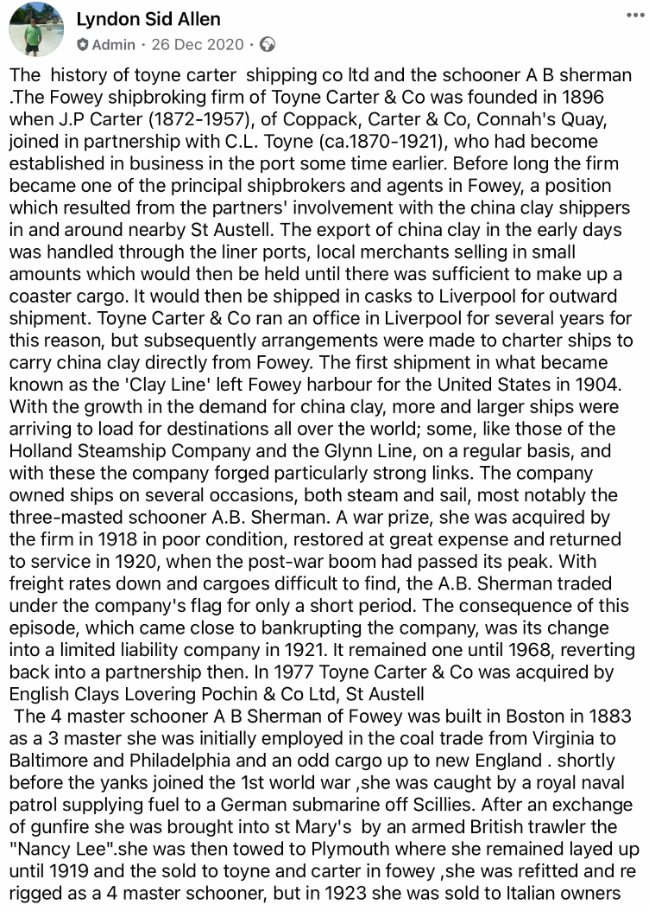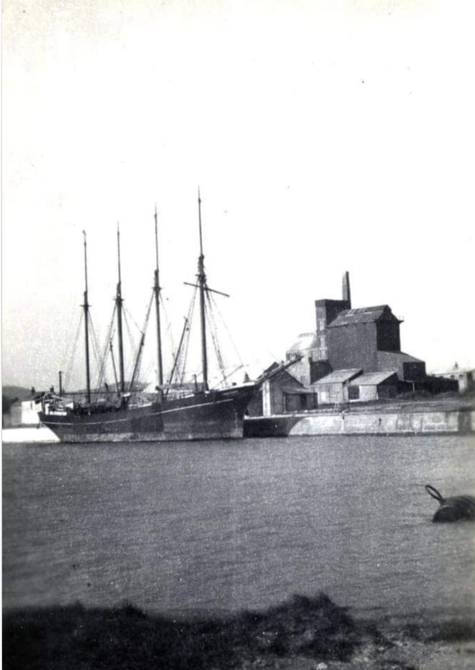
In Par

