Brigantine Agnes Cairns

Vessel Name | Official Number |  |  | Signal letters | Rig /Type | Where built | Builder | Year built |  | Year end | reg tons
AGNES CAIRNS | 65787 |  |  | MSCB | Brigantine | Limecilns, Whitehead | J.Whitehead | 1873 |  | 1917 | 136
OWNERS/ MANAGERS/REGISTRATION DETAILS |  | Notes |  |  |  |  |  |  | MASTERS
1896 John Ennor, 2 View Bay Villas Newquay |  |  | LOA 92.5 x 22.6 x 12ft. 1873 registered in Leith 1892. reg in Aberystwyth.9th April 1893 ran aground on Gunfleet sands on passage from Shields to Rochester with cargo of fire bricks and coke. She refloated with aid of lifeboats without damage. Sold that year to Fowey 1912 moved to Guernsey Register. Scuttled 26th April 1917 by UC65 submarine 8 miles NE of Alderney end route Portsmouth to Guernsey with coal. AGNES CAIRNS, brigantine, 146/1873, J Penaliggon, Guernsey-reg, sailing Portsmouth for Guernsey with coal. Sunk by bombs 8 miles NE of Alderney, Channel Is |  |  |  |  |  | H.Jones 1896-1898

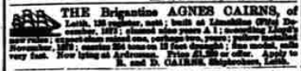

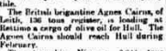

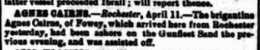

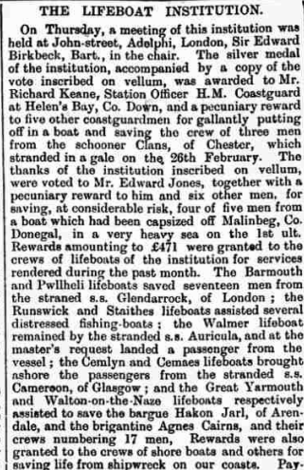

Name | Official number | Flag | IMO
AGNES CAIRNS | 65787 | GBR
Year built | Date launched | Date completed
1873 | 18/12/1873
Vessel type | Vessel description
Cargo | Wood Sailing Vessel Brigantine
Builder |  | Yard | Yard no
James Whitehead, Limekilns

Tonnage | Length | Breadth | Depth | Draft
146 grt / 136 nrt / | 92.5 ft | 22.6 ft | 12.0 ft
Engine builder | ,
Engine detail

First owner | First port of register | Registration date
James Cairns, Buckhaven, Robert Cairns, Leith and John Nicholson, Leven, Fife . | Leith | 12/01/1874
Other names
Subsequent owner and registration history
4.1881 John Davies, Newquay, Cardiganshire - reg Aberystwyth
1887 Jonathan Jones, Swansea
5.1892 John Ennnor, Newquay, Cornwall - reg Fowey
4.1901 Joseph Penaliggon, Newquay, Cornwall - reg Guernsey
Vessel history
1892 --grt 98nrt; c1901 146grt 111nrt
Remarks
End year | Fate / Status
1917 | Scuttled 26/04/1917
Disposal Detail
Captured by German submarine UC-65 eight miles NE of Alderney (Portsmouth for Guernsey with coal). Crew taken off and AGNES CAIRNS scuttled.

Agnes Cairns United Kingdom World War I: The sailing vessel was scuttled in the English Channel 8 nautical miles (15 km) north east of Alderney, Channel Islands by SM UC-65 ( Imperial German Navy). Her crew survived.
J Penalligon;, Master; age, 54; place of birth, Newquay; previous ship, same ship.
L Jowell; Mate; age, 36; place of birth, Ashford; previous ship, same ship.
C Gill; Able Seaman; age, 35; place of birth, Guernsey; previous ship, Fawn.
J Prout;, Able Seaman; age, 37; place of birth, Guernsey; previous ship, same ship.
J Fouzier, Able Seaman; age, 49; place of birth, Brest; previous ship, Esperanza.
W Cowley; Able Seaman; age, 49; place of birth, Douglas; previous ship, Hebe.
A Awty; Able Seaman; age, 29; place of birth, Hull; previous ship, Spurnpoint.
L Fowells; Mate; age, 37; place of birth, Ashford; previous ship, same ship.
C Gill; Able Seaman; age, 35; place of birth, Guernsey; previous ship, Fawn.
J Prout; Able Seaman; age, 37; place of birth, Geurnsey; previous ship, same ship.
William Cowley; Able Seaman; age, 49; place of birth, Douglas; previous ship,
Date made 1915

