Schooner Amy A Lane
o.n. 95725

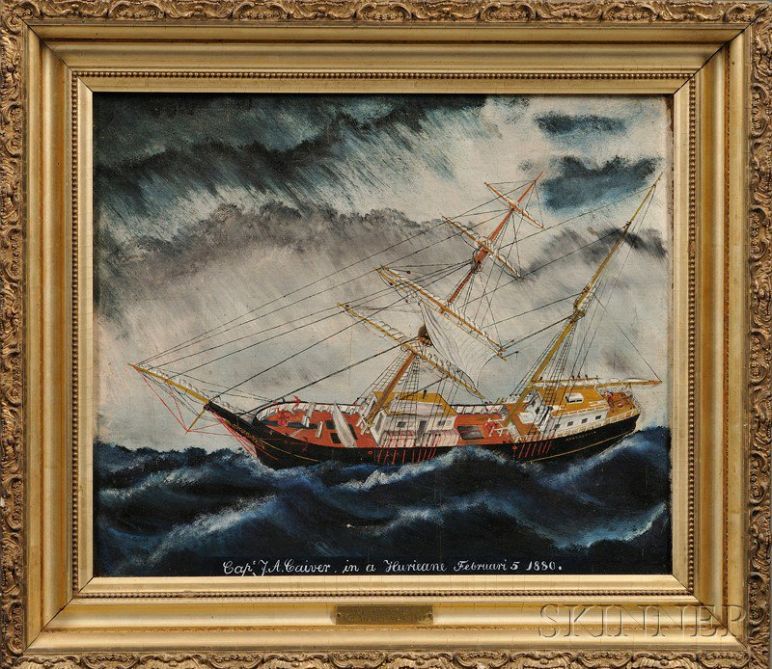American School, 19th Century Portrait of the Brigantine Amy A. Lane in a Hurricane February 5, 1880.
American School, 19th Century
Portrait of the Brigantine Amy A. Lane in a Hurricane February 5, 1880. Unsigned, inscribed "Capt. Caiver in a Hurricane February 5 1880" below, vessel identified on hull, and on plaque below. Oil on canvas, 20 x 24 in., in probably original gilt-gesso frame. Condition: Relined, craquelure.
Note: According to a small plaque mounted to the frame, the brig Amy A. Lane was built in Seaport, Maine, in 1867.

Vessel Name | Official Number |  | Signal letters | Rig /Type | Where built |  | Builder |  | Year built |  |  | Year end |  | reg tons
AMY A LANE | 95725 |  |  | Brigantine |  | Seaport, Maine, USA |  | Lane |  | 1867 |  |  |  |  | 382
OWNERS/ MANAGERS/REGISTRATION DETAILS |  | Notes |  |  |  |  |  |  |  |  | MASTERS
Registered in Fowey 21st May 1890. 1891 George H. Bate (MO) |  | LOA 121 x 27.7 x 16.6 ft . reg closed 1894. sold to Sweden interests. |  |  |  |  |  |  |  |  | Caiver 1880 W.J.Roberts 1889

