Schooner Ann and Elizabeth
Vessel Name | Official Number |  | Signal letters | Rig /Type | Where built |  | Builder |  | Year built |  |  | Year end |  | reg tons
ANN & ELIZABETH | 11477 |  | KSTC | schooner |  | Fowey |  | Thomas Nickels |  | 1837 |  |  | 1871 |  | 87
OWNERS/ MANAGERS/REGISTRATION DETAILS |  | Notes |  |  |  |  |  |  |  |  | MASTERS
registered in fowey 18th April 1837. 1849 Hick Edward Leaman, Par 1865 R.Tregaskis Polruan. |  | stranded and lost at Newcombe Sands on a voyage from Middlesbrough to Brittony Ferry with a cargo of pig iron on 11th February 1871. Crew of 5 |  |  |  |  |  |  |  |  | Smith 1846 Tregaskis 1847-1849 Thomas Tadd 1851 Seaman 1870-71

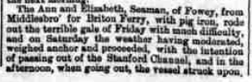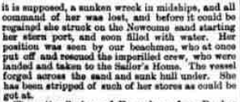

1870

