Schooner Bessie
Vessel Name | Official Number |  | Signal letters | Rig /Type | Where built |  | Builder |  | Year built |  |  | Year end |  | reg tons
BESSIE | 44899 |  | VBDH | Schooner |  | Polruan |  | R & J (Nicholas) Butson |  | 1863 |  |  | 1872 |  | 152
OWNERS/ MANAGERS/REGISTRATION DETAILS |  | Notes |  |  |  |  |  |  |  |  | MASTERS
Registered in Fowey 7th November 1863.1864 Moss and co. 1868 John Rickards ,Sheviock,Cornwall |  | LOA 99.5 x 22 x 12ft . launched 26th August 1863 for foreign trade. 11th January 1872 went aground on the Goodwins on passage from Antwerp for Bristol with cargo of 220 tons beetroot sugar. Crew took to their boat and got onto the North Sand Head Light vessel. They were later landed in Broadstairs. The derrilick vessel floated of and was towed to Calais . she was bought by Thos Ellis Poole of Hayle in 1874 then registered in Plymouth in 1875. In 1855 ownership changed T E POOL & SON of Hayle and then to to David W.Bain of Portreath. not registered in 1889 |  |  |  |  |  |  |  |  | Joseph Moss 1863-1867 Pill 1866 R.Ham 1870-1874 J.B.Bennett 1872 Andrew Roberston 1872 Davis W.Bain 1886-88
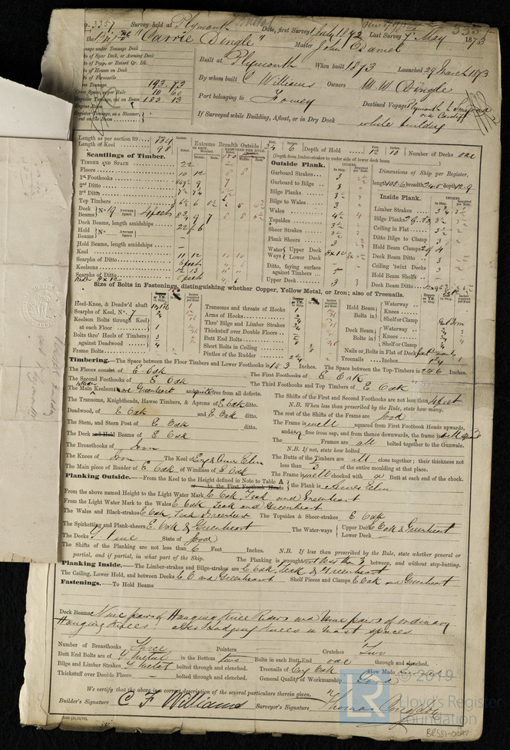
Survey Report for Carrie Dingle, 7th May 1873
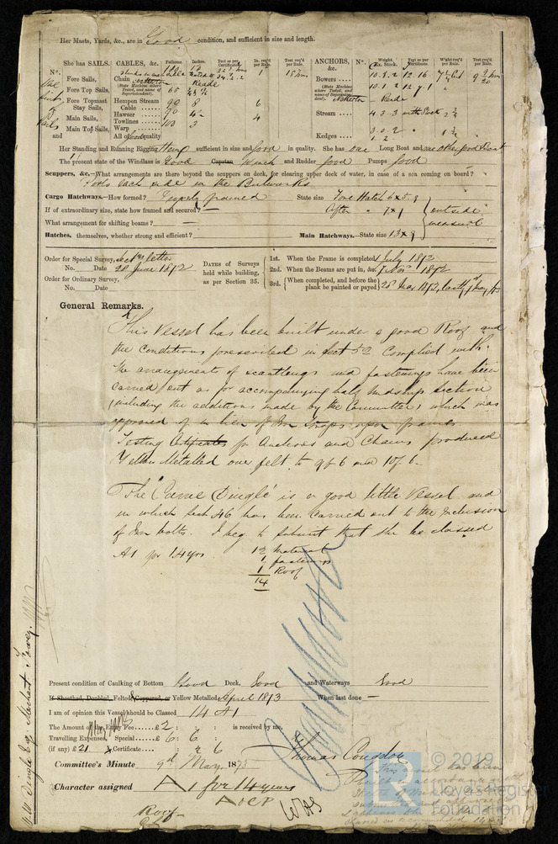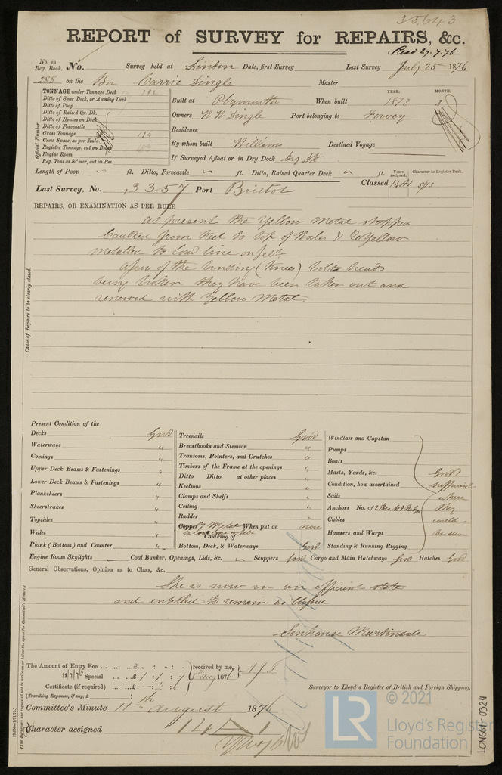

Report of Survey for Repairs, &c for Carrie Dingle, 25th July 1876

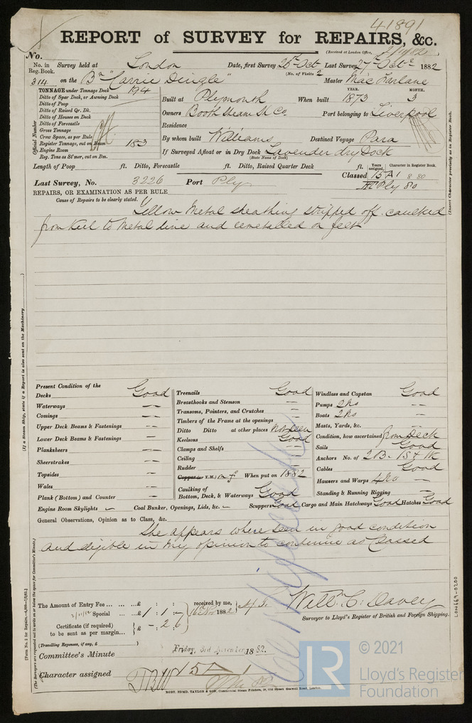

Report of Survey for Repairs, &c for Carrie Dingle, 27th October 1882

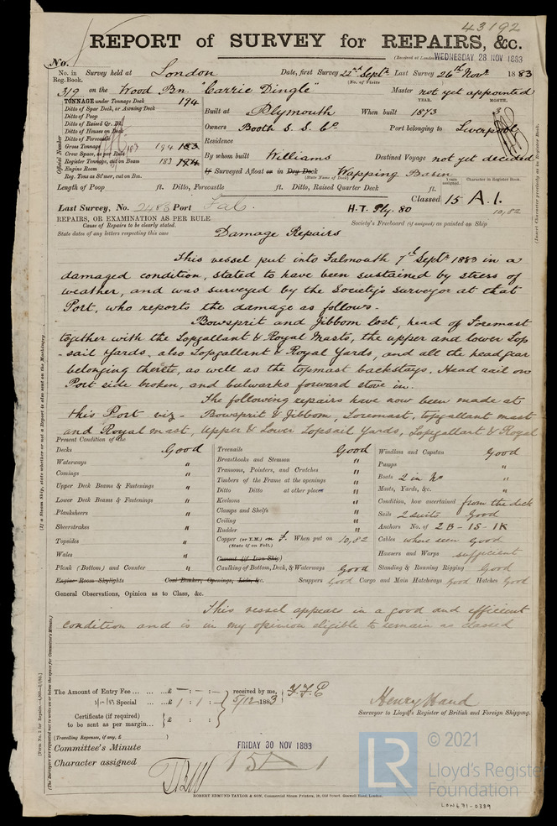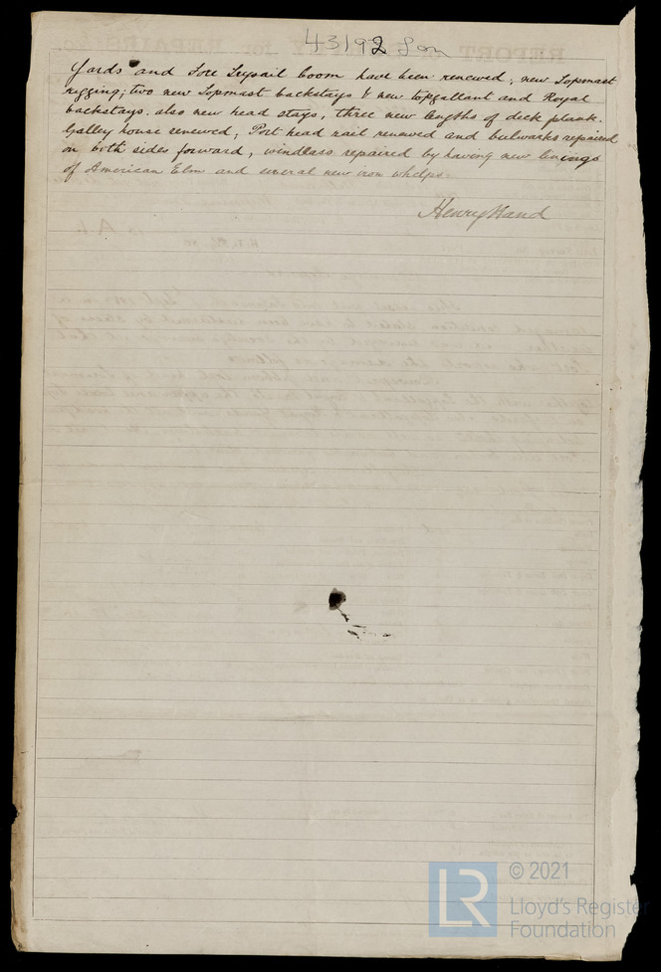

Report of Survey for Repairs, &c for Carrie Dingle, 26th November 1883

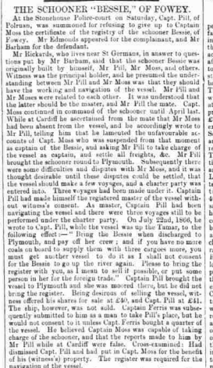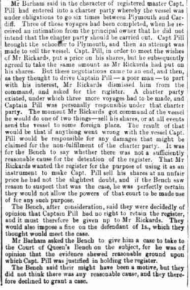
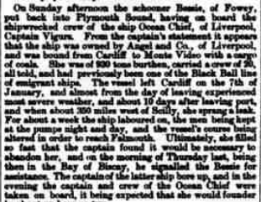
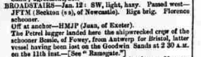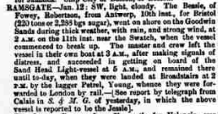

Crew of the Bessie 1876
GLANVILLE SPRAY 35 HAYLE MASTER BESSIE, PLYMOUTH,
JOHN MARTIN 24 PORTREATH MATE BESSIE, PLYMOUTH,
SIMON MORAN 33 WEXFORD COOK BESSIE, PLYMOUTH,
RICHARD GRENFELL 20 ST IVES AB BESSIE, PLYMOUTH,
MATTHEW FREEMAN 20 ST IVES AB BESSIE, PLYMOUTH,
THOMAS SMITH 32 SHETLAND AB FLORIDA, WICK,
DAVID BROWN 20 EDINBURGH AB FLORIDA, WICK,
GEORGE DYSON 35 PLYMOUTH AB MILTON, N'CASTLE,
WILLIAM BAZELEY 18 PLYMOUTH OS FINGAL, HULL,
WILLIAM JOHNS 56 MILTON AB GEORGETOWN, LONDON,
JOHN ROSEWARNE 55 HAYLE AB TRIO, PORTREATH,
OLIVER THOMAS 28 HAYLE AB AGILIS, GUERNSEY,
JOHN H BURT 32 HAYLE AB NICHOLAS HARVEY, HAYLE,
JOHN BUTLER 20 TRURO OS MAID OF ANGLESEA, CHESTER,
PHILIP WILLIAMS 56 LUDGVAN MATE KILLIOW, PENZANCE,

GLANVILLE SPRAY 35 CORNWALL MASTER BESSIE, PLYMOUTH, 1876
JOHN CADDY 30 CORNWALL MATE BESSIE, PLYMOUTH, 1876
JOHN LENYMAID 23 CORNWALL COOK PERSEVERANCE, FOWEY, 1876
HUGH CURTIS 20 CORNWALL AB PERSEVERANCE, FOWEY, 1876
THOMAS TERRY 23 CORNWALL AB PERSEVERANCE, FOWEY, 1876
W H ROACH 20 CORNWALL AB BESSIE, PLYMOUTH, 1876
JOHN NICHOLAS 21 CORNWALL AB BESSIE, PLYMOUTH, 1876
SIMON MORAN 32 WEXFORD MATE S G G THOMPSON, 1876
WILLIAM GILBERT 25 PENZANCE AB MAVIS, 1876
JOSEPH COOK 19 CORNWALL AB MARTHA STEPHENS, 1876
THOMAS GRANT 43 INVERNESS AB PROVIDENCE, 1876
JOSEPH SATY 23 PENZANCE AB PROVIDENCE, 1876
RICHARD KNEEBONE 21 HAYLE AB FRANK, 1876
SAMUEL CALLAGHAN 29 DUBLIN AB INVERESK, 1876

MATTHEW FREEMAN 20 ST IVES AB ELTA, 1876
RICHARD GRENFELL 20 ST IVES AB ELTA, 1876
THOMAS MATTHEWS 19 LONDON AB INVERESK,
https://www.crewlist.org.uk/people/transcript?DocumentId=105958&NameId=0

