Schooner Brenton

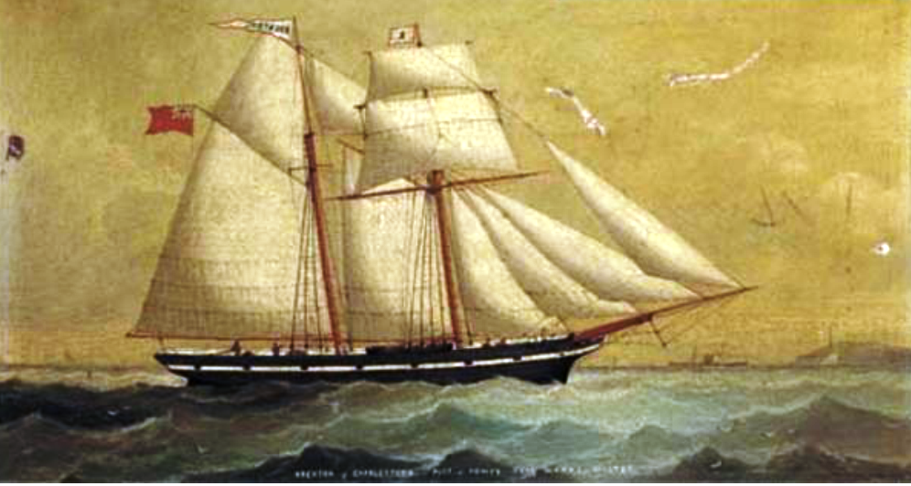
Vessel Name | Official Number |  | Signal letters | Rig /Type | Where built |  | Builder |  | Year built |  |  | Year end |  | reg tons
BRENTON | 28672 |  | QBLQ | 2 masted topsail schooner |  | Mevagissey |  | Nicholas Lelean |  | 1861 |  |  | 1900 |  | 83
OWNERS/ MANAGERS/REGISTRATION DETAILS |  | Notes |  |  |  |  |  |  |  |  | MASTERS
registered in Fowey 6th April 1861. 1870 Richard H williams, Cuddra House,St.Austell, Cornwall. 1895 John Stephens Par |  | LOA 69'9 x 19 x 10'5 2 masts square stern with woman bust figure head. Put up for sale at the Rashleigh Arms Charlestown on 23rd October 1869. On 8th December 1869 on passage from Adrossan to Newport with a cargo of pig iron went onto Skullmartin Rock. Crew were landed by the lifeboat and she was helped off and brought into Ballywater and then later to Belfast for repairs. October On returning to Ardrossan in ballast 4th January 1870 she drove ashore at Horse Point .Crew landed in their own boat. Refloated later. on 1881 The lifeboat belonging to Port Madoc, Carnarvonshire, rescued the crew of the schooner Brenton, of Fowey. 25th June 1895 Dutch steamer Leyden, on arrival at Cardiff, reported that when off Porthcawl his vessel collided with the schooner Brenton, of Fowey. The latter's headgear was carried away, but the former was not damaged. She was wrecked at Smoky Tickle, Labrador. She had been used on newfoundland trade. Register closed 1900 |  |  |  |  |  |  |  |  | C.Warne 1865-69 Morgan 1869-70 James Brewer Rich 1870-1874, Charles Henry Deacon 1894

