The History
of the tug Cannis

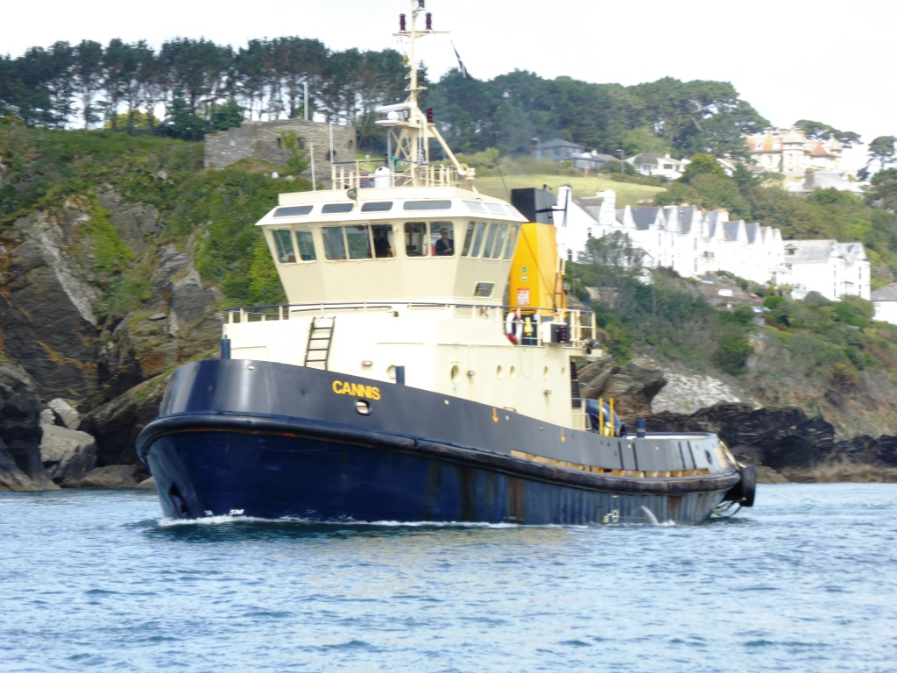

Previous names:- Lady Constance, Svitzer Constance

Built:- Cochrane & Sons Ltd" at Selby (YN 115) in 1982.

In service

Period in Fowey:- 2014
(This is the 2nd tug with the name Cannis)
Name of Vessel | Cannis
Previous Names | Lady Constance,  Svitzer Constance

Built as the Lady Constance for Humber Tugs Ltd by Cochrane & Sons Ltd" at Selby (YN 115) in 1982.

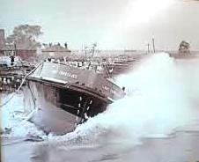

The launching of the Lady Constance

She has an Overall length of 30.21 m with a beam of 9.73m and a draft of 3.81m

With a GRT 285, and 85 NRT and a displacement of 170 tons Powered by 2x diesel 4tew 6cyl Ruston type 6RKCM, developing 2640bhp-1942kW total, operating two VSP,voith units. This gives her a speed of 12,5kn, and a Bollard pull of 32tonnes.

She was registered in Hull, with ON 389072, IMO number 8102141 ,MMSI 235053755 and the call sign GCRY

Humber tugs house flag

Cochranes was founded at Beverley in 1884 and relocated to Selby in 1898.The Company was established by the Craggs family to take over the shipyard on the Dutch River previously operated by T. Scott and Company, and continued their yard number sequence beginning with the steamer BIA, yard number 47 in 1902..
In 1914 the company leased a 10-acre site on the Old Goole side of the Dutch River from the Aire & Calder Navigation, and production moved there from 1917. The company suffered in the recession and was replaced by the (1927) company from 1927 to 1934, when the old title was regained. Acquired by the Ross group in 1965 and the Drypool Group in 1969. Subsequently acquired by United Towing and renamed Cochrane Shipbuilders in 1977. Acquired Goole Shipbuilders in 1984, but this yard closed in 1988, and the Selby yard closed in 1993.In November 1967 the company became a subsidiary of the Swan, Hunter Group (Small Ship Division), and was nationalised in 1978 when it became Goole Shipbuilders Ltd. The yard was closed in April 1984 but was bought later in the same year by Cochrane Shipbuilders, Selby and resumed building until the last vessel, the tug LADY SYBIL was completed in January 1988.

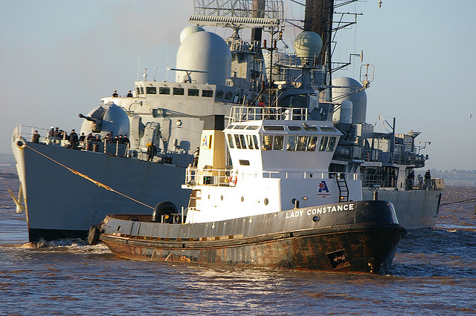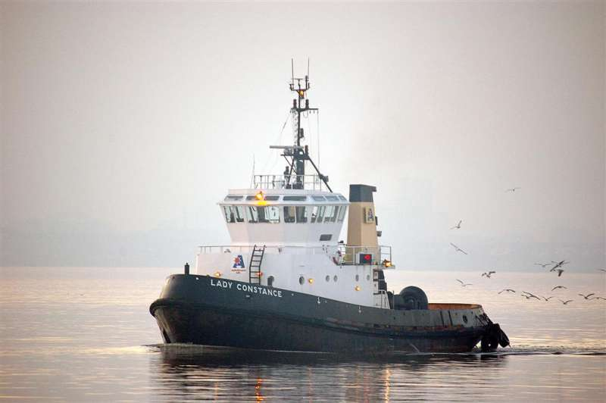

Towing HMS Nottingham November 8, 2006

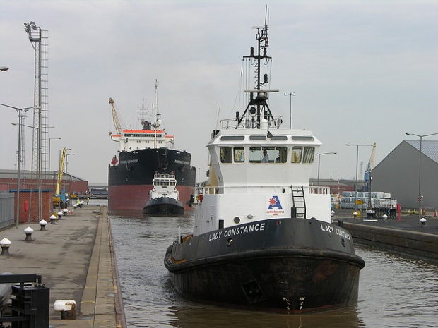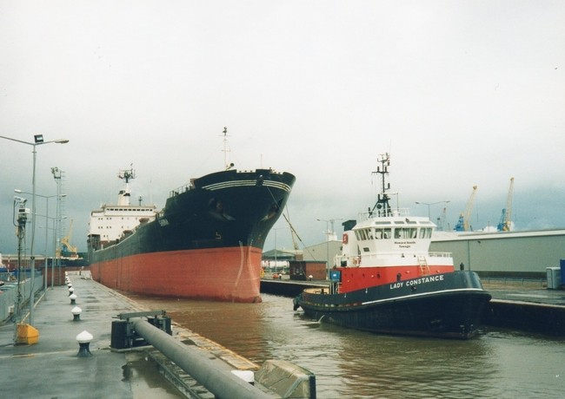

In the Lock at Hull Assisting The "SABINA" Into the Lock at King George Dock Hull 2001
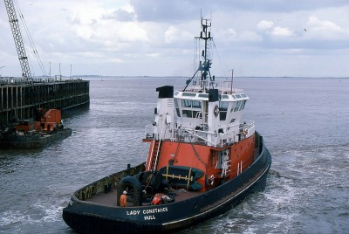

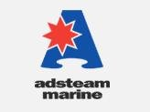 Adsteam Humber Limited

The UK’s largest and most powerful port tug fleet operates out of Immingham and Hull, sailing under the Adsteam flag.

Since the early 1990s the Humber tug fleet has been a noted operator of modern omni-directional vessels, mainly Voith Schneider propelled, which have combined the manoeuvrability required for ‘ship assist’ in enclosed docks with the power needed to cope with the fast flowing tides in the country’s most hazardous estuary.

Adsteam’s fleet of thirteen tugs includes eight with fire fighting capability, one fitted for oil dispersant spraying, and the most recent addition the azimuthing stern drive tug “Lady Laura” providing even more power – all of which ensures that Adsteam continues to meet the day to day needs of the busy Humber estuary.

As the Lady Constance she suffered an engine room fire at 11.40 pm Thursday, June 22nd 2000. She was anchored, on the River Hull off Saltend, near Hull when the fire occurred. She had four crew on board. Humber Fire Brigade sent six firemen to the scene on board her sister tug ‘Lady Elizabeth’.The fire was quickly put out and ‘Lady Elizabeth’ towed ‘Lady Constance’ back into port alongside in King George Dock. Nobody was injured and the damage was to serious.

Between April and July 2007 the Adsteam operation was taken over by Svitzer Marine and along with other Hull based tugs Lady Constance had as the Registered owner SVITZER HUMBER LTD Triton House, Alexandra Road, Immingham Dock, Immingham, DN40 2LZ, United Kingdom. Her name was changed to Svitzer Constance
The Svitzer House flag and the propeller emblem on a blue and white funnel, and cap badge

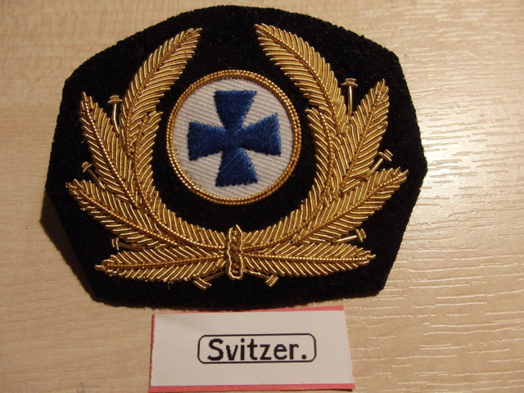

As the Svitzer Constance she had a minor collision at1345hrs on 9th March 2009, whilst berthing m.v.Finnhawk King George Dock lock, Hull.

The report below covered the incident.

The harbour tug Svitzer Constance was assisting with the entry of the Finnish-registered 11,530 gt ro-ro cargo vessel Finnhawk into King George Dock, Hull. Svitzer Constance was connected to the port aft mooring station on Finnhawk. This was to counter both the wind, which was gusting to force 5, and Finnhawk’s inoperative stern thruster; there was also no centre-line aft fairlead available on Finnhawk. As the two vessels began to exit the lock into the dock, Svitzer Constance’s stern was pushing on the port side of Finnhawk’s stern. However, as the tug approached the inner lock gates, her stern slipped off. No longer in push mode, her skeg was affected by Finnhawk’s wake, causing her stern to shear towards one of the inner lock gates. The shear was exacerbated as the tow wire, with a particularly high lead angle to Finnhawk’s mooring station, became taut.
Despite an emergency avoiding manoeuvre, Svitzer Constance made heavy contact with the lock gate and gate recess, hanging up on the latter for around 20 seconds and, in turn, causing the tow wire to part as Finnhawk continued into the dock. Svitzer Constance was able to manoeuvre off the recess, and her crew conducted an initial damage assessment. She then continued to assist with berthing Finnhawk in push mode before returning to her own berth. Svitzer Constance experienced no flooding, with all of the damage above the waterline. Minor damage was sustained to the lock gate and gate recess.
Penetration damage to starboard quarter in way of freshwater tank and rope hold, and damage to the winch; minor damage to lock gate and gate recess.

Under the Svitzer flag she worked in numerous ports but mainly in the Tees. These included on July 29th 2011, she was working on the Thames. In September that year she was back on the Tees. In November she was back to her old stomping ground at Hull.

On Tuesday, 11th December 2012 she became the first tug to take up permanent residence in the Port of Sunderland for more than 25 years. Middlesbrough based Svitzer Marine Ltd had invested substantially during the vessel’s recent special survey dry-docking to make her suitable to operate in the Port of Sunderland. Svitzer Constance was seen as the perfect fit for Port of Sunderland as the Voith Schneider propulsion system is generally considered to provide enhanced stability and mobility in smaller, more confined areas like those on the banks of the Wear.

She continued to carry out duties in other ports and in July 2013 she had a spell covering the port of Grangemouth and on the river Forth. September 2013 saw her working in Rosyth and in January 2014 she was back on the Forth. She was down in Blyth in May and covering the Svitzer Sun next door on the Tyne.

At the Teesport Svitzer tug base with other tugs

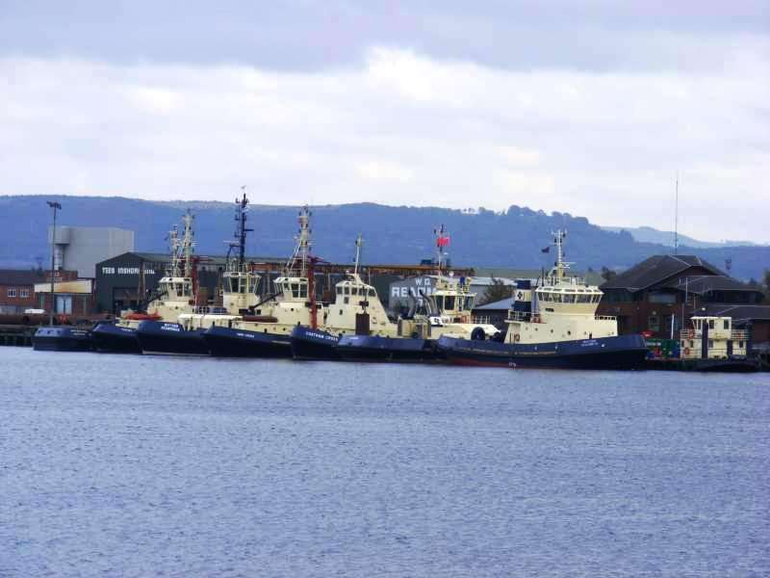

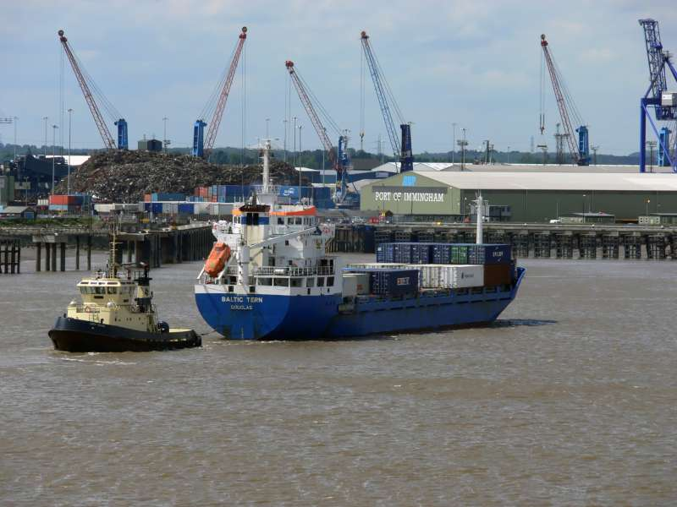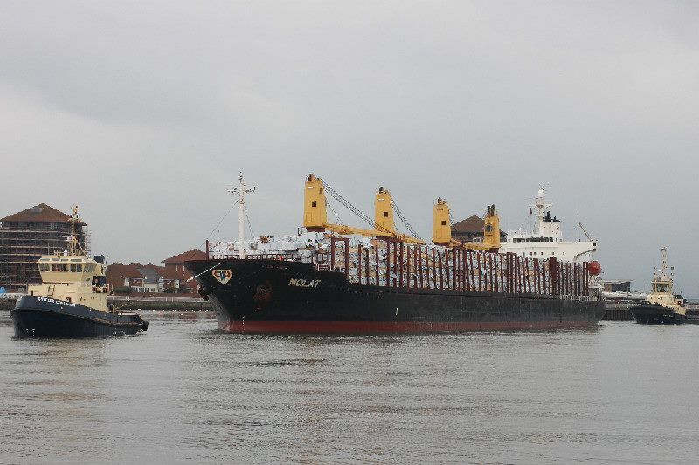

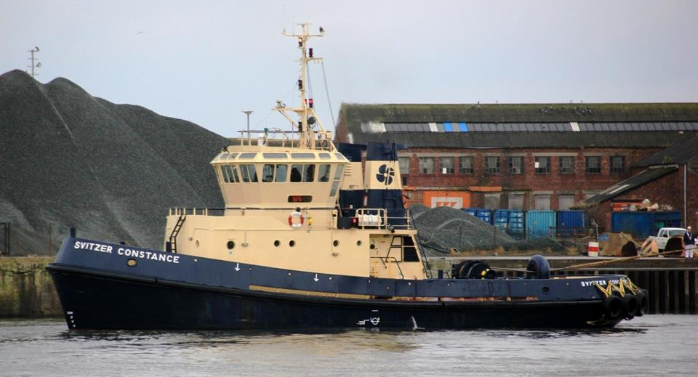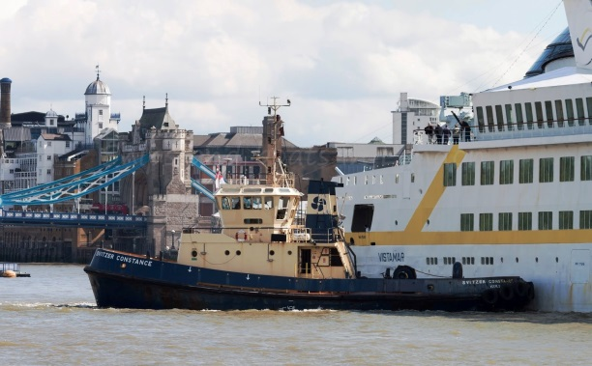

Towing Molat in Sunderland Berthing Vistamar in pool of London August 2011
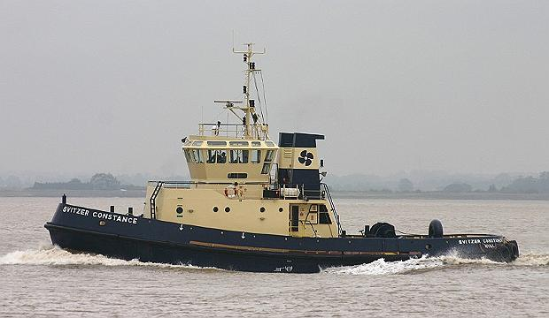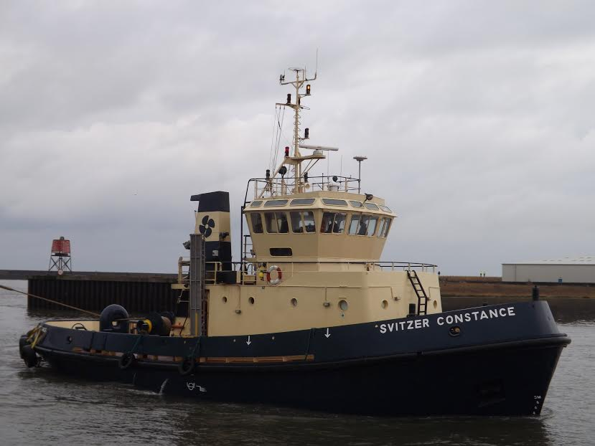

On the Tyne in Sunderland

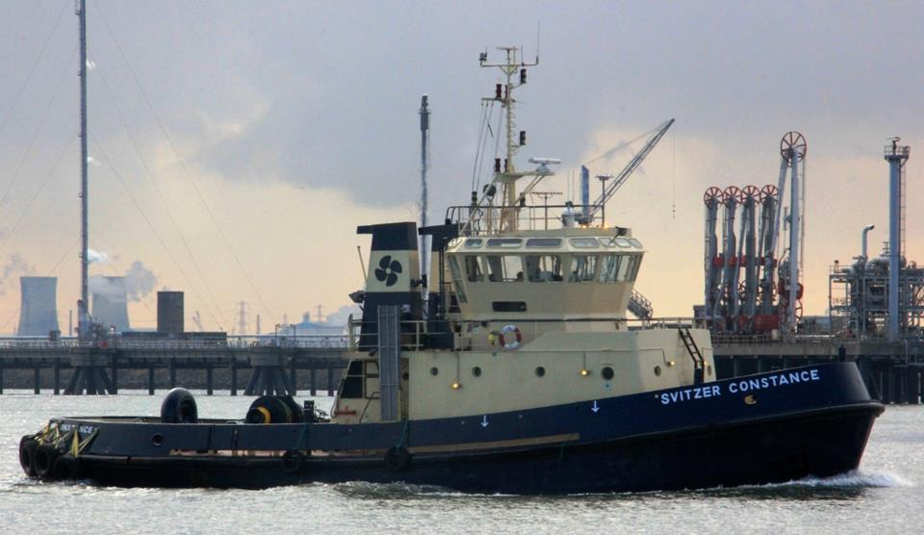

Berthing the Molat January 2013 On the Tees April 2013

In Drydock

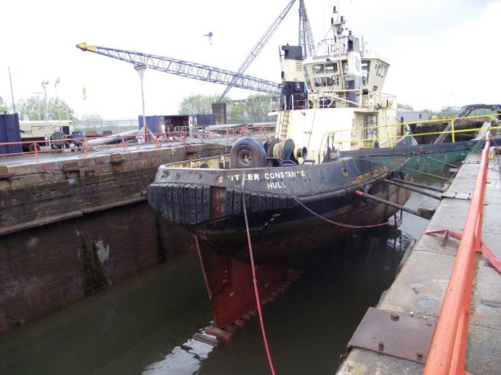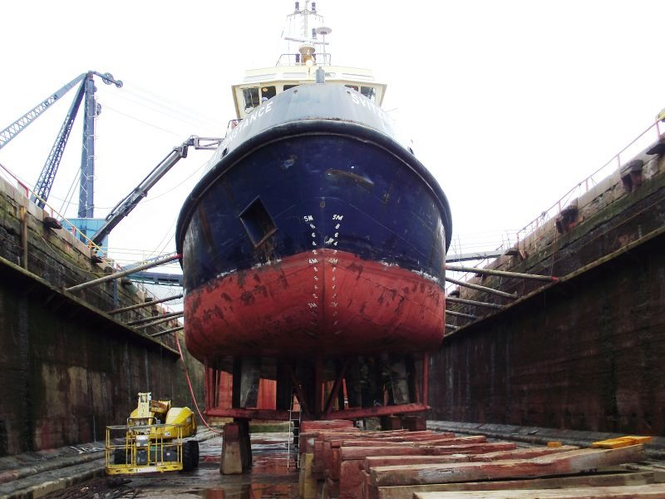

A view from aft as the water is pumped out Down on the blocks and shores in

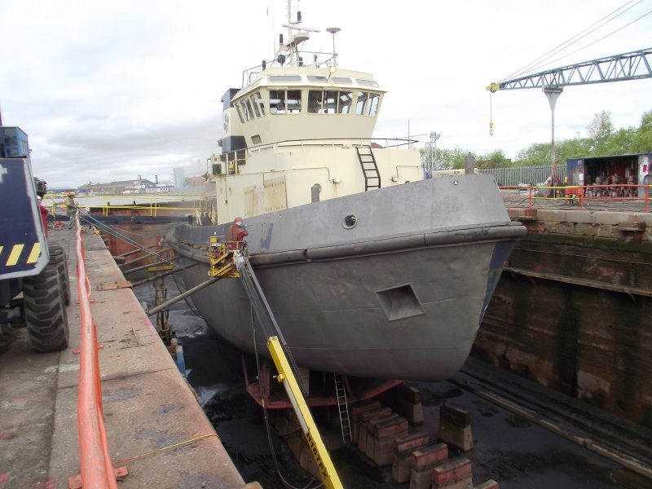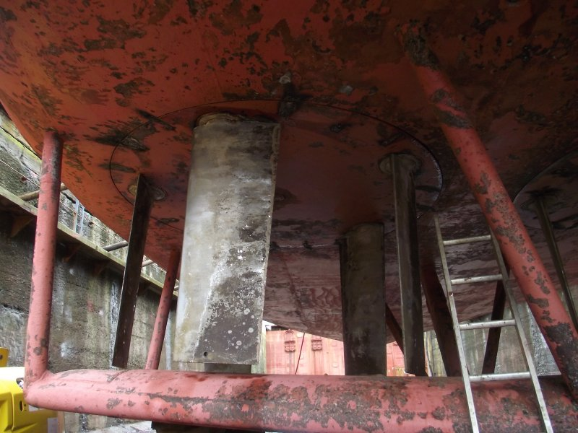

The hull with its coat of grey primer on the blades of the Voith unit

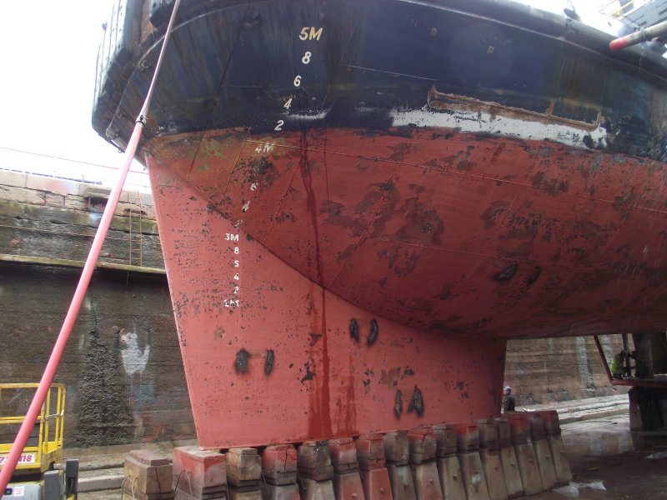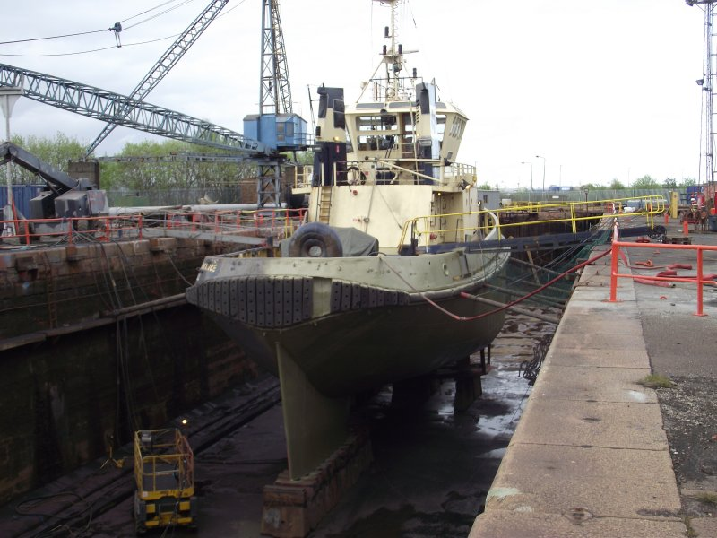

View of the skeg giving her stability in steering a view from aft

Transfer to Fowey Harbour Commissioners

Following the disposal of the “Cormillan” after damage it was necessary to acquire a second tug capable of towage in Fowey but also to provide service to Plymouth, Falmouth and other operations in the south west approaches.After an extensive search the Svitzer Constance came on the market.This was the third occasion business was done with Svtzer Marine and a sale was agreed in mid July 2014.

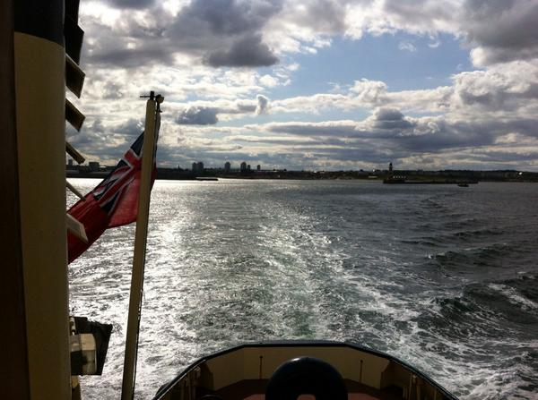
Zvitzer Constance departed from Sunderland on 29th July 2014 bound for Fowey

Arrival Fowey
The tug arrived in the early hours of 1ST August 2014

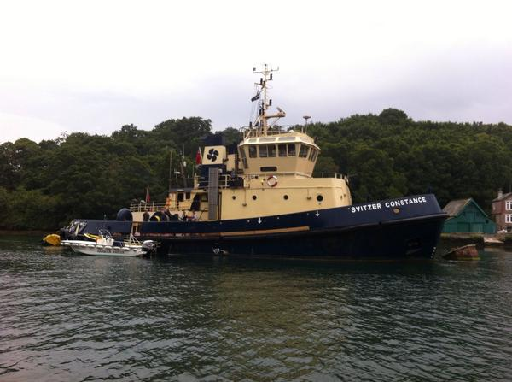

The naming ceremony

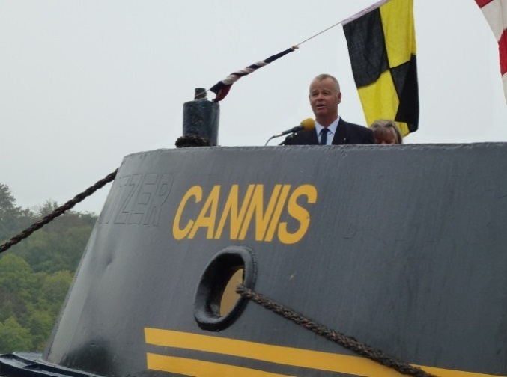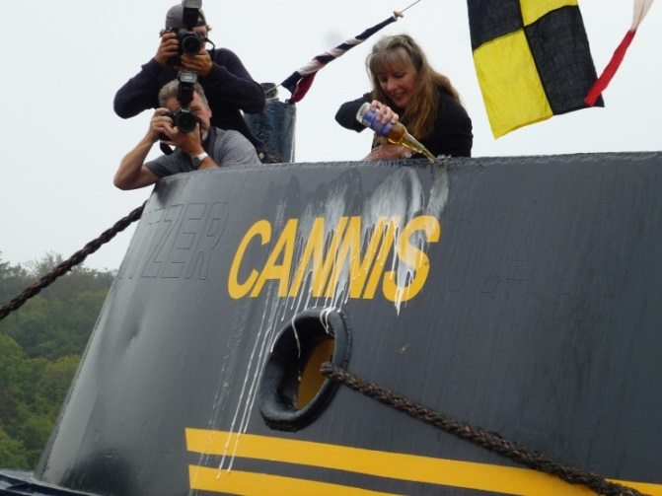

Captain Will Mitchell Chairman giving the welcoming speech and his Wife Shirley naming The tug “Cannis” after the first diesel tug in the port and the Rocks off Gribbin Head

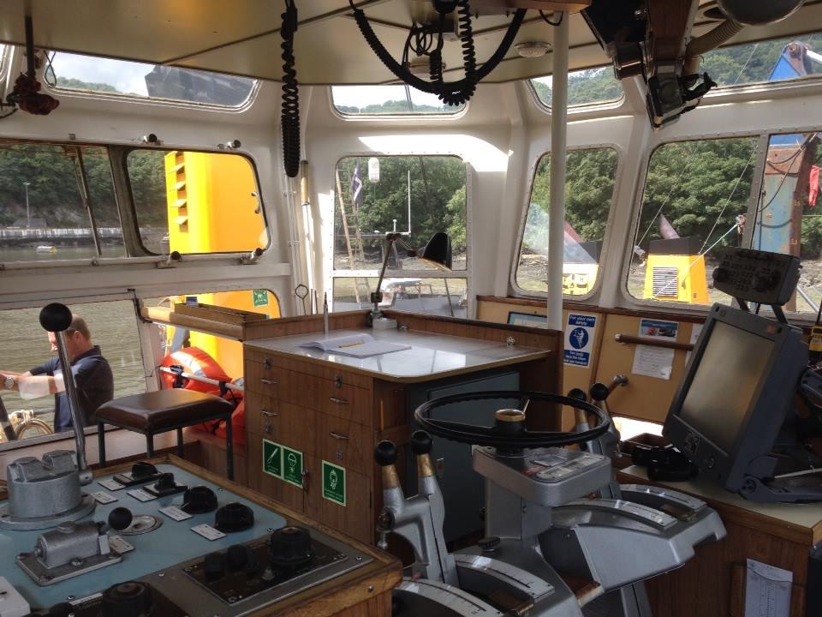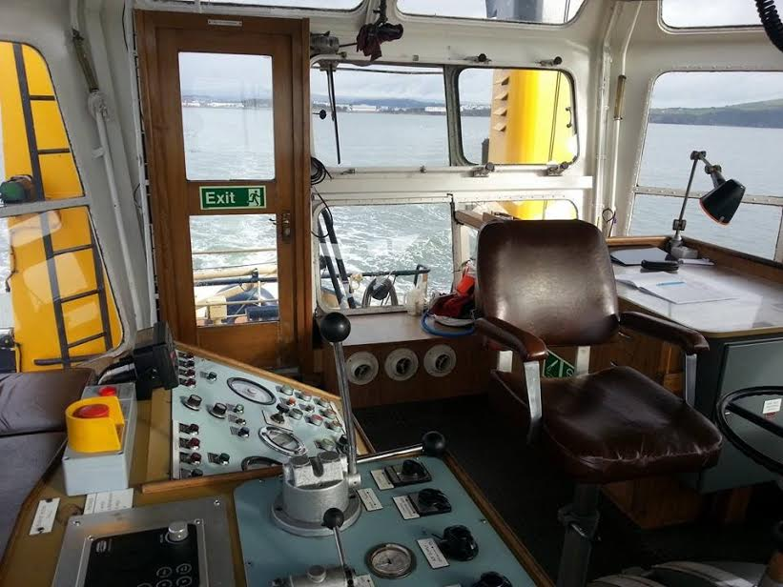

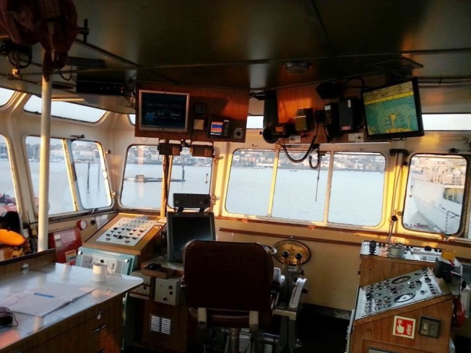
The bridge with the voith unit controls

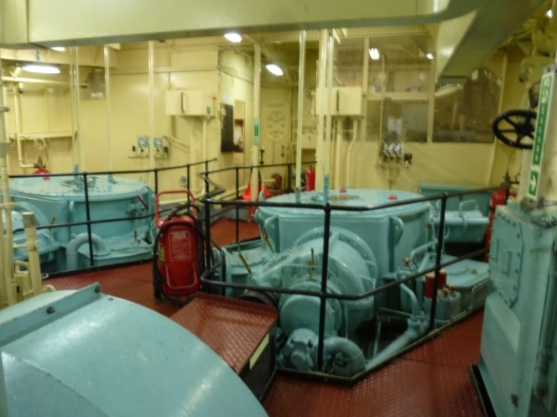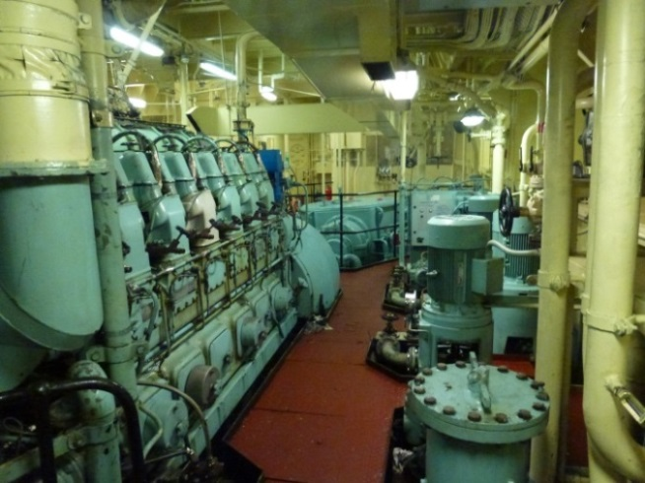

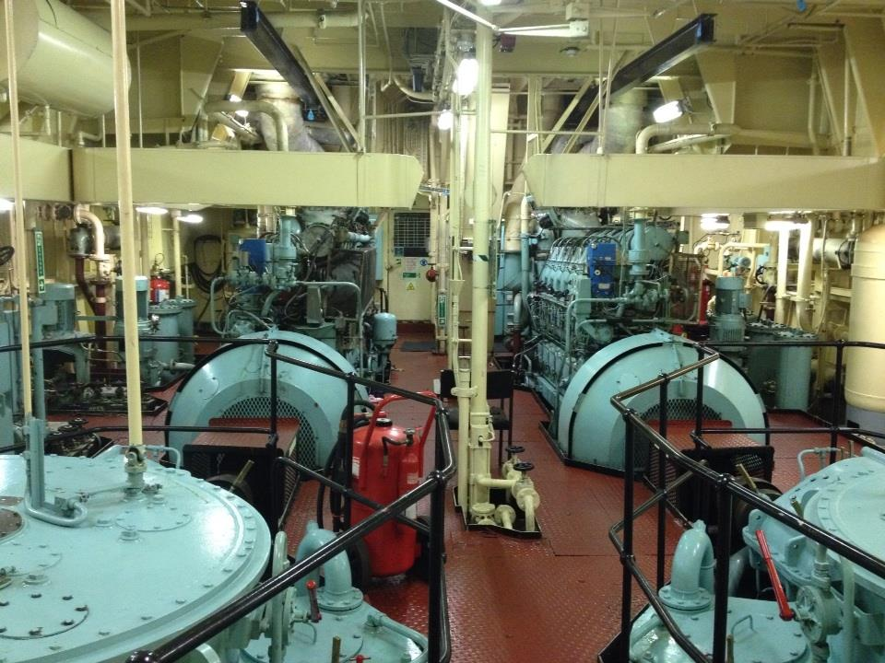
The engine room, galley and mess room, fore deck arrangements and aft deck towing gear

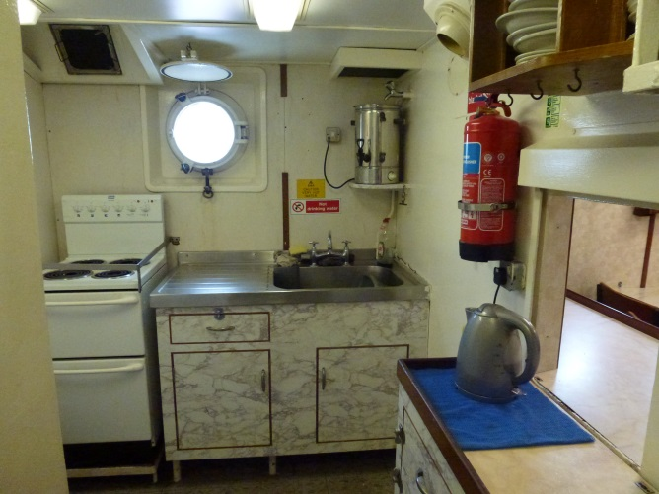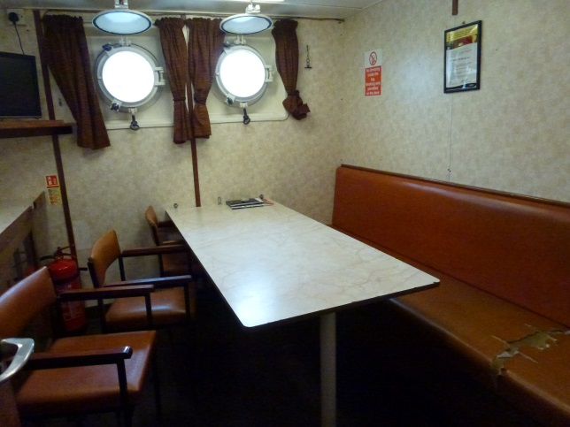

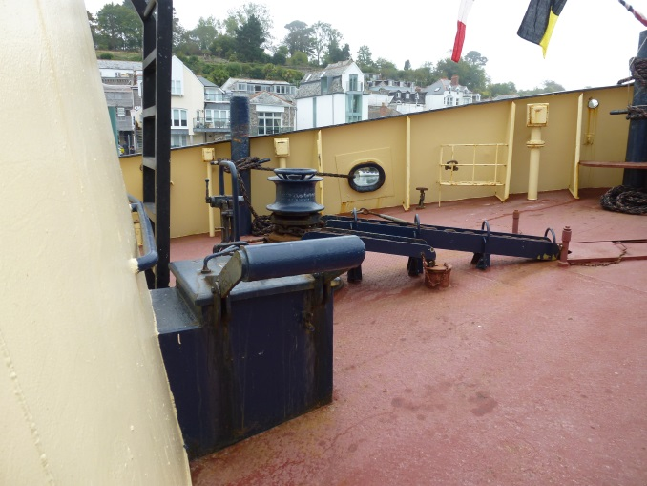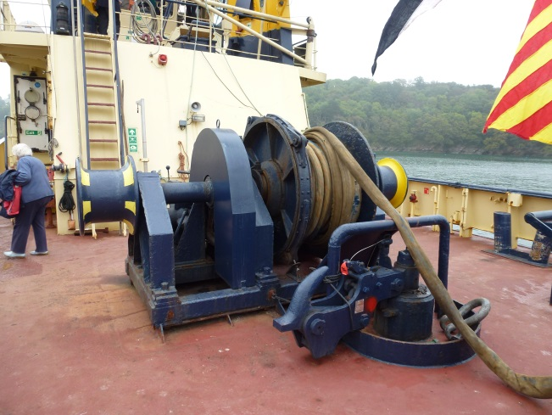

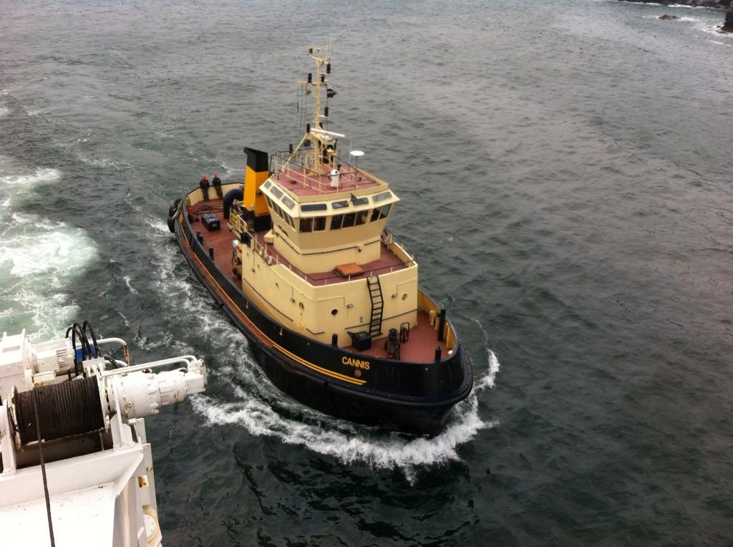

Seen from bridge wing by Pilot Capt. Will Mitchell

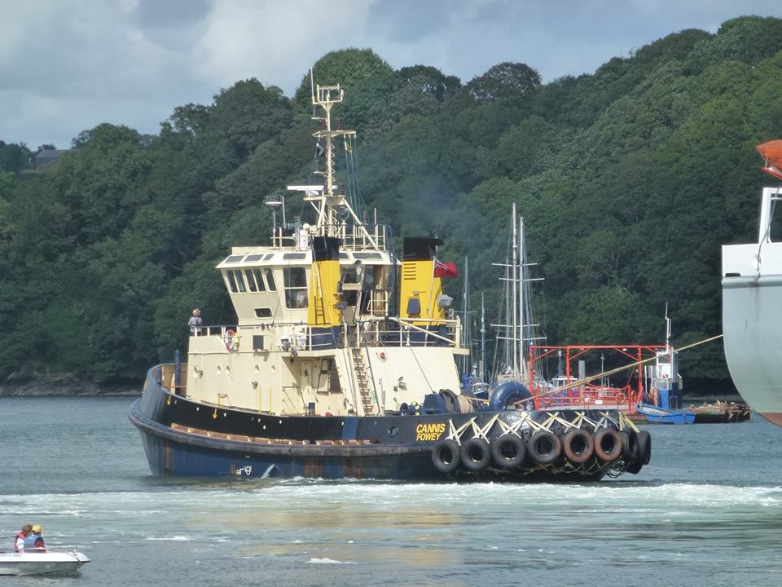

1st Job in Fowey 11thAugust 2014

Cannis seen passing St. Catherine’s Castle
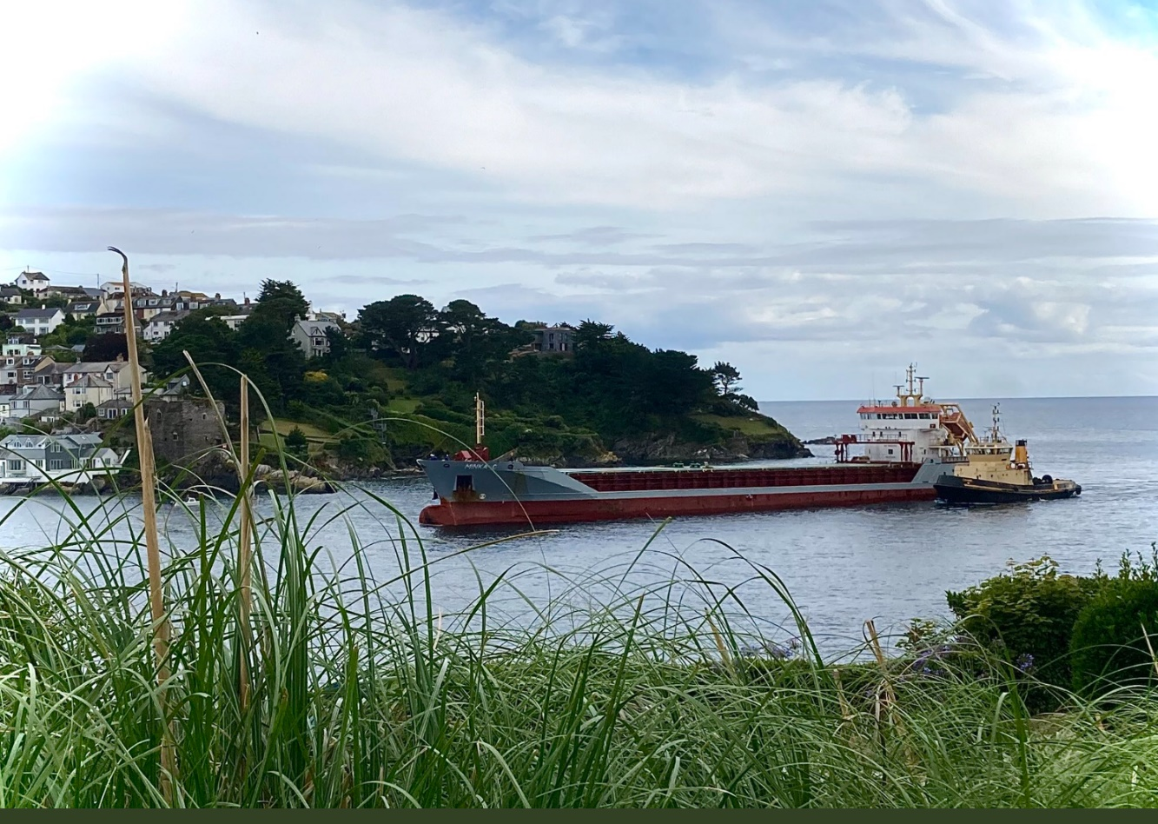

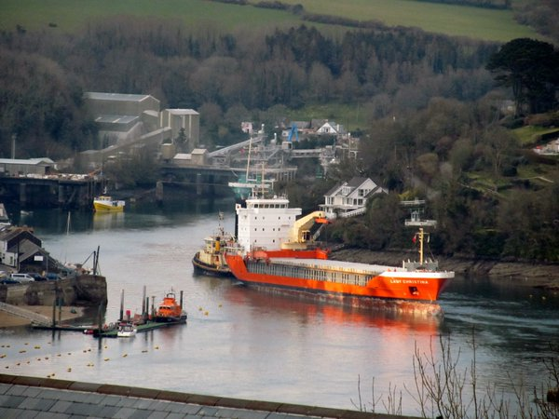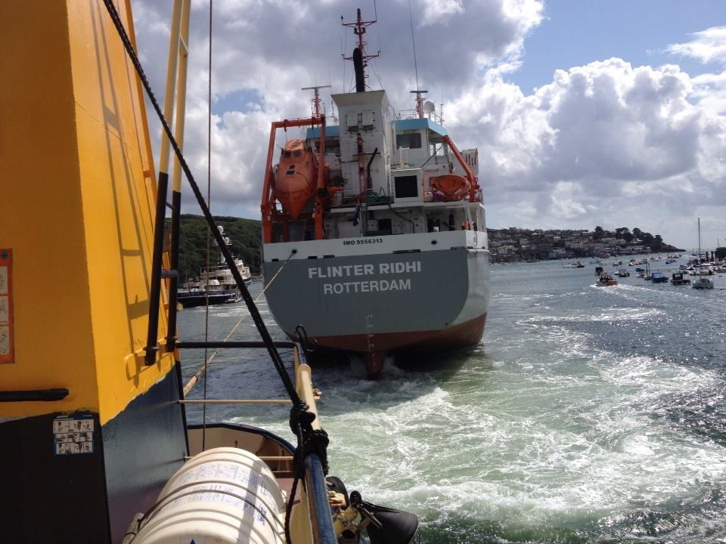

Towing the Lady Catherine and the Flinter Ridhi

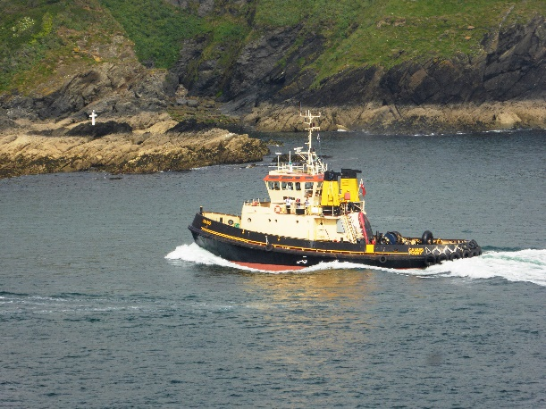

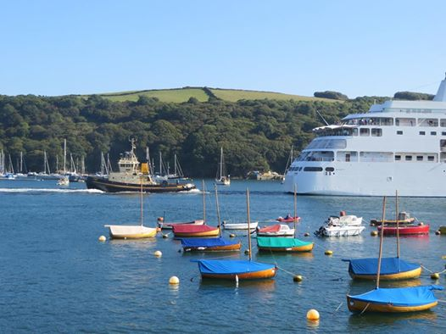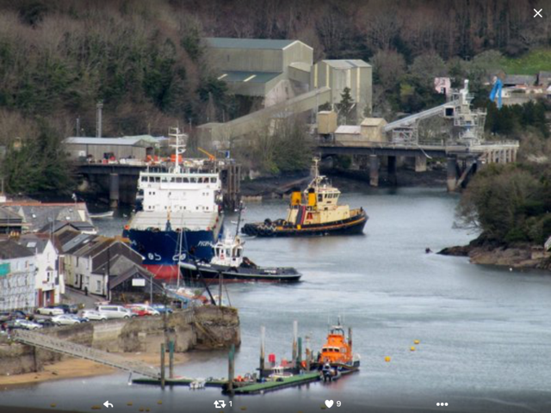

With a Cruise ship and towing a ship through Lew Roads with the help of a Serco tug

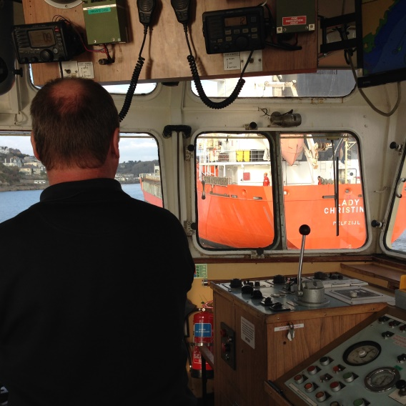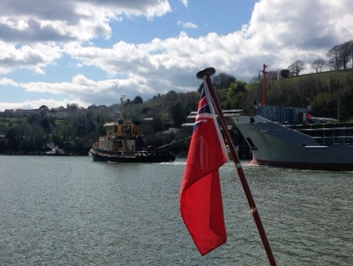

John Burgess as skipper approaching the Lady Christina and in Lew Roads

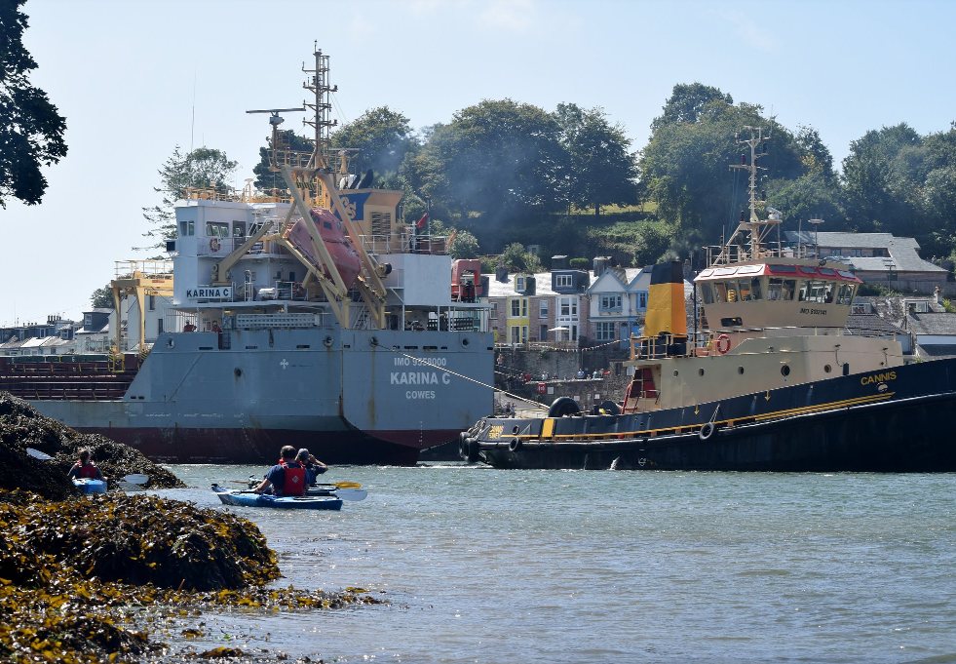

OUT OF PORT TOWING

She was soon at work doing “outside”towing

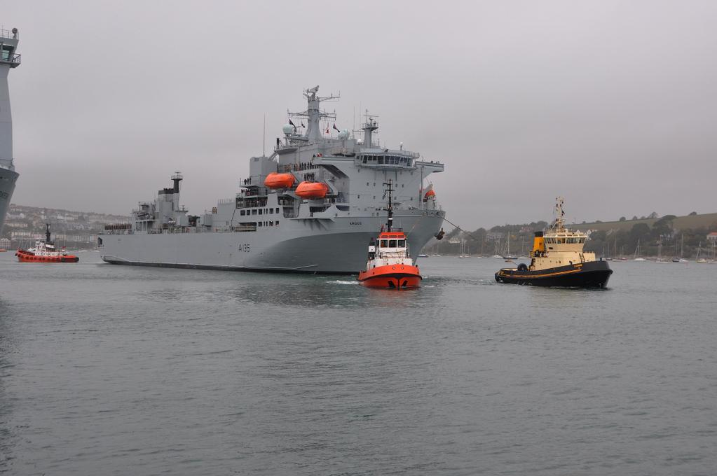

Cannis alongside St.Piran Towing RFA Argos to sea October 2014 picture Capt.David Barnicoat

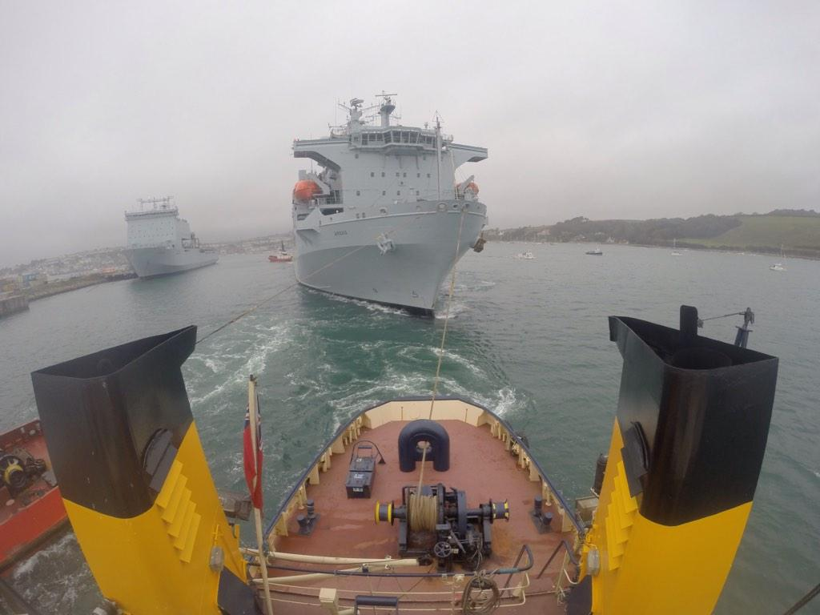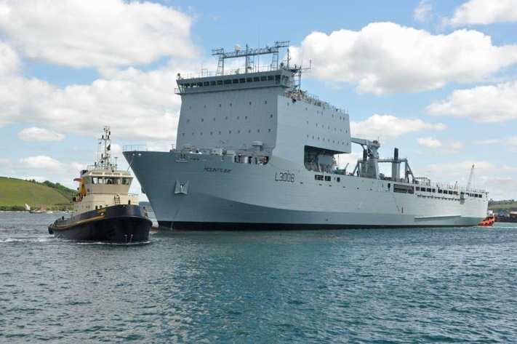

View of Argos from on board Bow tug on RFA Mounts Bay
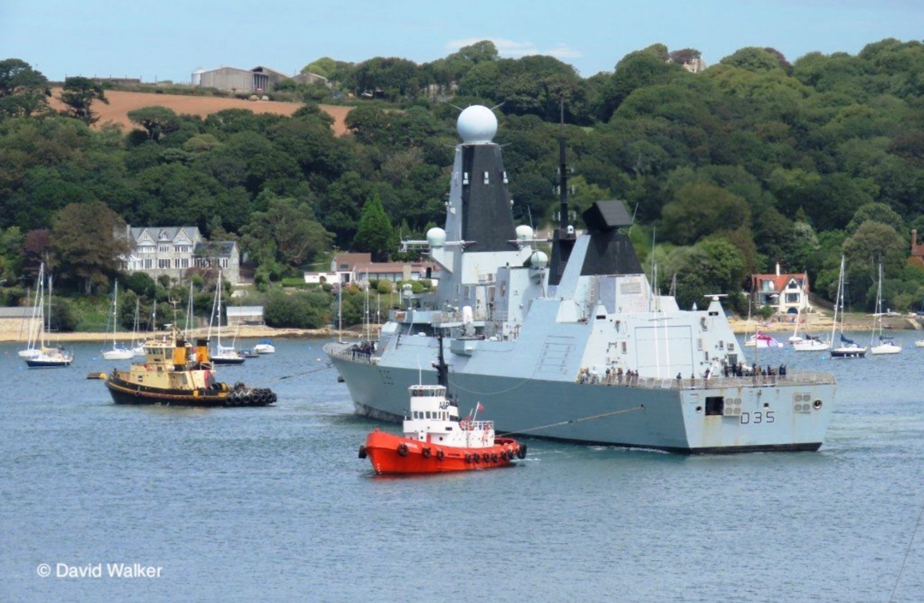

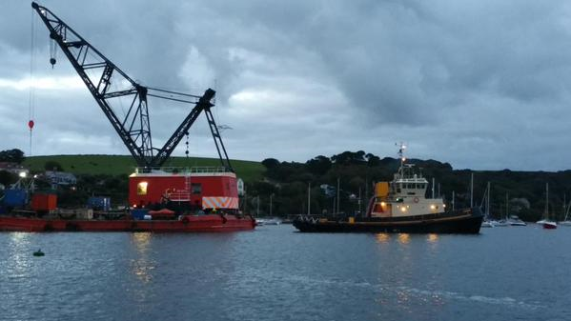

Towing a crane barge from Famouth to recover a sunken fishing boat off Looe

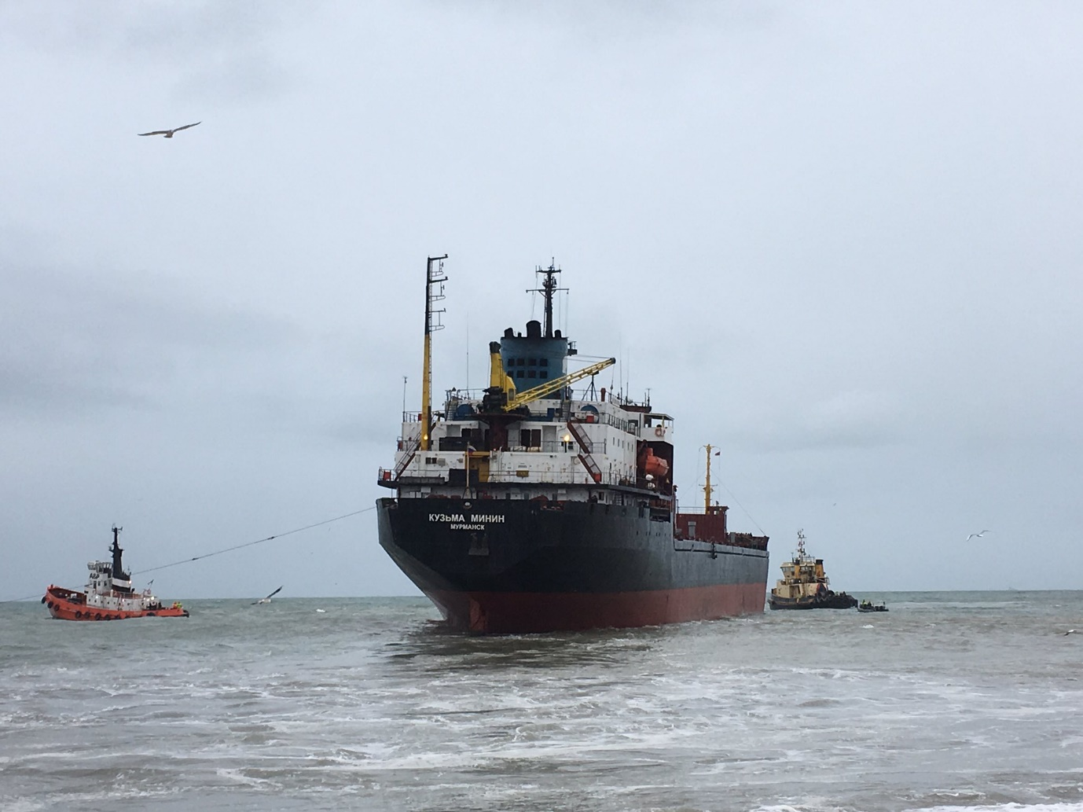

Helping tow off Russian ship aground of Falmouth

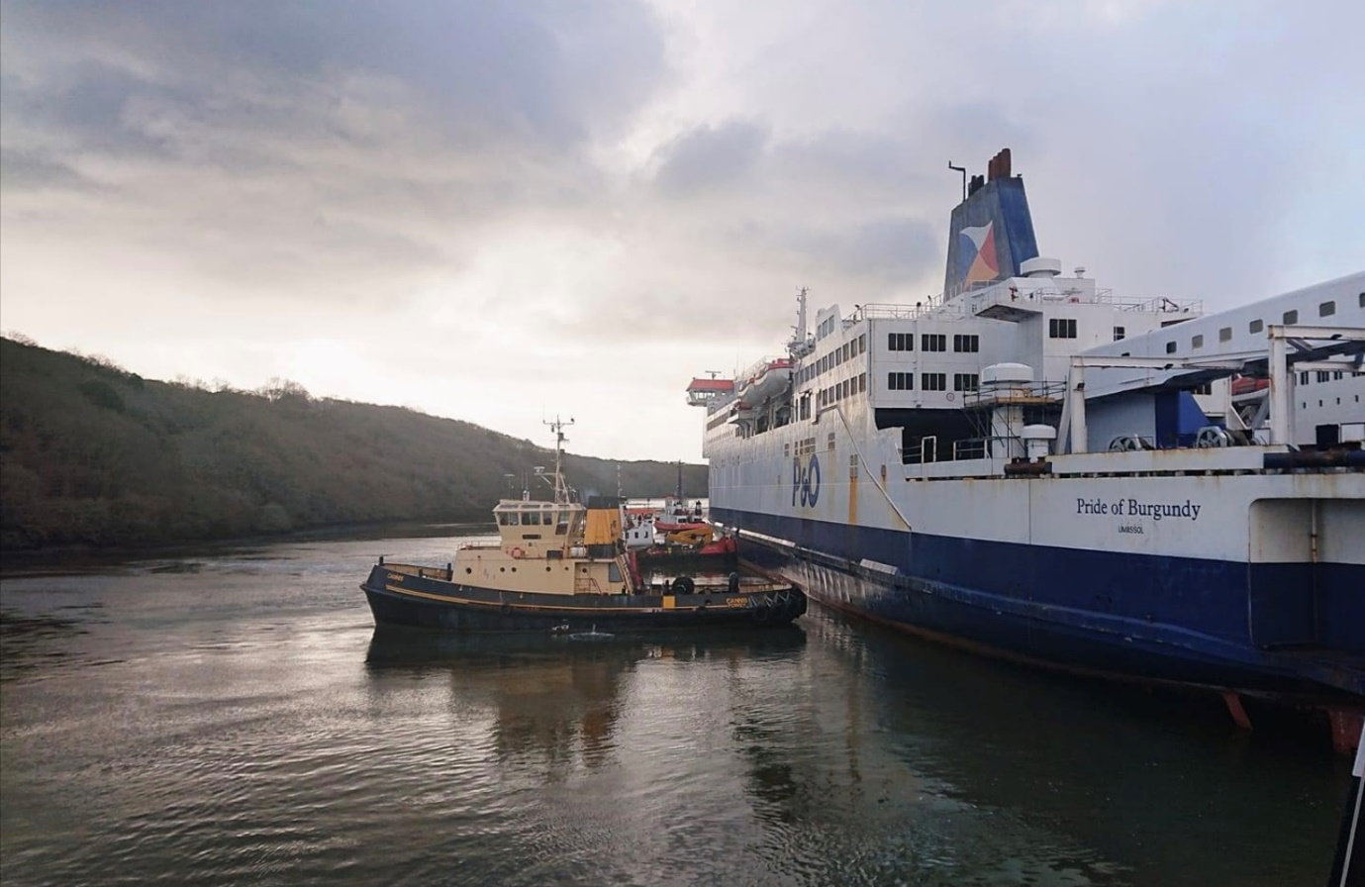

Berthing ferry in layup in river Fal

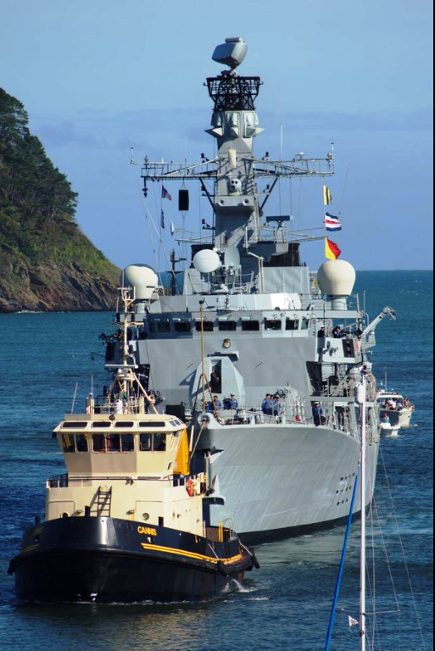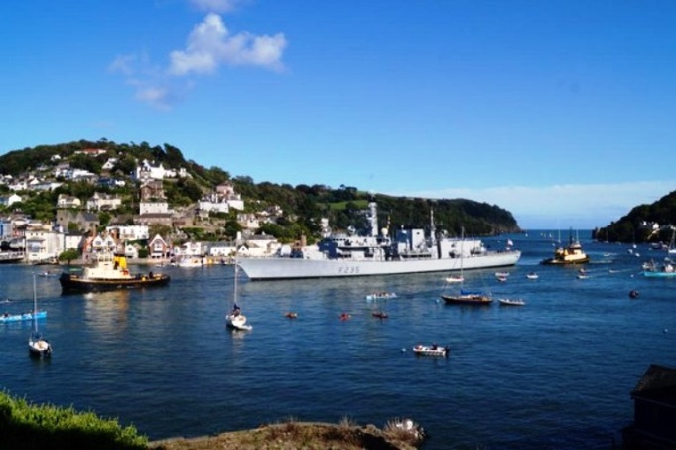

Towing H.MS.Monmouth into Dartmouth. With Morgawr as drag tug

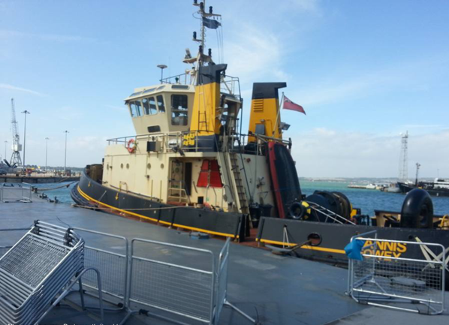

All secured in Portsmouth

Name of Vessel in Fowey  Previous Names |  |  |  |  |  | Cannis  Lady Constance  Svitzer Constance
Built for |  |  |  |  |  | Humber Tugs Ltd
Year Built | 1981 Keel Laid  1982 launched |  |  |  | Official nos IMO Nos  Call Sign |  |  |  | 235053755  8102141  GCRY |  |  | G.R.T.  N.R.T. | 285  85
Builders |  |  | Cochrane Shipbuilders Ltd, Selby, N.Yorks
Dimensions |  |  |  |  |  |  |  | Length |  |  | Beam |  | Draft
 |  |  |  |  |  |  |  | 30 m |  |  | 9.2m |  | 4.2m
Engines |  | 2 x Ruston 6RKCM  PORT IH 9272  STBD IH 9273  2604 hp at 750rpm |  |  |  |  |  |  |  | Bollard pull |  |  | 32 tons
Propulsion units |  | 2 Voith AD40FH |  |  |  |  |  |  |  | Auxilaries |  |  | 2 6LXB Gardeners
Fresh water |  | 14.3 tons |  | fuel |  |  | 65.9 tons |  |  | speed |  |  | 12.5 knots
Owners in Fowey |  |  |  |  |  |  |  | 2014 |  | Fowey Harbour Commissioners

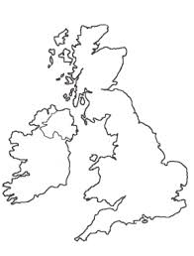
Teesport
2009 to 2012
Humber 1982 to 2009/10
Rosyth and Forth
2013/14
London
2011
Sunderland
2012 to 2014
VOYAGES OF THE TUG CANNIS
Fowey
2014 to present
Built in Selby
1981/82

