Schooner Elizabeth Davey

Vessel Name | Official Number |  | Signal letters | Rig /Type | Where built |  | Builder |  | Year built |  |  | Year end |  | reg tons
ELIZABETH DAVEY | 9487 |  | KHNL | schooner |  | Appledore, Devon |  | W.Clibbett |  | 1856 |  |  | 1896 |  | 89
OWNERS/ MANAGERS/REGISTRATION DETAILS |  | Notes |  |  |  |  |  |  |  |  | MASTERS
registered in Fowey 24th July 1856. 1858 John Clark Isaac,Liskeard  1880 Alfred Luke, Charlestown  1885 John Ennor, Newquay |  | 77'6" x 20'1 x 10'6 2 mast square stern full female figurehead.22nd November 1892 while being towed by the tug Queen up the river Tweed with a cargo of China clay ran aground on Sandstell point in thick fog. both vessels refloated on next tide. Sailed from from Plymouth with grain for Hayle on 23rd September 1896 not heard of . vessel wrecked on or near the Udder Rock. Figure head washed up on Par beach. |  |  |  |  |  |  |  |  | Joseph Davey 1858-59 Anthony Hanson 1877-1879 Peake 1879 Edward Lane 1883 Clemens 1892

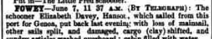
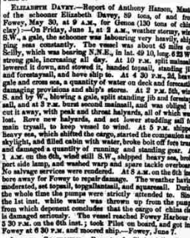

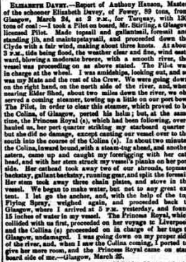

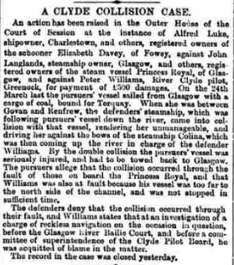

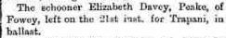
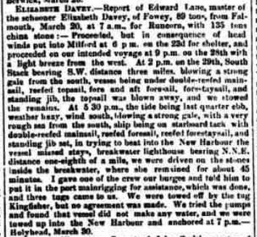

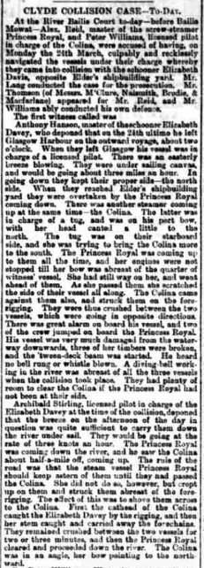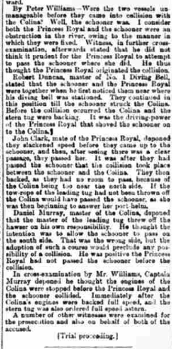

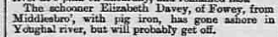

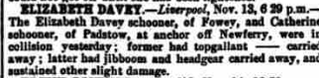
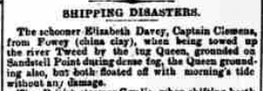
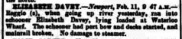

Schooner Elizabeth Davey, wood 89 tons, built W. Clibbett, Appledore 1856. Owned John Ennor, Newquay, Cornwall. Voyage Plymouth to Hayle with grain. Captain Clemens. On 23 September 1896 (likely date, reported 10 October): lost with all hands, Lantivet Bay Approximate position 50°19.117N, 4°33.355W.
From Lloyd's List: Fowey, Oct. 12. - The tug Gallant, from Plymouth, reports that on the evening of Oct. 10, when about three miles east of Fowey, she passed what appeared to be the mastheads of a small schooner, showing about eight feet above water; the hull appeared to be on the ground, as the mastheads were swaying with the sea. The vessel is presumed to be the Elizabeth Davey, Clemens, which left Plymouth for Hayle, with wheat, on Sept. 23, and has not yet arrived.

From Cornubian and Redruth Times, Friday 16 October 1896 LOSS OF THE ELIZABETH DAVEY OF NEWQUAY WITH ALL HANDS. As the Looe fishing boats were on the grounds in Lantivet Bay, between Polperro and Fowey, they saw the topmasts of a schooner standing about six feet out of the water, a quarter mile east of the Udder Rock. From various circumstances, they concluded that she was the Elizabeth Davey, formerly of Looe, but latterly of Newquay. The vessel belonged to Looe for many years, and, in the recent gale, she was seen from there reaching down the Channel, bound from Plymouth to Hayle with grain. She was also noticed near the bay by a crew of a Looe fishing boat who were returning to harbour on the evening of the same day. The figure head of the Elizabeth Davey was picked up on the Par beach, a few days since. The general supposition is that she struck on the Udder, which is dangerous sunken rock in the bay. The mast can only be seen in the day time. After striking, she must have drifted from there to the spot where she was seen and sunk. Nothing has been heard of the crew, who, it is feared, went down with her. Read more at

wrecksite: https://wrecksite.eu/wreck.aspx?297803

