Schooner Elizabeth hill
Vessel Name | Official Number |  | Signal letters | Rig /Type | Where built |  | Builder |  | Year built |  |  | Year end |  | reg tons
ELIZABETH HILL | 14497 |  | LNJK | schooner |  | Plymouth |  |  |  | 1856 |  |  | 1923 |  | 65
OWNERS/ MANAGERS/REGISTRATION DETAILS |  | Notes |  |  |  |  |  |  |  |  | MASTERS
1868 William Morcom, Par 1875 William Polkinghorne, Tywardreath,Par.1880 Jno Tregaskis,Par 1882 Inkerman Tregaskis, Par 1896 John Warden Padstow,(MO) |  | Previously Plymouth14th april 1856. register.1899 transferred to Padstow register she collide with schooner Beby near Ellesmere port and had damage to bulwarks, stanchions and rails on 25th May 1877. |  |  |  |  |  |  |  |  | William Hill 1862 Thomas Bunt Rowe 1871 H.White 1872 -1874 Hill 1874 William Bruford 1905

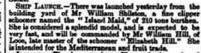
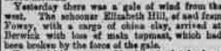

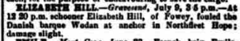

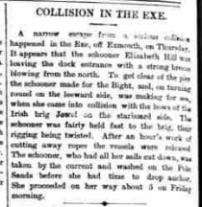

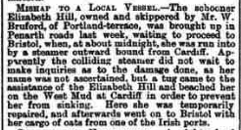

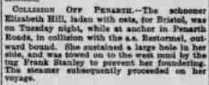

Ship details
Vessel ELIZABETH HILL Dates 17/4/1863 to 11/5/1863
Official number 14497 List type AC
Ownership WILLIAM HILL Registered PLYMOUTH, 8/1856

LOOE, CORNWALL Tonnage 78 net
Master WILLIAM HILL Archives Devon Archives and Local Studies
LOOE, CORNWALL Archives reference 1976/ELIZABETH HILL/14497
Crew names
Forename Surname Age/DOB Birthplace Capacity Previous vessel
WILLIAM HILL 38 LOOE MASTER ELIZABETH HILL, PLYMOUTH
WILLIAM P LASE 37 LOOE BOATS ELIZABETH HILL, PLYMOUTH
WILLIAM PEARCE 33 [...] AB ELIZABETH HILL, PLYMOUTH
JAMES GERRY 22 NORFOLK AB ELIZABETH HILL, PLYMOUTH
JOHN JONES 14 CARRIGON OS ELIZABETH HILL, PLYMOUTH

