Schooner Elizabeth Mary Ann

Vessel Name | Official Number |  | Signal letters | Rig /Type | Where built |  | Builder |  | Year built |  |  | Year end |  | reg tons
ELIZABETH MARY ANN | 32991 |  | RCLJ | schooner |  | Mevagissey |  | Nicholas Lelean |  | 1840 |  |  | 1887 |  | 110
OWNERS/ MANAGERS/REGISTRATION DETAILS |  | Notes |  |  |  |  |  |  |  |  | MASTERS
registered in Fowey 3rd July 1840. 1846 Pearce. 1856 Pearce and co. 1866 Williams & co.1870 J.E.Levers, Mevagissey. 1872Mrs Ann Furse, Mevagissey1878 Benjamin H.Roberts, Mevagissey 1887 James Phelp, Mevagissey |  | LOA 70.3 x 18.5 x 12.3ft. She struck a rock in the Menai Straits and was making water and put into Bangor on 25th November 1869. she was on passage from Garston to Seville with coals. the cargo was discharged to affect a repair. 4th May 1877 The steam ship Pelican from Cardiff to Cork ran into the vessel and she drifted to Penarth beach where she rolled over breaking her main mast and suffering considerable damage. 11th January 1887 she went ashore at Sidmouth fully loaded. crew were saved. She was on a voyage from Antwerp to Topsham |  |  |  |  |  |  |  |  | James Ball 1843-1846 West 1852 W.Williams 1856-1870 William J. Oliver 1851 Levers 1869

1841
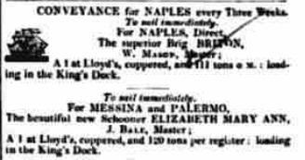
1844
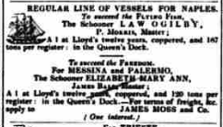

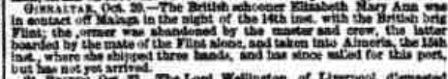
1852
