Schooner Emily Ellen
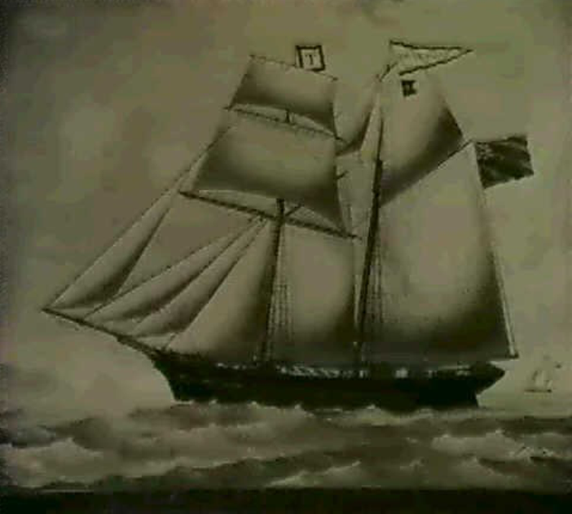
Off Cape St. Vincent
Peter Tadd, Master
Vessel Name | Official Number |  | Signal letters | Rig /Type | Where built |  | Builder |  | Year built |  |  | Year end |  | reg tons
EMILY ELLEN | 62690 |  |  | 2 masted topsail schooner |  | Padstow |  | John Stribley |  | 1872 |  |  | 1878 |  | 97
OWNERS/ MANAGERS/REGISTRATION DETAILS |  | Notes |  |  |  |  |  |  |  |  | MASTERS
1876 John Stribley, Padstow, 1878 P.Tadds , Fowey |  | LOA 83.6 x 22.6 x 10.8ft registered in Padstow 29th October 1872.foundered on passage from the Mediterranean to Liverpool March 1878. master Peter Tadd and all hands lost |  |  |  |  |  |  |  |  | Peter Tadd 1878

