**Steamship Foy**

|  |  |  |  |  |  |  |  |  |  |  |  |  |  |  |  |
| --- | --- | --- | --- | --- | --- | --- | --- | --- | --- | --- | --- | --- | --- | --- | --- |
| **Vessel Name** | **Official Number** | | **Signal letters** | **Rig /Type** | **Where built** | | **Builder** | | **Year built** | | | **Year end** | | **reg tons** | |
| **FOY** | 116062 | | TPLF | Steam ship | | Workington | | R. Williamson & Son | | 1902 | | |  | | 354 |
| **OWNERS/ MANAGERS/REGISTRATION DETAILS** | | **Notes** | | | | | | | | | **MASTERS** | | | | | |
| Registered in Fowey 21st July 1902. 1902 The Fowey (no 3 ) steamship co Ltd,C.L.Toyne, Fowey 1915 Charles L.Toyne and John P.Carter 1919 Holman Coal and shipping co Ltd, Phoenix Buildings, Bute Dock, Cardiff | | 136.4' x 23.8' x 9.2 cylinder 69 hp engine.1915 Charles L.Toyne and John P.Carter 1927 rename **Ravensdale** and registered in Newcastle1928 Derwent Steam Shipping Co Ltd, 12-14 Dean St Newcastle then renamed **Flevomeer** and registered in Holland in 1933 owner A Mannaart | | | | | | | | | KEAST 1904- 1907 D.Edwards 1908 James Armstrong 1915 -20 T.Rundell 1918 | | | | | |

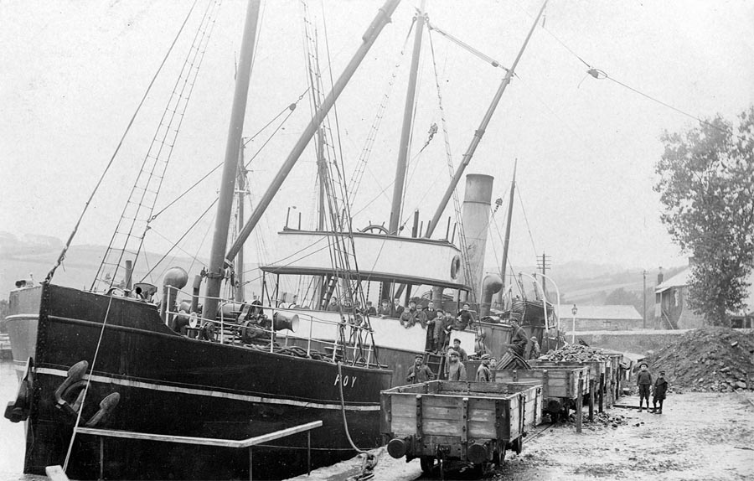

**Discharging coal in Pentewan**

**From 'The Pentewan Railway'** : The first of three photographs of the coastal steamer Foy of Fowey (for those not aware, both names are pronounced the same!) unloading coal at Pentewan around 1905. Foy was part of the small fleet of steamers operated by Toyne, Carter & Co. of Fowey, started in 1897 by Charles Toyne with the purchase of the secondhand vessel Stockton, built in 1856. As with most small ship companies, the vessel was owned and financed by a separate company set up by Toyne, the Fowey Steam Ship Co. Ltd. These satellite ownership companies protected the main business in the event of the vessel’s loss and Toyne’s model was obviously successful because he went on to set up five more, one for each ship he acquired. In 1898, he bought the 1882-built Deerhound and the following year, having been joined in the business by John Carter, the steamer Norma, built in 1877 and, at 507 gross tons, the largest vessel in their small fleet. In 1900, they commissioned the first of three new builds, the 429 gross ton Torfrey, which was followed by Par in 1902, of 436 tons; both ships were built by the same yard in Paisley and were presumably virtually identical in appearance. Finally, also in 1902, Toyne, Carter & Co’s smallest steamer, the 354 ton Foy, was completed by builders at Workington, as a replacement for Norma, which foundered off the Longships whilst inbound to Fowey with coal from Newport. Here, the coal is being unloaded by hand using baskets into wagons on the quayside. The presence of so many of the village lads, many of whom are on Foy’s bridge, suggests that this visit by a steam coaster was not a regular occurrence. Neil Parkhouse collection

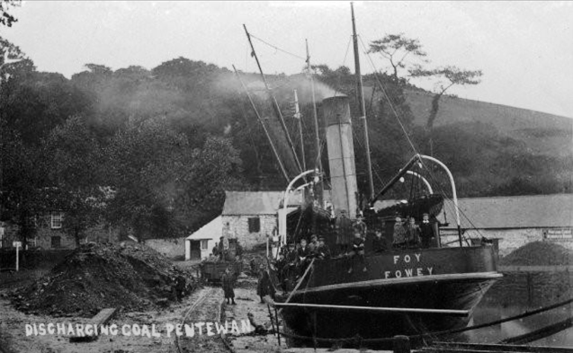



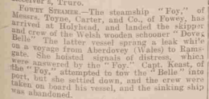

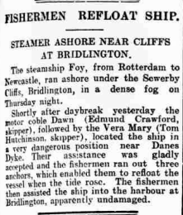

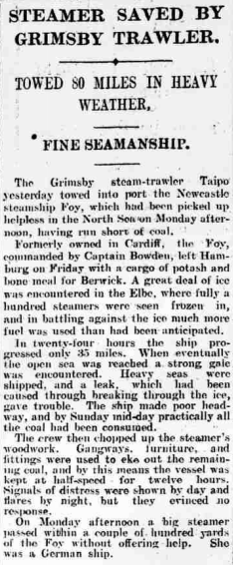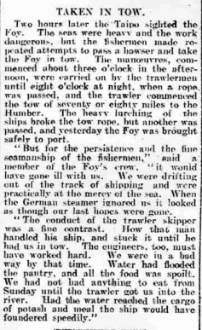

Agreements and Official Logs for Ship Foy, Official Number 116062

James Armstrong; rank/rating, Master; age, 39; place of birth, Belfast; previous ship, same.

Thomas Rundell; rank/rating, Mate; age, 55; place of birth, Par; previous ship, same.

James Lester; rank/rating, Boatswain; age, 28; place of birth, London; previous ship, same.

Frank Down; rank/rating, Able Seaman; age, 27; place of birth, Appledore; previous ship, Mallard of Appledore.

Thomas Sully; rank/rating, Able Seaman; age, 22; place of birth, Appledore; previous ship, Great City of London.

Edward Budden; rank/rating, First Engineer; age, 35; place of birth, Cardiff; previous ship, same. Thomas Moyses; rank/rating, Second Engineer; age, 35; place of birth, Mevagissey; previous ship, same.

James Richardston; rank/rating, Fireman; age, 37; place of birth, ?land; previous ship, same.

George Dopson; rank/rating, Fireman; age, 21; place of birth, Middlesex; previous ship, same.

James McKenzie; rank/rating, Fireman; age, 28; place of birth, Southampton; previous ship, Tantallon of Glasgow. A B Sawyer; rank/rating, Fireman; age, 29; place of birth, Mistley; previous ship, Hull Trader of Hull.

Thomas Holland; rank/rating, Fireman; age, 57; place of birth, Runcorn; previous ship, same.

James Lester; rank/rating, Mate; age, 28; place of birth, London; previous ship, same.

Thomas Sully; rank/rating, Boatswain; age, 22; place of birth, Appledore; previous ship, same.

Joseph Fellows; rank/rating, Able Seaman; age, 18; place of birth, Connahs Quay; previous ship, Hannah Crosdale of Barrow.

Alfred Kingwell; rank/rating, Fireman; age, 40; place of birth, London; previous ship, Daisy of Liverpool.

Hugh McMaster; rank/rating, Fireman; age, 19; place of birth, Maybole; previous ship, Miner of Glasgow.

William Billing; rank/rating, Boatswain; age, 53; place of birth, Newquay; previous ship, Ballinbreich Castle of Padstow.

G Whitley; rank/rating, Able Seaman; age, 28; place of birth, Bradford; previous ship, Ballinbreich Castle.

W Shaw; rank/rating, Fireman; age, 57; place of birth, Runcorn; previous ship, Abercraig of Dundee.

Date made

1915

James Armstrong; rank/rating, Master; age, 41; place of birth, Belfast; previous ship, same.

James Lester; rank/rating, Mate; age, 28; place of birth, London; previous ship, same.

William Billing; rank/rating, Boatswain; age, 53; place of birth, Newquay; previous ship, same.

Joseph Fellows; rank/rating, Able Seaman; age, 19; place of birth, Connahs Quay; previous ship, same.

George Whitley; rank/rating, Able Seaman; age, 28; place of birth, Hull; previous ship, same.

Edward Budden; rank/rating, First Engineer; age, 35; place of birth, Cardiff; previous ship, same.

Thomas Moyses; rank/rating, Second Engineer; age, 34; place of birth, Mevagissey; previous ship, same.

William Wilson Shaw; rank/rating, Fireman; age, 52; place of birth, Runcorn; previous ship, same.

Alfred Kingwell; rank/rating, Fireman; age, 40; place of birth, London; previous ship, same.

Alfred John Williams; rank/rating, Able Seaman; age, 29; place of birth, London; previous ship, James Tennant of Newcastle.

John Moran; rank/rating, Boatswain; age, 49; place of birth, Kilrush; previous ship, ?wich.

Michael Hennessy; rank/rating, Able Seaman; age, 26; place of birth, Kilrush; previous ship, C S Parnell of Dublin.

George Pickering; rank/rating, Fireman; age, 30; place of birth, Ashton Under Lyne; previous ship, Compass of Newcastle.

George Pickering; rank/rating, Second Engineer; age, 30; place of birth, Ashton Under Lyne; previous ship, same.

William W Shaw; rank/rating, Fireman; age, 52; place of birth, Runcorn; previous ship, same.

William Hughes; rank/rating, Fireman; age, 30; place of birth, Bangor; previous ship, Ardglass of Glasgow.

James Moyse; rank/rating, Able Seaman; age, 65; place of birth, Newquay; previous ship, Redestram of Fowey.

W Hughes; rank/rating, Boatswain; age, 50; place of birth, Bangor; previous ship, same. ?

Coote; rank/rating, Fireman; age, 43; place of birth, Runcorn; previous ship, Inna of Belfast.

Alfred Peacock; rank/rating, Able Seaman; age, 38; place of birth, London; previous ship, Par of Fowey.

George Whitley; rank/rating, Able Seaman; age, 28; place of birth, Hull; previous ship, Pink Rose of Liverpool.

1915 2nd articles