Schooner Frederick William
Vessel Name | Official Number |  | Signal letters | Rig /Type | Where built |  | Builder |  | Year built |  |  | Year end |  | reg tons
FREDERICK WILLIAM | 11862 |  | KVJR | schooner |  | Aldborough, Suffolk |  |  |  | 1837 |  |  |  |  | 59
OWNERS/ MANAGERS/REGISTRATION DETAILS |  | Notes |  |  |  |  |  |  |  |  | MASTERS
1868 Samuel Moss, Par 1875 Edward John Treffry, Place,Fowey 1876 Thomas Trebilcock Newquay |  | 1857 Reg Ipswich1860 registered in Padstow 2oth October 1860.+ Messrs. Tngerthen Dunn and Co. offered for public sale, near the Koatii Dock, the schooner Frederick William, of Fowey, now stranded on the East Mud at Cardiff There was a good attendance. The auctioneer first sub- mitted the cargo, comprising 95 ton. or Monmouth- shire house coat, which, after a keen companion, was sold to Mr. C. Roberts, of Bristol, for 7s, 9d. a ton. The schooner was afterwards sold to Mr. Roberts for £82. |  |  |  |  |  |  |  |  | John Rowe 1887-1891

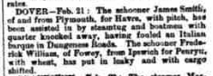

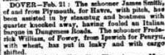

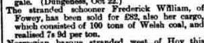
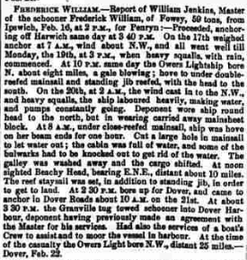
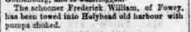
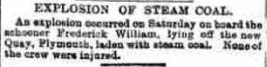
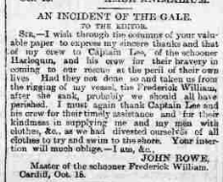

Ship: Frederick William; Official number: 11862.
John Rowe; rank/rating, Master; age, 45; place of birth, Watchet; previous ship, same ship.
Frederick Dickson; rank/rating, Mate; age, 20; place of birth, Upton; previous ship, unknown.
William Philip Davis; rank/rating, Boy; age, 18; place of birth, Landore, Wales; previous ship, unknown.
Date: | 1891 Jan 1 - 1891 Dec 31

