Brigantine Gudrun
Vessel Name | Official Number |  | Signal letters | Rig /Type | Where built |  | Builder |  | Year built |  |  | Year end |  | reg tons
GUDRUN | 86186 |  | WLMN | Brigantine |  | Varazze, Italy |  |  |  | 1874 |  |  | 1892 |  | 228
OWNERS/ MANAGERS/REGISTRATION DETAILS |  | Notes |  |  |  |  |  |  |  |  | MASTERS
1885 John E Hocken, Polruan 1889 George Henry Bate, Fowey(MO) |  | LOA 115.3 X 25.1 x 12.5ft . Registered in Liverpool 22nd June 1884. 15th March 1892 wrecked on the Shingle off Yarmouth Isle of Wight, in heavy weather. Wreckage strewn all over the beach and The Totland lifeboat unsuccessfully endeavoured to save the crew, all of whom, believed to number ten, were drowned. four bodies picked up. She had been on passage from Fowey to Leith with cargo of china clay. |  |  |  |  |  |  |  |  | Slade 1888 Crews 1890 Alexander MacGarell 1892  MCGAREL Alexander L of Belfast (Master Mariner, Capt of Gudrun) Drowned

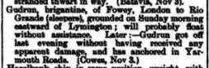
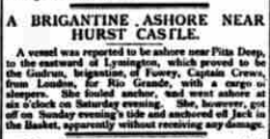
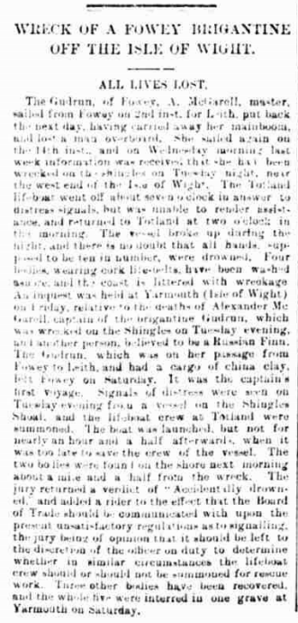
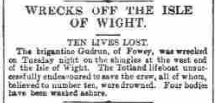
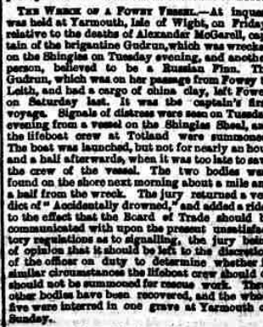

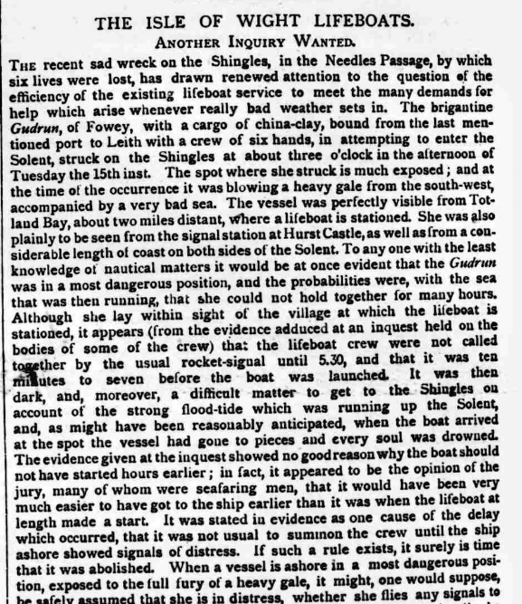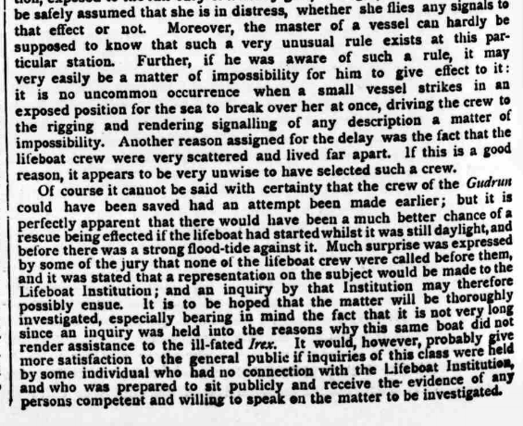
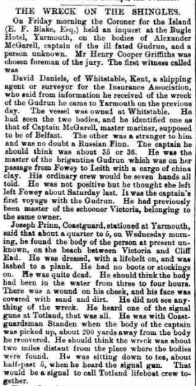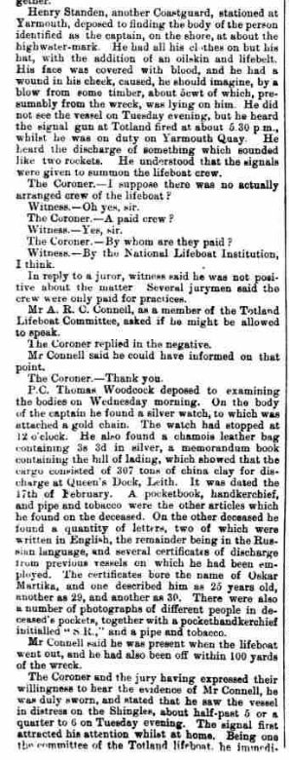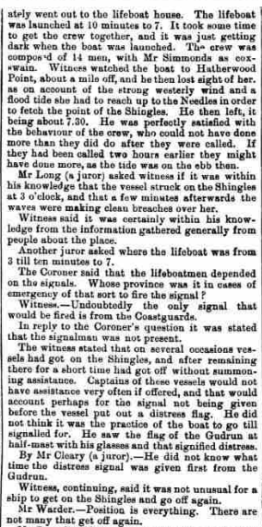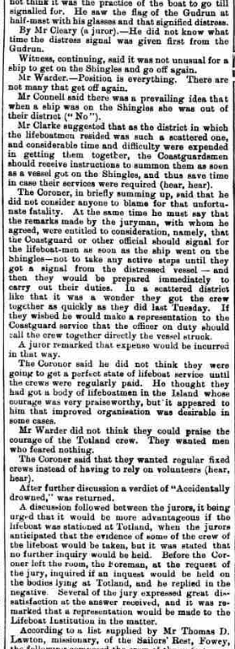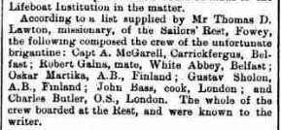
Wreck of the Brigantine “Gudrun”
238 tons register ship of Fowey in Cornwall, laden with china clay and bound for Leith, floundered on the shingles off Totland Bay with the loss of her crew.

Names listed in order of mention in the County Press report 19 Mar 1892.

MCGAULEY Capt (Commander Yarmouth Coastguards)
MCGAREL Alexander L of Belfast (Master Mariner, Capt of Gudrun) .. drowned
BLAKE E.F. Esq (Coroner)
GRIFFITHS Henry Cooper (Foreman of the jury)
DANIELS David of Whitstable, Kent (Shipping Agent/surveyor for Insurance ass)
MARTIKA Oskar 29 of Finland (crew – AB, a Russian) .. drowned
PRINN Joseph (Yarmouth Coastguard)
STANDEN Henry (Yarmouth Coastguard)
CONNELL A.R.C. (member of the Totland Lifeboat Committee)
WOODCOCK Thomas (PC)
SIMMONDS (Coxwain Totland Lifeboat)
LONG Mr (a Juror)
CLEARY (a Juror)
WARDER Mr (Jury)
CLARKE Mr (Jury)
LAWTON Thomas D. (Missionary of the Sailors Rest, Fowey)
FERGUS Carrick of Belfast (crew) .. drowned
GALNA Robert of White Abbey, Belfast (crew – mate) .. drowned
SHOLON Gustav of Finland (crew – AB) .. drowned
BASS John of London (crew – cook) .. drowned
BUTLER Charles of London (crew – OS) .. drowned

