Schooner Helena Anna
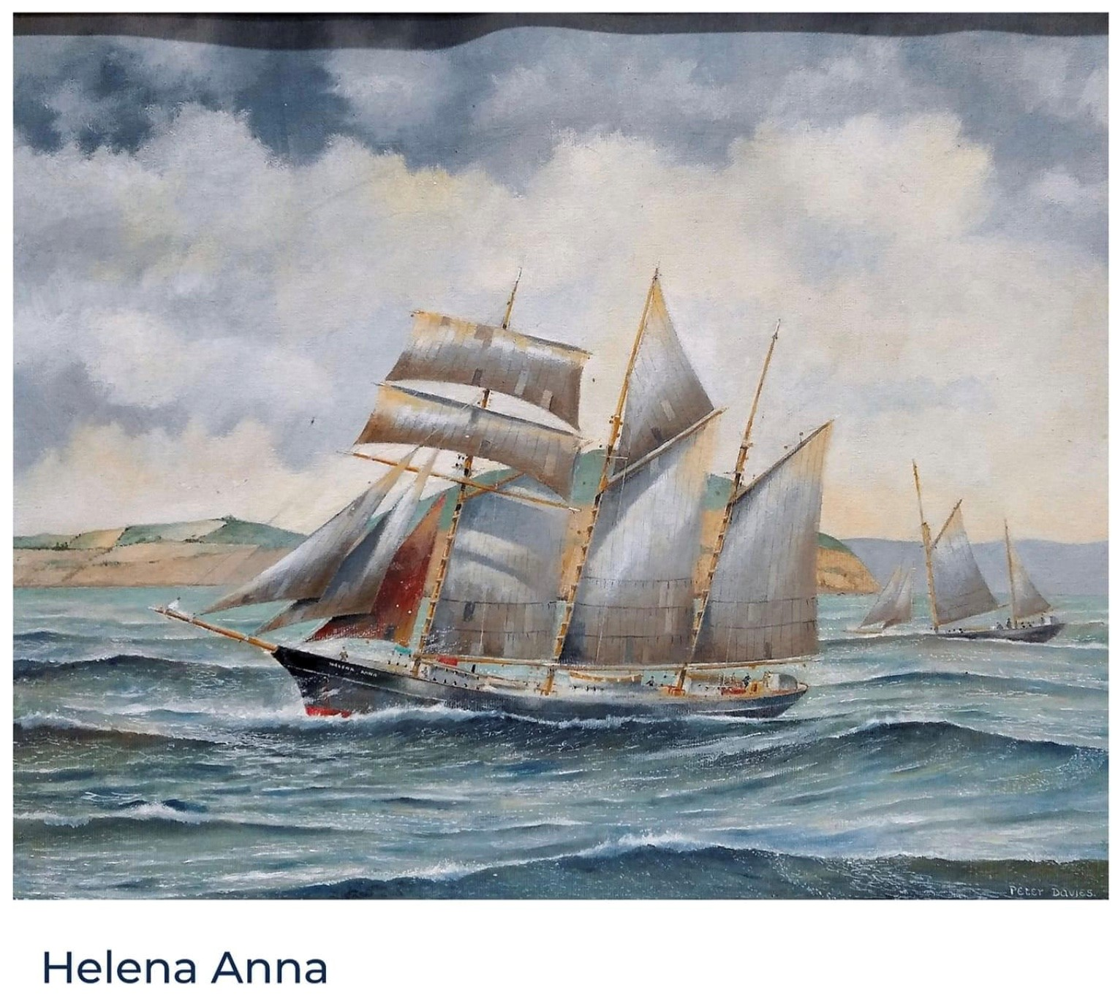
A painting by Captain Peter Davies of Mylor
Vessel Name | Official Number |  | Signal letters | Rig /Type | Where built |  | Builder |  | Year built |  |  | Year end |  | reg tons
HELENA ANNA | 85257 |  | NRFK /MQRT | 3 masted topsail Schooner |  | Pekela ,Holland |  | Axel Drenth |  | 1870 |  |  | 1941 |  | 134
OWNERS/ MANAGERS/REGISTRATION DETAILS |  | Notes |  |  |  |  |  |  |  |  | MASTERS
1893 D.Hunkin , 1893 William Varcoe Kellow, Pentewan 1920 Kellow moved to Tywardreath then Par station, |  | LOA 106.2 x 25.2 x 11.7ft Originally owned by F.J.Drenth in Poland. Registered in Penzance on 28th June 1883.Owned by F.C.Matthews . until 1892.Put up for sale by auction at the Par Inn on 16th October 1893. 1897 badly damaged by fire had new topsides and deck. In September 1899 She was bound from Dordrecht, in Holland, to Sunderland with a cargo of moss litter, and although the Dutch coast is only about 100 miles from Yarmouth, the terrific weather caused the voyage across the North Sea to occupy three weeks. The schooner was blown about to all points o f the compass. Three times she got as far as Cromer, and on each occasion was driven back again. The stock of provisions was becoming exhausted, and the water was giving out, when the tug Norseman took her in tow, and brought her into Yarmouth. 24th January 1912 on passage from Antwerp to Preston with Pig ore had stopped in Portland for shelter on departing she collided with the breakwater and was pulled of by the tug Tortoise. Struck bottom 3 times off Kentish Knock 27th December 1920. Leaking she made for Dover for repairs. She had been on passage from Antwerp to Ipswich with a cargo of phosphate of lime. Laid up in September 1933 in Pont her yards were covered and bored to let out water. She was commandeered and sunk as a block ship in harbour mouth at Readymoney cove in 1941. cut up as fire wood at end of war. |  |  |  |  |  |  |  |  | HFH’kklmn 1877 J. Nichols 1885 T.Truscott 1894 - 1899 J.H.Prynn 1899 T.English 1909 John Keeler 1910-1915 Kendall 1920 T.Truscott 1930-32

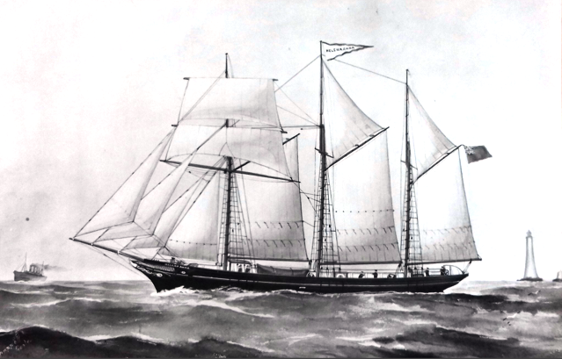
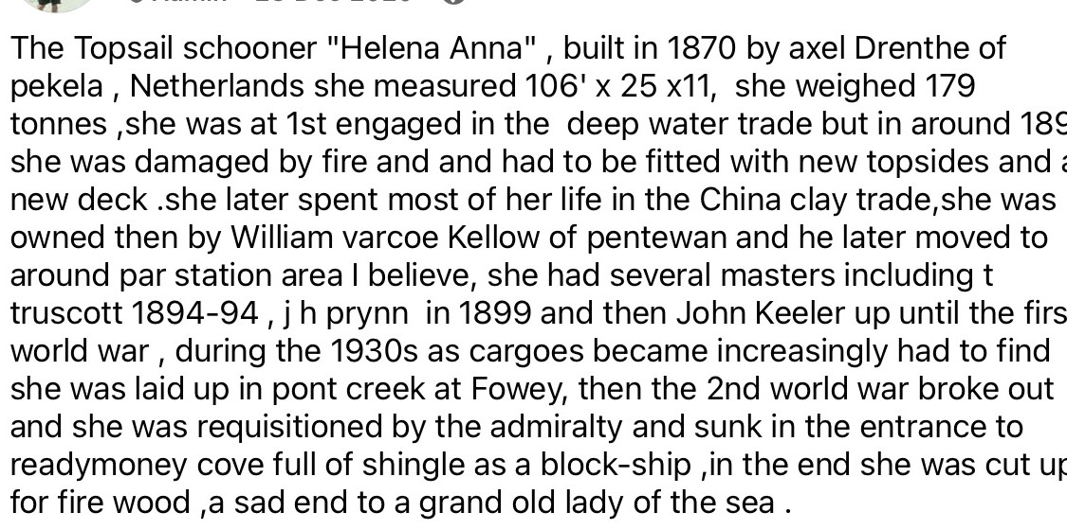

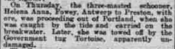

Crew list 1915
John Keeler; rank/rating, Master; age, 49; place of birth, British; previous ship, same ship.

Frank Clare; rank/rating, Mate; age, 53; place of birth, British; previous ship, same ship.

John Tierney; rank/rating, Able Seaman; age, 50; place of birth, British; previous ship, same ship.

Denis O'Leary; rank/rating, Able Seaman; age, 28; place of birth, British; previous ship, same ship.

Robert Parker; rank/rating, Cook; age, 39; place of birth, British; previous ship, same ship.

John Reid; rank/rating, Able Seaman; age, 28; place of birth, British; previous ship, Spin Away of Fowey.

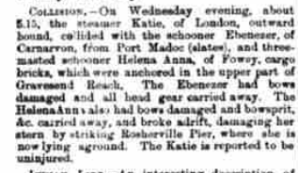

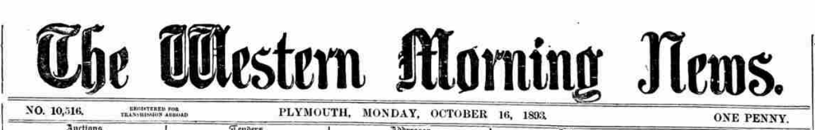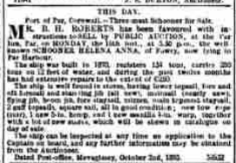

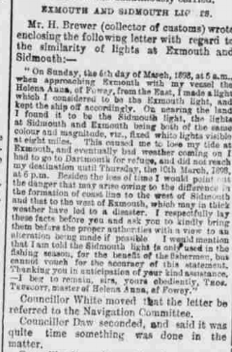

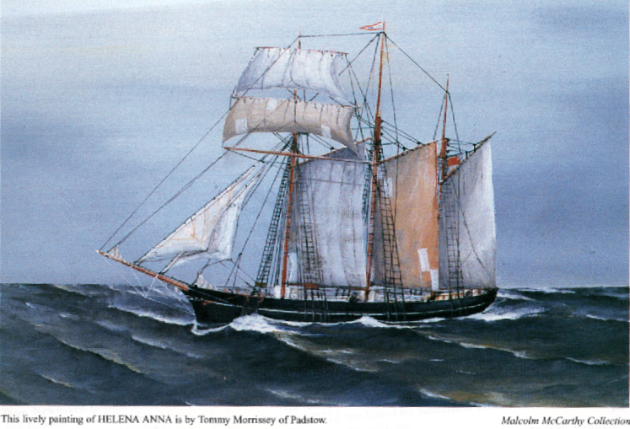

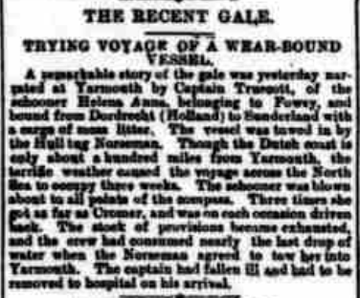

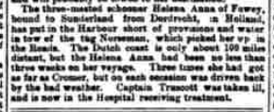
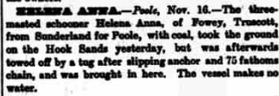

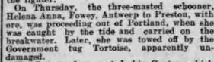
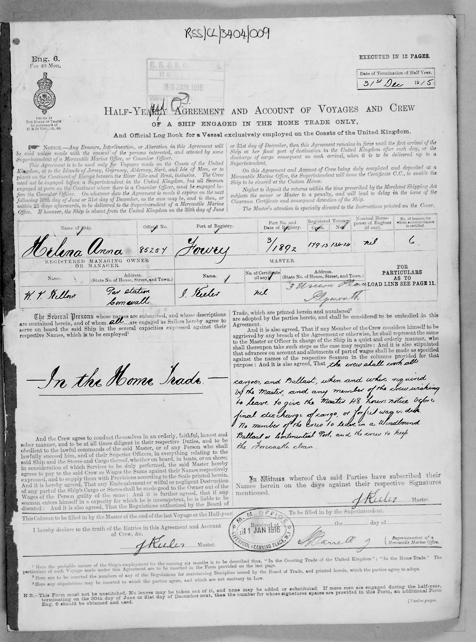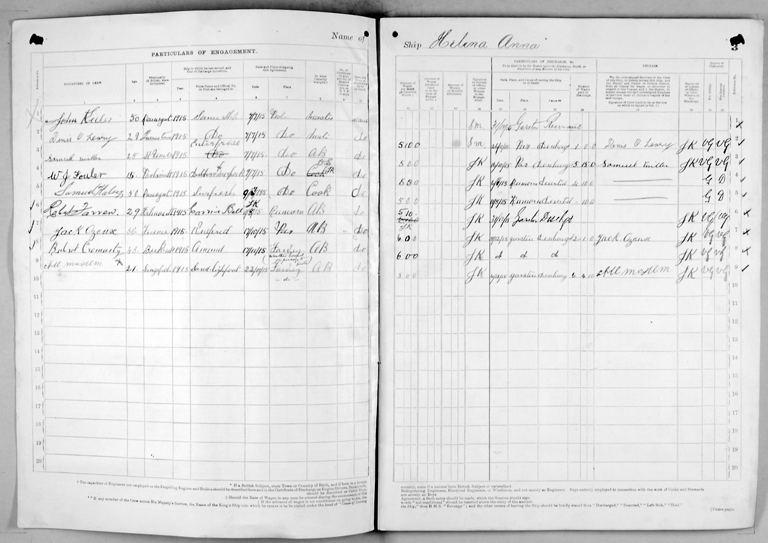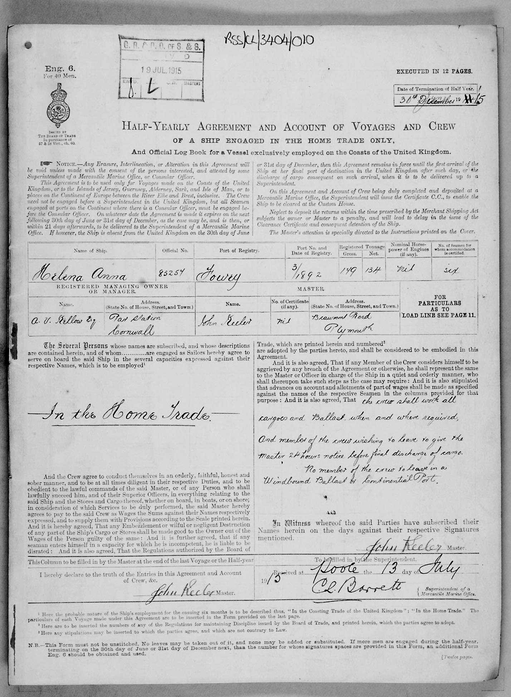
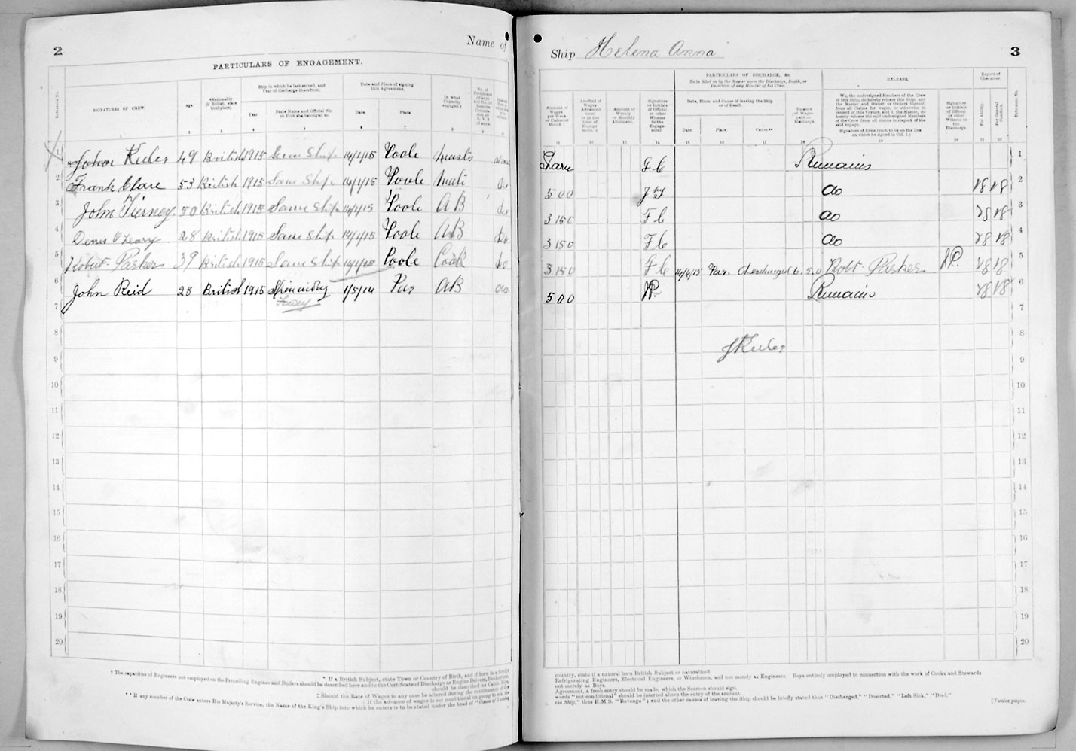
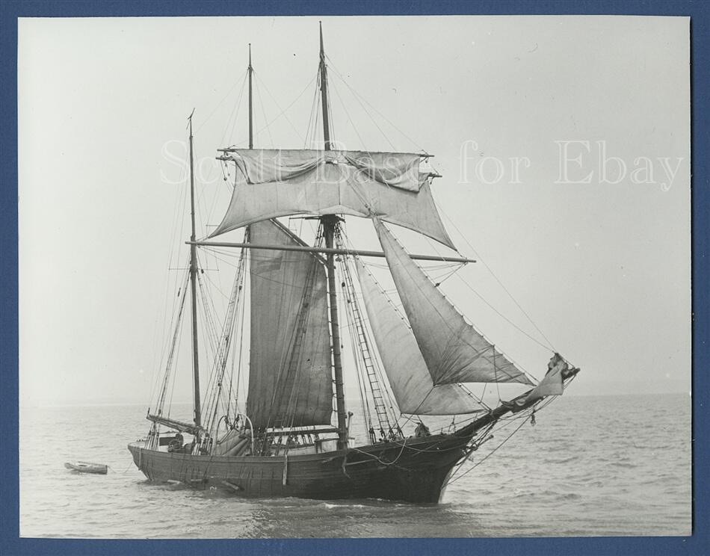

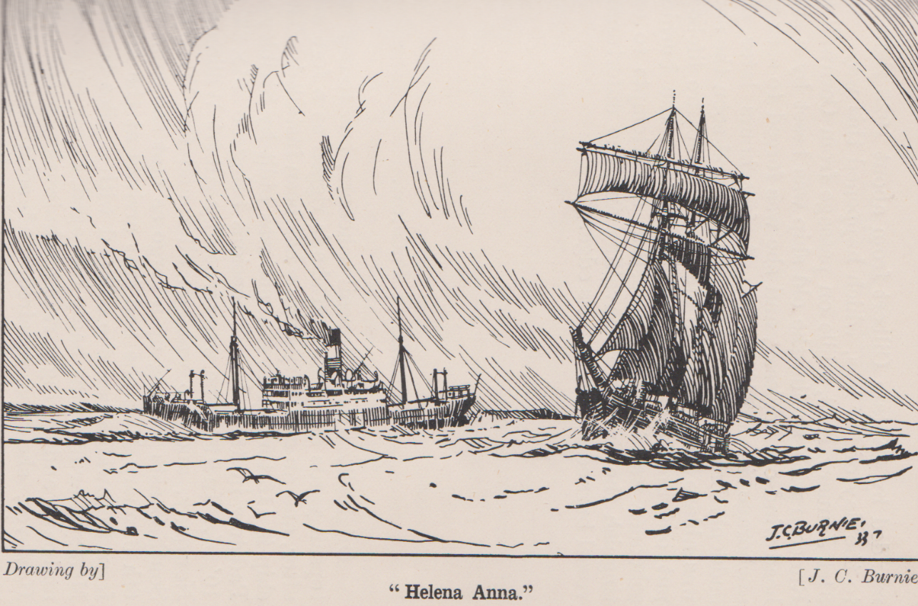
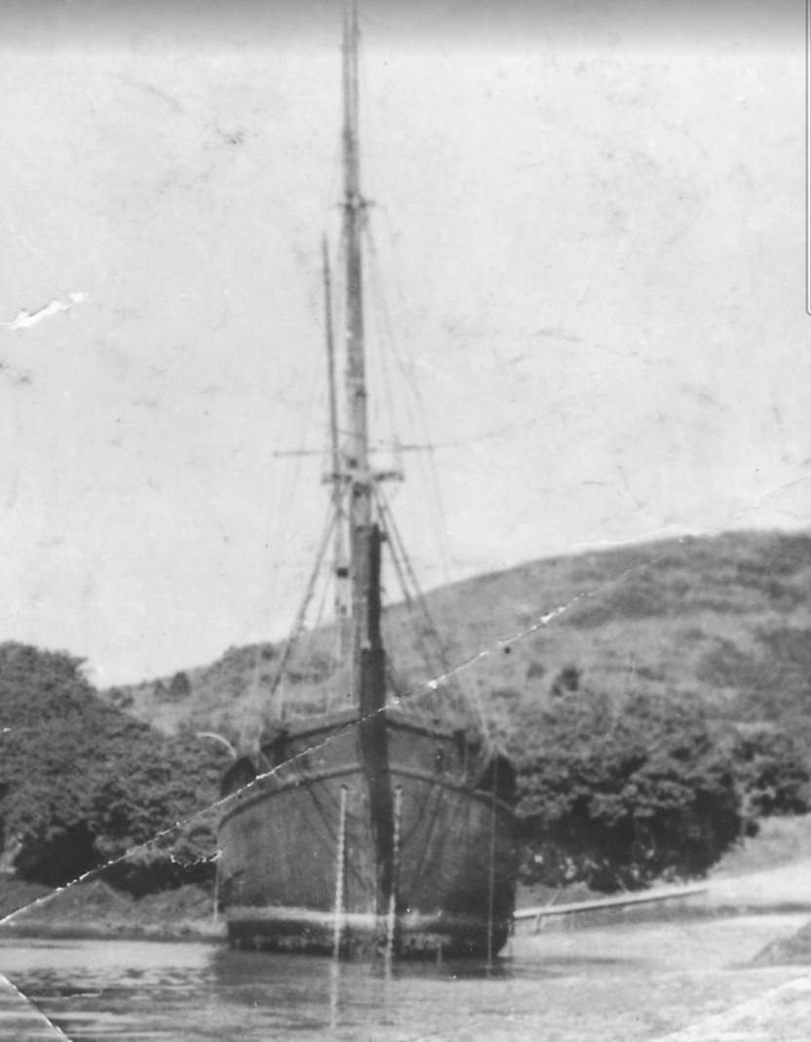

Laid up in Pont Pill before being used at a block ship. She was beached there in September 1933 with yards covered and holes bored in her bottom to let water in and out. Refloated to become blockade vessel.

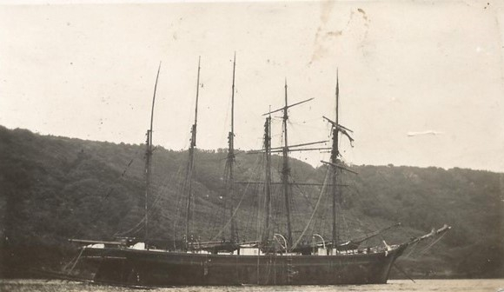

With the Frances and Jayne in Pont in 1931-3 cables of laid up ships astern

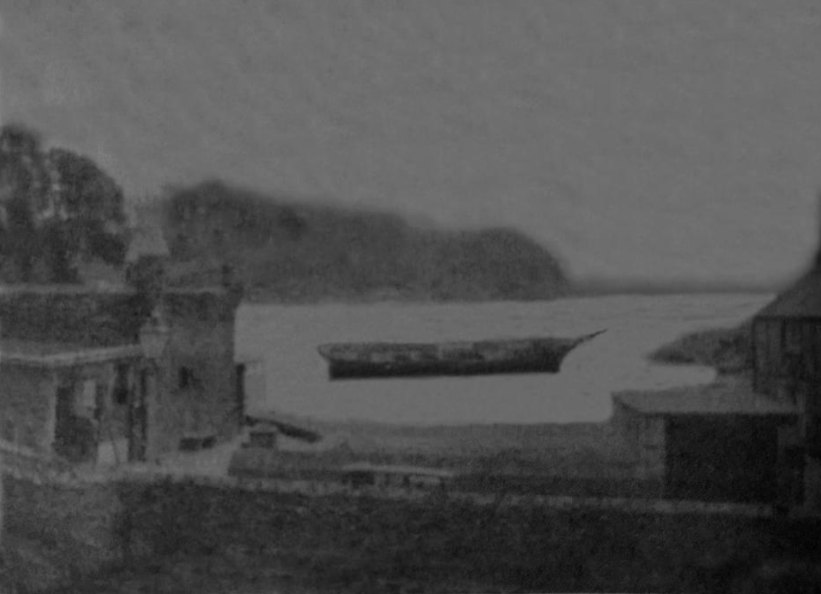

As a block ship in WWII at Readymoney cove.

