Schooner “Jane Banks”

3-mast schooner 176 grt – 156 nrt Dims: 31.08 x 7.34 x 3.80 m Built 1878 at Portmadoc by S Jones

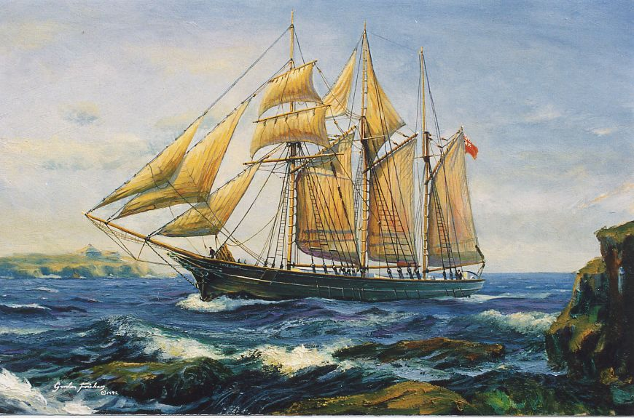

The schooner “Jane Banks“, running mate of the famous ‘Waterwitch‘ of Fowey, sailed into history as the last pure sailing British square rigger to trade abroad and the engine-less last topsail schooner to operate from a British Port, Fowey in Cornwall.

Paintings by Gordon Frickers

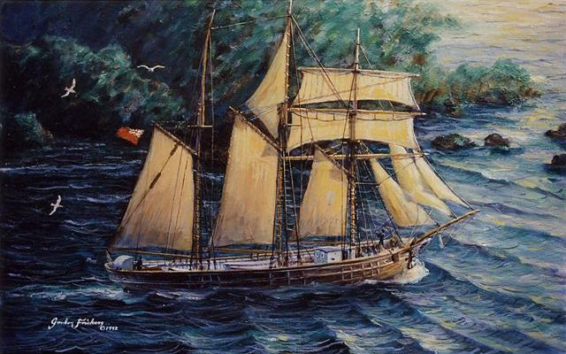

The Frau Minna Peterson, later Jane Banks, later Viir was built as a general purpose vessel.
The schooner “Jane Banks” leaving Fowey, Cornwall

Vessel Name |  | Official Number |  | Signal letters | Rig /Type |  | Where built |  | Builder |  | Year built |  | Year end |  | reg tons
JANE BANKS / FRAU MINNA PETERSEN | 77428 |  | SBVJ/KDJV/MJTS |  |  | 3 masted topsail Schooner |  | Portmadoc |  | Simon Jones |  | 1878 |  | 1944 |  | 142

OWNERS/ MANAGERS/REGISTRATION DETAILS | Notes | MASTERS

Registered in Fowey no 3 1901. and again in 1920 under new name. 1904 Robert May, Par. 17th December 1919 Shipping controller, London .Edward Stephens Par(MO) 23rd march 1924 64/64 shares Edward Stephens 30th June 1927 Thomas Stephens, 3 Elm Par Par and then Annie Stephens 14th April 1927. | 102′ LOA, 24.3′ Beam and 12.6′ Max Draft. One of the first vessels to be launched sideways. registered in Caernarvon 27th July 1878 as FRAU MINNA PETERSEN Hugh Parry, Borth, Portmadoc. Owner. First rigged as a staysail schooner and carried slate.3 masted schooner round stern and female bust figurehead. During the war she fell into enemy hands and spent the war and remained in port for 5 years. Changed name to Jane Banks 2nd January 1920. 25th October 1923 she collided with the breakwater at Dover and lost bowsprit and bow was damaged. shortly after her masts came down and she was towed into harbour. January 1929 she was caught in a severe storm in Brixham harbour. anchored with both down the crew were taken off by the Brixham lifeboat. She was on passage from Teignmouth to Glasgow with clay. In 1936 on death of her owner she was laid up in Par Harbour. de registered after 1938 sale to Estonian owners and renamed "Viir”. Originally used in Phosphate rock trade to west Indies then Newfoundland and west Indies. She was Lost of the coast of Finland in 1944 | Howard 1909 Robert Philip 1912 May 1914 and again in 1919 W.T.Carrick 1929 Rundle 1935 R.Gilbert 1935

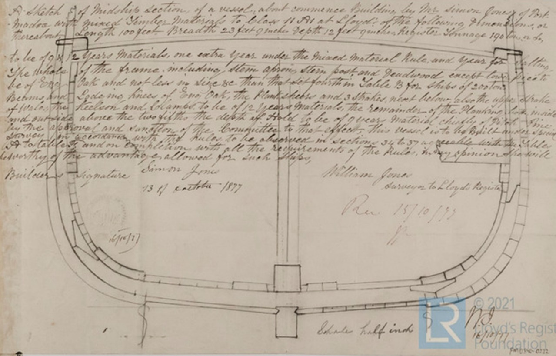

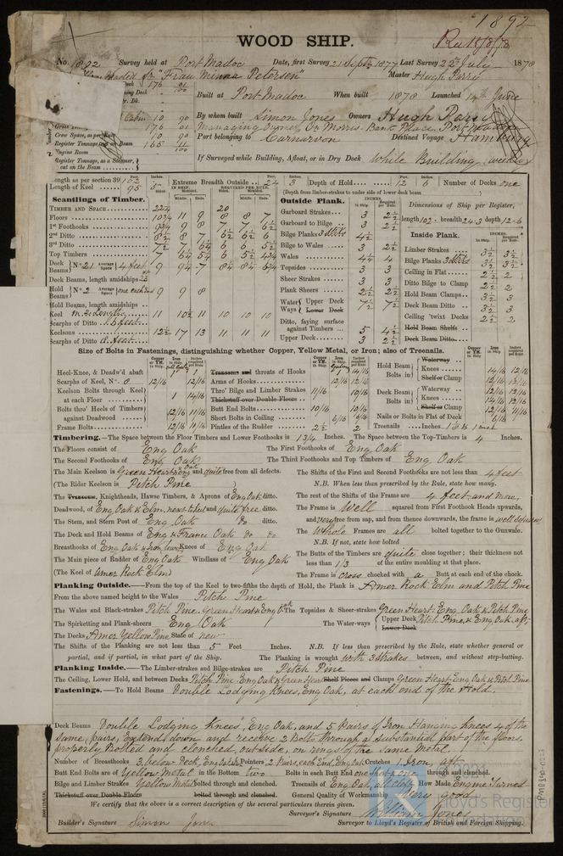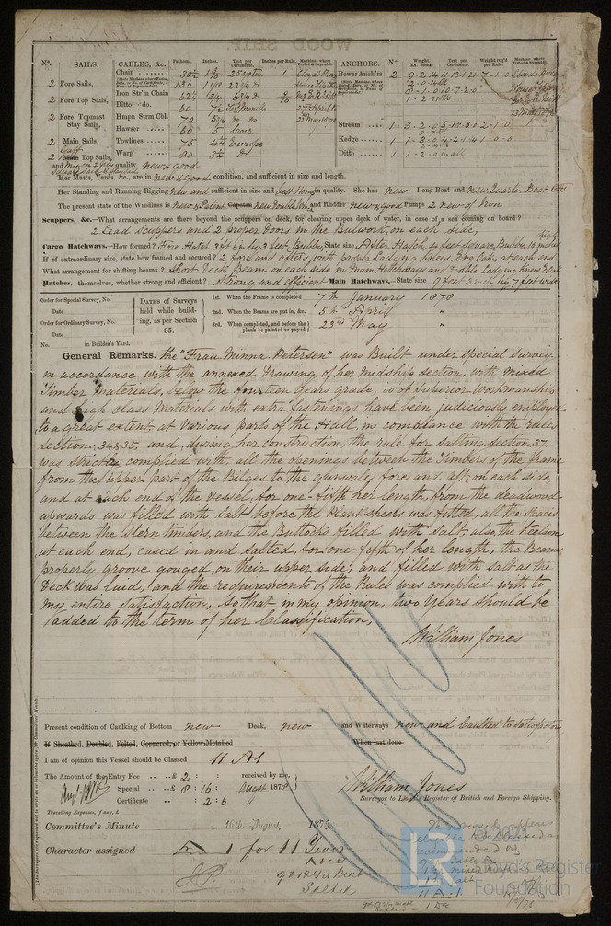
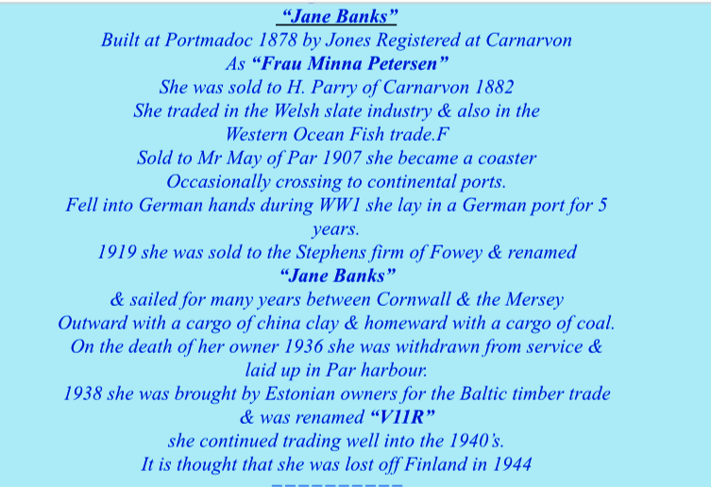

AN article by Gordon Frickers

British builders and owners had always experimented with new rigs and hulls Generally in the early 19 century, the favoured rig for small general traders was the brig, a two masted vessel (a ship is three masted) square sail rigged on both masts with staysails between fore and main mast.
This rig was well suited to open sea voyages and fairly handy.
It did though need a crew of up to 16 men.
Also, regulations required that the master hold a square rigged certificate.
Qualified men were in great demand however, most local men held no formal qualification or in later years just a “fore and aft” qualifications.
A compromise was the “Jack barquentine”, more manoeuvrable and with a smaller crew of 10.
These were two and later more often three masted schooners (the latter often crewed by 6 in the summer season) with square sails on the foremast and rigged fore and aft on the main and mizzen masts with an additional staysail between main and fore.
This rig allowed the schooner men command.
This rig and the trades to the med, Azores and Newfoundland and Labrador which had developed since as early as pre 1492 resulted, in the 1890s, in the evolution of the “Western Ocean Yachts” – fine lined, fast three masted topsail schooners, strongly built with exceptional sea going characteristics.

The years 1877 and 1878 saw a spurt of building activity in Llyn and Eifionydd. 18 vessels were built at Portmadoc and Borth y Gest.
This was a transition period as the builders and owners experimented with various rigs adapted for particular trades.

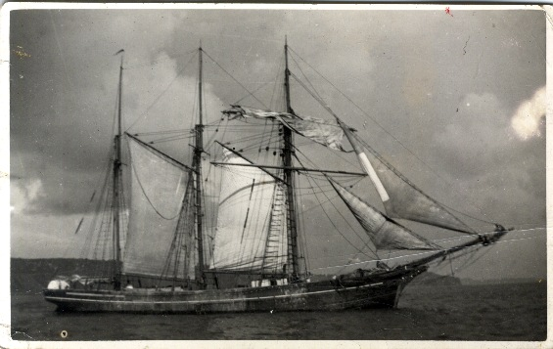
Seen off Par as the Jane Banks
The Frau Minna Peterson was one of these general purpose vessels.
She was built by Simon Jones at Portmadoc.
Her dimensions were:- 176 GRT, 102′ LOA, 24.3′ Beam and 12.6′ Max Draft.
Reg at Caernarvon.
She was owned outright (64/64ths) by Hugh Parry of Borth y Gest.
For twenty three years the vessel sailed the Atlantic Ocean, Baltic and Mediterranean with visits to Portmadoc to load slate for Germany.
Her launch, in 1878, was watched with great interest.
She was the first vessel launched sideways but unfortunately stuck during the operation.
This was considered a bad omen which proved unfounded as she was to sail for many years.
The FRAU MINNA PETERSON was named after a German slate merchant’s wife which was a common practice.
She entered a trade with origins going back to the days before Christopher Columbus when men of the Atlantic coast of Europe were already fishing off the Newfoundland and Maine coasts for cod.
Frau Minna Peterson proved an ideal vessel for the Western Ocean passage, beating against the prevailing winds and handy amongst the creeks and inlets of the Newfoundland and Labrador coasts.
In 1901 Frau Minna Peterson was sold to Fowey in Cornwall and renamed the Jane Banks.
From this port (which the author lived close by hence the painting,) and nearby Par, china clay was her main cargo, often returning with coal or industrial products from the Mersey.
She was in this trade for many years.
There are some excellent photos of the vessel underway, taken during this period in Basil Greenhill’s book Schooners and also several of her at anchor and alongside, in the National Maritime Museum collection.
She was sold to Estonia in 1938 and her story thereafter was uncertain however, information from Torsten Hagnéus, of Sweden, who sent the following extract from “Estland zur See 1918-1940” (Estonia at sea 1918-1940) :-
VIIR

Her record
year | name | owner | port
1878 | Frau Minna Peterson | H Parry | Caernarvon,
1901 | Frau Minna Peterson | R May | Caernarvon
1914 August, |  | taken as prize at Emden | Use during the war not known
1919 | Jane Banks | given back to GB The Shipping Controller | London
1921 | Jane Banks | E Stephens, managing owner | Fowey,
1928 | Jane Banks | T J Stephens | Fowey
1938 | Viir Anton Vilu |  | Tallinn
1940 | taken by Soviet troops at the occupation of Estonia | Estonian State Shipping Co | Tallinn
1941 October 9 |  | fallen into German hands | Tallinn.
1944 October |  | sailed with Estonian refugees to Sweden
1949 |  | deleted from Lloyd’s Register
All Estonian vessels which came to Sweden with refugees were given back to the Soviet Union.
The former owners were however compensated economically by the Swedish Government

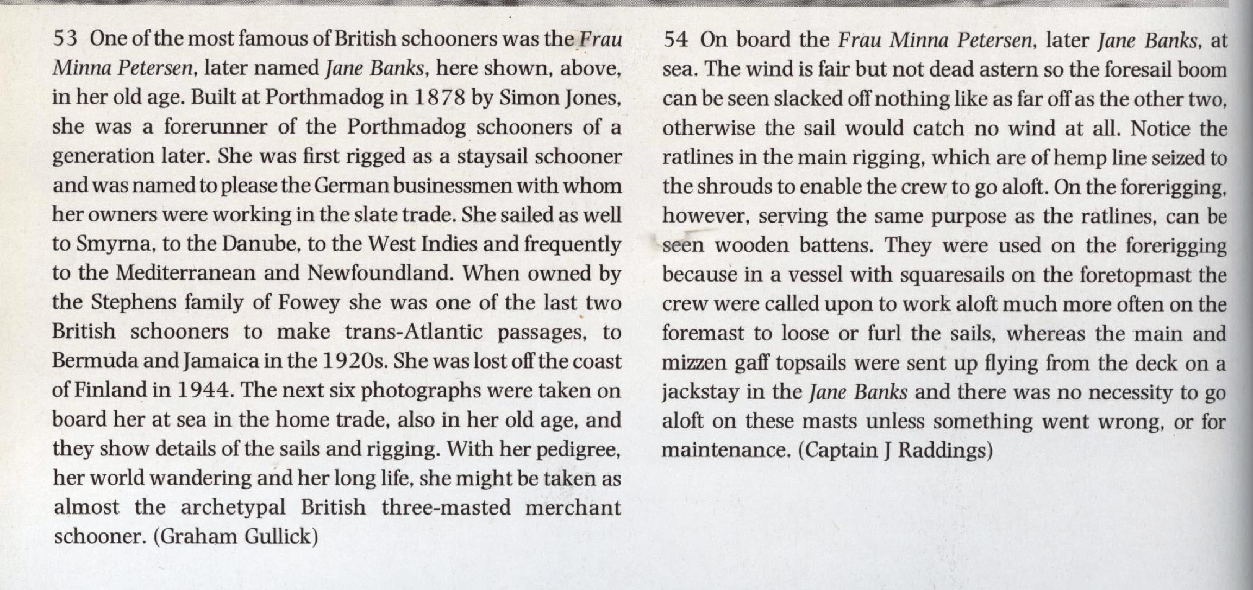

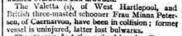
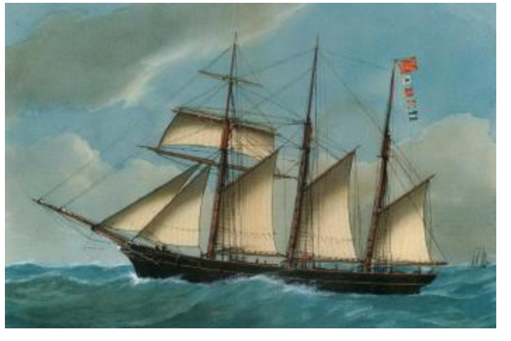

As the Frau Minna Peterson

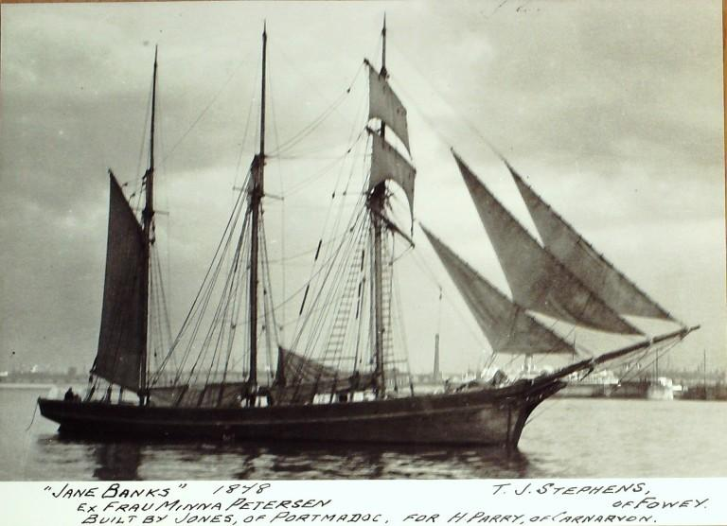

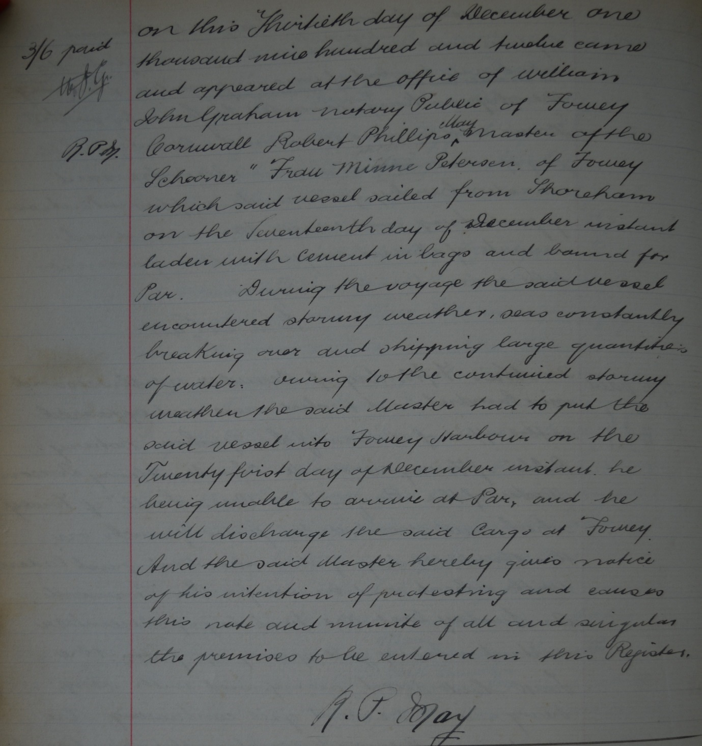
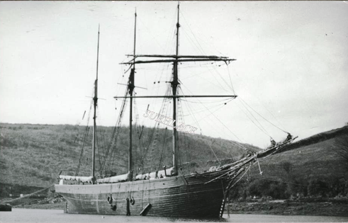

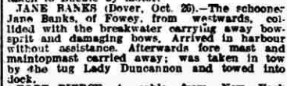

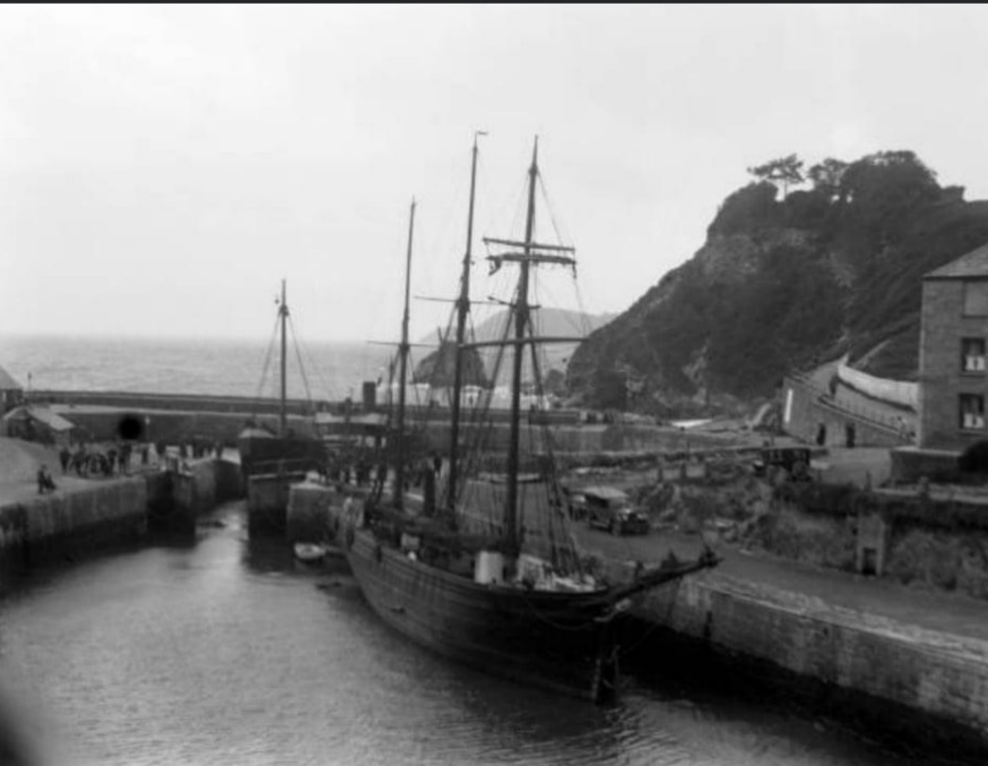

In Charlestown owned by Edward Stephens

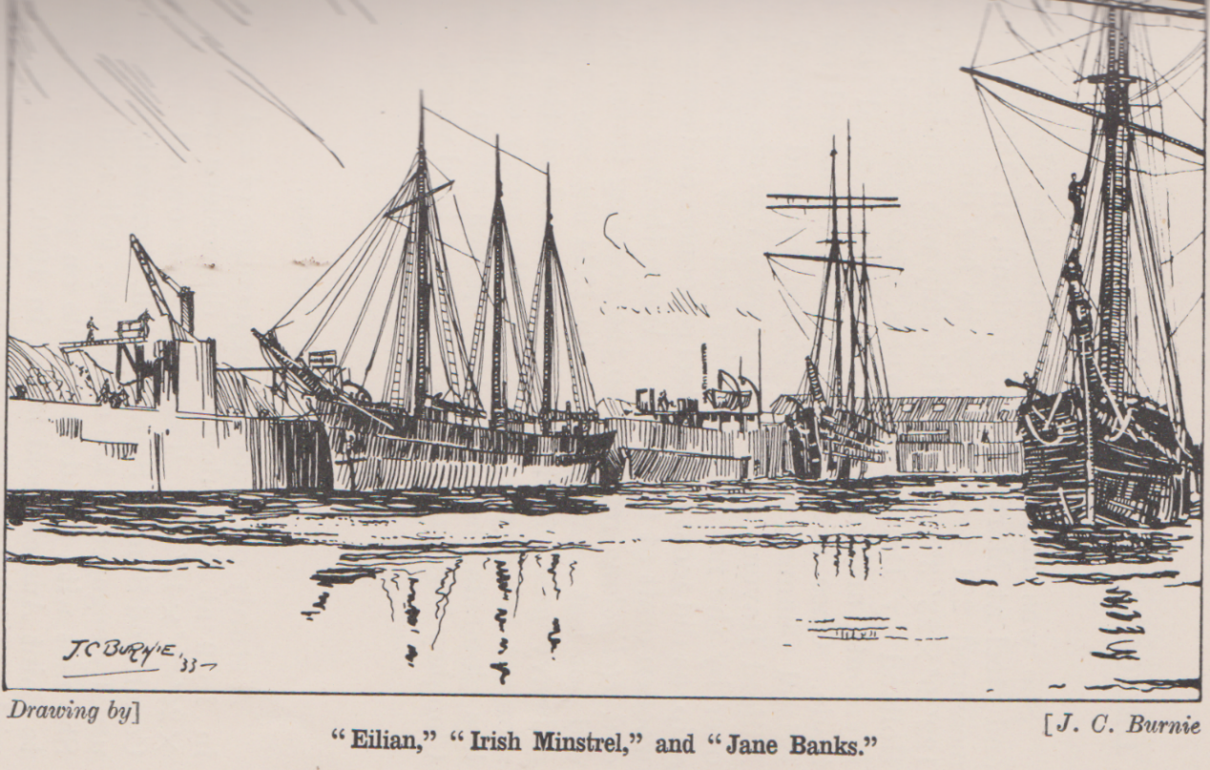

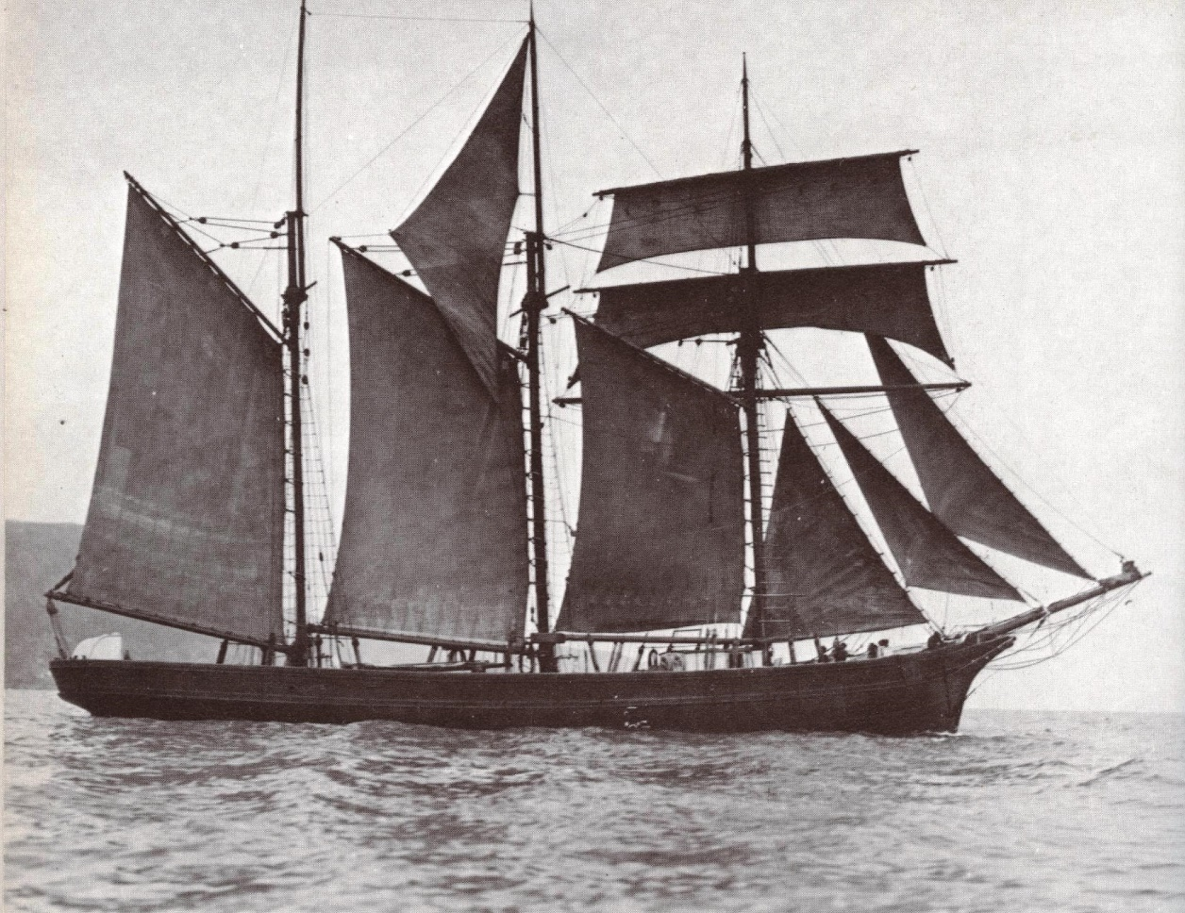

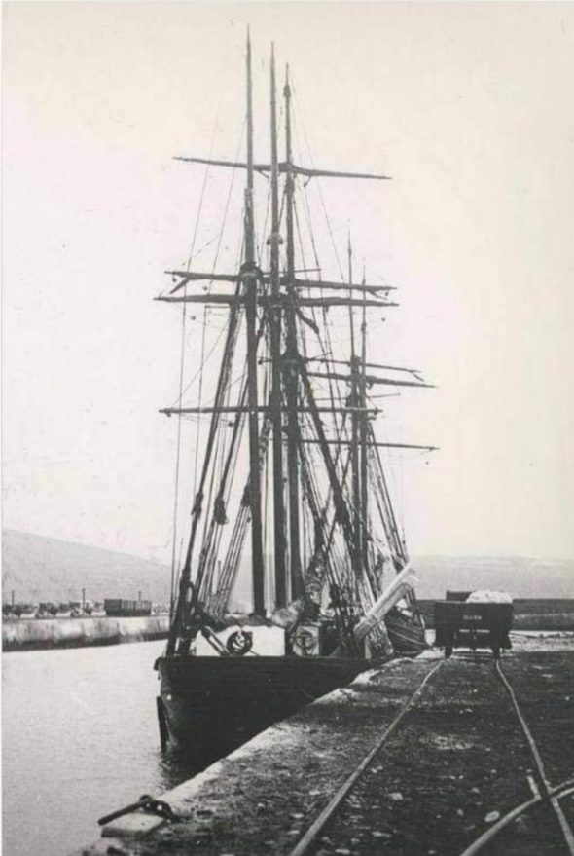

Jane Banks in Par
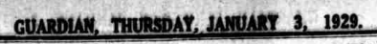
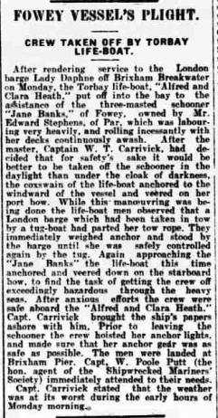

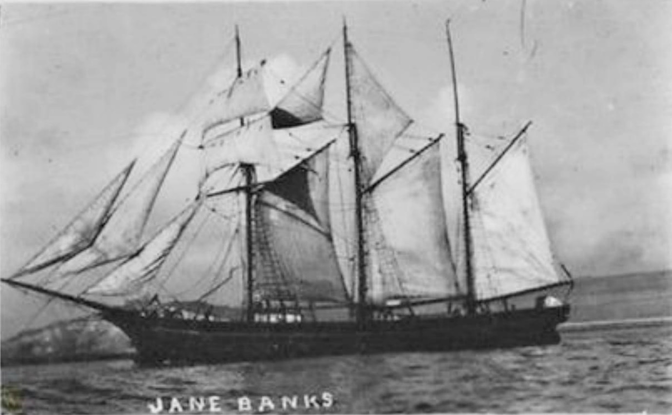

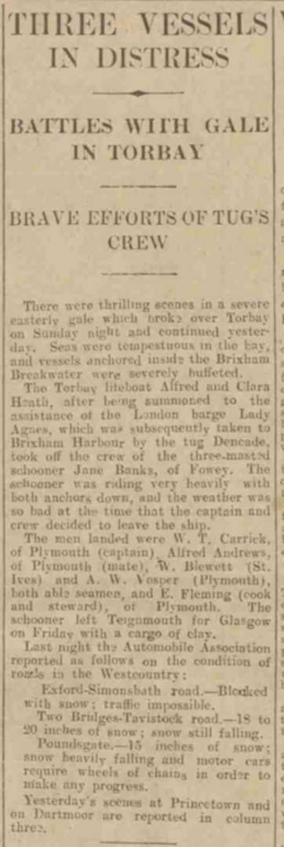

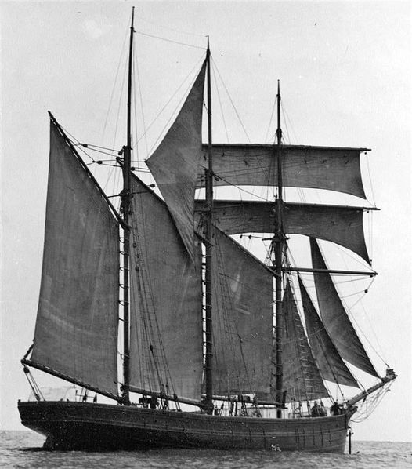
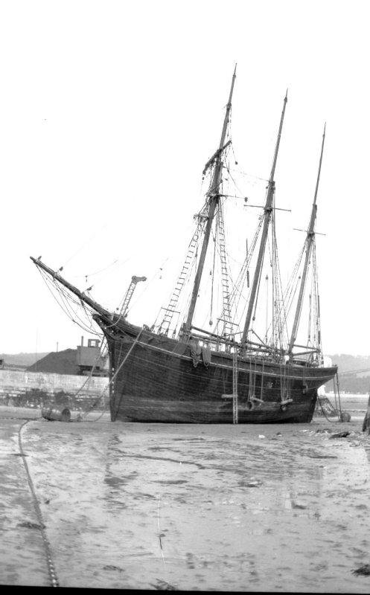

Laid up in Par

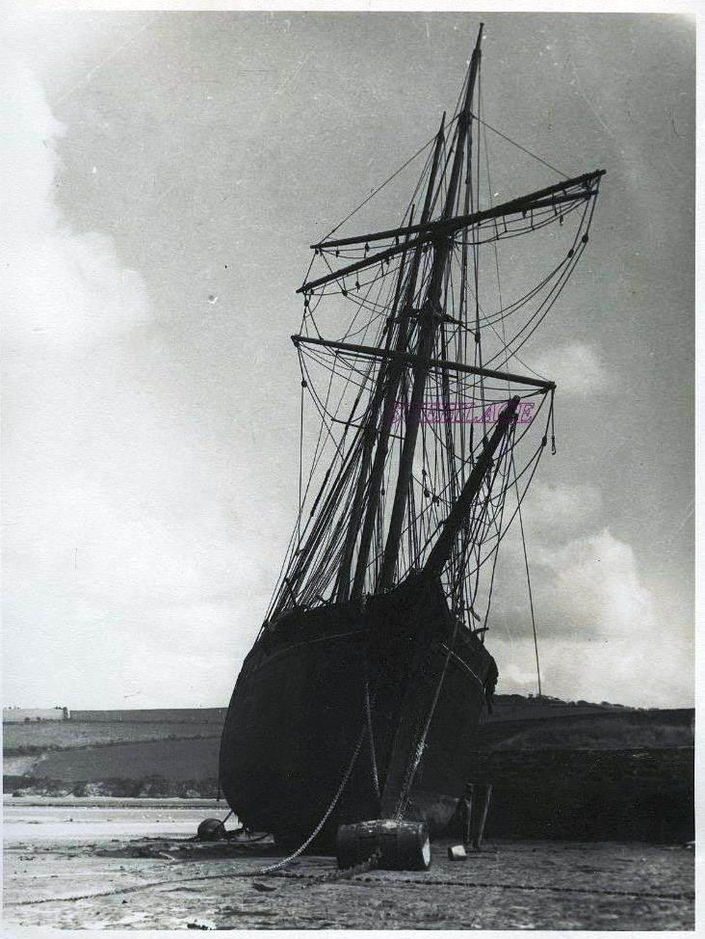

Laid up in Par
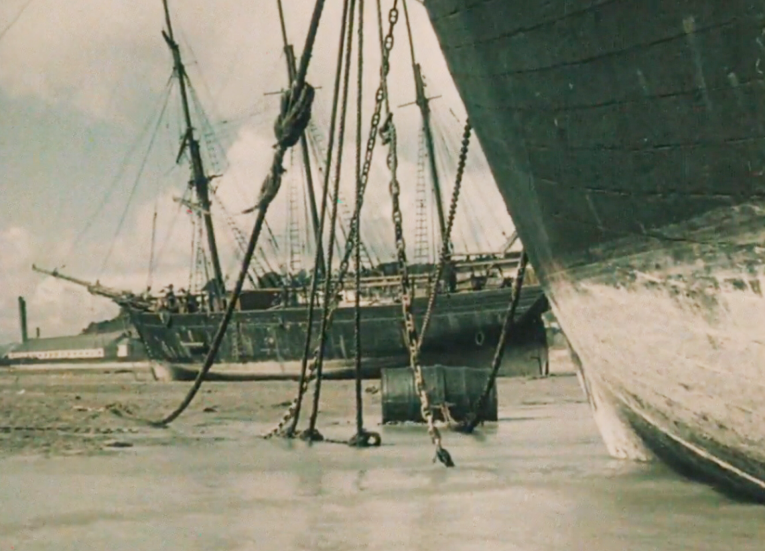

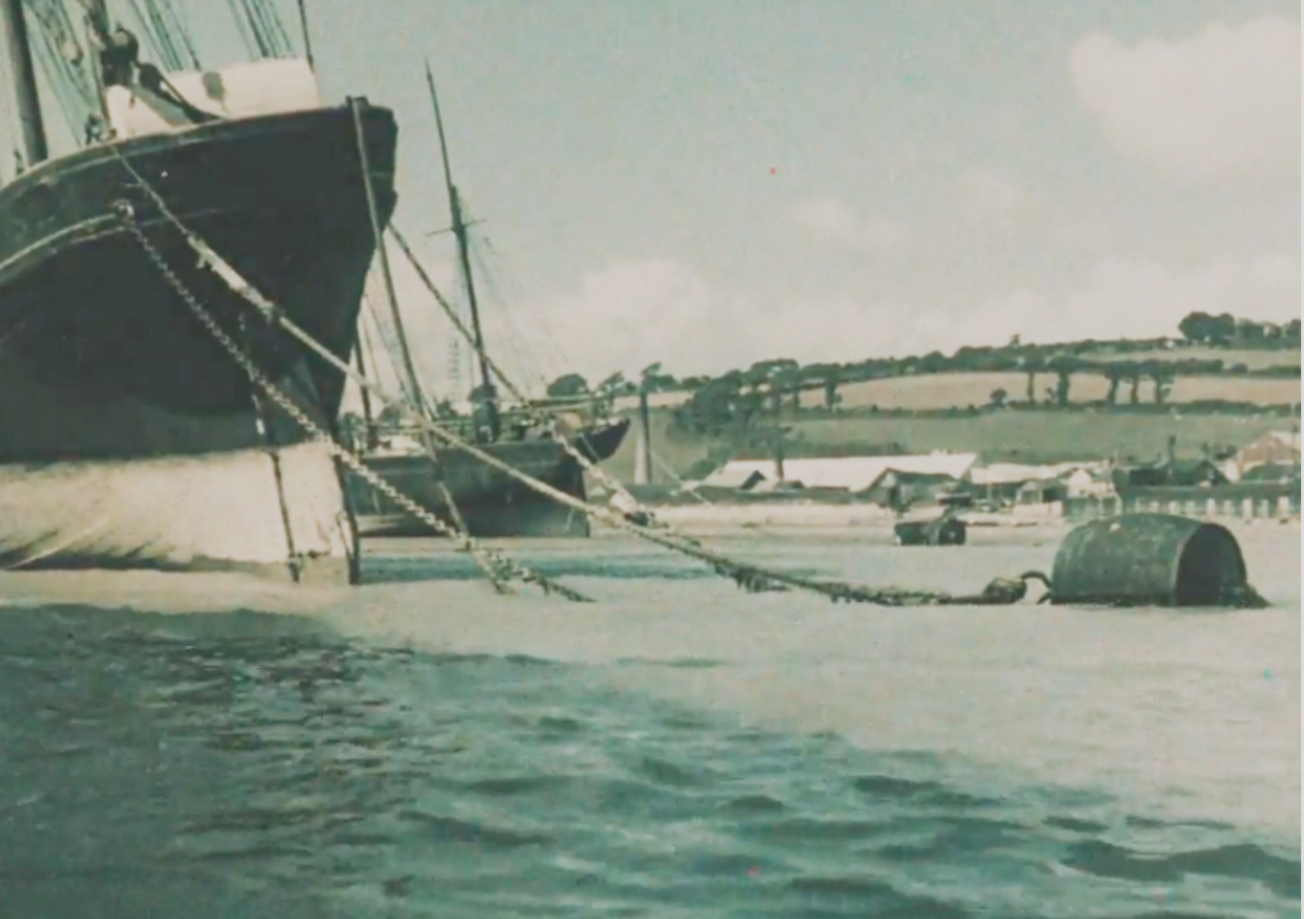

Laid up in Par

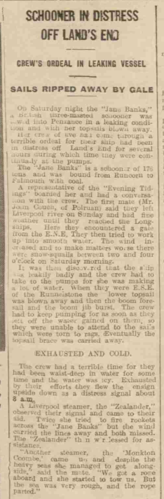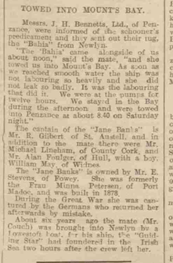

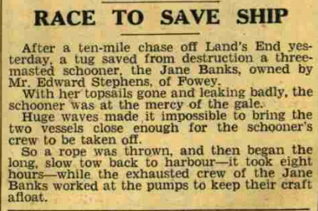

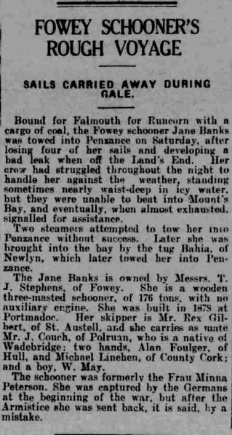

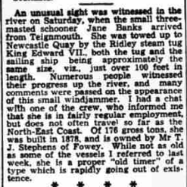
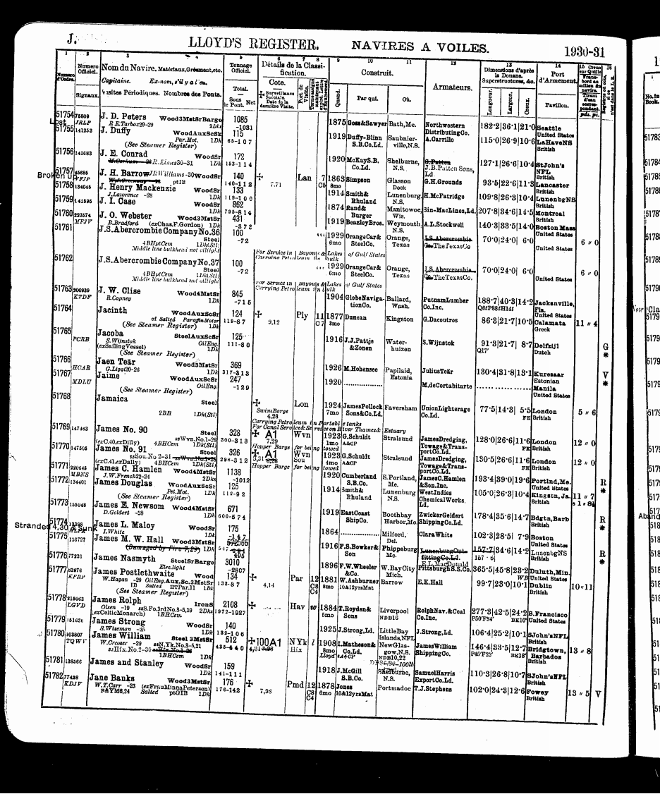
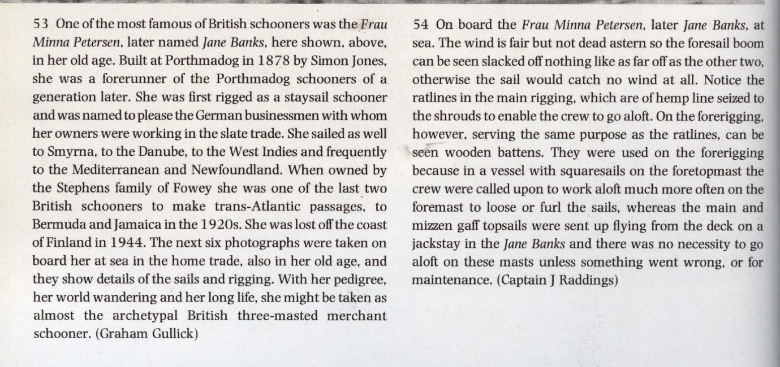

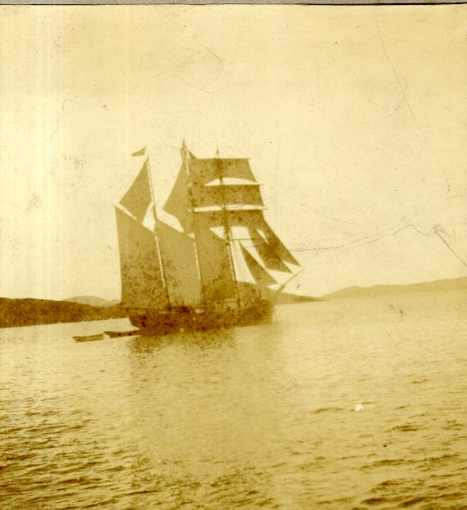

FRAU MINNA PETERSEN

