Barque Jane Kilgour
Vessel Name | Official Number |  | Signal letters | Rig /Type | Where built |  | Builder |  | Year built |  |  | Year end |  | reg tons
JANE KILGOUR | 68271 |  | NDGJ | Barquentine |  | Dundee |  | Tay ship building co. |  | 1874 |  |  | 1920 |  | 214
OWNERS/ MANAGERS/REGISTRATION DETAILS |  | Notes |  |  |  |  |  |  |  |  | MASTERS
1894 William Rosevear, Pentewan.(MO) |  | LOA 126.8 x 24.1 x 12.8ft previously registered in Dundee on 8th July 1874.1899 registered in South Shields then Cape Town 1913 and finally Port Louis 1917, Mauritius as a motor vessel. UK Register closed 1897 |  |  |  |  |  |  |  |  | W.Rosevear 1894-1904 Chesterfield 1906

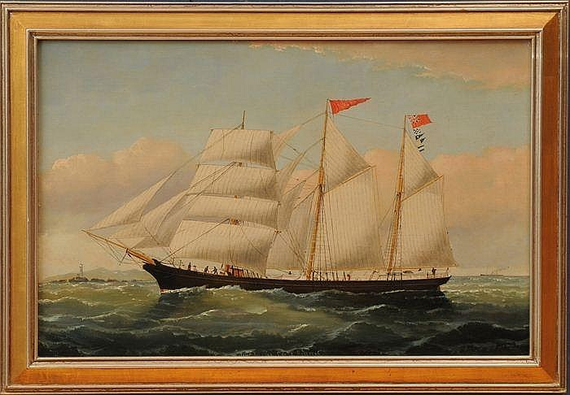
WILLIAM HOWARD YORKE (1847-1921): JANE KILGOUR - CAPT. E. ROSEVEAR
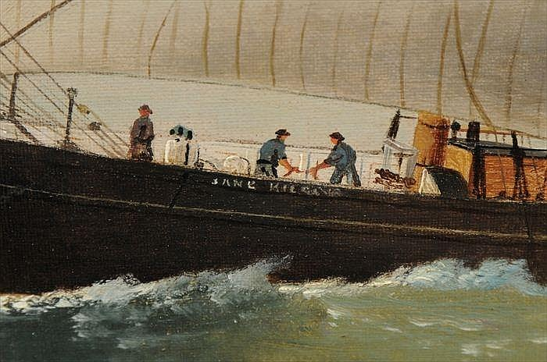
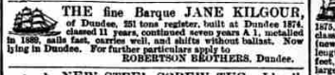

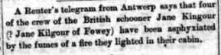

1915 crew
MARINER | RANK
Donovan, John | Ordinary Seaman
Harvey, Henry | Ordinary Seaman
Thomas, John | Cook and Steward

