Schooner Jane Slade
Vessel Name | Official Number |  | Signal letters | Rig /Type | Where built |  | Builder |  | Year built |  |  | Year end |  | reg tons
JANE SLADE | 63961 |  | JQKS | Schooner |  | Polruan |  | William Salt Slade J. Slade & sons, |  | 5 / 1870 |  |  | 1928 |  | 149
OWNERS/ MANAGERS/REGISTRATION DETAILS |  | Notes |  |  |  |  |  |  |  |  | MASTERS
1st registered in Fowey 9th August 1870 Wm.Geake Bank House St. Columb 1897 Thomas Slade Fowey,(MO) 1910,Samual Slade, Esplanade, Fowey 1915 Ernest C.Slade East Street, Polruan |  | LOA 97.7 x 22.9 x 12. 3ft.March 1892. launched by miss Slade. The British schooner Jane Slade, from Fowey for Leghorn, has put into Gibraltar with loss of yards and main boom. She jettisoned about five tons of cargo during heavy weather. February 1904 was in collision with the smack Briton in Brixham bay. Reg closed 1929 Beached in Pont on East side and left to rot having been stripped of rigging and anything useful. Figure head to Ferry Side home of Daphne Du Maurier. Last voyage left London on 7th July 1924 heading for Fowey via Cardiff, Kirkaldy, Queensferry and Hull arriving finally on 6th November 1924 Broken up 1928 in situ in Pont. Some parts remain. |  |  |  |  |  |  |  |  | Thomas Slade 1870- 1892 T.H.Slade 1892-1894 J.S.Slade 1894 A.Veale 1896-1899 George Thomas 1899-1903 John Andrews 1903-1910 P.M.Jacobs 1910-1914 Henry David Smith 1914-1918 Ben Williams 1918-1919 H.Cohring 1919-1920 G.Kearon 1920-1923 W.H.Cort 1923-1924+

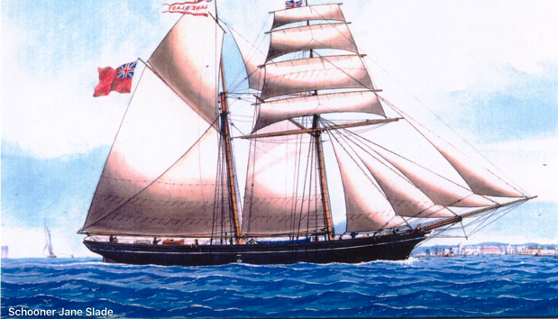
Off Leghorn 1887.

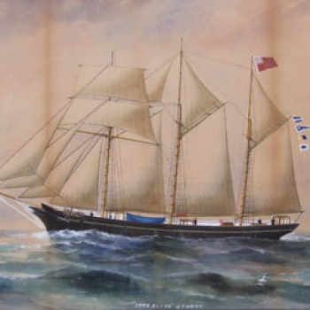
painted by celebrated maritime artist, Reuben Chappell (1870-1940), painted in 1913

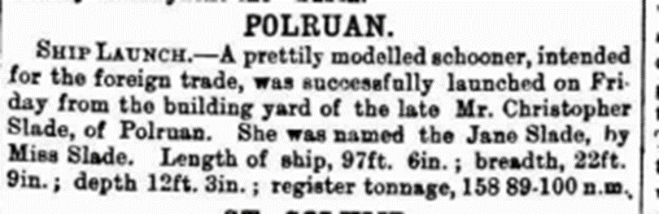

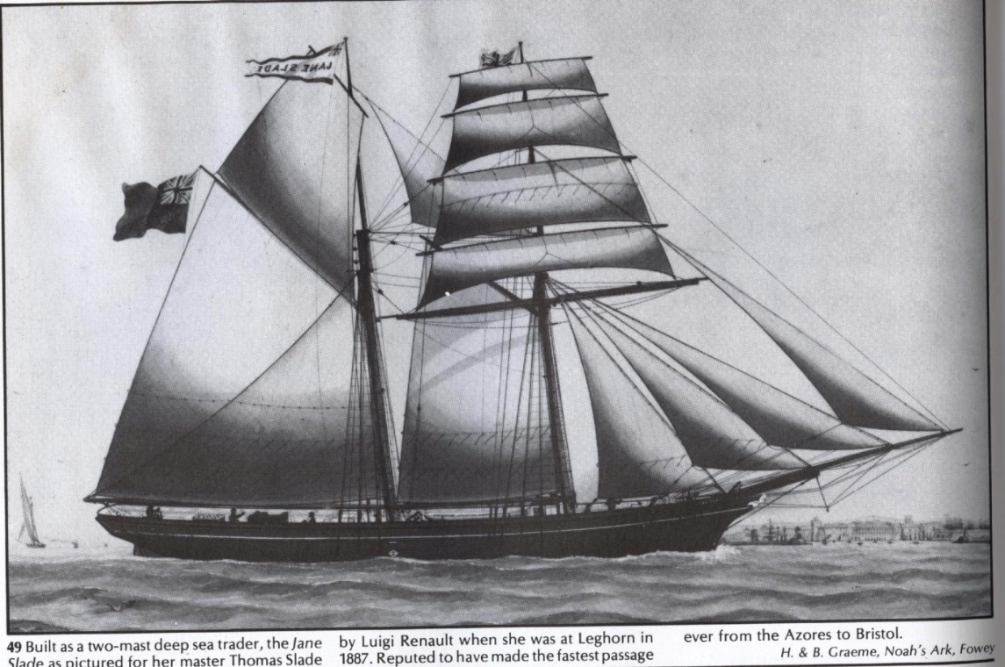

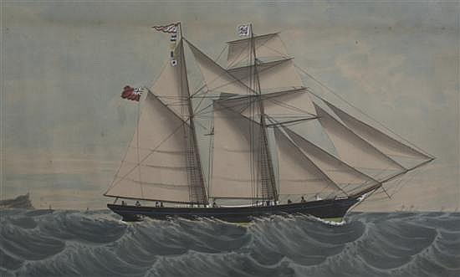
Anthony Lusso (19th C.) Schooner 'Jane Slade' of Polruan,

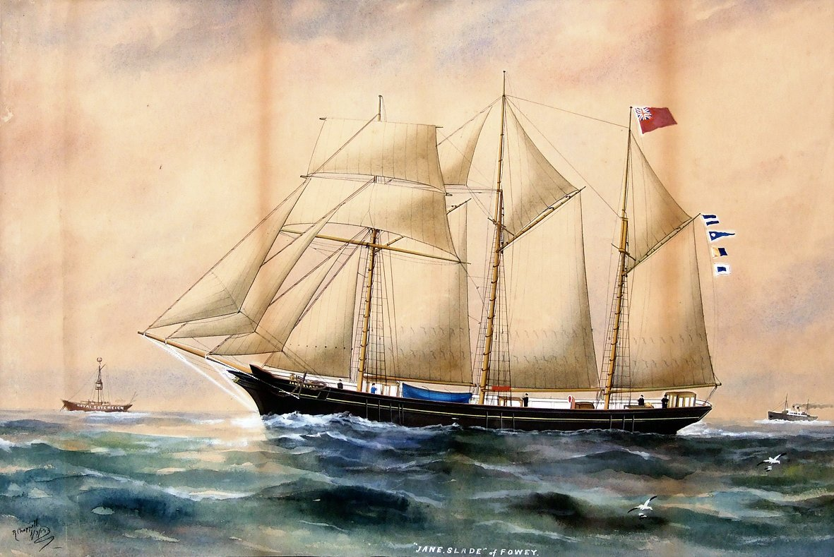

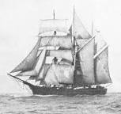

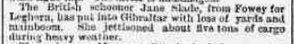

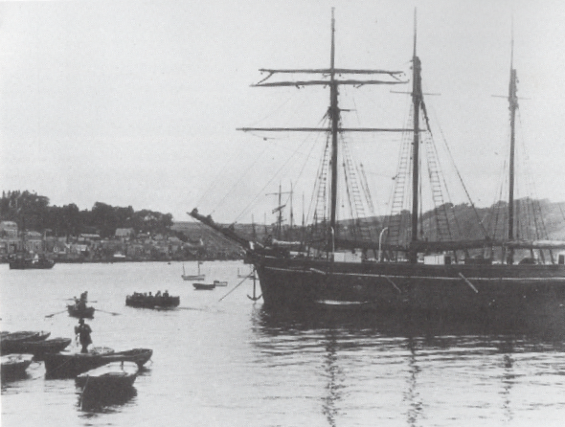

Moored of Polruan probably for repairs.
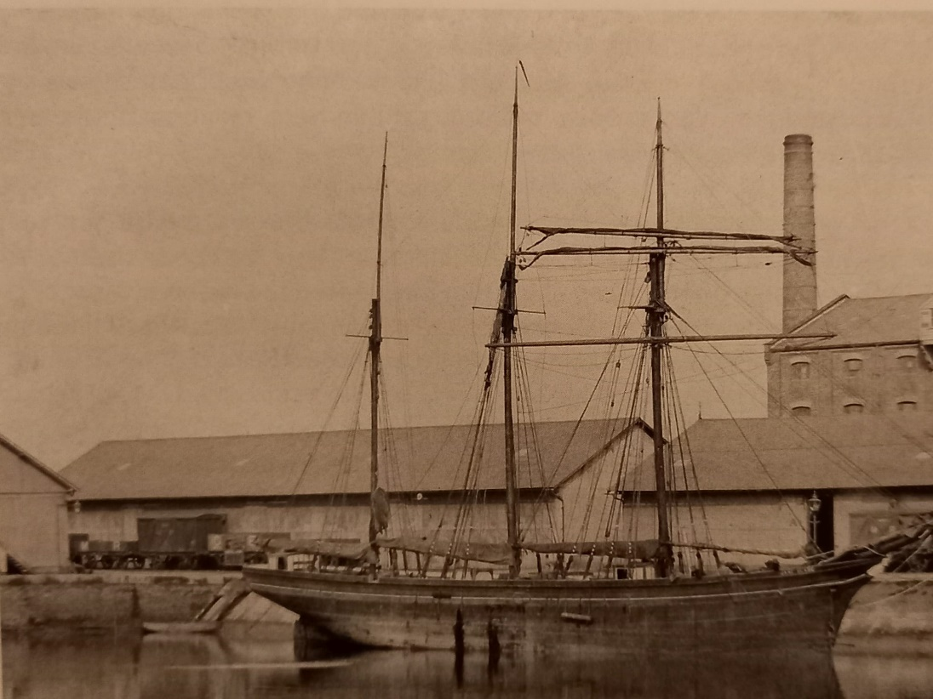
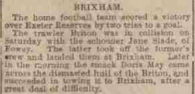
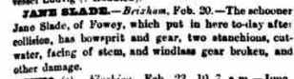
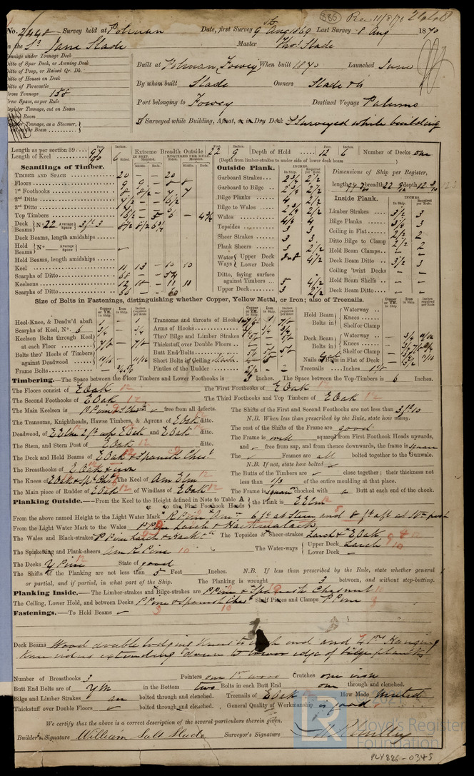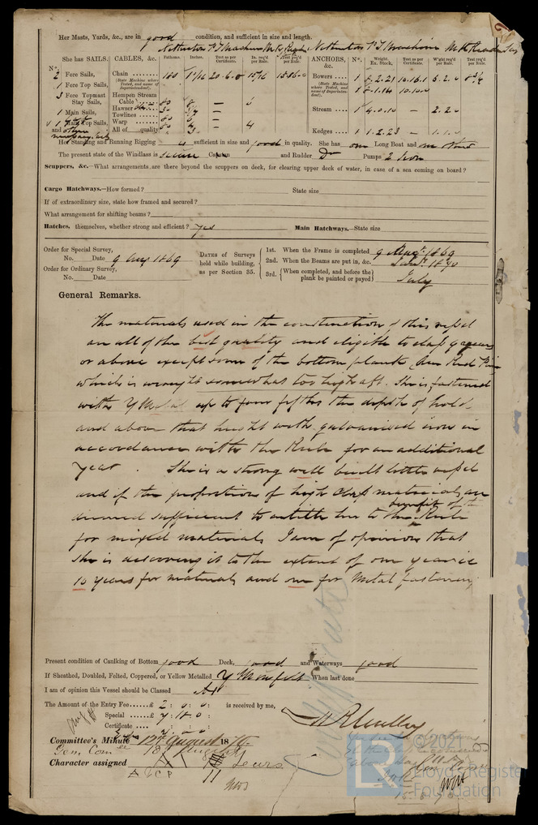
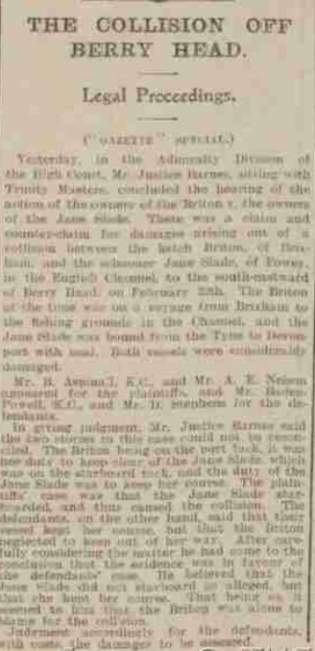
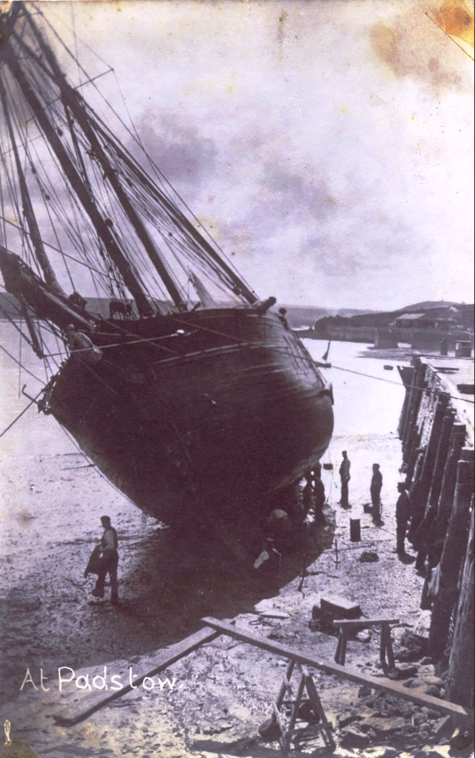
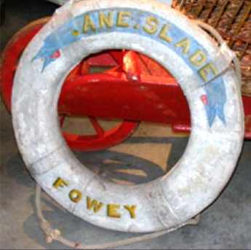

Her lifebuoy is in the Maritime museum in Falmouth
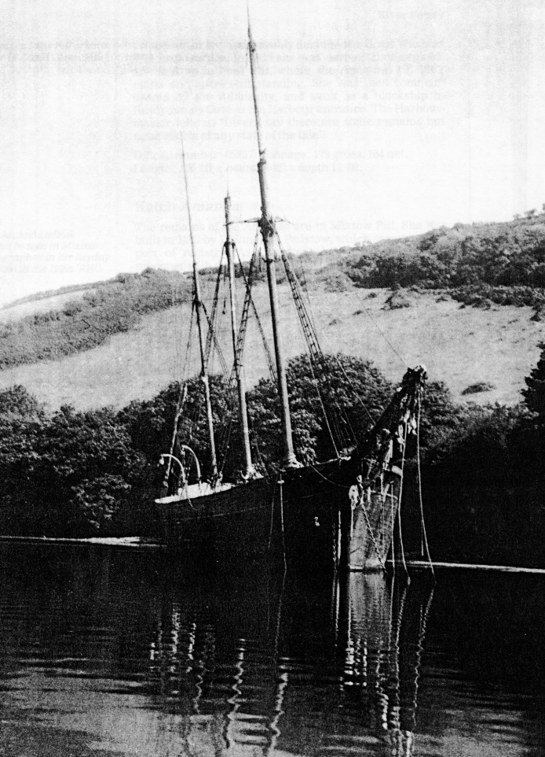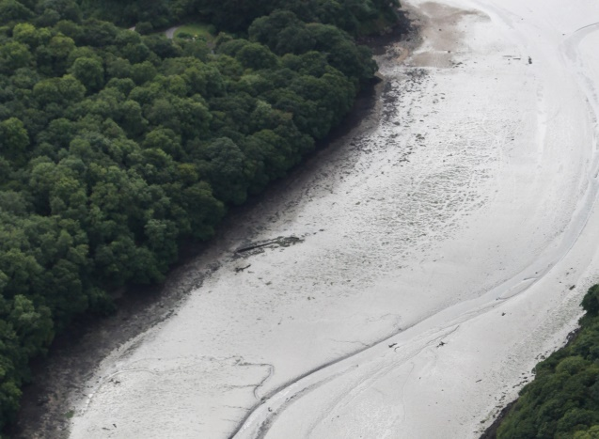
Jane Slade laid up in Pont Pill on the south side .Here she was stripped and became a hulk. Remains still exist below

Built by William Slade in 1870 159 tons copper fastened and yellow metalled rigged as two masted topsail schooner but converted in 1905 to three masted vessel

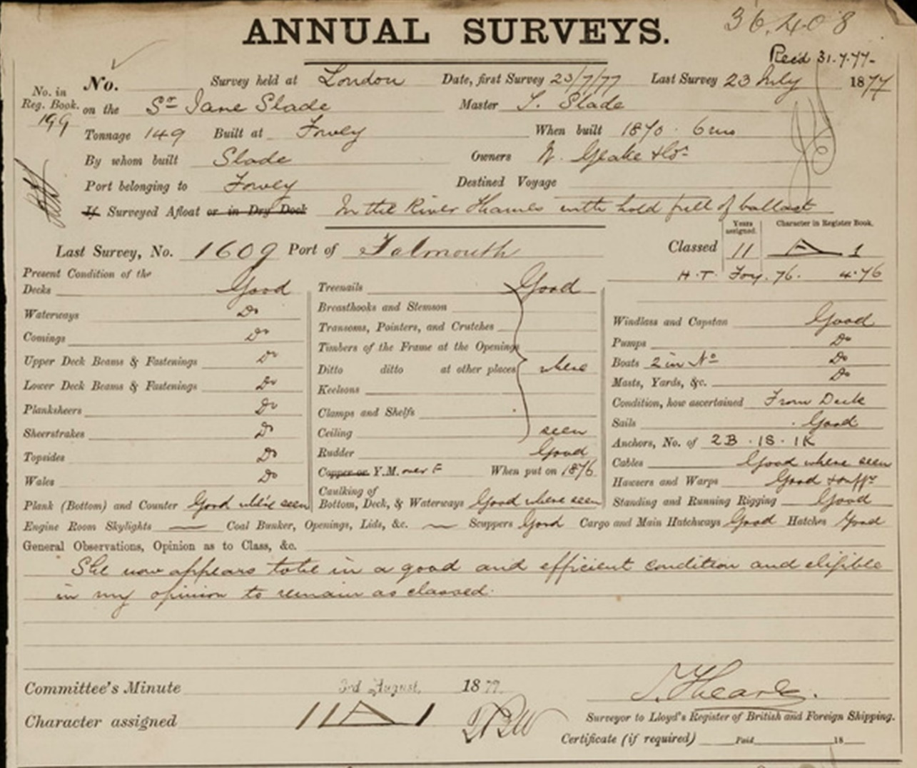

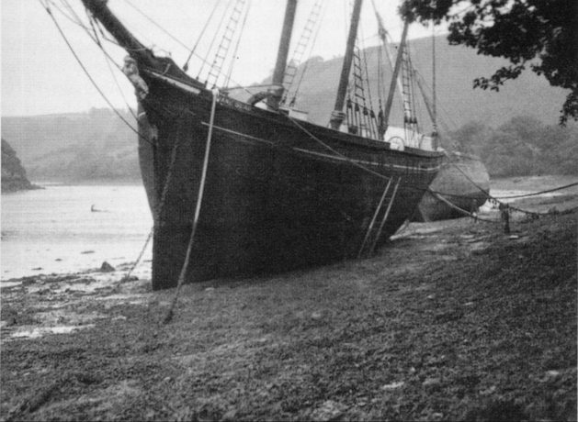

Laid up in Pont with The Francis and Jane
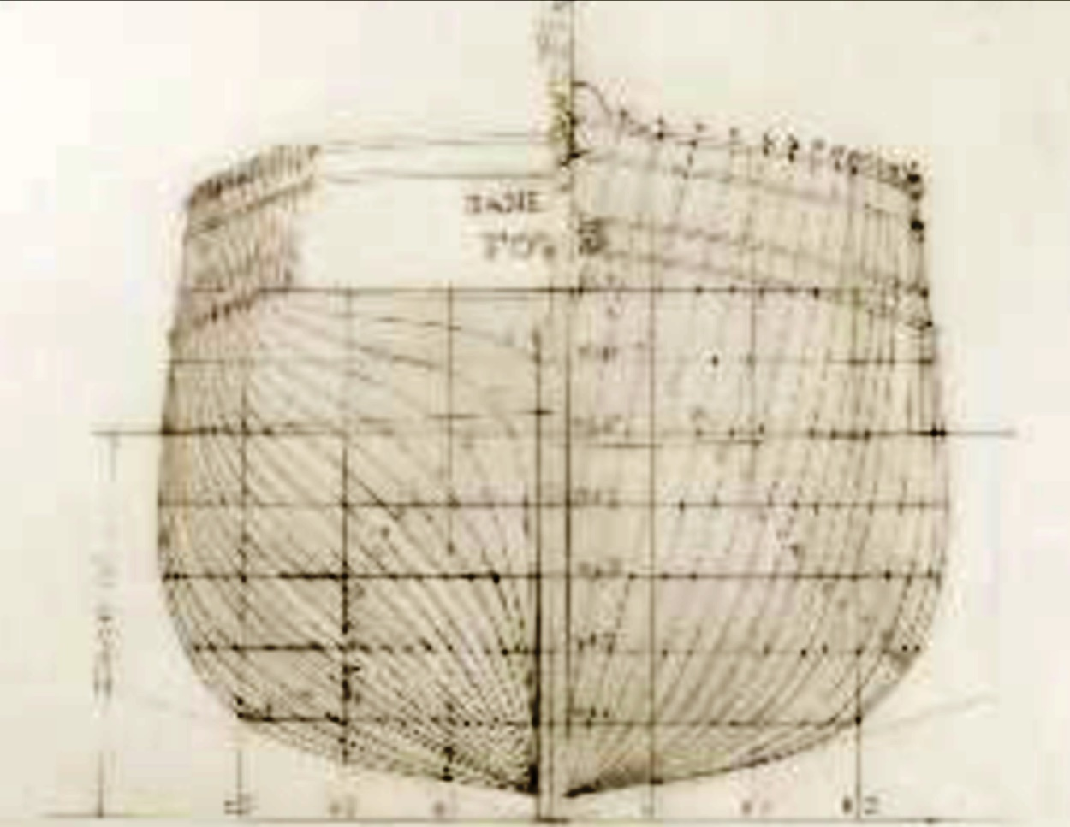

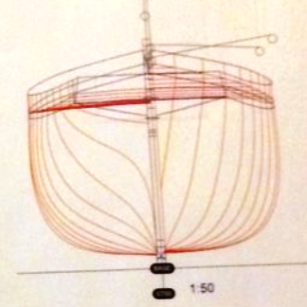

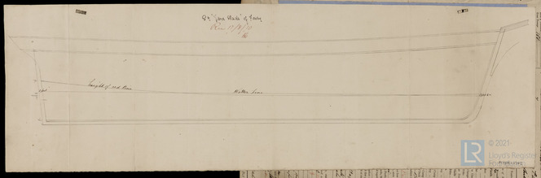

Under Captain Peter Avery held record for fastest time passage St.Michaels to Bristol with cargo of fruit.

On passage from Hull towards west country went aground and brought home for repair. She was laid up in Pont and gradually dismantled.

Owners:-

Name | Residence | profession | Nos of shares
Jane Symons Slade | Polruan | shipbuilder | 36
John Hawken | polruan | Blacksmith | 2
Richard Clog | Polruan | Butcher | 1
John Edward Hocken | Polruan | Sailmaker | 2
Elias Roskelly Tadd | Polruan | Master Mariner | 2
Fanny Stevens | Polruan | Grocer | 1
Elizabeth Salt | Polruan | Widow | 1
John Hicks | Polruan | Yeoman | 3
Thomas Pearce | St. Blazey |  | 2
Thomas Mutton | Lerryn | butcher | 2
William Geake | St. Columb | gentleman | 2
William Luke | Charlestown | merchant | 2
Nehimiah Stephens | Liskeard | Gentleman | 2
John Bawden | St.Austell | Cabinet Maker | 2
John Martin | Fowey | Farmer | 2
Total |  |  | 62

Crew list 1881
Thomas Slade; rank/rating, Master; age, 43; place of birth, Polruan; previous ship, same ship.
William Jolly; rank/rating, Mate; age, 24; place of birth, Fowey; previous ship, Silver Stream.
John Webb; rank/rating, Boatswain; age, 29; place of birth, Kingsbridge; previous ship, same ship.
G H Mansfield; rank/rating, Able Seaman; age, 24; place of birth, London; previous ship, same ship.
James Greig; rank/rating, Able Seaman; age, 20; place of birth, Leith; previous ship, same ship.
William A Lucas; rank/rating, Able Seaman; age, 20; place of birth, London; previous ship, same ship.
William Harris; rank/rating, Cook Steward; age, 45; place of birth, Bath; previous ship, same ship.
James S Slade; rank/rating, Ordinary Seaman; age, 15; place of birth, Polruan; previous ship, same ship.
Michael Jordan; rank/rating, Cook Steward; age, 24; place of birth, Liverpool; previous ship, Sheila.
Anders Andersson; rank/rating, Able Seaman; age, 24; place of birth, Yotas; previous ship, William Engels.

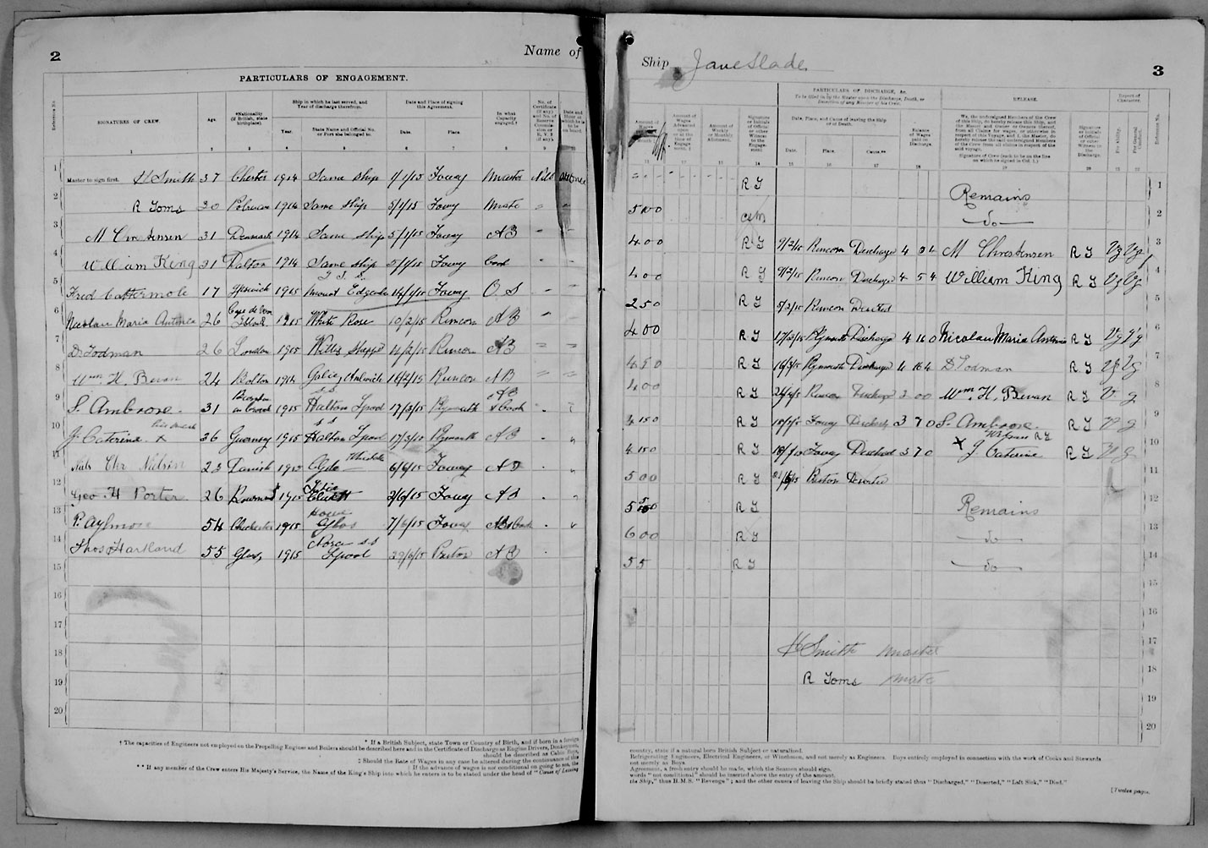
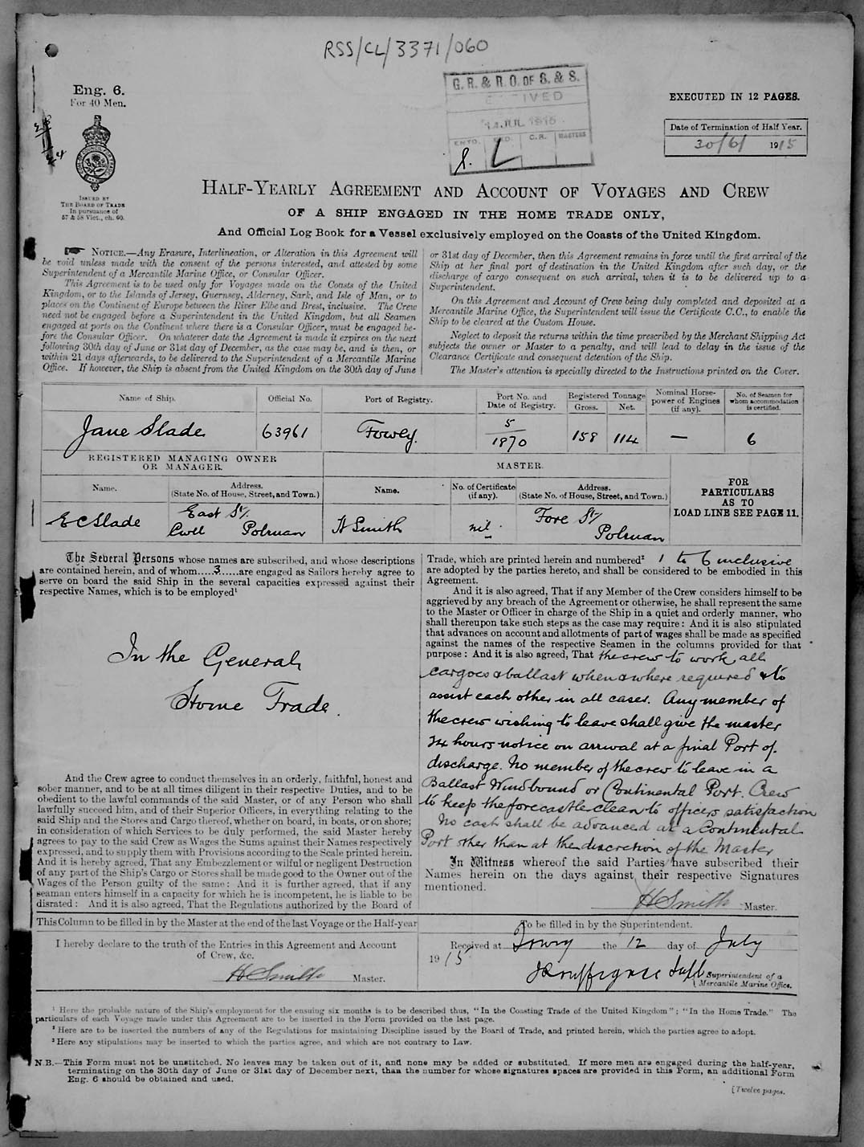

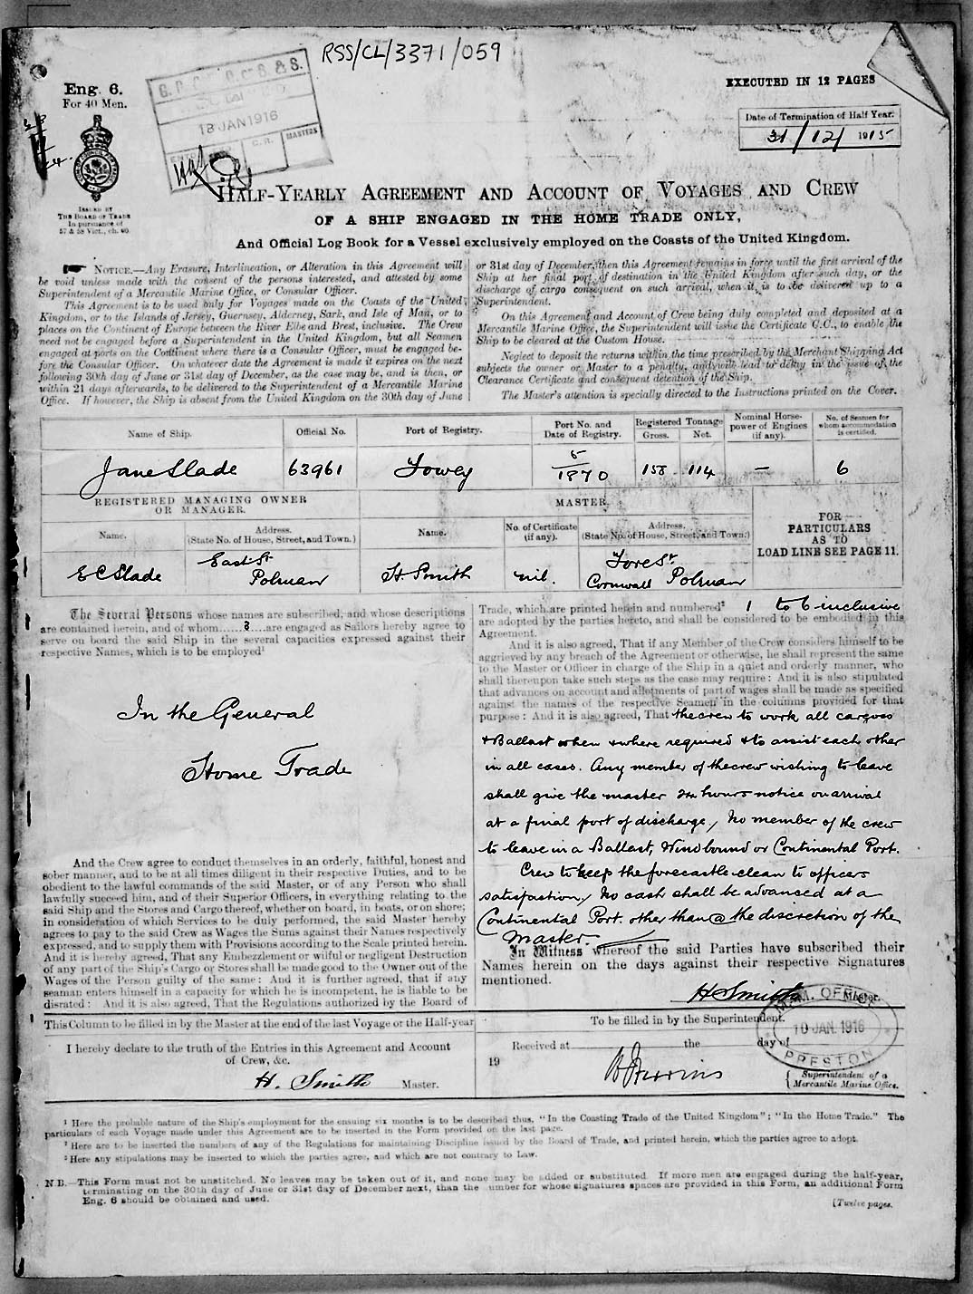
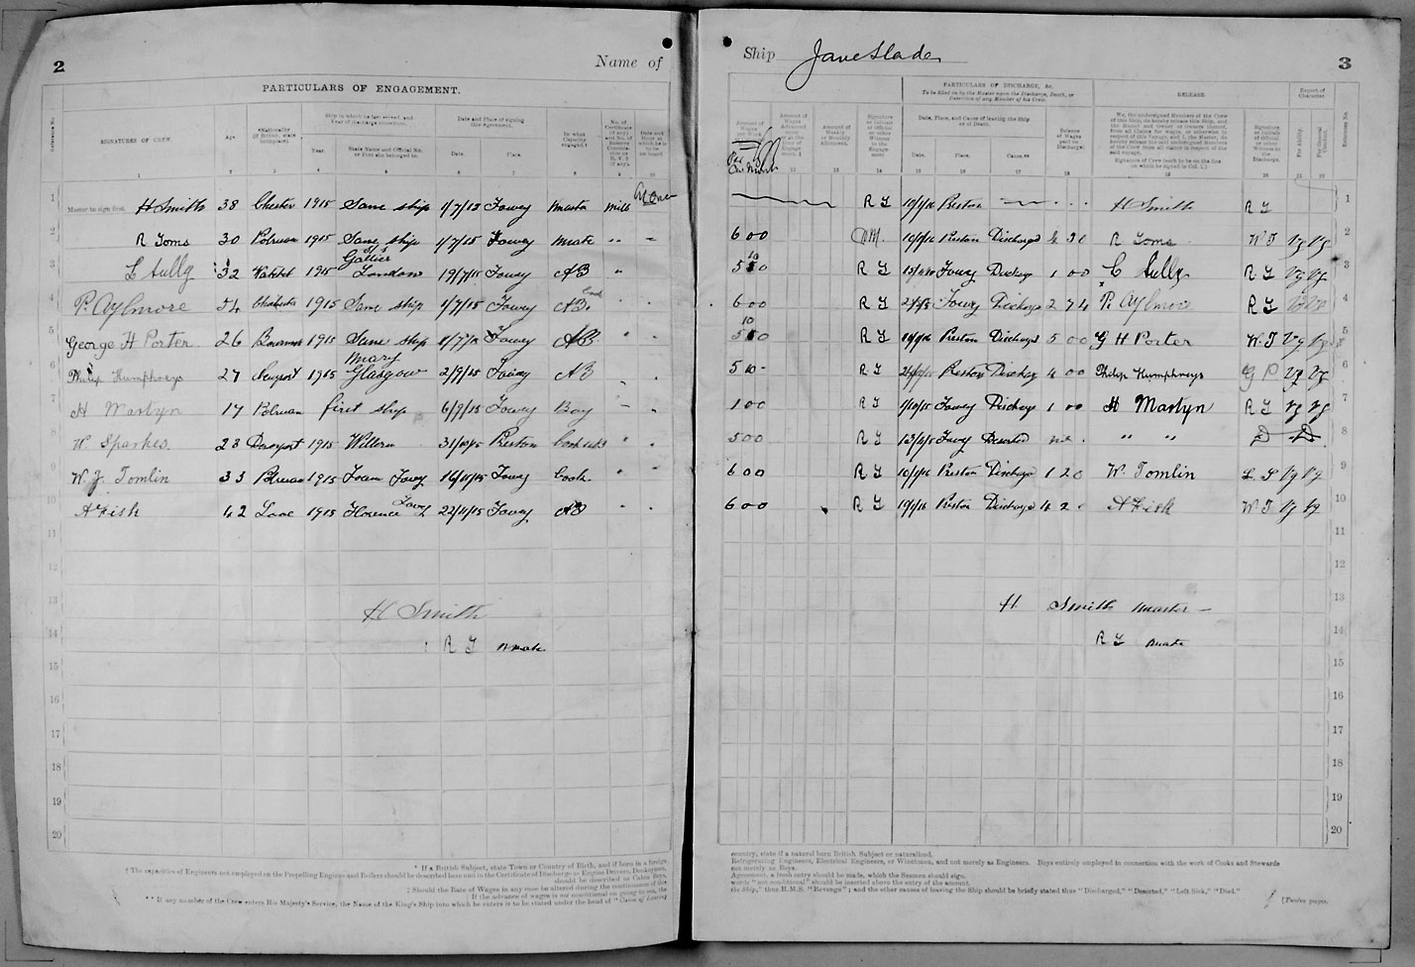

Ship: Jane Slade; Official number: 63961. Date: 1915

H Smith; rank/rating, Master; age, 38; place of birth, Chester; previous ship, same.
R Toms; rank/rating, Mate; age, 30; place of birth, Polruan; previous ship, same.
C Sully; rank/rating, Able Seaman; age, 32; place of birth, Watchet; previous ship, Gallier of London.
P Aylmore; rank/rating, Able Seaman; age, 54; place of birth, ?; previous ship, same.
George H Porter; rank/rating, Able Seaman; age, 26; place of birth, ?; previous ship, same.
Philip Humphreys; rank/rating, Able Seaman; age, 27; place of birth, Newport; previous ship, Mary of Glasgow.
H Martyn; rank/rating, Boy; age, 17; place of birth, Polruan; previous ship, first.
W Sparks; rank/rating, Cook?; age, 23; place of birth, Devonport; previous ship, ?
W J Tomlin; rank/rating, Cook; age, 33; place of birth, Polruan; previous ship, Foam of Fowey.
A Fisk; rank/rating, Able Seaman; age, 42; place of birth, Looe; previous ship, Florence of Fowey.

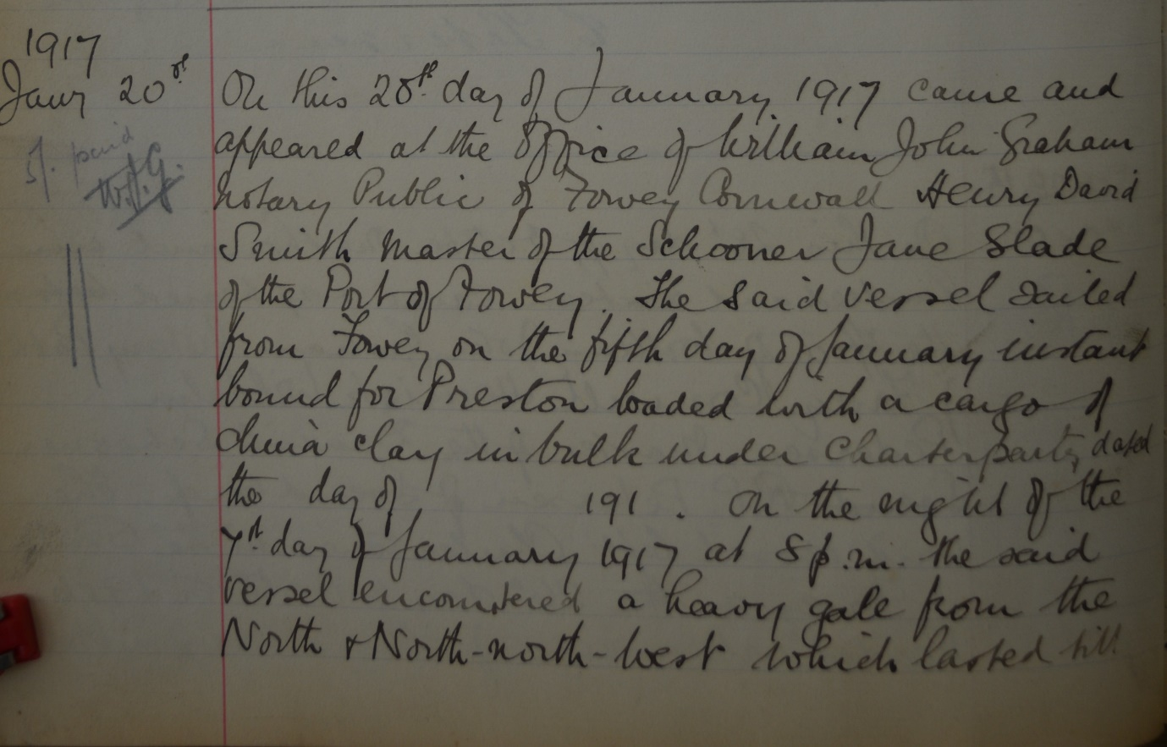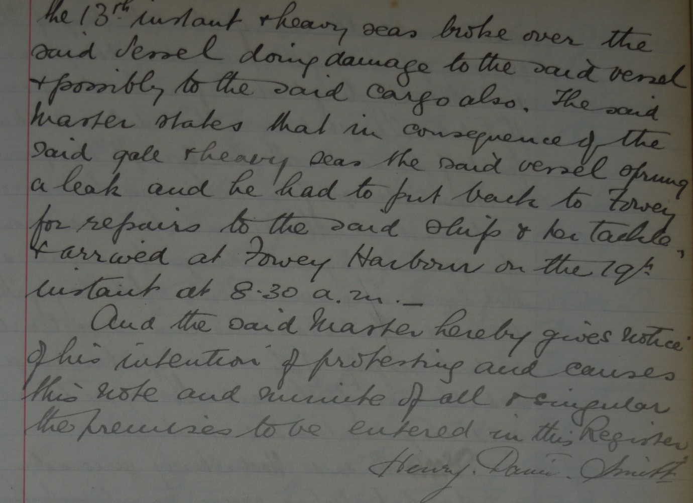
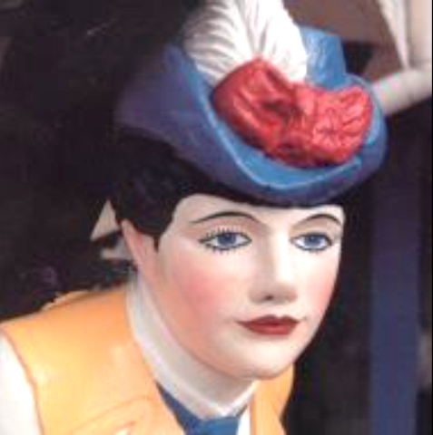
The Jane Slade’s figure head on Ferryside at Bodinnick

Across the estuary, the Hall Walk leads to Pont Pill, a tidal creek with quiet banks cloaked in woodland. Ivy clings to fallen trees, primroses peer from mossy crevasses and the occasional muffled hoot of a boat drifts on the air. Below, the creek glides by at full flood: opaque and impenetrable, with the hulls of long-dead ships concealed in its green depths.

One such ship, a 97ft schooner called the Jane Slade, came to rest here during du Maurier's time. "She lay there on the mudflats, abandoned to die, her hulk rotting but her colourful figurehead proudly challenging the passage of time," du Maurier remembered. That figurehead was a carving of the real Jane Slade, mother of the boat's builders and grandmother of the wife of the du Mauriers' boatman. Tales of the ship, the Slade family and their boatyard in nearby Polruan sparked the young Daphne's imagination. The result was The Loving Spirit, her first novel.

The boat's figurehead still adorns the façade of "Ferryside", du Maurier's first Cornish home. The curious wooden house was itself once used for boat-building and dominates the water's edge at Bodinnick, across the estuary from Fowey. It remains in the du Maurier family.

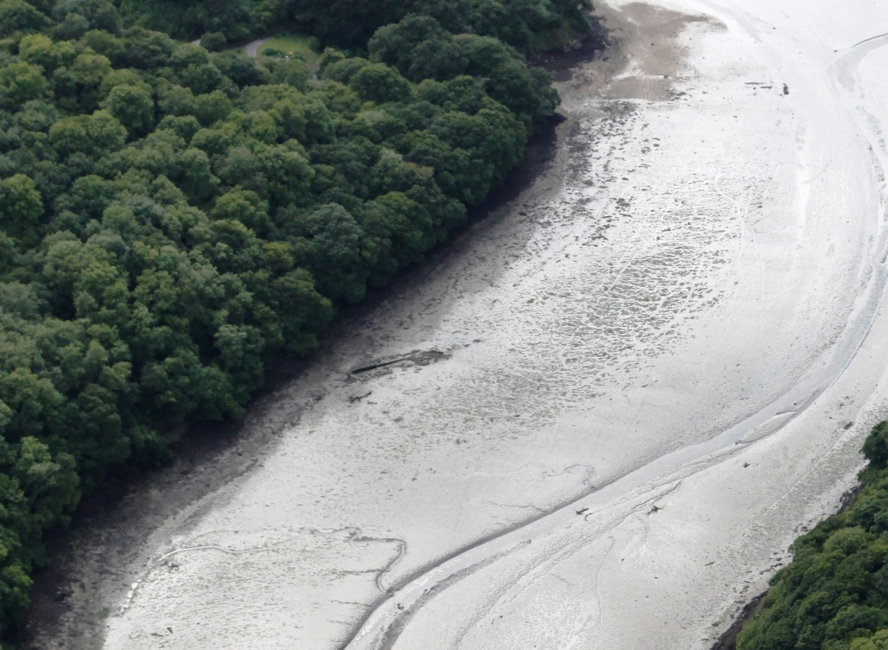
The final resting place of the Jane Slade in Pont Pill, Fowey harbour

