Brigantine JANIE GOUGH

Vessel Name | Official Number | Signal letters | Rig /Type | Where built | Builder | Year built | Year end | reg tons

JANIE GOUGH | 81951 |  | SPDL | Brigantine | Carrickfergus | Rogers | 1870 |  | 1895 | 204
OWNERS/ MANAGERS/REGISTRATION DETAILS |  | Notes |  |  |  |  |  | MASTERS
1891 William Fras Hannan Fowey |  | LOA 114 x 24.6 x 12.5ft. Previously registered in Belfast 28th June 1879.In a report dated 30th January 1895 a lifeboat belonging to the vessel was picked up off Lands’ End. She was presumed lost with crew of nine. On passage from Mounts Bay to Liverpool. she had left Rochester for Garston on the 17th December with a cargo of cement and Mounts Bay on the 1st January, not registered in 1896 |  |  |  |  |  | J.Toms 1894

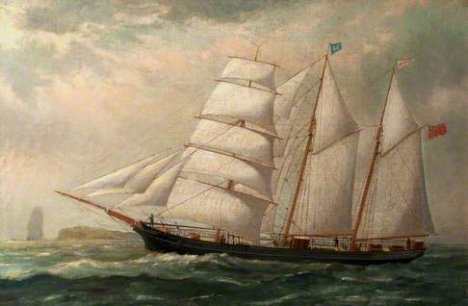
The Schooner 'Janie Gough', Reuben Chappell (1870–1940),
