Schooner Jasper
Vessel Name | Official Number |  | Signal letters | Rig /Type | Where built |  | Builder |  | Year built |  |  | Year end |  | reg tons
JASPER | 85825 |  | JQBR | schooner |  | Falmouth |  | C. Burt |  | 1884 |  |  | 1904 |  | 119
OWNERS/ MANAGERS/REGISTRATION DETAILS |  | Notes |  |  |  |  |  |  |  |  | MASTERS
registered in Fowey 9th October 1884. 1885 Arthur Jenkyns, Charlestown 1899 Richard Jas Hockin, Sedgmoor House,Tower Rd(MO) |  | LOA 96 X 23 x 11.3ft.3 masted schooner. wrecked 16/1/1904 The Caister lifeboat landed at Yarmouth four hands of the three-masted schooner Jasper, of Fowey, which was wrecked on Haisborough Sands; and also, the body of Charles Lundsberg, ordinary seaman who died from exposure. |  |  |  |  |  |  |  |  | T.Hocking 1889-1894 J.Paull 1897-1898 Larson 1904

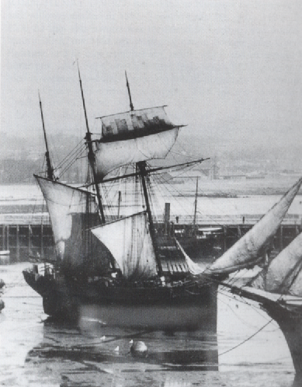
Jasper dried out in harbour.

