Schooner Jessie
Vessel Name | Official Number |  | Signal letters | Rig /Type | Where built |  | Builder |  | Year built |  |  | Year end |  | reg tons
JESSIE | 76576 |  | JTKM | Schooner |  | Kingston-on -Spey |  | Spence |  | 1878 |  |  | 1917 |  | 91
OWNERS/ MANAGERS/REGISTRATION DETAILS |  | Notes |  |  |  |  |  |  |  |  | MASTERS
1904 William A Jenkins,Mackworth Villas, St. Thomas, Swansea1906 Ralph Fishley, 114 Station Rd, St.Blazey(MO) 1911 Robert Grimes,Hoarrock, The Skerries, Dublin |  | LOA 85.8 x 21.4 x 10.5 ft. draft. Previously registered in Banff 8th July 1878 and Dublin. Sunk by U-boat on 27th April 1917 7 miles west of Portland Bill with a cargo of coal from Cardiff to Carten in France |  |  |  |  |  |  |  |  | George Brown 1871 W.Howard 1897 R.Gill 1909 R Grimes 1915

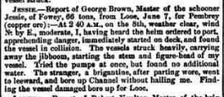

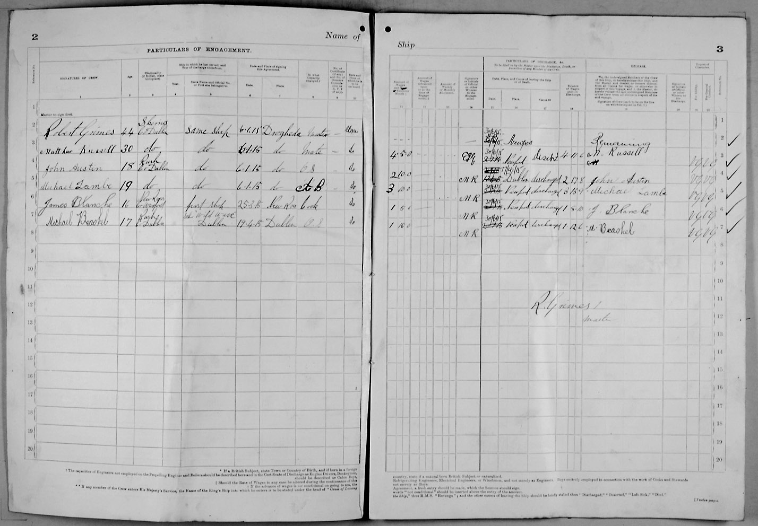
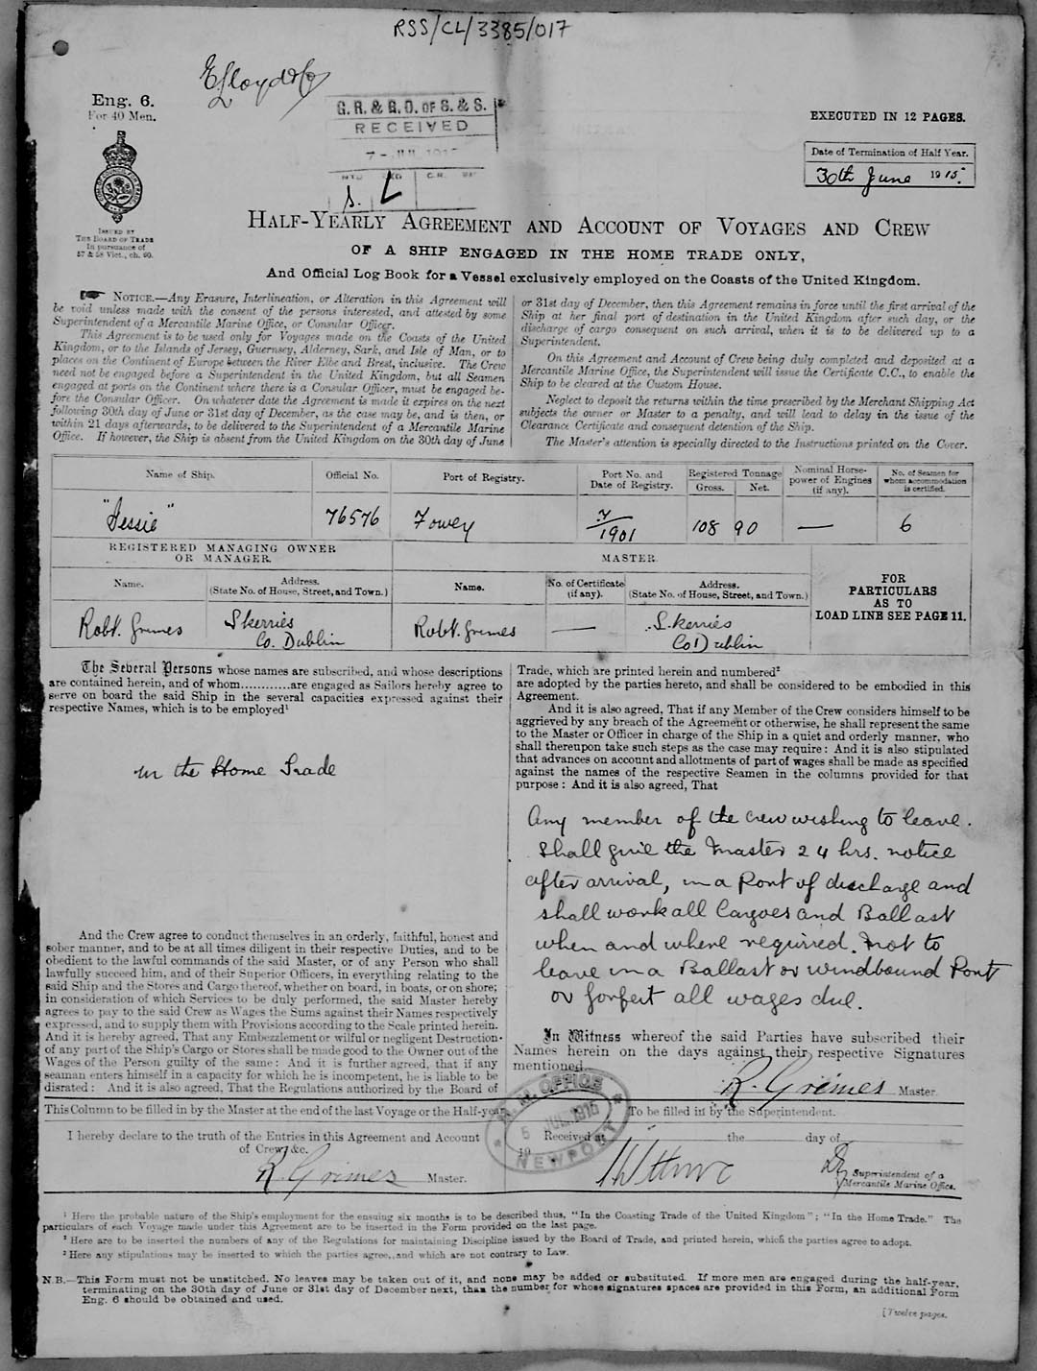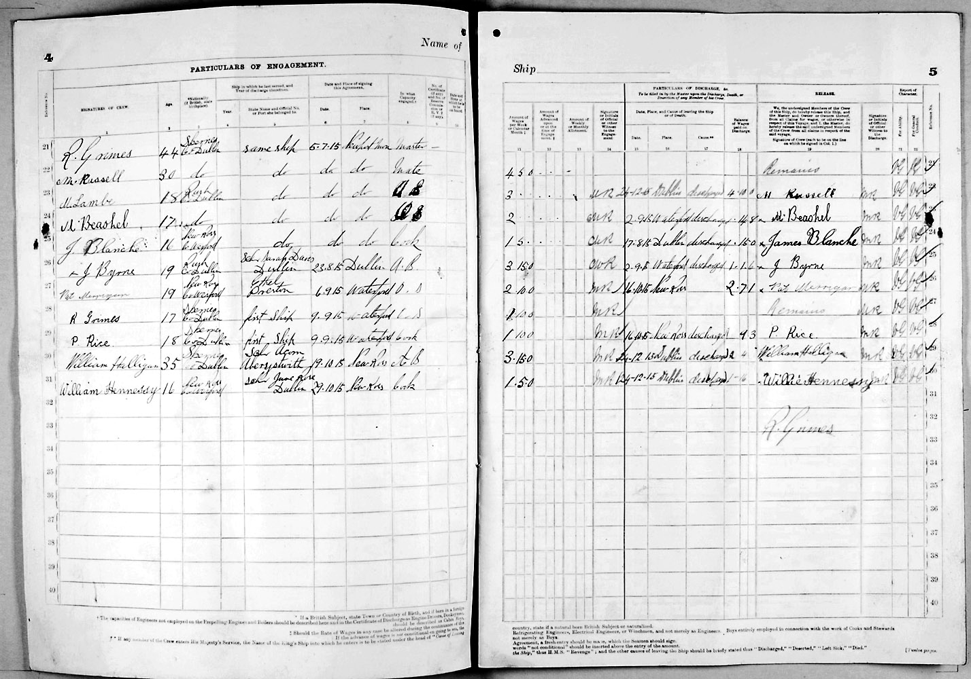
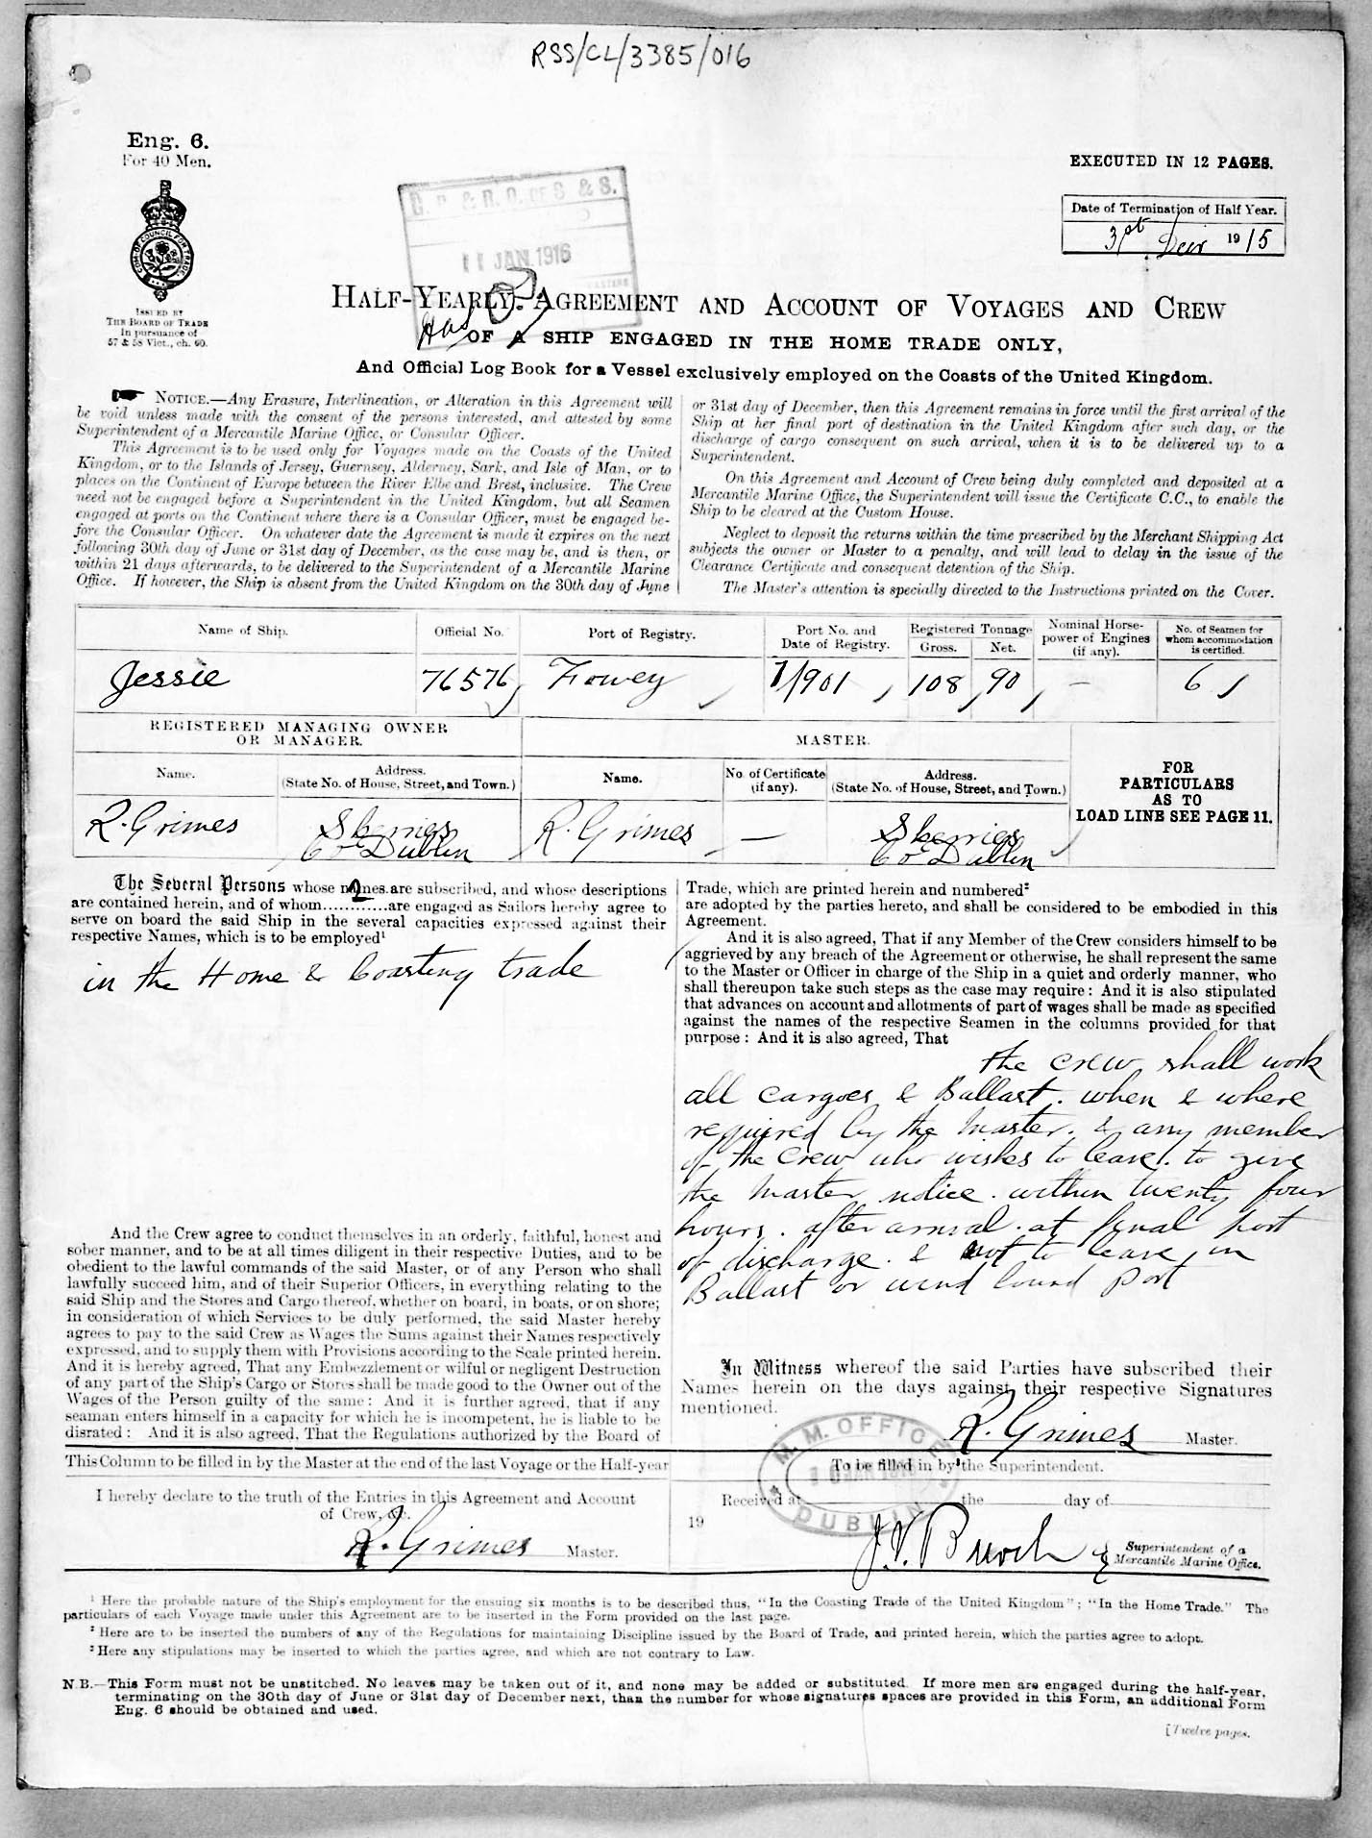

Ship: Jessie; Official number: 76576.

R Grimes; rank/rating, Master; age, 44; place of birth, Skerries, County Dublin; previous ship, same ship.

Matthew Russell; rank/rating, Mate; age, 30; place of birth, Skerries, County Dublin; previous ship, same ship.

Michael Lambe; rank/rating, Able Seaman; age, 18; place of birth, Rush, County Dublin; previous ship, same ship.

Michael Beashel; rank/rating, Ordinary Seaman; age, 17; place of birth, Rush, County Dublin; previous ship, same ship.

James Blanche; rank/rating, Cook; age, 16; place of birth, New Ross, County Wexford; previous ship, same ship.

J Byrne; rank/rating, Able Seaman; age, 19; place of birth, Rush, County Dublin; previous ship, Sarah Davis of Dublin.

Patrick Merrigan; rank/rating, Ordinary Seaman; age, 19; place of birth, New Ross, County Wexford; previous ship, Ethel of Preston.

R Grimes; rank/rating, Ordinary Seaman; age, 17; place of birth, Skerries, County Dublin; previous ship, first ship.

P Rice; rank/rating, Cook; age, 18; place of birth, Skerries, County Dublin; previous ship, first ship.

William Halligan; rank/rating, Able Seaman; age, 35; place of birth, Skerries, County Dublin; previous ship, Schooner Acorn of Aberystwith.

William Hennessey; rank/rating, Cook; age, 16; place of birth, New Ross, County Wexford; previous ship, Schooner June Rose of Dublin.

Date: 1915

