Schooner Lady Ernstine
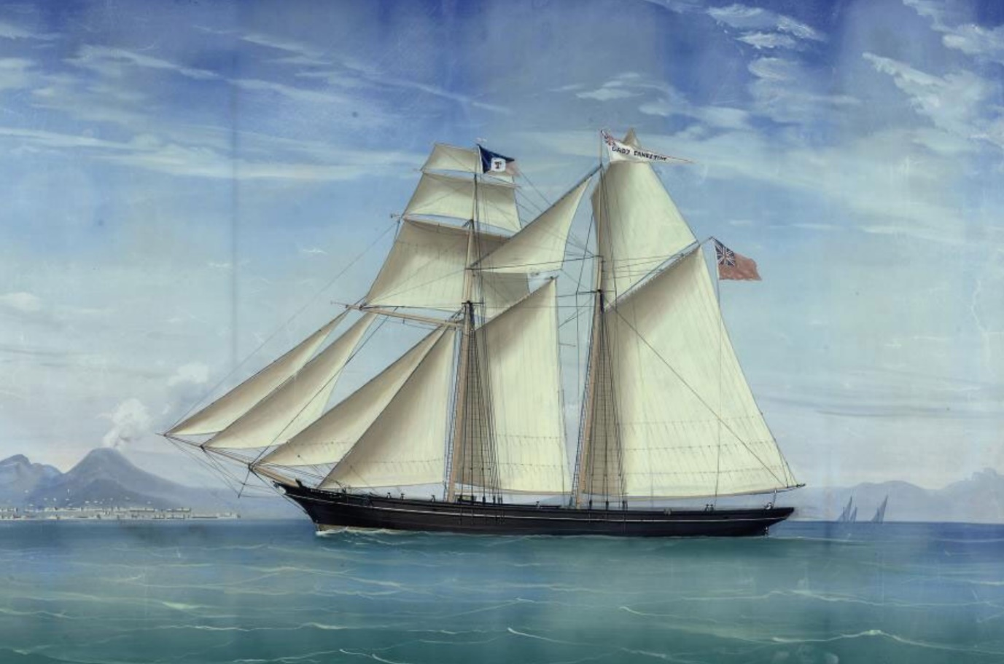
Vessel Name | Official Number |  | Signal letters | Rig /Type | Where built |  | Builder |  | Year built |  |  | Year end |  | reg tons
LADY ERNESTINE | 62149 |  | JGRW | 2 masted Schooner |  | Cremyll, cornwall |  |  |  | 1869 |  |  | 1886 |  | 139
OWNERS/ MANAGERS/REGISTRATION DETAILS |  | Notes |  |  |  |  |  |  |  |  | MASTERS
1872 Richard Prior Toms, Polruan . 1878 John Merrifield, Plymouth(MO) 1886 William Lock Phillips (MO) |  | 1st registered in Plymouth 25th September 1869.Reg in Fowey 24th February 1873. Peake Brothers & Co were owners. transferred from Plymouth register on 24th February 1873. Female bust figurehead with elliptical stern. Mediterranean trade. On passage to Plymouth with a cargo coal she was wrecked Near Aldburgh on the Suffolk coast on 6/11/1886. crew saved by Thorpe RNLI lifeboat. |  |  |  |  |  |  |  |  | George Gibbons of Exmouth 1873 Richard Prior Toms,1874-86

