Schooner Little Beauty
Vessel Name | Official Number |  | Signal letters | Rig /Type | Where built |  | Builder |  | Year built |  |  | Year end |  | reg tons
LITTLE BEAUTY | 73257 |  | PLRT | Schooner |  | Polruan |  | J.Stephens / Slades Newquay yard. |  | 1875 |  |  | 1889 |  | 90
OWNERS/ MANAGERS/REGISTRATION DETAILS |  | Notes |  |  |  |  |  |  |  |  | MASTERS
registered in Fowey 14th October 1875 John Stephens, Fowey 1878 William H.Luke, Charlestown 9th July 1880 Thomas Stephens, Par. |  | LOA 86.2' x 20.2' x 10.1' 2 mast schooner square stern with female figurehead. Launched 30th September 18752nd March 1885 ashore at North Salt Fleet Haven on passage to Goole. She Went missing after 21st January 1889 on voyage from Figueira, Portugal to Mevagissey with cargo of salt. Newfoundland and medi trade. |  |  |  |  |  |  |  |  | Edward Coombes 1875-81 William Jolly Braddon 1889

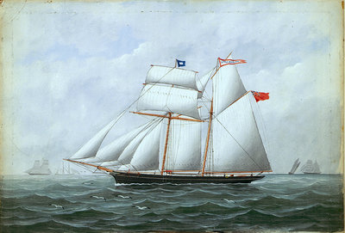
John Stephens ownership
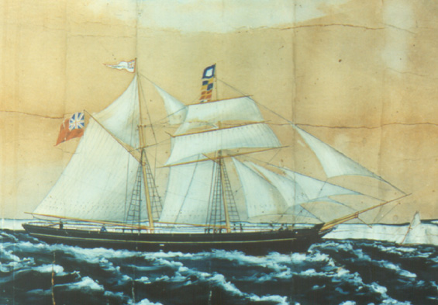The schooner "Little Beauty," official number 73257, 90 gross tons, was built in 1875 at Polruan, Cornwall, England by Stephens, and was owned by Thomas and John Stephens of Par. The vessel was well known in the Newfoundland and fruit trades, and was lost on a voyage from Figuera to Mevagissey, last heard of on January 28, 1889.
