Schooner Little Minnie
Vessel Name | Official Number |  | Signal letters | Rig /Type | Where built |  | Builder |  | Year built |  |  | Year end |  | reg tons
LITTLE MINNIE | 53004 |  | NSQC | Schooner |  | Padstow |  | Fredrick William Willmott. |  | 1865 |  |  | 1897 |  | 98
OWNERS/ MANAGERS/REGISTRATION DETAILS |  | Notes |  |  |  |  |  |  |  |  | MASTERS
transferred to Fowey register 9th March 1891John Stephens ,Par |  | LOA 82 x 21.2 x 10.2 previously Named Minnie. Registered 5th July 1865 in Padstow and again in 1869 possibly with change of name. Wrecked on Renews Island, Newfoundland 23rd January 1897 whilst on passage to St. Johns with a cargo of salt. Captain drowned. crew crawled over the ice and climbed a 50ft cliff to find safety. |  |  |  |  |  |  |  |  | Charles Jago,1897 John Philips 1897

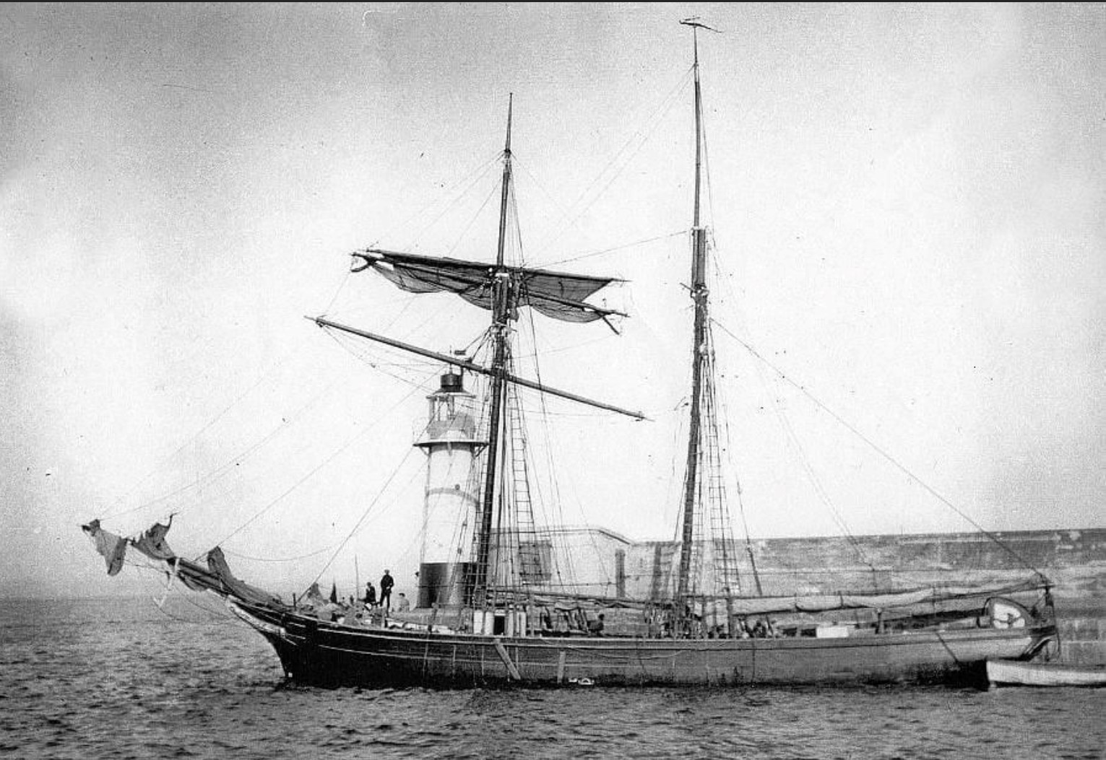

Leaving Newlyn
