Schooner Little Mystery
Vessel Name | Official Number |  | Signal letters | Rig /Type | Where built |  | Builder |  | Year built |  |  | Year end |  | reg tons
LITTLE MYSTERY | 85828 |  | KNBS | 2 masted Schooner |  | Kingsbridge |  | W.Date and Sons |  | 1887 |  |  | 1917 |  | 100
OWNERS/ MANAGERS/REGISTRATION DETAILS |  | Notes |  |  |  |  |  |  |  |  | MASTERS
sparrows Plymouth stone merchant previously owned her. registered in Fowey 27th July 1887. John Stephens, Par (MO)1904 Edward Stephens , Fowey (MO) |  | LOA 84.5' x 21.1' x 10.8'.2 masted with a square stern and Eagle figurehead Little Mystery, built by W. Date & Sons, Kingsbridge in 1887 and part owned and managed at the time of her loss by E. Stephens, Fowey, was a British wooden schooner of 114 tons. On April 30th, 1917, Little Mystery, on a voyage from Cardiff to Cherbourg with a cargo of coal, was scuttled by the German submarine UC-61 (Georg Gerth), approx. 22.5 m SSE of Portland Bill. There were no casualties REGISTER CLOSED 1917 |  |  |  |  |  |  |  |  | W.H.Hobber 1897-1896 John Henry Greet 1898-1915

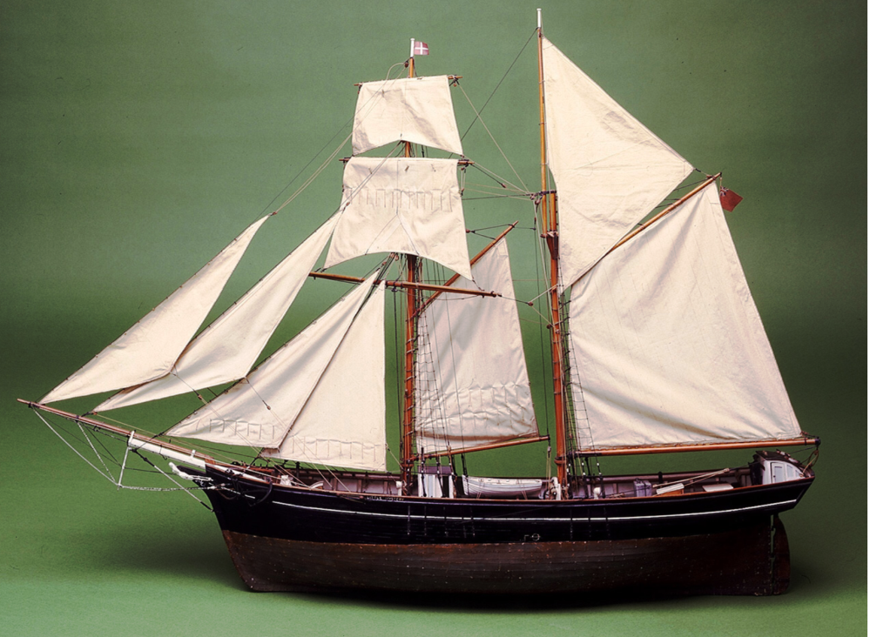
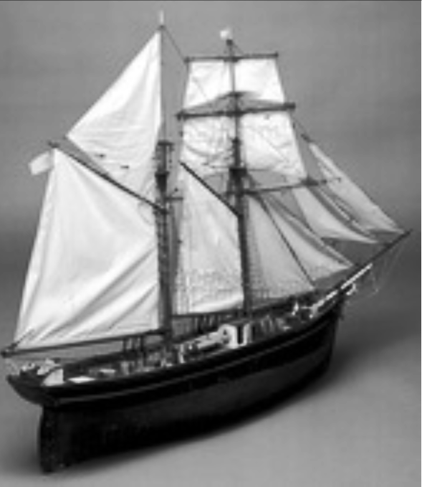

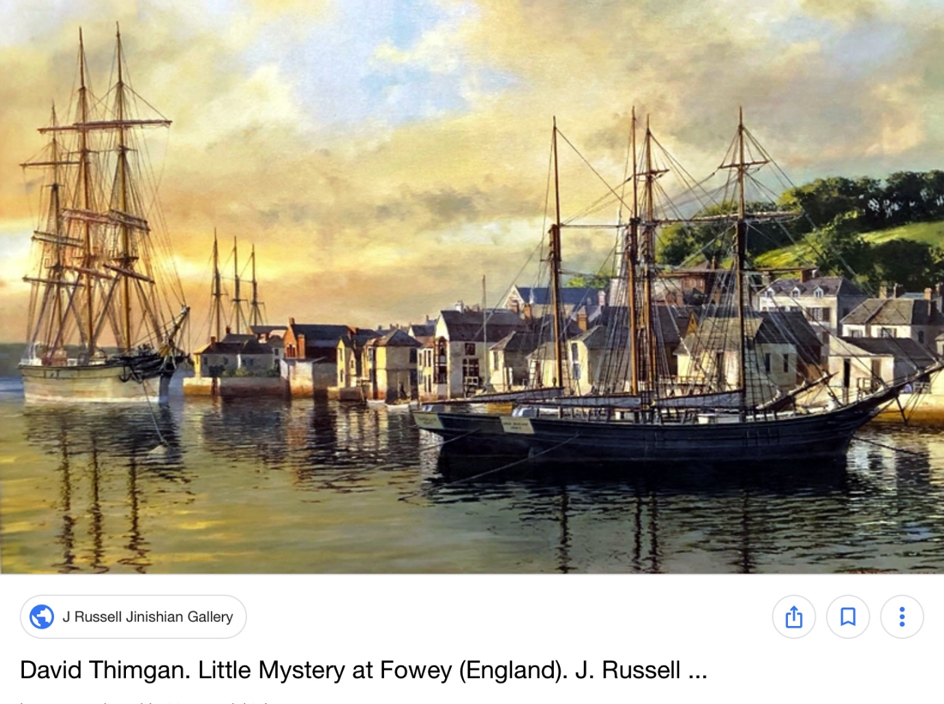

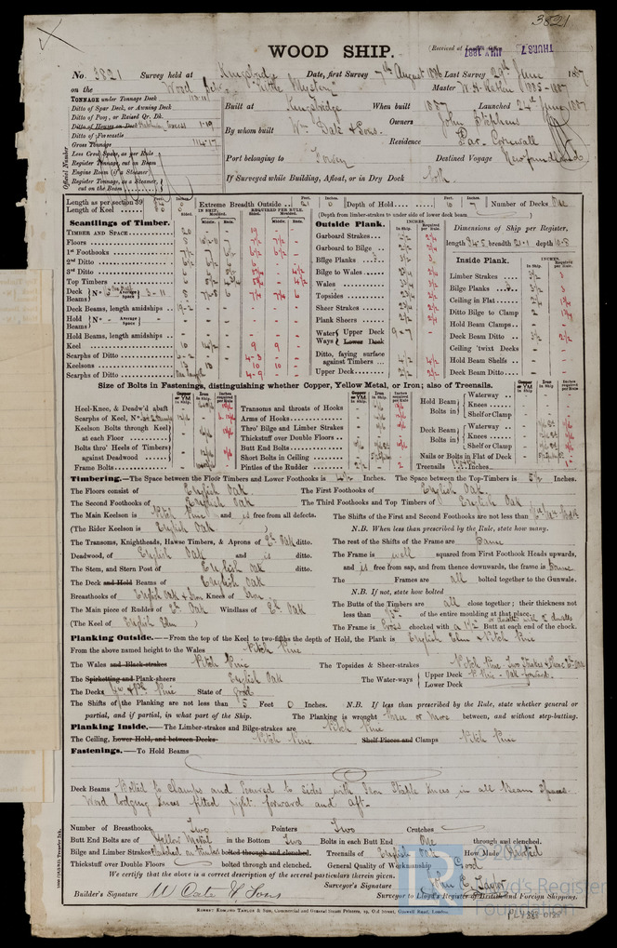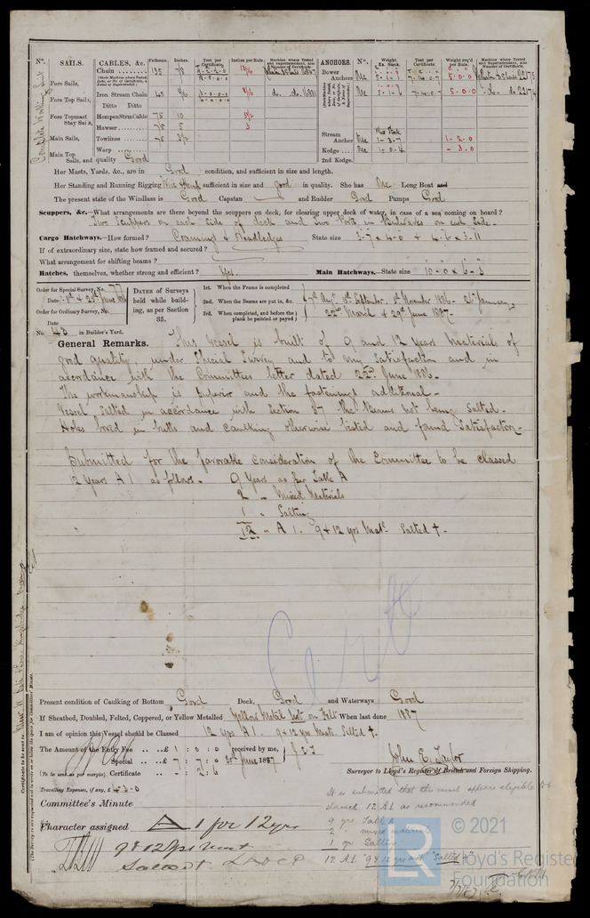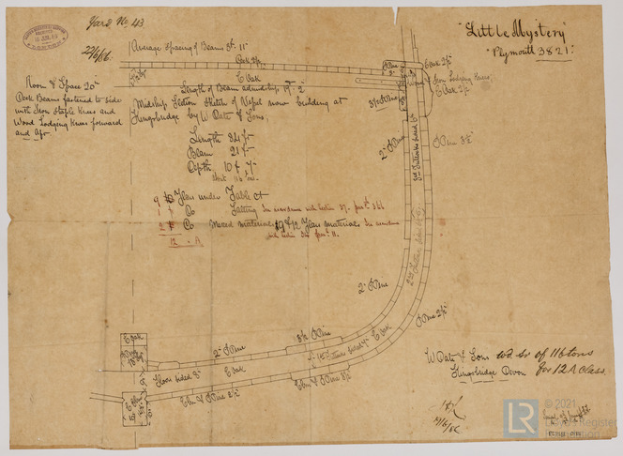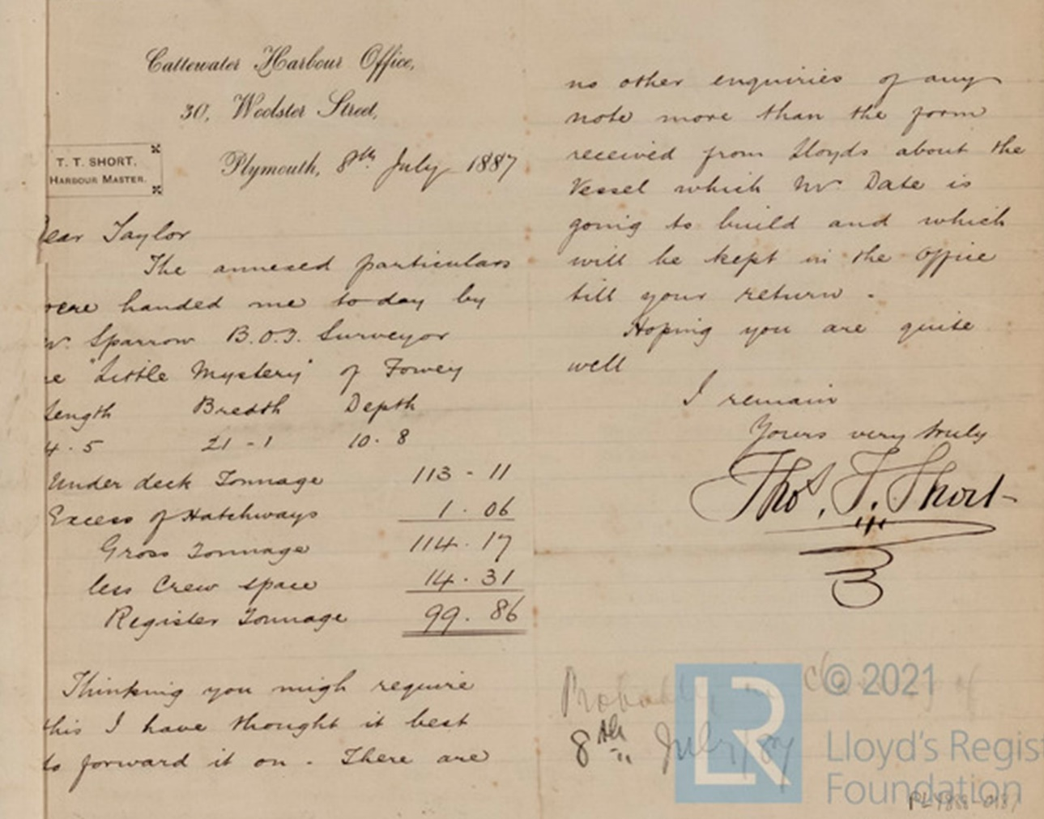
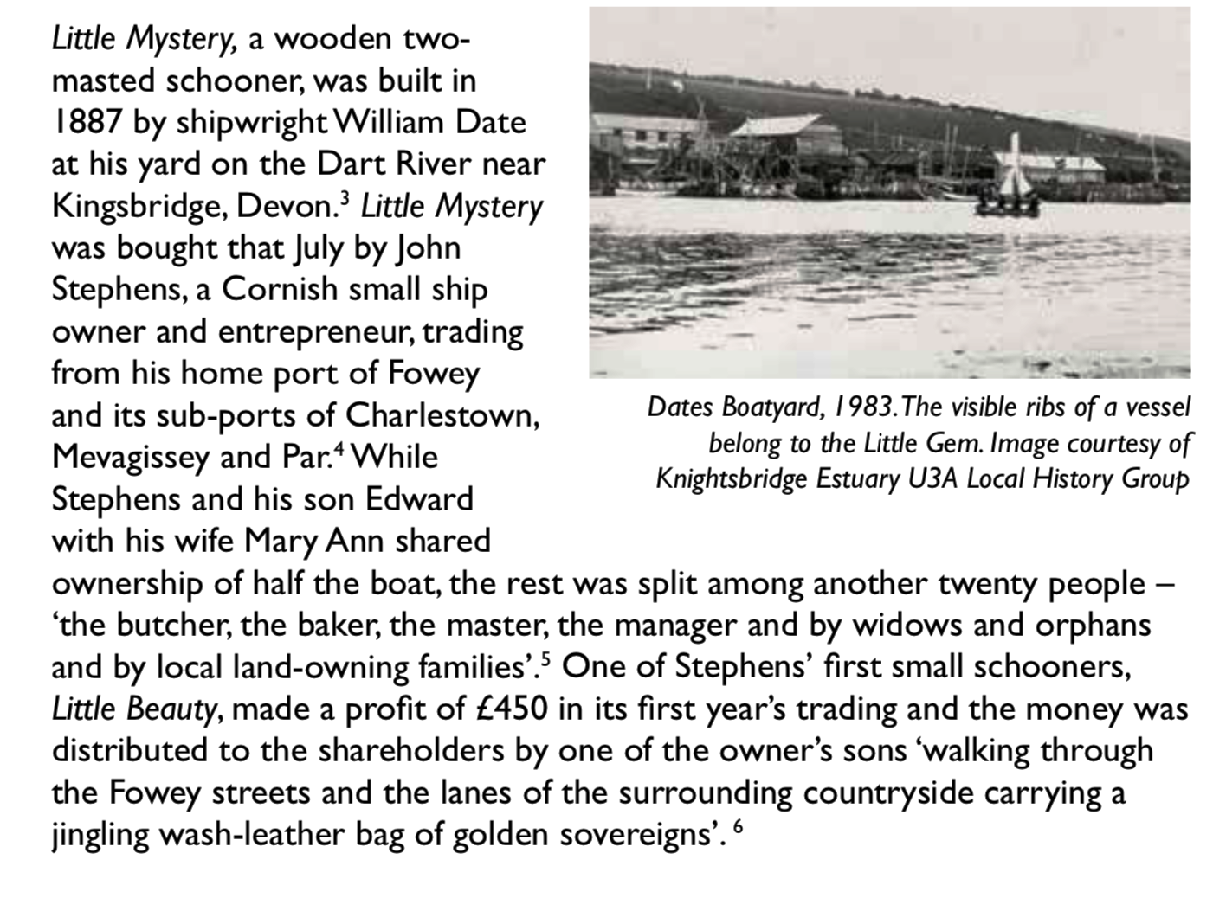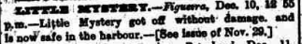
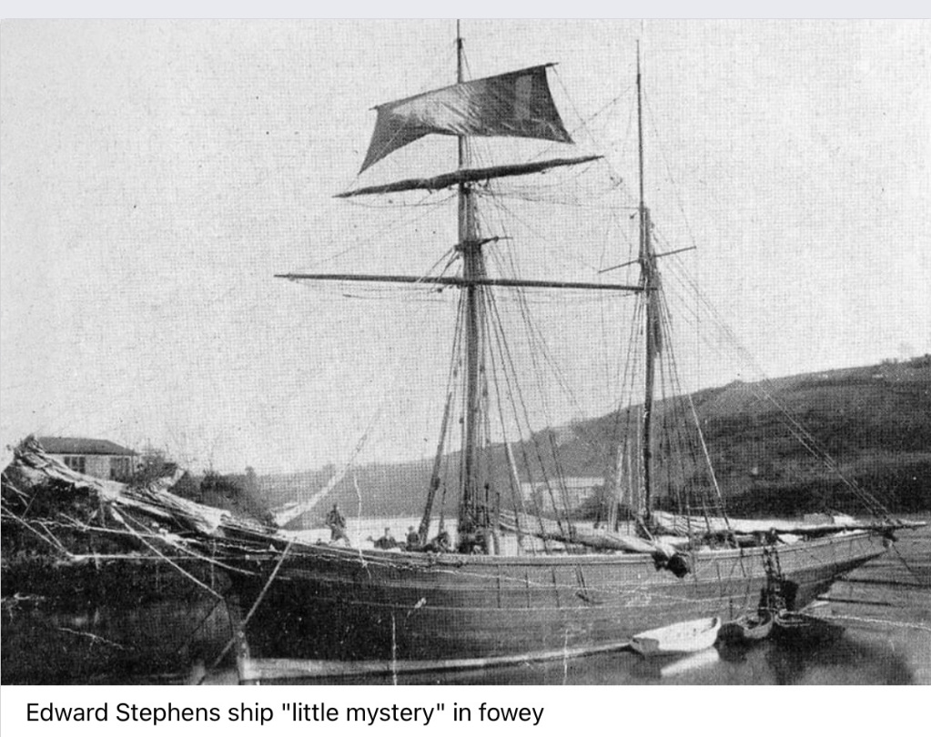
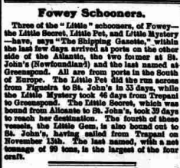

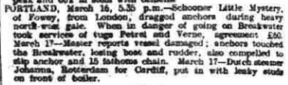
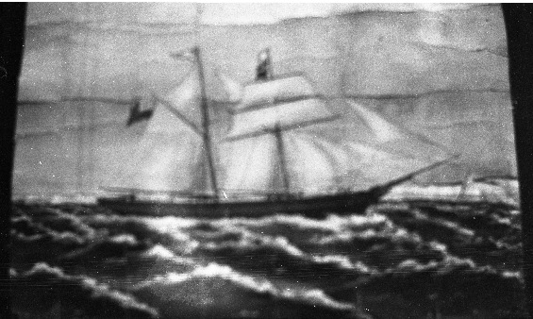
The topsail schooner "Little Mystery", offical number 85828, gross tonnage 100, was built 1887 in Kingbridge, Devon, by W. Date & Sons and registered at Fowey, Cornwall to John Stephens of nearby Par. By 1904 Edward Stephens of Fowey was the registered owner. On April 30, 1917, while on a voyage from Cardiff to Cherbourg with a load of coal, the vessel scuttled by German submarine UC-61, near Portand Bill, Dorset.
Custodial History: | The photographs were owned by Norma Godden, formerly of Harbour Grace, Newfoundland
Little Mystery, built by W. Date & Sons, Kingsbridge in 1887 and owned at the time of her loss by E. Stephens, Fowey, was a British wooden schooner of 114 tons.
On April 30th, 1917, Little Mystery, on a voyage from Cardiff to Cherbourg with a cargo of coal, was scuttled by the German submarine UC-61 (Georg Gerth), approx. 22.5 miles SSE from Portland Bill. There were no casualties.
Both sisterships and wooden schooners of 114 tons, Little Gem and Little Mystery, owned by E. Stephens of Fowey were sunk by German submarines in WWI. Read more at wrecksite: https://www.wrecksite.eu/wreck.aspx?155628

