**Schooner Little Pet**

|  |  |  |  |  |  |  |  |  |  |  |  |  |  |  |  |
| --- | --- | --- | --- | --- | --- | --- | --- | --- | --- | --- | --- | --- | --- | --- | --- |
| **Vessel Name** | **Official Number** | | **Signal letters** | **Rig /Type** | **Where built** | | **Builder** | | **Year built** | | | **Year end** | | **reg tons** | |
| **LITTLE PET**  **ex ZINGARI** | 81035 | | THDL | Schooner | | Fowey | | Albertus Dingle / J.Stepens | | 1880 | | | 1922 | | 75 |
| **OWNERS/ MANAGERS/REGISTRATION DETAILS** | | **Notes** | | | | | | | | | **MASTERS** | | | | | |
| 1890 John Stephens, Par | | LOA 76 x 19.8 x 9.5ft 2 masted with a square stern and male figurehead. Launched 13th March 1880. registered as the Zingari in Plymouth on 15th April for Sparrow of Plymouth . Registered in 1918. 1st April 1903 she sailed into Dundee with sails blown away and top gallant mast and jib boom carried away. She had left Montrose with a cargo of potatoes. She was overtaken by a tidal wave when about 13 miles off St. Ann's Head with a crew man being washed overboard and the damage done. Transferred to Gibraltar Register 7th September 1915. she was then wrecked and sold to M.H.Bland & co her salvors registered after 1922. | | | | | | | | | Hill 1880 Philip Bartlett W.T.Carrivick 1897-1898 P.Mulenburg -1899 Piper 1908 Edwin Cardell 1915 | | | | | |



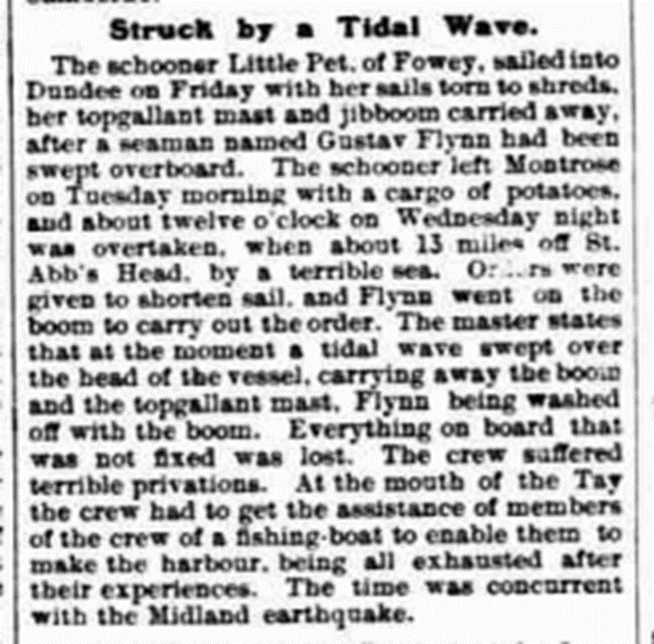

crew list in 1915







. 

