Top sail schooner Maria
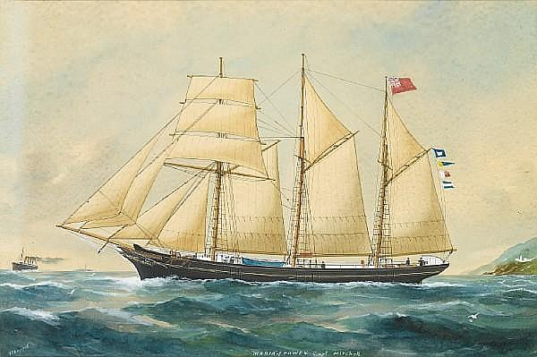
Painting by Reuben Chappell for Captain Mitchell
Vessel Name |  | Official Number |  |  | Signal letters |  | Rig /Type | Where built |  | Builder |  | Year built |  |  | Year end |  | reg tons
MARIA | 49985 |  |  | WGHJ |  | 3 masted Brigantine later topsail schooner |  |  | Hayle |  | Harvey and Co. |  | 1865 |  |  |  |  | 138
OWNERS/ MANAGERS/REGISTRATION DETAILS |  |  | Notes |  |  |  |  |  |  |  |  |  |  | MASTERS
1894. Joseph Cubert ,1895- 1899 Thomas May Junr, Port Isaac (MO) 1900- 1903 Wm J.D.Mutton, Truro (MO)1904- 1918 wm V. Kellow (MO) |  |  | LOA 105.6 x 24.3 x 12.1 ft registered in Hayle 6th December 1865. MARIA, sailing vessel, 175grt, 13 April 1917, 25 miles S by W from Portland Bill, captured by submarine, sunk b |  |  |  |  |  |  |  |  |  |  | S.Harris 1885 T.May 1897-1898 R. Mitchell 1913 W.V.Kellow and W.M.Lewis 1915

