Brig /topsail schooner MARTHA EDMONDS
Vessel Name | Official Number |  | Signal letters | Rig /Type | Where built |  | Builder |  | Year built |  |  | Year end |  | reg tons
MARTHA EDMOND | 60768 |  | LWNR | built as Brig converted 3 masted topsail schooner in 1901. |  | Milford |  | Jones |  | 1873 |  |  | 1915 |  | 183
OWNERS/ MANAGERS/REGISTRATION DETAILS |  | Notes |  |  |  |  |  |  |  |  | MASTERS
registered in Fowey no 8 1878/ 1879 James Clunes, Fowey 1890 Edward Rillston,Fowey (MO) 1910 Edward Stephens, Fowey (MO) |  | LOA 102.7 x 23 x 12.8. ft Previously registered in Llanelly on 28th May 1873.elliptic stern woman bust; figurehead became 3 masted schooner. 27th July 1897 she ran aground AT Porthoustock in thick fog. in getting off she hit rocks and damaged her keel. She was towed into Falmouth by the tug Eagle and then back to Fowey to discharge cargo and be repaired. she had been on passage from Fowey to for Leghorn. . 27 July 1900. Ran aground on the Goodwins 21st November 1902. Crew got to lightship tug and lifeboat attended. On August 20th, 1915, Martha Edmonds, a British sailing vessel of 162 tons, was sunk by gunfire by the German submarine U-38 (Max Valentiner), 62 miles WNW from Ushant (Ouessant) when on route from Rouen for Seville with a cargo of silversand. |  |  |  |  |  |  |  |  | J.Dully 1889 W.J.Bartley 1894 -95 R.Pilcher 1897 C.Lynch 1898 George Beynon 1902-1915
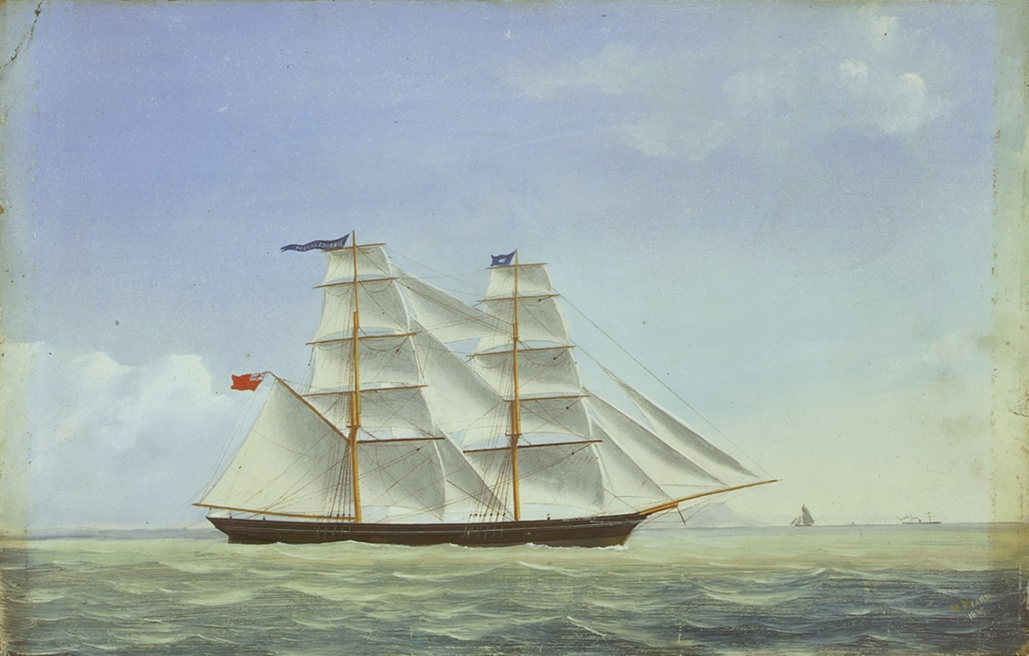
As a brigantine By W Pearn,

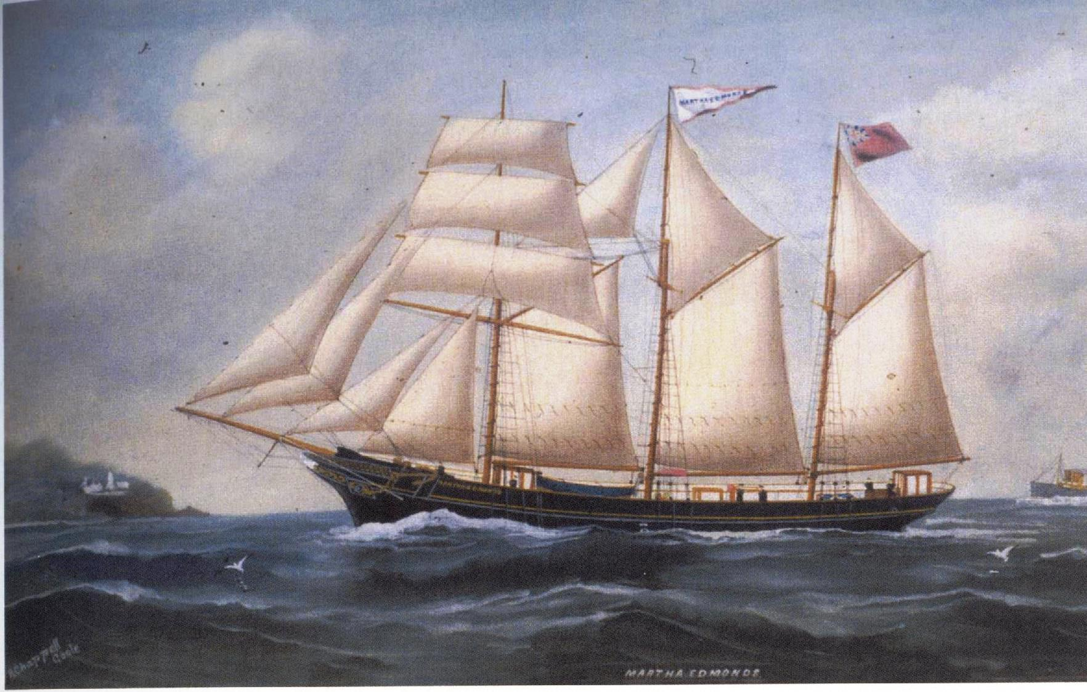

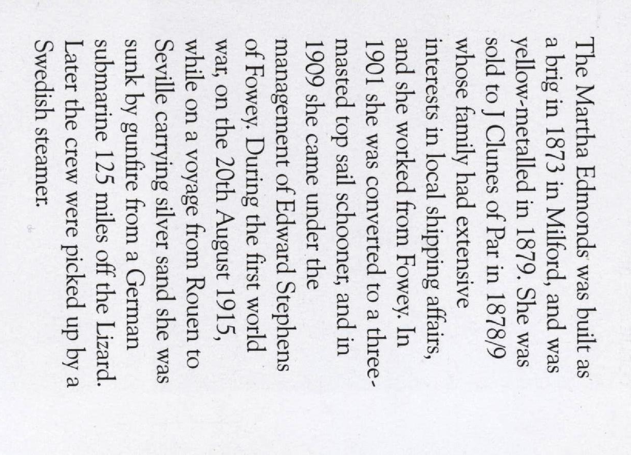
she was yellow metaled to prevent marine growth in 1879 probably because she may have been used to trade into tropical waters. In 1901 she was converted to a 3 masted topsail schooner.
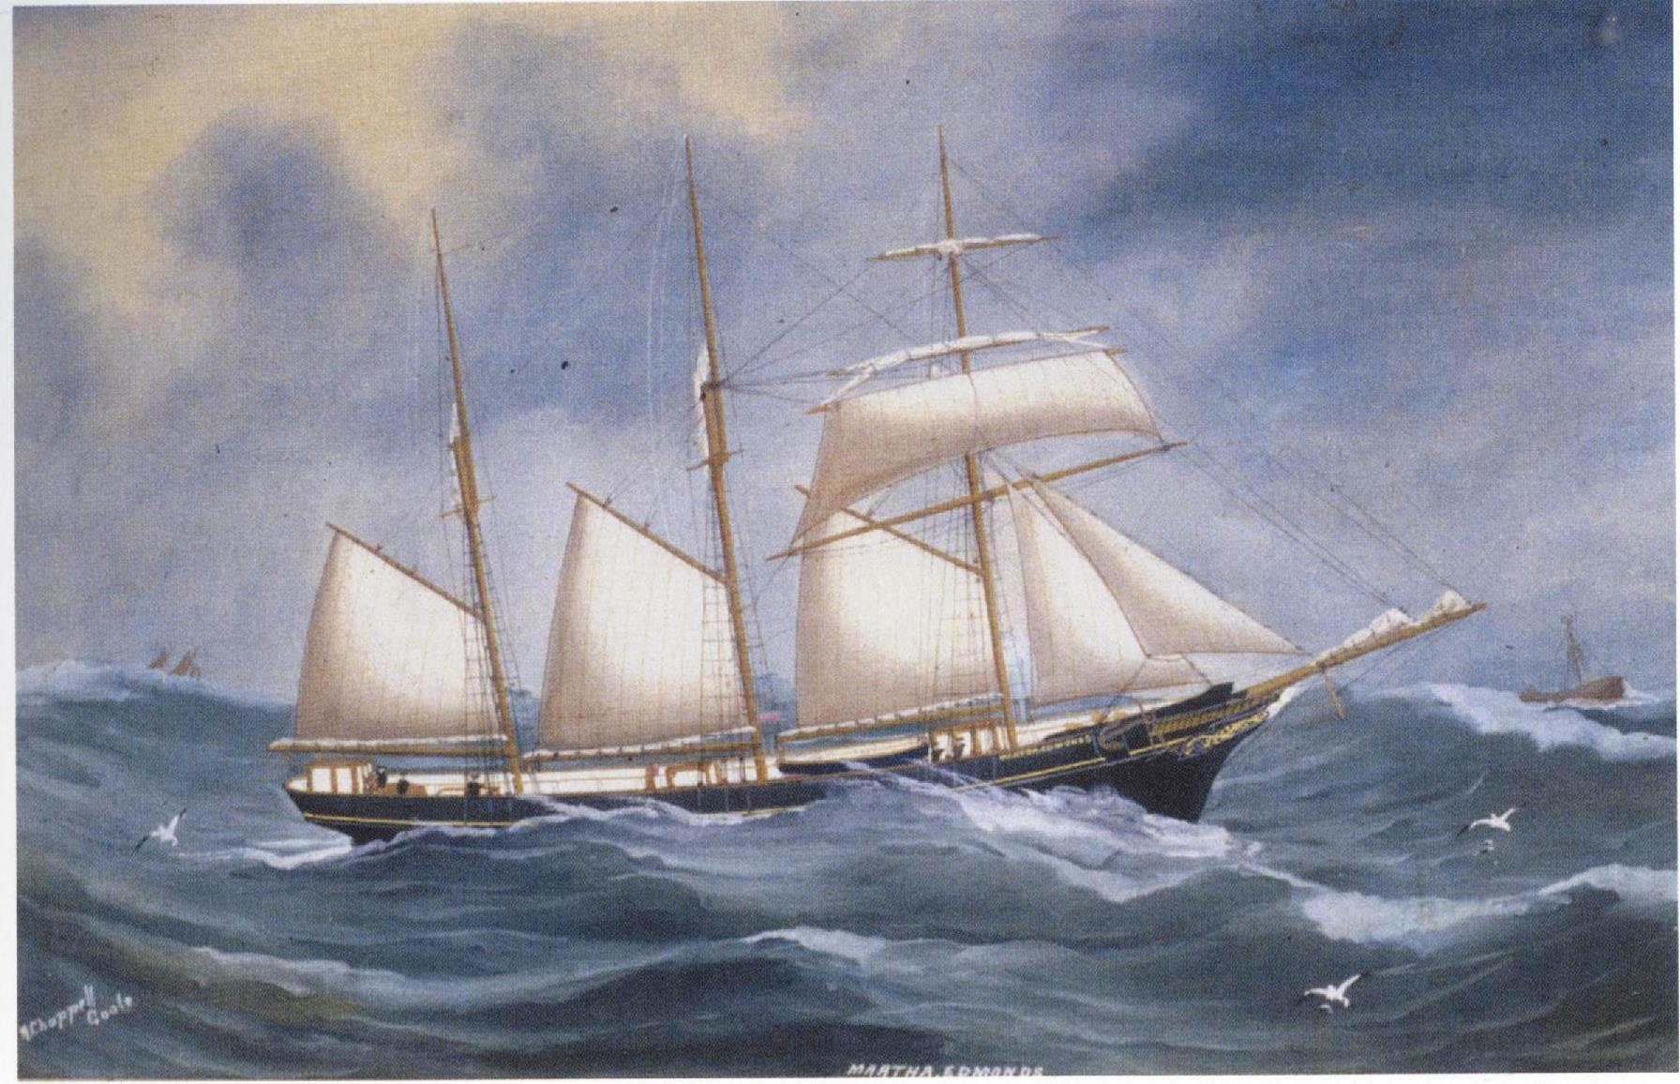

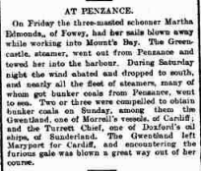
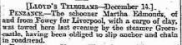
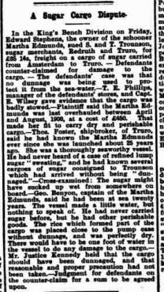
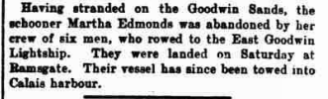

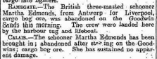

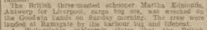

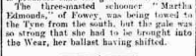
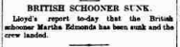

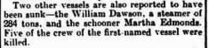

Ships hit during WWI

Martha Edmonds
Name | Martha Edmonds
Type | Sailing vessel
GRT | 182 tons
Country | British
Built | 1873
Builder | Jones, Milford
Operator | Annie Stephens, Fowey
History | Wooden three-masted schooner.

U-boat attacks on Sailing vessel Martha Edmonds
 | Date | U-boat | Loss type | Position | Location | Route | Cargo | Casualties
1 | 20 Aug 1915 | U 38 (Max Valentiner) | Sunk | Stopped and sunk 62 miles WNW of Ushant |  | Rouen - Seville | silversand | 0

All her crew were picked up by a Swedish vessel.
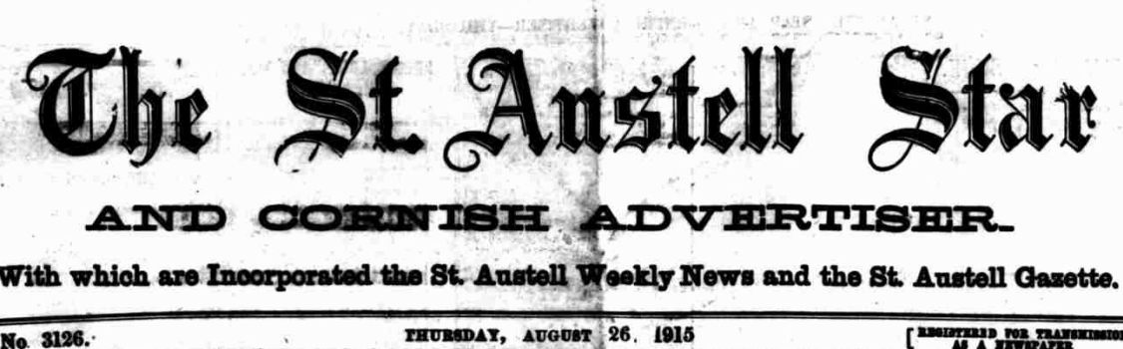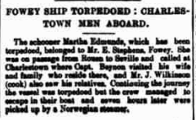
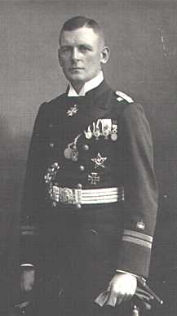
Max Valentiner
Kapitänleutnant

Crew list 1915
MARTHA EDMONDS; Official number: 60768.
George Beynon; rank/rating, Master; age, 45; place of birth, British; previous ship, Martha Edmond. John Wickman; rank/rating, Mate; age, 30; place of birth, Riga; previous ship, Martha Edmond. James McCready; rank/rating, Able Seaman; age, 34; place of birth, Hobart, Tasmania, Australia; previous ship, ?
Joseph Wilkinson; rank/rating, Cook; age, 17; place of birth, Charlestown; previous ship, first ship. William Morgan; rank/rating, Able Seaman; age, 40; place of birth, Swansea; previous ship, Ocean Swell.
Julius Hansen; rank/rating, Able Seaman; age, 21; place of birth, Copenhagen; previous ship, Loydes of Denmark.
Robert Gadilhe; rank/rating, Able Seaman; age, 21; place of birth, Riga; previous ship, Mary of Russia.

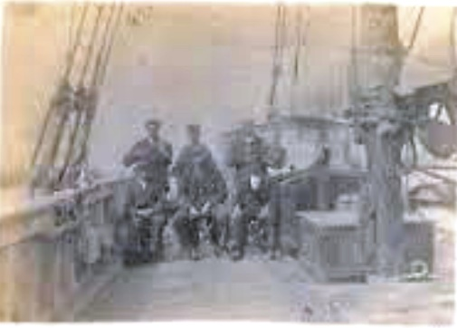

Her crew 1904 in Charlestown

George Beynon was her Master

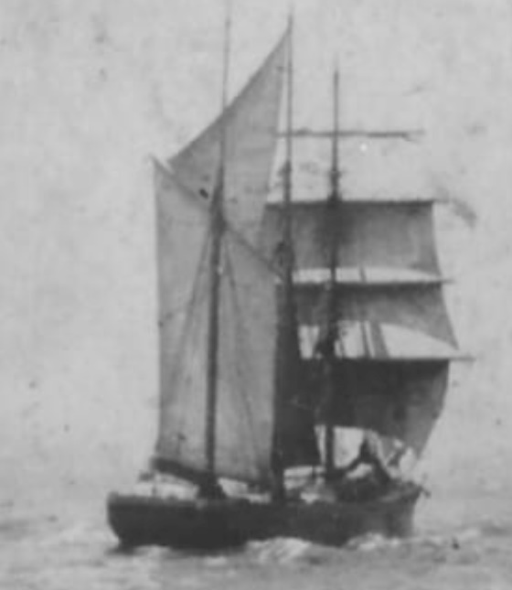

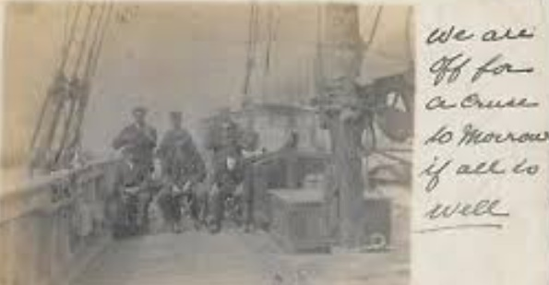

On August 20th, 1915, Martha Edmonds, a British sailing vessel of 162 tons, was sunk by gunfire by the German submarine U-38 (Max Valentiner), 62 miles WNW from Ushant (Ouessant) Calculated as '62 mile W N W [292.5°] from Ushant, Île d'Ouessant'. Read more at wrecksite: when on route from Rouen for Seville with a cargo of silversand. Read more at wrecksite:
https://www.wrecksite.eu/wreck.aspx?129021
