**Schooner Natal**

|  |  |  |  |  |  |  |  |  |  |  |  |  |  |  |  |
| --- | --- | --- | --- | --- | --- | --- | --- | --- | --- | --- | --- | --- | --- | --- | --- |
| **Vessel Name** | **Official Number** | | **Signal letters** | **Rig /Type** | **Where built** | | **Builder** | | **Year built** | | | **Year end** | | **reg tons** | |
| **NATAL** | 43936 | | TRCB | 3 masted Schooner | | Alloa | | Adamson | | 1861 | | | 1897 | | 189/ 214 |
| **OWNERS/ MANAGERS/REGISTRATION DETAILS** | | **Notes** | | | | | | | | | **MASTERS** | | | | | |
| 1877 William Stephens, Par1890 Thomas Pellow,Bodmin (MO) 1896 Mrs A. Pellow,Bodmin (MO) | | LOA 123.2 x 23.8 x 13.9 ft. Registered in London 1861. 1876 registered in PLYMOUTH. 30th November 1893 the tug Gallant from Fowey arrived in Cowes to bunker coal whilst towing the Natal from Le Havre back to Fowey with her cargo of China clay after she had been badly damaged in the recent gales. She had been bound for Leith. lost at St.Pol near Dunkirk on 25th January 1897 west of the port with cargo of china clay for Dunkirk. all saved. | | | | | | | | | William.Couch 1879-1895 Luke 1889 and 1893 Langmaid 1896-97 Wm.Couch 1897 | | | | | |

**1887**

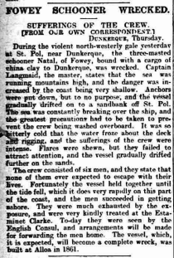

The British schooner Natal carrying china clay from Fowey to Dunkirk was wrecked west of Dunkirk harbour 0n 26/01/1897

Read more at wrecksite: <https://wrecksite.eu/wreck.aspx?304795>