s.s.NORMA
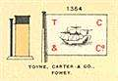
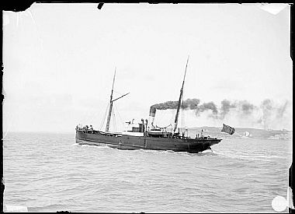
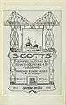
Vessel Name | Official Number |  | Signal letters | Rig /Type | Where built |  | Builder |  | Year built |  |  | Year end |  | reg tons
NORMA | 67822 |  | RCDH | Steamship |  | Greenock |  | J. E. Scott, Greenock (17) |  | 1877 |  |  | 1902 |  | 513
OWNERS/ MANAGERS/REGISTRATION DETAILS |  | Notes |  |  |  |  |  |  |  |  | MASTERS
1899 The Fowey No 3.Steamship Co Charles L.Toyne |  | 174.4 x 26.5 x 12.2 ft. registered in Goole 30th June 1877. Previously owned by Humber Steamship Co, Goole. Captain John Tasker. In 1881 registered in Goole. Harris Bros and Co 28/01/1902 abandoned off Trevose Head and sank off Lands’ End on passage from Newport for Fowey with coal. She encountered terrible weather in the Bristol Channel and listed right over to port, and showed signs of sinking. Trevose Head was bearing SSE at 12 miles. The crew of eleven got into the, lifeboat, and after three-quarters of a hour were picked up by the French steamer Racine and landed at Newlyn |  |  |  |  |  |  |  |  | Tasker 1874 H.T.Thomas 1897-98 J.Hughes 1899- 1900 Williams 1901

Built | 1877
Type | Cargo ship
Tonnages | 490 grt, 322 nrt
Dimensions | 174.4 x 26.5 x 12.2 ft
Shipbuilder (yard number) | J. E. Scott, Greenock (17)
Engine builder | Kincaid, Donald & Co., Greenock
Engine | Compound 2cyl (24, 42 x 33in), 86nhp
O.N. | 67822
Owners | 1877 Humber Steam Shipping Company, Goole
 | 1895 Goole Steam Shipping Company
 | 1895 Harries Bros. & Co., Goole
 | 27/04/1866 transferred to Fowey register
 | 1899 Fowey (No.3) Steam Shipping Co. (Toyne, Carter & Co.), Fowey.
Fate | 28/01/1902 sank off Lands’ End on passage from Newport for Fowey with coal

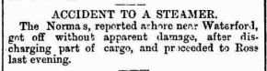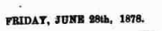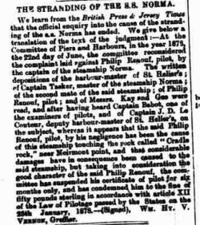
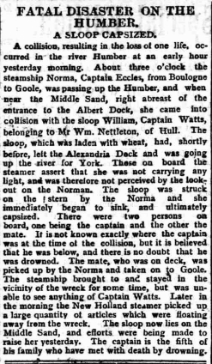

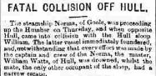
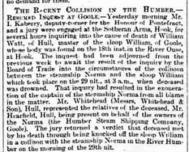

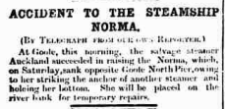

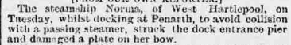

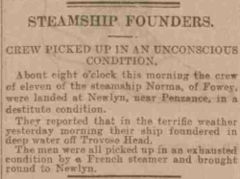

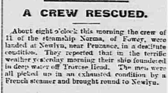

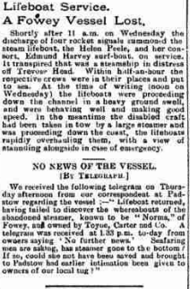
Wreck position 50.02 N 5.44 w off Lands end
The British steamer Norma was a coaster of 507 tons, built in 1877 and owned by Toyne, Carter & Co., Fowey. She foundered, off the Longships, Lands End, United Kingdom on 28th January 1902 when on route from Newport for Fowey with a cargo of coal.
Read more at wrecksite: https://wrecksite.eu/wreck.aspx?165969
Nationality: british purpose: transport type: cargo ship subtype/class: coastal cargo ship class propulsion: steam date built: 1877 details tonnage: 513 grt dimensions: 53.2 x 8.1 x 3.7 m material: iron engine: 1 x 2 cyl. compound engine, single shaft, 1 screw power: 86 n.h.p. yard no.: 17 IMO/Off. no.: 67822 about the loss cause lost: foundered date lost: 28/01/1902 [dd/mm/yyyy] about people builder: Scott Shipbuilding & Engineering Co. - John & Robert Scott, Greenock engine by: Kincaid Donald, Greenock last owner: [1] Toyne, Carter & Co., Fowey (Cornwall) SS Norma (+1902) period 1899 ~ 1902 IMO/Off. no.: 67822 prev. owners: [2] Harries Bros. & Co., Swansea SS Norma period 1895 ~ 1899 IMO/Off. no.: 67822 [3] Goole Steam Shipping Co., Goole SS Norma period 1895 ~ 1895 IMO/Off. no.: 67822 [4] Humber S. S. Co, Goole SS Norma period 1877 ~ 1895 IMO/Off. no.: 67822 Read more at wrecksite: https://wrecksite.eu/wreck.aspx?165969

