Barquentine Ocean Ranger

Vessel Name | Official Number |  | Signal letters | Rig /Type | Where built |  | Builder |  | Year built |  |  | Year end |  | reg tons
OCEAN RANGER | 73259 |  | WTNF | 3masted Brigantine |  | Appledore, Devon |  | Cook |  | 1875 |  |  | 1916 |  | 268
OWNERS/ MANAGERS/REGISTRATION DETAILS |  | Notes |  |  |  |  |  |  |  |  | MASTERS
Registered in Fowey 17th December 1875. John Henry Hocken, Fowey. 1892 John Edward Hocken, Polruan(MO). 1909 David W. Davies 59 Coupkland st. Manchester (MO) 1915 Pritchard brother Portmadoc. |  | LOA 125 x 25.1 x13.9ft. Built with iron beams. Sold in 1904 for £1100 to Manchester mariner register closed 1916 . Went to Cape Province, Natal, Mauritius, Port Adelaide and New Zealand |  |  |  |  |  |  |  |  | W.Hocken 1876- 89 A.Mitchell 1897 A.D.Piper 1893-1904 D.W. Davis 1905-1915

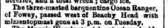

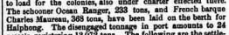

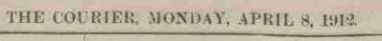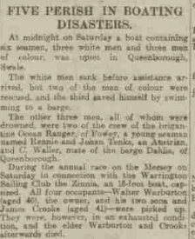

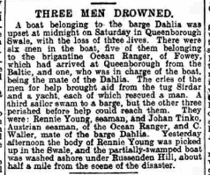

Ship: Ocean Ranger; Official number: 73259. 1915

D Davies; rank/rating, Master; age, 55; place of birth, Carnarvon; previous ship, same.

Thomas Jones; rank/rating, Mate; age, 50; place of birth, Tremadoc; previous ship, William Pritchard of Carnarvon.

Peter Tiller; rank/rating, Boatswain; age, 28; place of birth, Riga; previous ship, Emily Millington of Runcorn.

John Williams; rank/rating, Cook; age, 39; place of birth, Harlech; previous ship, same.

Thomas Butcher; rank/rating, Seaman; age, 38; place of birth, Ipswich; previous ship, same.

Edward Owens; rank/rating, Seaman; age, 36; place of birth, Liverpool; previous ship, same.

Lewis Williams; rank/rating, Ordinary Seaman; age, 17; place of birth, Portmadoc; previous ship, Robert Morris of Carnarvon.

F Holmquist; rank/rating, Able Seaman; age, 36; place of birth, Malmo, Sweden; previous ship, Robert Eggleton of Sunderland.

James William Tose; rank/rating, Cook and Steward; age, 40; place of birth, Barbados; previous ship, Jamaica.
