Brigantine Ocean Swell

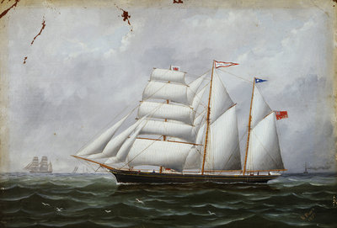
A ship’s portrait of the barquentine 'Ocean Swell' under full sail in port-broadside view. The ship's name is on the pennant at the mainmast head. There is a Union Jack with a white border at the head of the fore-upper-topgallant, which from 1823 was used as a signal for requesting a pilot. The blue and white triangular pennant at the mizzen is the '2nd' pennant in the Marryat code. Three figures are visible on the deck and the schooner is shown with other shipping in the distance, including a steam ship on the right, the smoke from which trails over the right of the image. A barque, lugger and brigantine can be seen to the left in the distance.the right, the smoke from which trails over the right of the image.

Vessel Name | Official Number |  | Signal letters | Rig /Type | Where built |  | Builder |  | Year built |  |  | Year end |  | reg tons
OCEAN SWELL | 73256 |  | NWVG | 3 masted Brigantine |  | Fowey |  | John Stephens |  | 1875 |  |  | 1917 |  | 187
OWNERS/ MANAGERS/REGISTRATION DETAILS |  | Notes |  |  |  |  |  |  |  |  | MASTERS
registered in Fowey 23rd June 1872.1872 T.Hocking Polruan. 1875 William Smith, Polruan, 1890 George H. Bate,Fowey(MO) 1892 Edward Rillston,Fowey(MO) 1900 Edward Stephens, Par (MO) 1904 Edward E.Hocken,Fowey (MO) 1911 Edward Stephens, Par (MO) |  | LOA 111.4' x 24.4' x 12.9' 3 mast square stern with 3/4 women figure head. Launched on the 2nd July 1875 by Mrs Joshua Rundle wife of her master. Charles Henry Deacon Master under Stephens ownership .28th November 1893 run into by trawler H193 of Whitby. Her starboard quarter was damaged, and she put into Newhaven. She was carrying a cargo of chalk from London to Newcastle. On the 5th July 1917, en route from Granville for Fowey with a cargo of wooden hoops she was captured by German submarine UB-31 (Captained by Thomas Bieber), and sunk by gunfire when 15 miles SE from Start Point, Devon. There were no casualties, the crew being taken on board the U-Boat before the Ocean Swell was sunk. |  |  |  |  |  |  |  |  | Charles Henry Deacon 1875 Joseph Rundle 1875 Abbott 1881 W.Hocken 1883 G.Dobson 1889 W.J.Gully 1894 A .Rilliston 1897 W.J.Bowman 1909 Charles Henry Deacon 1899- 1917

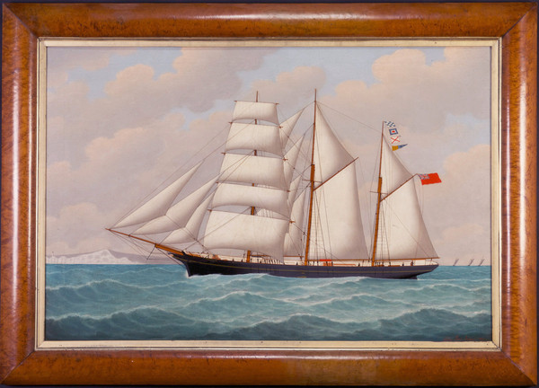
Ocean Swell by 'John Loos 1900'
Description A portrait of the barquentine Ocean Swell, painted oil on canvas and within a fine maple veneered frame of the period. Signed and dated by the artist. Ocean Swell, a British sailing ship of 195 tons, was built by Stephen of Fowey in 1875 and at the time of her loss was still owned by them.
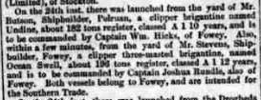
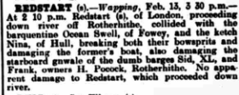
On the 5th July 1917, en-route from Granville for Fowey with a cargo of wooden hoops she was captured by German submarine UB-31 (Captained by Thomas Bieber), and sunk by gunfire when 15 miles SE from Start Point, Devon. There were no casualties, the crew being taken on board the U-Boat before the Ocean Swell was sunk.
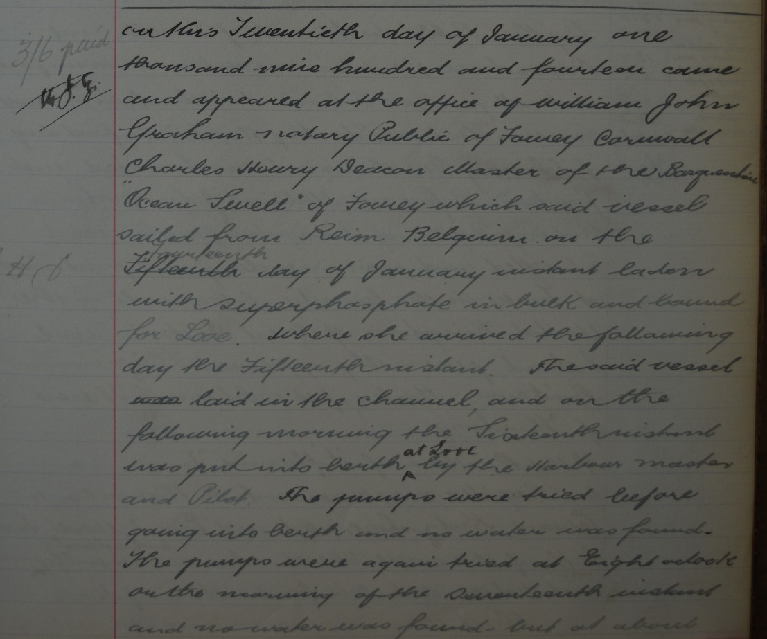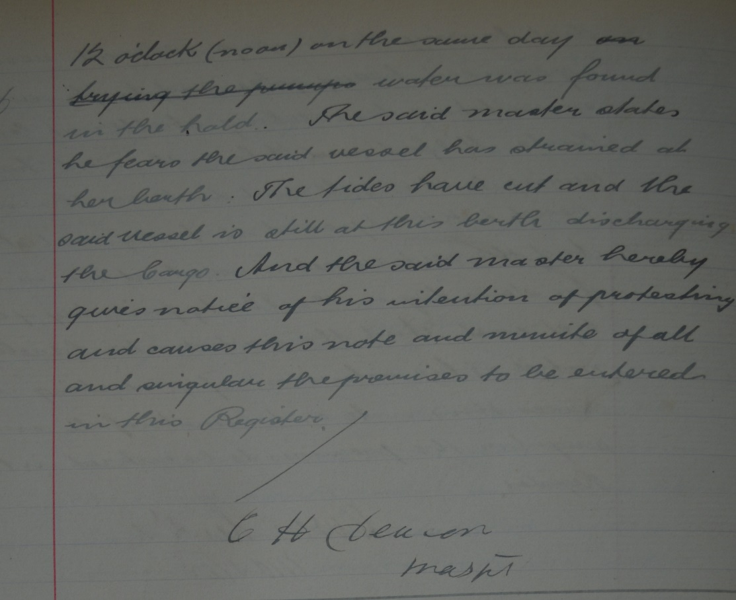
Crew list 1915
C H Deacon; rank/rating, Master; age, 40; place of birth, Devon; previous ship, same.
Alfred Dunn; rank/rating, Mate; age, 40; place of birth, Jersey; previous ship, same.
Adolphus Adams; rank/rating, Able Seaman; age, 24; place of birth, Charlestown; previous ship, same.
Thomas Shabley; rank/rating, Cook; age, 60; place of birth, Probus; previous ship, same.
Walter Fido; rank/rating, Able Seaman; age, 26; place of birth, Corsham; previous ship, Martha Edmonds of Fowey.
Rupert Harvey; rank/rating, Able Seaman; age, 25; place of birth, Todmorden; previous ship, Julia of Lancaster.
James Breen; rank/rating, Able Seaman; age, 23; place of birth, Kingston; previous ship, Theory of Belfast.

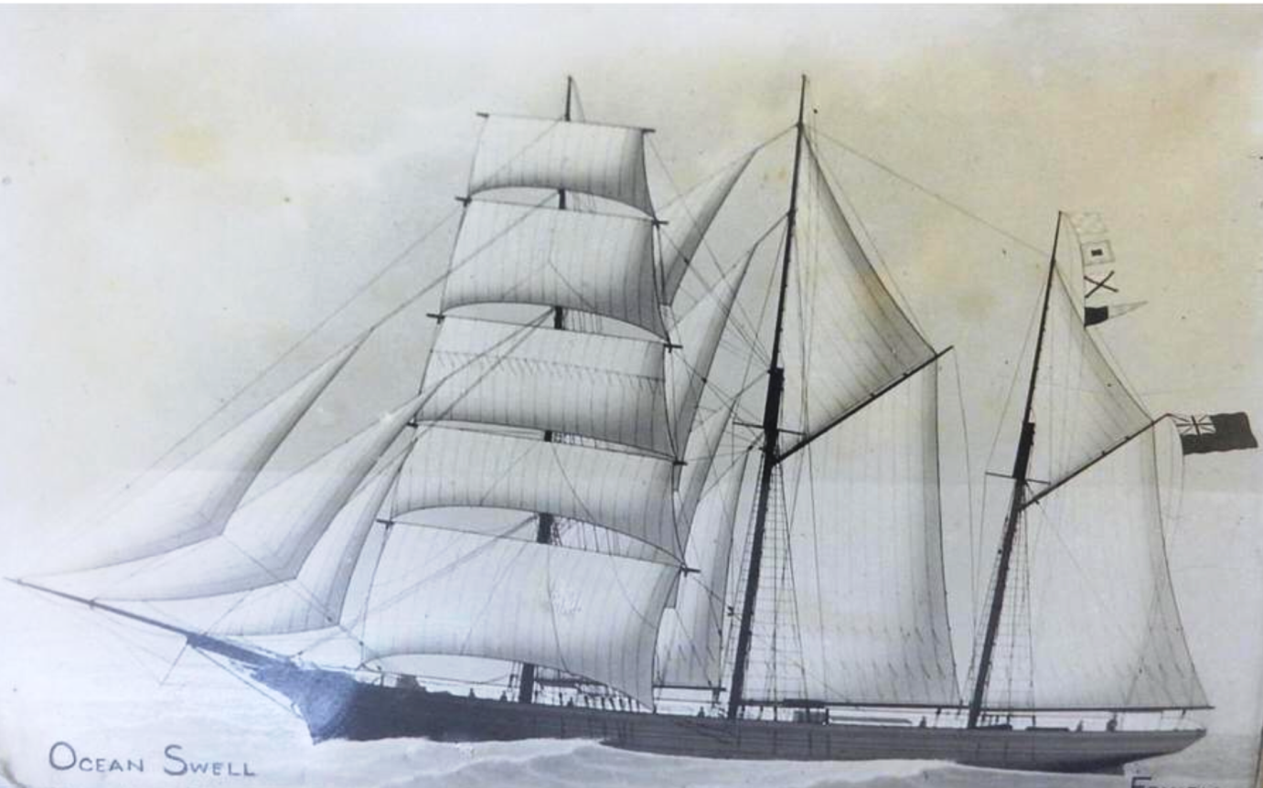

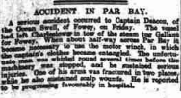

Ships hit during WWI

Ocean Swell
Name | Ocean Swell
Type | Sailing vessel
GRT | 195 tons
Country | British
Built | 1875
Builder | Stephen, Fowey
Operator | E. Stephens, Fowey
History | Wooden barkentine.

U-boat attacks on Sailing vessel Ocean Swell
 | Date | U-boat | Loss type | Position | Location | Route | Cargo | Casualties
1 | 5 Jul 1917 | UB 31 (Thomas Bieber) | Sunk | Stopped and sunk by gunnery 15 miles SE of Start Point |  | Granville - Fowey | wooden hoops | 0
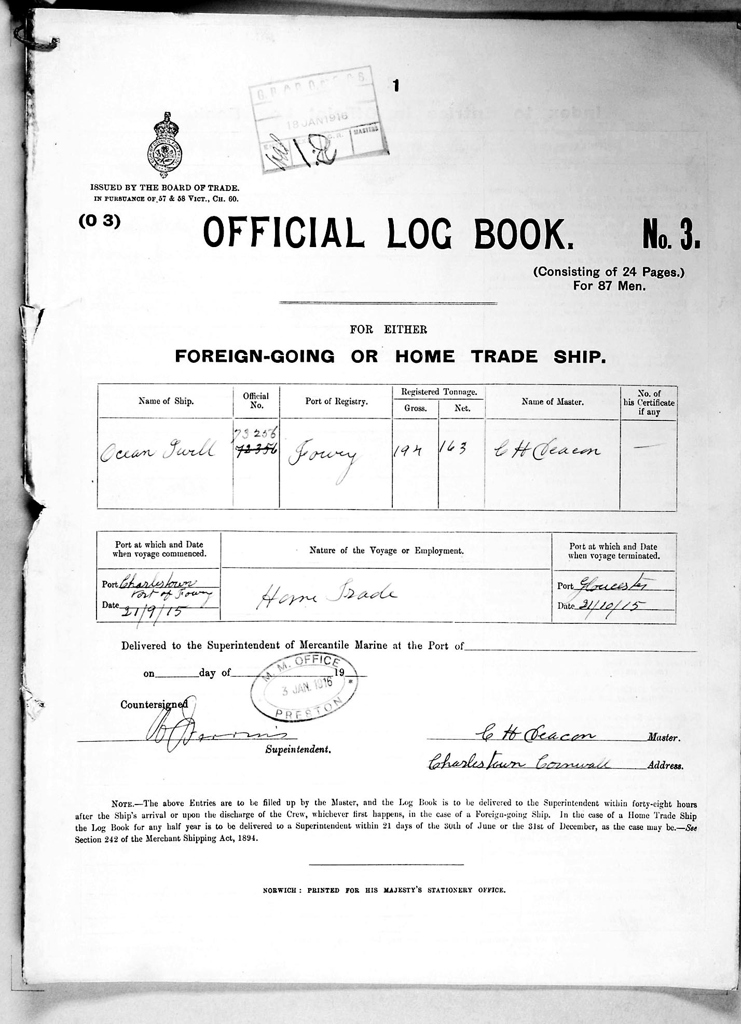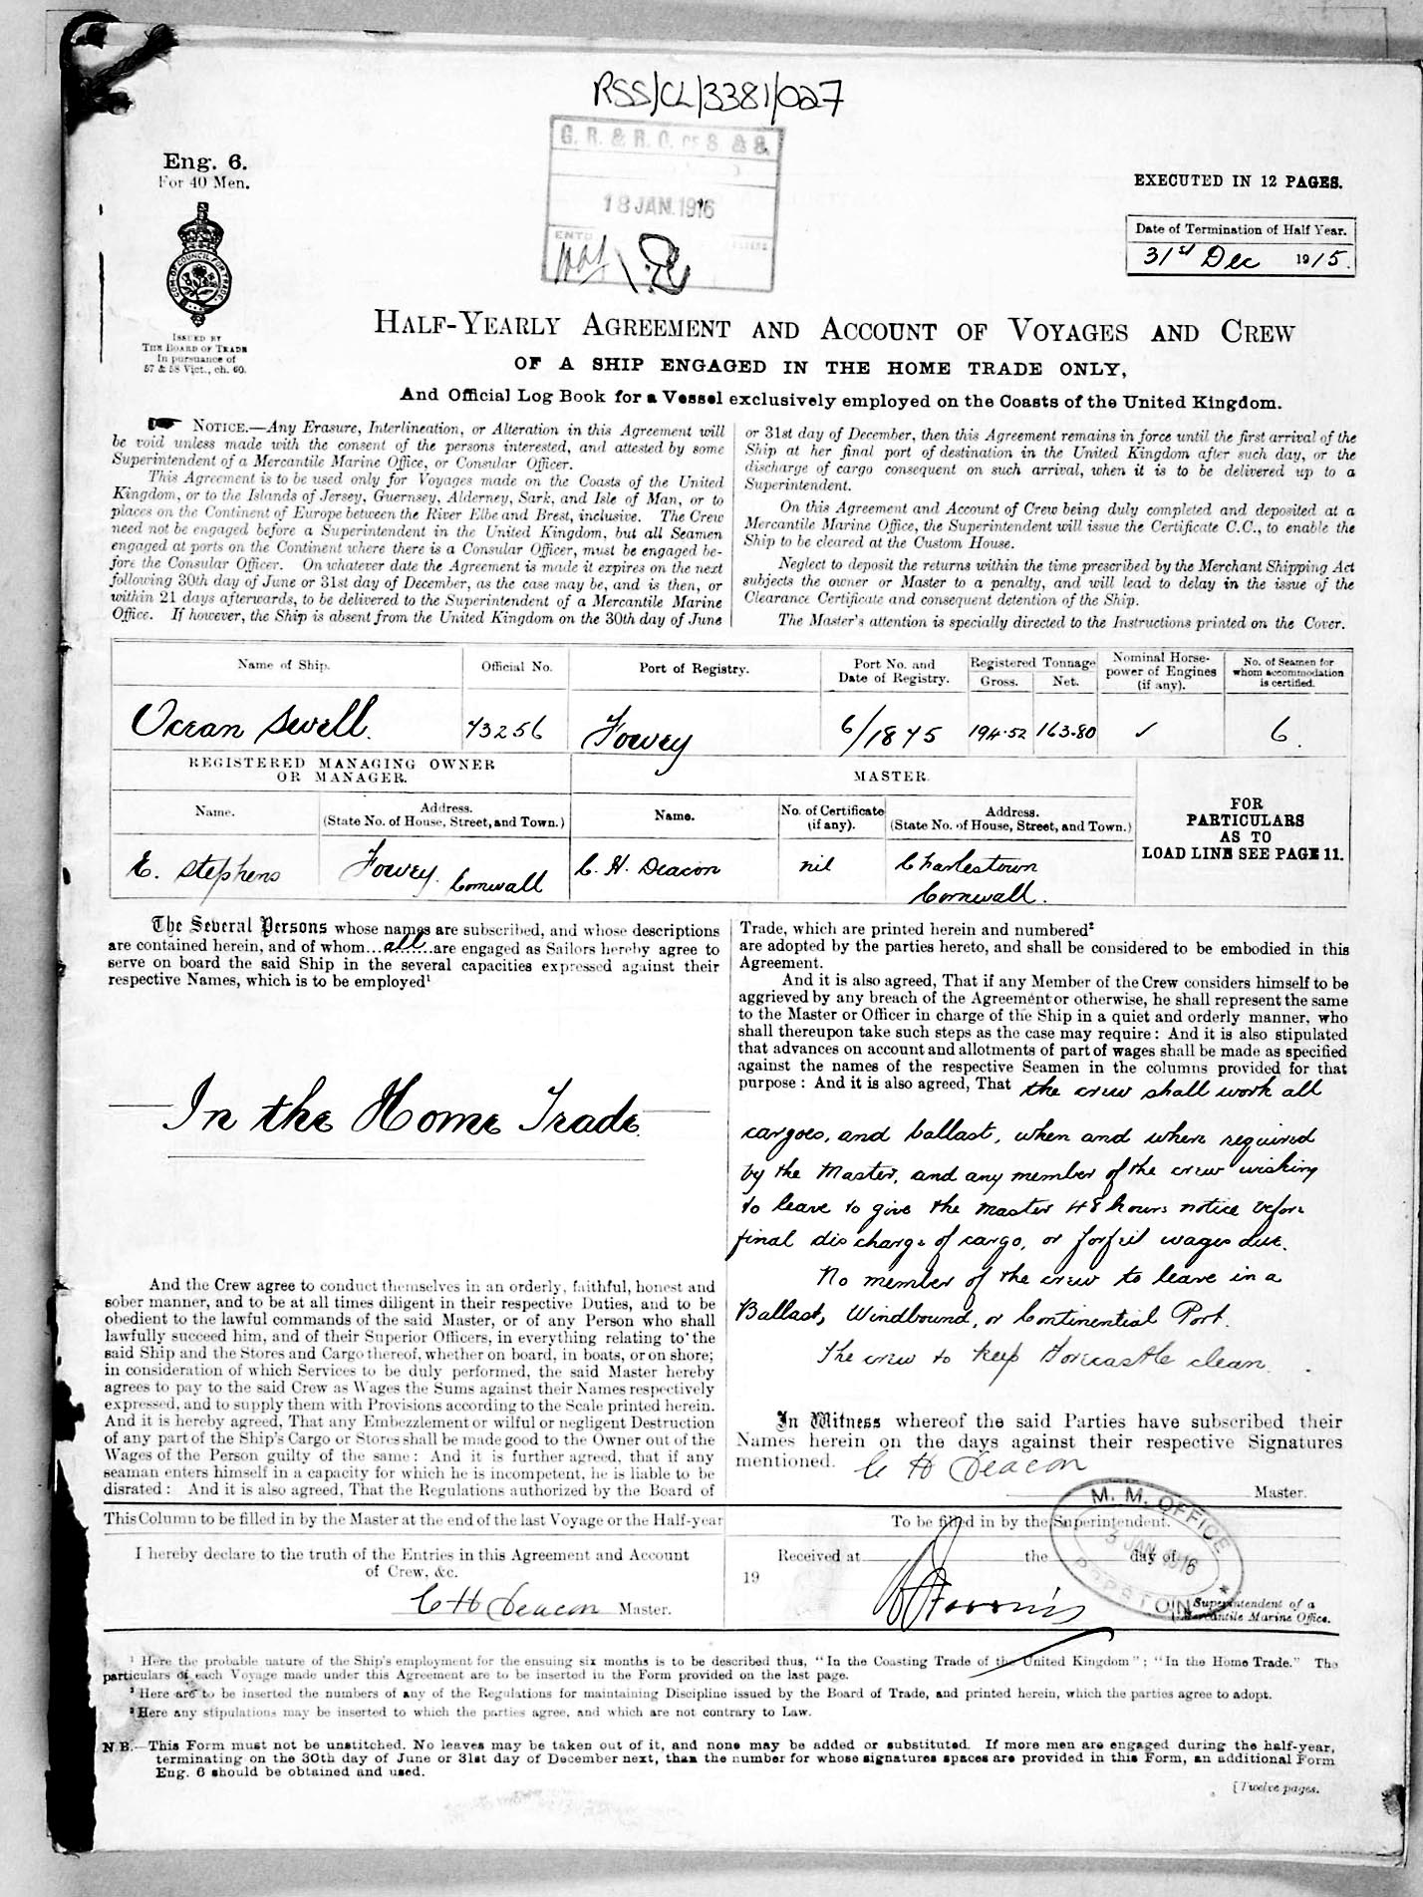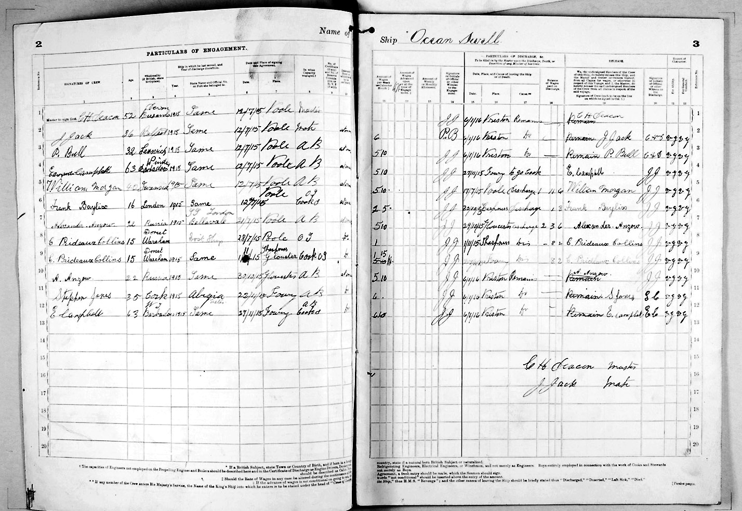

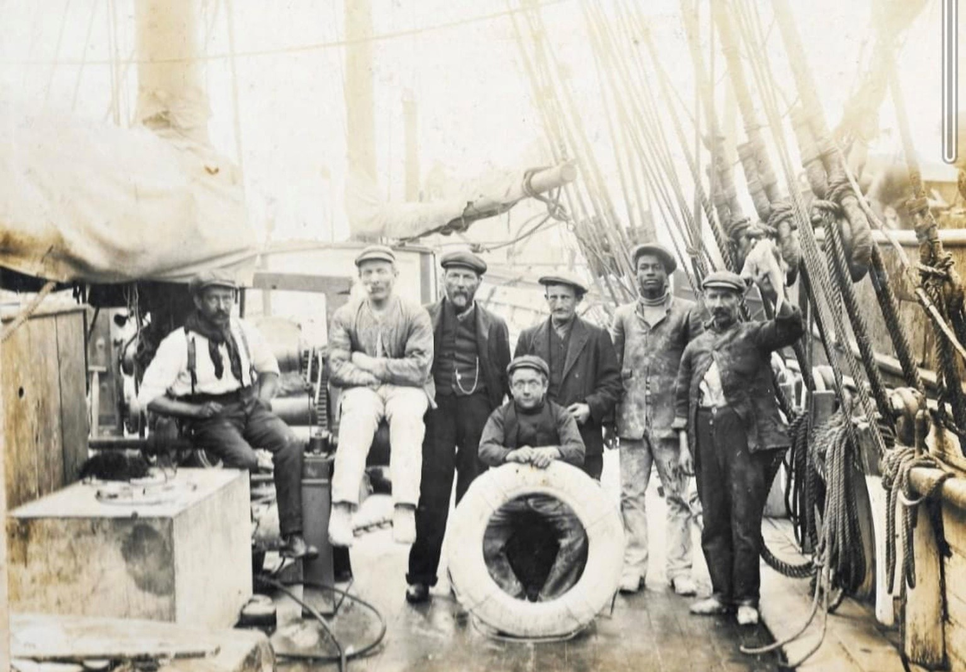

Crew of the Ocean Swell

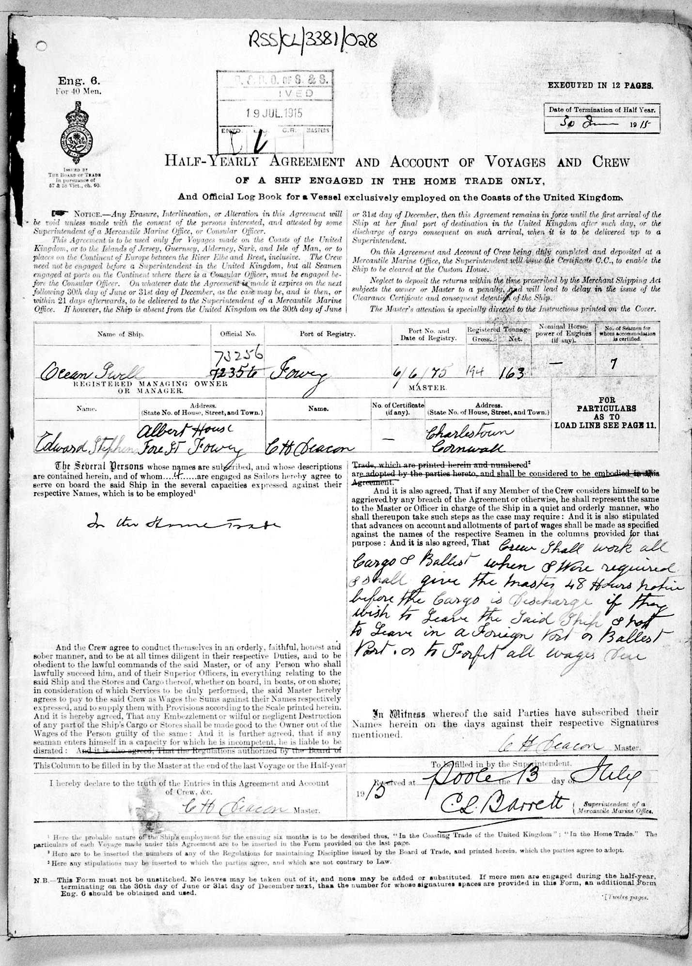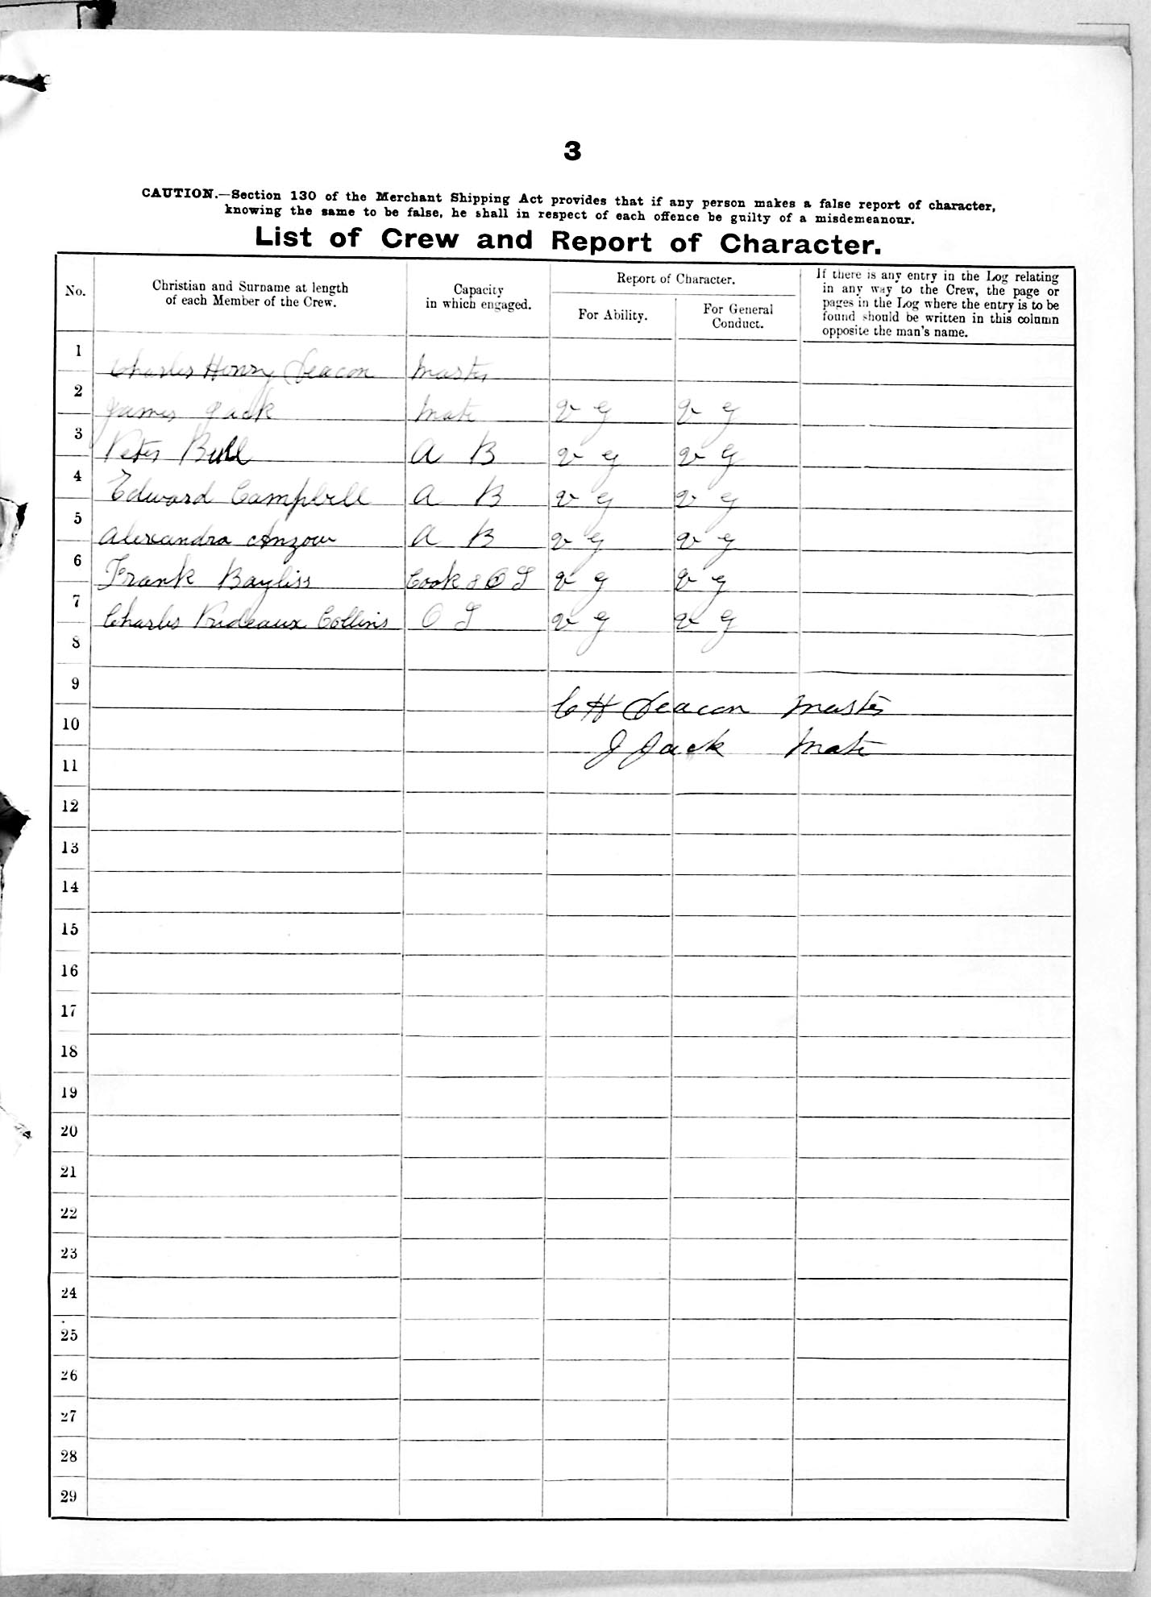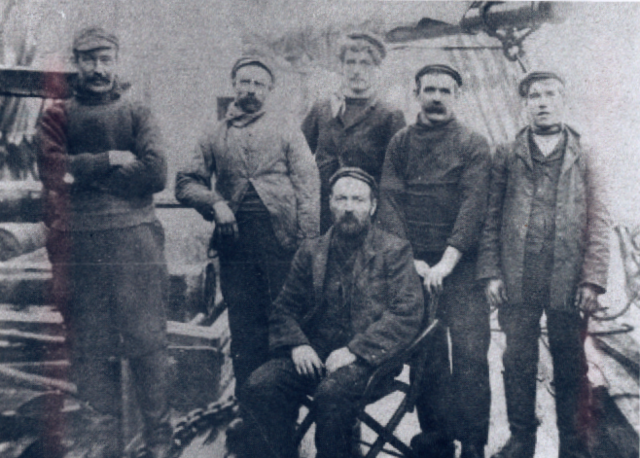

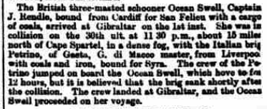
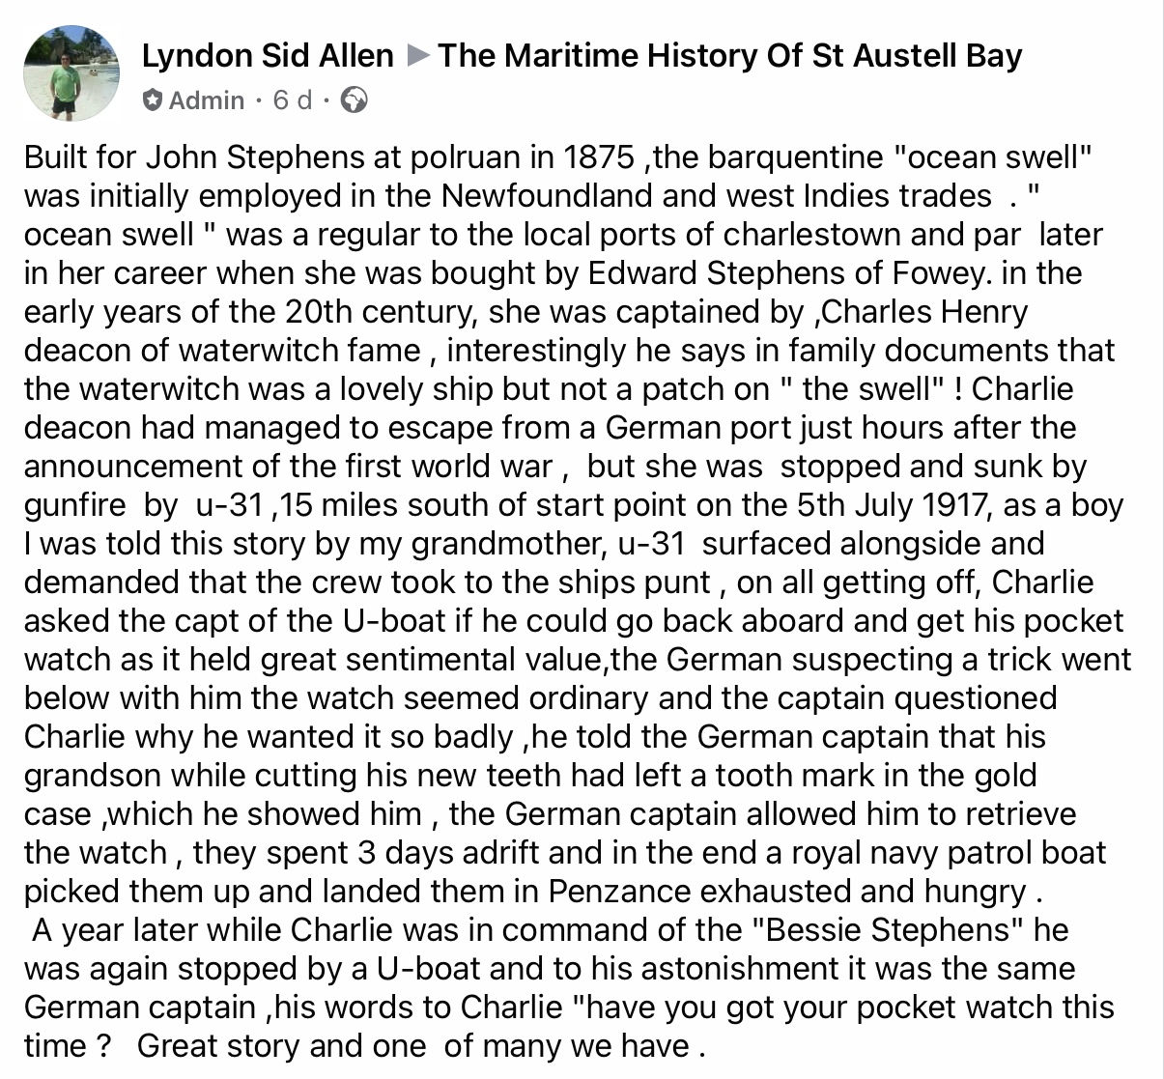

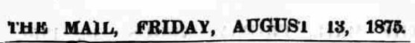
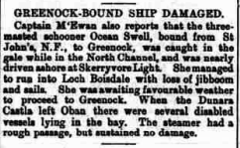
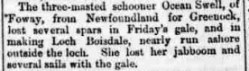
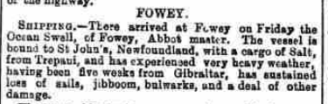

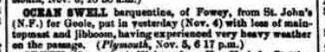

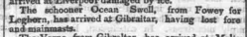

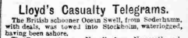

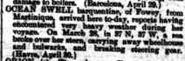
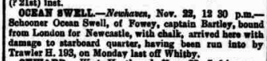
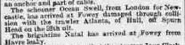
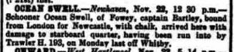

1894
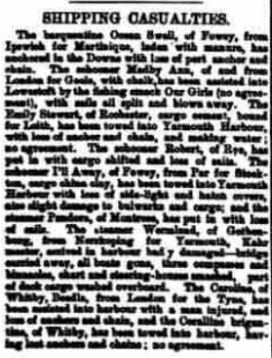
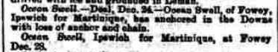
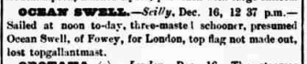
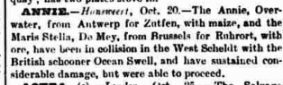

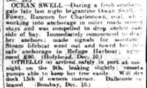
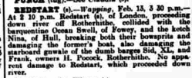

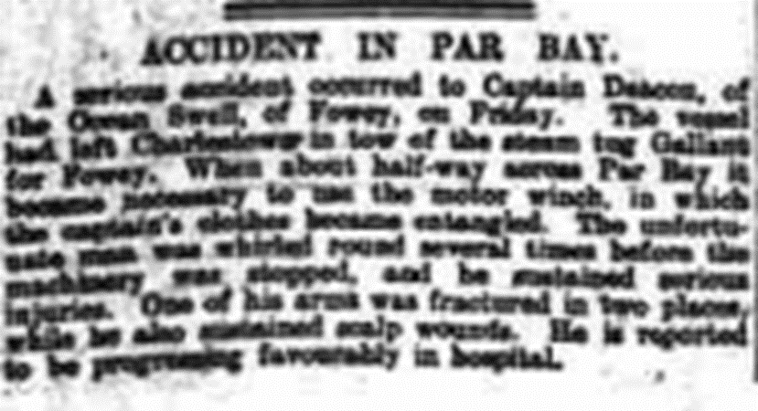

Ocean Swell, built by Stephen, Fowey in 1875 and owned at the time of her loss by E. Stephens, Fowey, was a British sailing vessel of 195 tons. On July 5th, 1917, Ocean Swell, on a voyage from Granville to Fowey with a cargo of wooden hoops, was sunk by gunfire by the German submarine UB-31 (Thomas Bieber), 15 miles southeast of Start Point. There were no casualties.
Read more at wrecksite: https://www.wrecksite.eu/wreck.aspx?13669

