Schooner Pedestrian

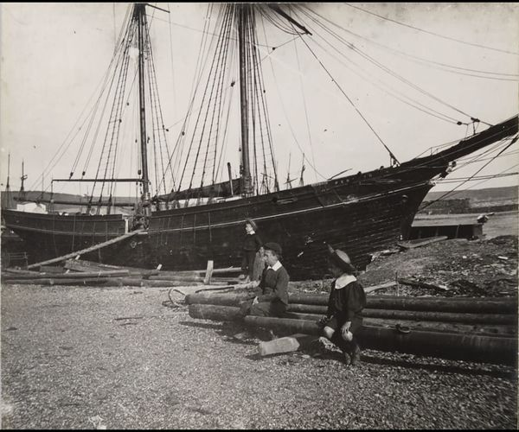

Vessel Name | Official Number |  | Signal letters | Rig /Type | Where built |  | Builder |  | Year built |  |  | Year end |  | reg tons
PEDESTRIAN | 77358 |  | WVDH | 3 masted topsail Schooner |  | Barnstable, |  | W.Westacott & sons |  | 1877 |  |  | 1927 |  | 132
OWNERS/ MANAGERS/REGISTRATION DETAILS |  | Notes |  |  |  |  |  |  |  |  | MASTERS
registered in Fowey 11th July 1877. John Tregaskis, Par 1882 Inkerman Tregaskis, Par 1900 (MO) 1919 Edward Stephens, Fowey (MO) 1919 William H.Marshall, Looe,/Mrs Annie Marshall, Hannafor, West Looe 1928 Wilfred J. Turner,11,Ker st, Devonport, Plymouth(MO) |  | LOA 100.4' x 22.3' 11.1'2 masts with round stern and male figurehead. 27th November 1891 in collision with the steamer Dorunda of Glasgow .she was on passage for Swansea with fire clay. All her masts were lost, and she was towed into Dungeness. She was towed back to Fowey for repairs. In a severe gale whilst in Par harbour on 24th December 1915 she broke adrift and went aground outside the harbour. Sold for £4000 in 1919 to Henry Marshall of Looe . went missing 13th December 1927. not registered after 1928 |  |  |  |  |  |  |  |  | William Purches 1882 W.Panches 1889 J.H.Langmaid 1897-1899 Richard Toms 1915 Turner 1928

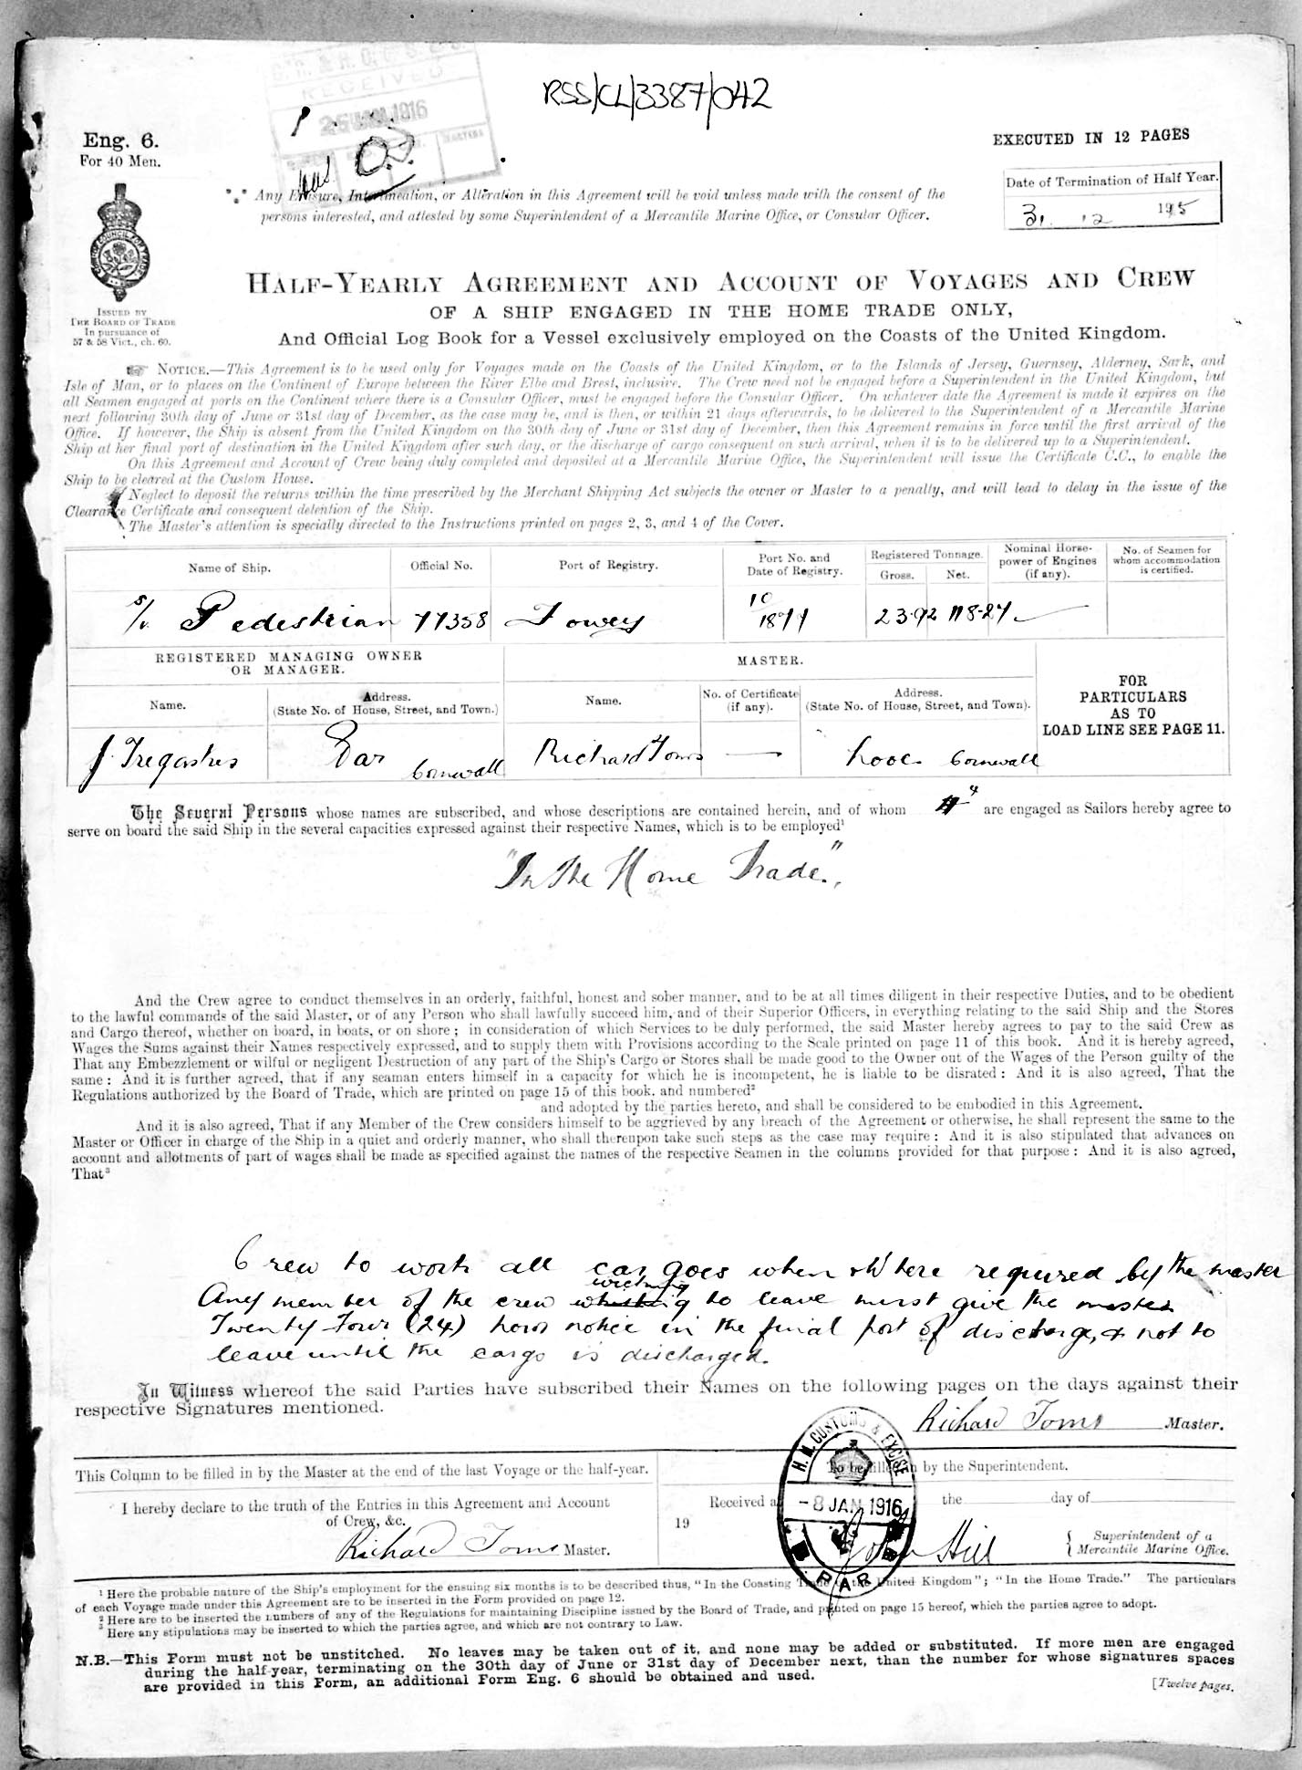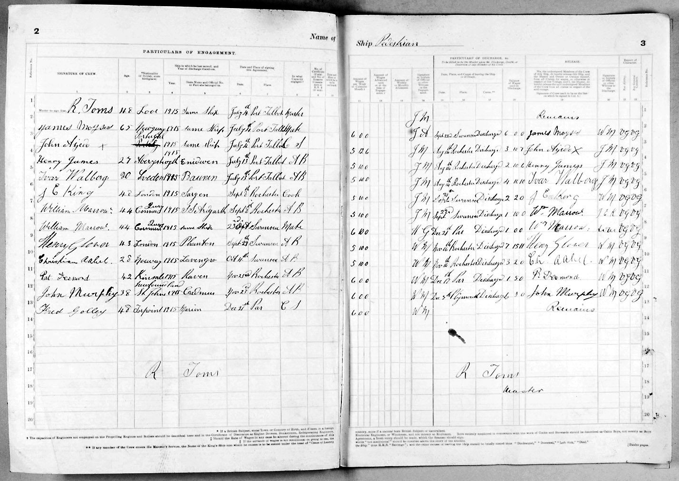

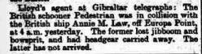
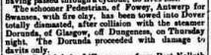
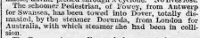
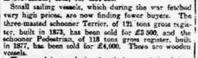

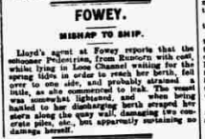

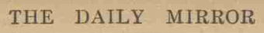
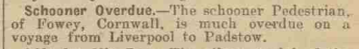

Crew list, Fowey 1915

R Toms; rank/rating, Master; age, 47; place of birth, Looe; previous ship, same.
Michael Ryan; rank/rating, Mate; age, 22; place of birth, Wexford; previous ship, same.
James Hurman; rank/rating, AB; age, 24; place of birth, Weston Super Mare; previous ship, same.
E C Morrett; rank/rating, AB; age, 34; place of birth, Bridgewater; previous ship, same.
John Murray; rank/rating, AB; age, 29; place of birth, Dublin; previous ship, Silvia.
James Moyses; rank/rating, Seaman; age, 64; place of birth, Par; previous ship, Alice Williams.
Alfred Pullman; rank/rating, Mate; age, 62; place of birth, Goole; previous ship, Sarah Lightfoot. Patrick Lindsey; rank/rating, Able Seaman; age, 38; place of birth, Wicklow; previous ship, Sarah Lightfoot.
James Moyses; rank/rating, Mate; age, 64; place of birth, Par; previous ship, same.
John Azedo; rank/rating, AB; age, 25; place of birth, Portugal; previous ship, Helena Tregenza.
John McGregor; rank/rating, Seaman; age, 21; place of birth, Glasgow; previous ship, Young Fox. William Sullivan; rank/rating, Seaman; age, 21; place of birth, Rineveth; previous ship, Donars.

