Barquentine Platina
Vessel Name | Official Number |  | Signal letters | Rig /Type | Where built |  | Builder |  | Year built |  |  | Year end |  | reg tons
PLATINA | 3809 |  |  | Barquentine |  | Sunderland |  |  |  | 1830 |  |  | 1855 |  | 303
OWNERS/ MANAGERS/REGISTRATION DETAILS |  | Notes |  |  |  |  |  |  |  |  | MASTERS
1832 Wilson and co 1840 Brooks and co, London 1850 T.Gillespy |  | Registered in Fowey No 2 on 17th April 1853 |  |  |  |  |  |  |  |  | Wellbank 1838 Wychley 1840 Wilson 1831 Watson 1850-3 Richards 1853

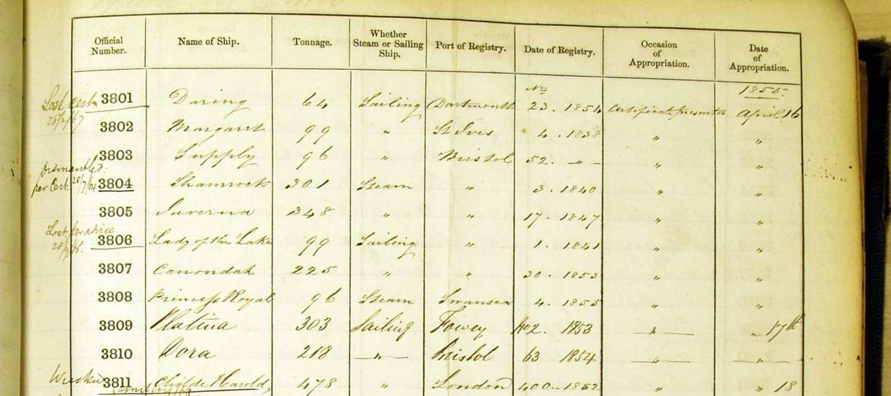
The vessel was Lloyd's Register ('LR') listed from 1832 thru 1852/53. Platina? The word would seem to mean either platinum, a rare metal, or an alloy of platinum & other metals. The vessel was initially owned, thru 1834, by 'Potter' of London, for service from London to India. The vessel clearly went to Australia, however, under Potter ownership, as follows:-
1. The vessel left London on Jul. 25, 1831, under the command of W. S. Wilson, via Portsmouth, for Hobart, Tasmania, where she arrived on Dec. 11, 1831. With a general cargo & about 20 passengers. She went on to Sydney & left Sydney for Liverpool on May 18, 1832 with colonial produce (incl. black & sperm oil, wool & timber).
2. On Apl. 9, 1833, Platina (Wilson) left London for Sydney, New South Wales ('NSW') via Rio de Janeiro, arriving at Sydney on Oct. 10, 1833. It left for Manilla, Philippines, in ballast on Dec. 14, 1833. On Apl. 24, 1834, the vessel was at Singapore when the shipment of tea to the U.K. became permitted. Troughton, a barque, took the first tea chest aboard & fired a celebratory 7 gun salute, which Platina answered with a salute of 13 guns. The vessel left Singapore on Jun. 13, 1834 for London, en route putting into Cape of Good Hope ('CGH') on Oct. 7, 1834 for repairs.
In 1835/36, the vessel was acquired by R. Brooks of London, who owned it thru 1848/49, for service from London to Sydney, thru 1838/39, for service ex London to NSW thru 1843/44, & for service to Launceston, Tasmania, from 1844/45 thru 1847/48. During the period of 'Brooks' ownership, the vessel, per LR, had just two captains i.e. G. Parker thru 1839/40 & 'Wychely' thereafter.
Some details as to the vessel's 'Brooks' voyages to Australia.
A. The vessel left London for Sydney on Oct. 14, 1835, under the command of G. H. Parker, with cargo & 22 passengers. It left Sydney on May 23, 1836 for London with a cargo of colonial produce incl. wool. If I read the words correctly, the vessel went around Scotland on its return voyage & was hit by a hurricane in the North Sea in the month of Nov. 1836. The vessel was saved by cutting away all of her masts when nine miles below the Nore (a sandbank at the mouth of the Thames estuary).
B. The ship was chartered to carry female convicts to Hobart Town, Tasmania. On May 3, 1837 the vessel left the Downs in the command of R. (Robson) Coltish. It hit tempestuous weather en route & as a result was detained at Cape Town for 12 days. There were great concerns for the vessel's safety due to its late arrival. Vessel described as 'proverbially a bad sailer'. It eventually arrived at Hobart on Oct. 22, 1837, with 113 (1 and 2) female convicts, after a voyage of 172 days. included in its cargo were the revolving lights for the Iron Pot & Launceston Lighthouses. It returned to London on or about Feb. 20, 1838.
C. On Sep. 29, 1838, the vessel left Gravesend, London, for Adelaide, South Australia, under the command of Captain Wellbank. The vessel arrived at Adelaide on Feb. 9, 1839 with 99 passengers, mostly emigrants in steerage. There were complaints as to passenger treatment - 9 died en route including all of the 3 children of Mr. & Mrs. Reid. The vessel arrived back at Gravesend, on Nov. 19, 1839, ex Batavia.
D. On Feb. 23, 1840, the vessel left the U.K., under the command of Captain Mitchell, for Port Nicholson (Wellington), New Zealand ('NZ'), chartered by the New Zealand Land Company to carry much needed foodstuffs. It arrived on Jul. 6, 1840. This book states that M. Wycherley was rather her captain & that the vessel was the first British merchant vessel to enter the port of Auckland. On Dec. 15, 1840 the vessel left Hokianga (NW N. Island, NZ) for Sydney, under the command of Captain Wycherly, with a cargo of timber. The vessel went on to Melbourne & left on her return voyage to London on May 23, 1841 with apparently a very large cargo.
E. On Apl. 5 or 6, 1842, the vessel left London for Melbourne, arriving there on Jul. 22, 1842. It went on to Sydney to land passengers & soon, on Sep. 3, 1842, left for India in ballast. F. In mid Jan. 1844 the vessel arrived at Melbourne after a voyage which seems to have originated at Leith, Scotland, via Adelaide & Geelong. It returned to London, arriving there on Jun. 7, 1844.
In 1848/49, the vessel was acquired by 'Gillespy' of London - initially Gillespy, but from 1850/51 T. Gillespy, for service in 1848/49 & 1849/50 from London to Coquimbo, Chile, & in 1850/51 & 1851/52 for service to Honduras. LR of 1852/53 names T. Gillespy as her owner but offers minimal other detail, which suggests that the vessel may have been sold or lost. It would seem, however, that the vessel was late in life registered at Fowey, Cornwall, the owner's name being unknown. A puzzle indeed is this report which advises that on Nov. 24,
Apl. 20, 1855, Platina arrived at Quebec, Canada, ex Bristol, under the command of Captain Richards with 10 passengers & a general cargo. I read that Platina, Richards her captain, of and from Fowey, foundered after being in contact, on Sep. 18, 1855. At 46N/54W which is on the Grand Banks, S. of Cape Race, Newfoundland. she was 92 ft. 11 in. long, signal letters HVST. Clearly she had guns, presumably to ward off pirates.
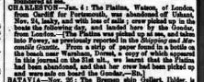
Name | Official number | Flag | IMO
PLATINA | 3809 | GBR
Year built | Date launched | Date completed
1830
Vessel type | Vessel description
Cargo General | Wood Sailing Vessel Barque
Builder |  | Yard | Yard no
Sunderland unknown, Sunderland

Tonnage | Length | Breadth | Depth | Draft
/ / 303 bm
Engine builder
Engine detail

First owner | First port of register | Registration date
R. Brooks | London
Other names
Subsequent owner and registration history
17/04/1853 reg. Fowey

