m.v.Poldhu
Vessel Name | Official Number |  | Signal letters | Rig /Type | Where built |  | Builder |  | Year built |  |  | Year end |  | reg tons
POLDHU | 164250 |  | MPMW | Motor |  | Foxhol Gronigen, Holland |  | Muller & Broerken |  | 1938 |  |  |  |  | 442
OWNERS/ MANAGERS/REGISTRATION DETAILS |  | Notes |  |  |  |  |  |  |  |  | MASTERS
registered in Fowey 23rd February 1939. Polpen Shipping Co Ltd, 3 Dolphin Houses, Fowey Cornwall Sydney J. Samuel,"Tregillan"St.Fimbarrus Rd,Fowey |  | LOA 145Ft 7" ,26ft x 9ft draft. steel .wrecked Ile de Sein,Pointe du Raz, Finisterre1940 after war in 1947 recovered and transferred to London Register and rename Roselyn

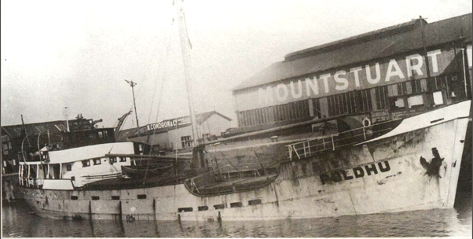

W.N.Lindsay's 1939 built
Built at Foxhol ,Holland as POLDHU for the Fowey based Polpen Shipping Co. Ltd., On 27th May 1940 she was wrecked at Point du Raz.After the war she was salvaged and changed ownership several times before being renamed Roselyn.
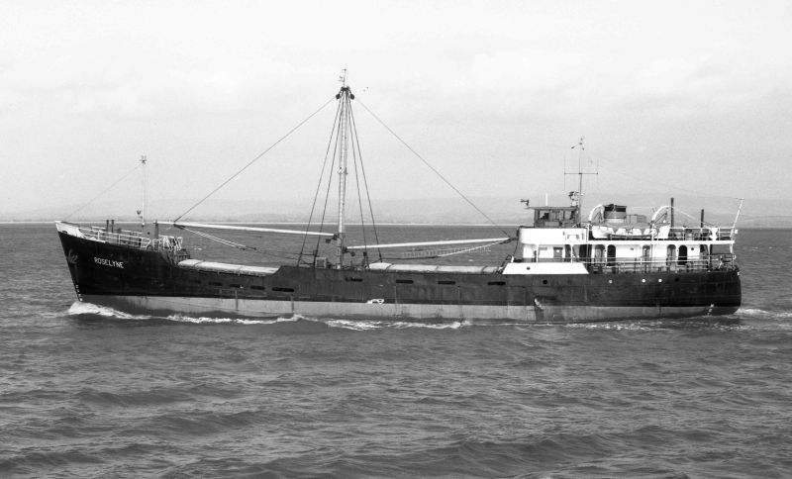
As the Roselyn
ROSELYNE which the Leith based company had owned from 1955 but soon sold to Greece. she was sold in September 1966 and, as ANNA, called at Lisbon on her way to the Mediterranean. She was sold to Italian buyers in 1976 to trade as ELEUSI. Her fate is unknown.
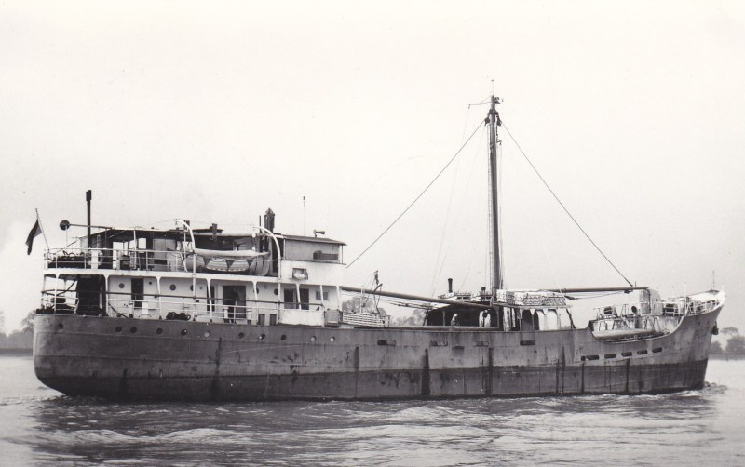
As the Eleusi
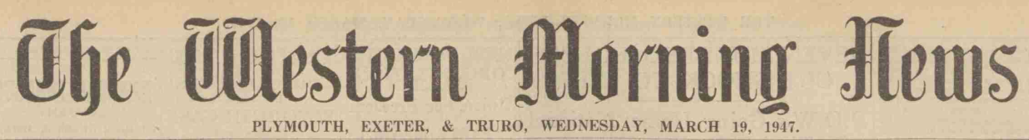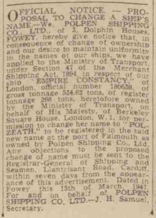

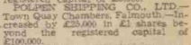
1915 crew lists
E H Orman | Master | 36 | Poole | Polvarth
James Jones | 1st Mate | 41 | Pembroke | poldhu
G Venardi | AB | 35 | Greece | ?
Nicolas Balrates | sailor | 21 | Greece | daybreak
W Finlayson | sailor | 20 | london | Poldhu
A Payones | sailor | 25 | Greece | Southlands
H Laver | sailor | 20 | london | Don Arturo
P P Enech | steward | 31 | Malta | Forestmoor
Domenick Magro | ships cook | 55 | Malta | Brunner
P G Revely | engineer | 46 | newcastle | Kathleen
Abdulla Kassein | Donkeyman | 30 | Delal | poldhu
Ali Ahmed | Fireman/Trimmer | 25 | Aden | Ambient
D Wikman | sailor | 21 | Riga | Civilian
Aksel Kristiansen | sailor | 19 | Norway | Polamhall
Samas Pisilon | sailor | 20 | Greece | Badmington
Strates Veles | ships cook | 24 | Greece | Mina

James Jones | Master | 43 |  | Poldhu
William A Thomas | Mate | 25 | Newlyn | Polwaula
Augustus Guias | 2nd mate | 56 | Montreal | Poldhu
D P Galliver | steward | 52 | Bristol | Penare
J Rees | cook | 44 | Newport | Mountsfield
R C Tyler | steward | 20 | london | Polvarth
Henry Buston | Boatswain | 54 | devon | Rele
John Cummings | AB | 43 | BANFF | Rossette
T Taylor | AB | 32 | Appledore | ?
S Clarke | sailor | 28 | london | ?
E J Mors | AB | 28 | Pangbourne | Poldhu
W Finlayson | sailor | 20 | london | Poldhu
G Olson | AB | 35 | Sweden | Polwau?
W Stephens | ord seaman | 16 | Newport | Heulemoor
James Farquharson | engineeer | 58 | Egremont | Poldhu
W O Conway | 2nd engineer | 50 | Shoeburyness | Throstle
J H Pleus | 3rd engineer | 42 | Cardiff | Brromfield
V Apoolaza | Donkeyman | 41 | Spain | Polvarth
Abdulla Muksin | Fireman/Trimmer | 35 | Aden | Poldhu
Abdulla Kassen | Fireman/Trimmer | 31 | Delal | Poldhu
Mohd Ahmed | Fireman/Trimmer | 34 | Aden | Polvarth
Ali Ahmed | Fireman/Trimmer | 25 | Aden | Polvarth
Malid Saleh | Fireman/Trimmer | 30 | Aden | Burbridge
M Johnstone | ships cook | 56 | Jedburgh | Haworth

