**The History**

**of the tug Polmear**

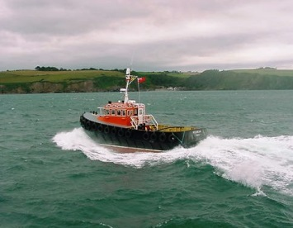

**Previous names:- Polmear**

**Built:- Toms Yard, Polruan**

**Scrapped:- In service Jenkins in Poole**

**Period in Fowey:- 1960- 1968**

|  |  |
| --- | --- |
| **Name of Vessel**  **in Fowey** | **Polmear** |

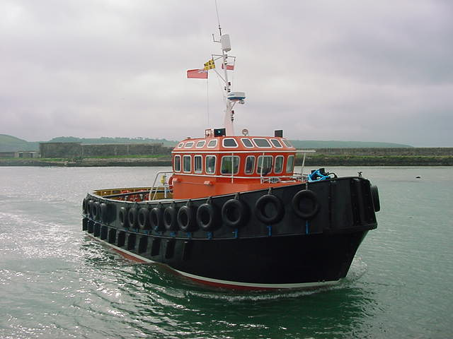

**In 2003 with the coming of new pilot regulations and the limitations and age of the Par pilot used for turning and towing ships in Par the harbour commissioners considered upgrading the tug/ pilot boat on service in that port. Imerys the port owners had plans to handle large and more ships exporting aggregate as well as china clay ships.**

**With this in mind the commissioners went out to Tender to construct a vessel meeting all the regulations, shallow enough to operate in Par harbour and with sufficient power to handle all the vessels expected and to also cover some operations in Fowey. The MCA was consulted before specifications were published.**

**Four yards tendered with the local yard of C.Toms , Polruan won the contract. This had the added advantage that building progress was easily monitored and engineering staff were able to be trained on all aspects of the vessels maintenance.**



**Plans of Polmear. Denis Swire ,Nautical architect of Falmouth was engaged by the builders to design a vessel meeting the pilot boat code and fit for use in Par and Fowey**

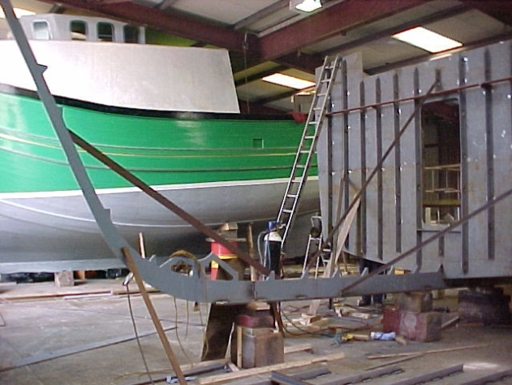 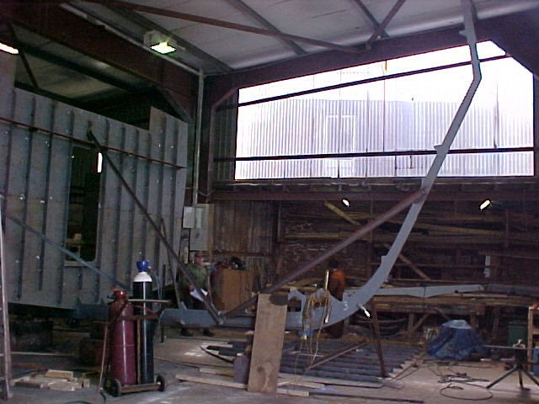

**The bow centerline frame and engine room bulkhead**

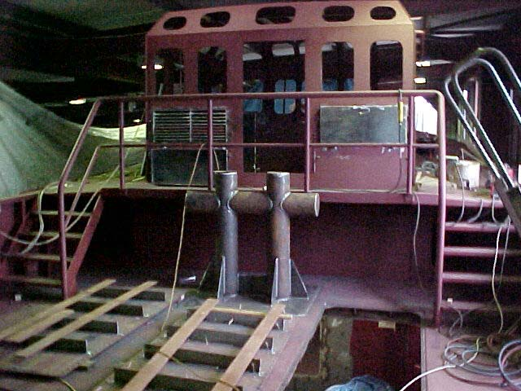 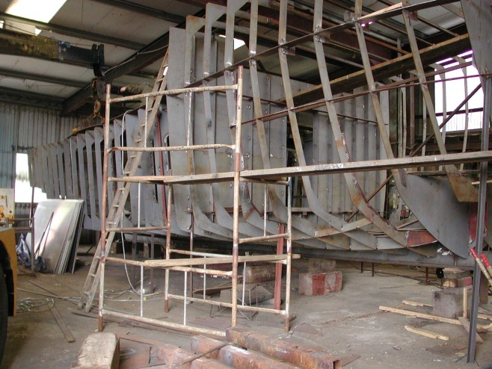

**The wheelhouse from aft all framed up**

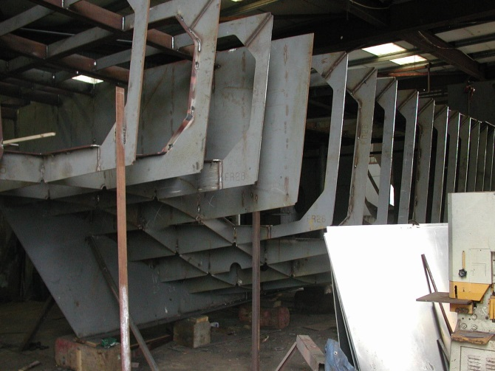 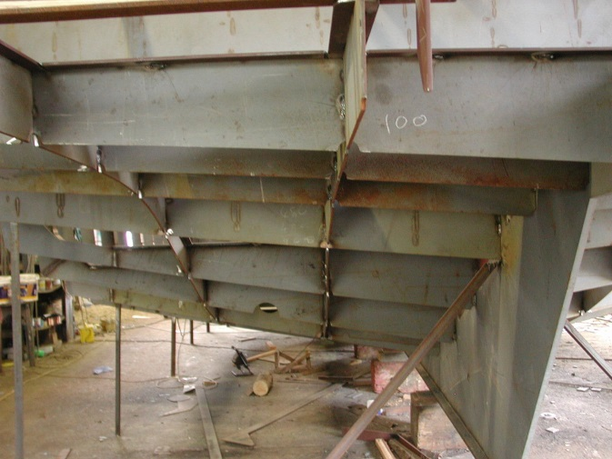

**View from aft starboard quarter Port quarter frames and skeg**

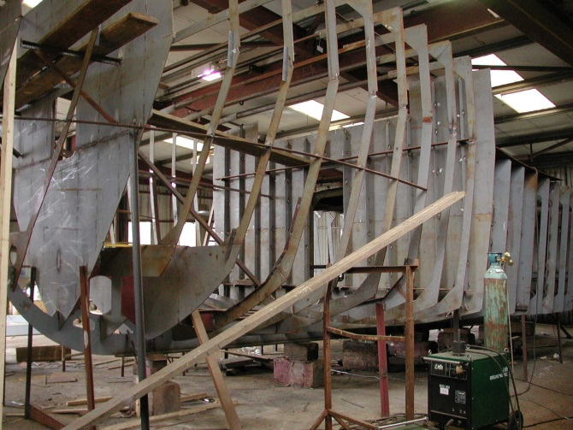 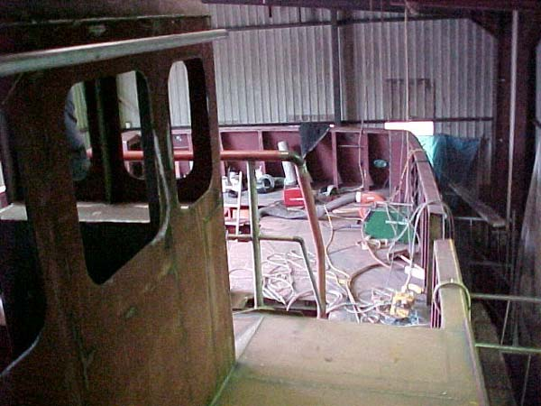

**Polmear being Built and Framed up View of the after tow deck**

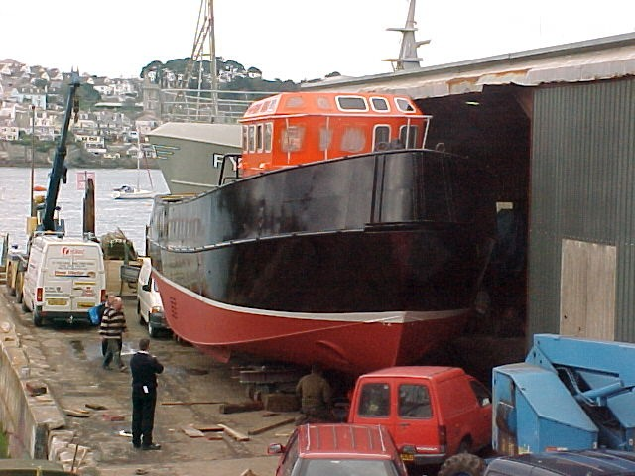 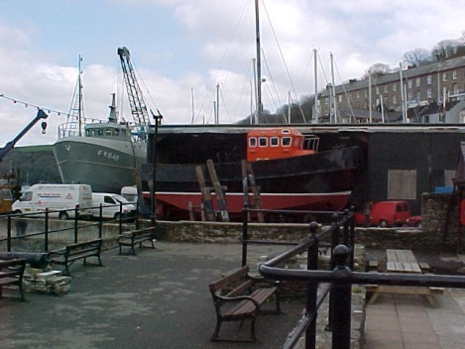

**Being maneuvered out of the shed**

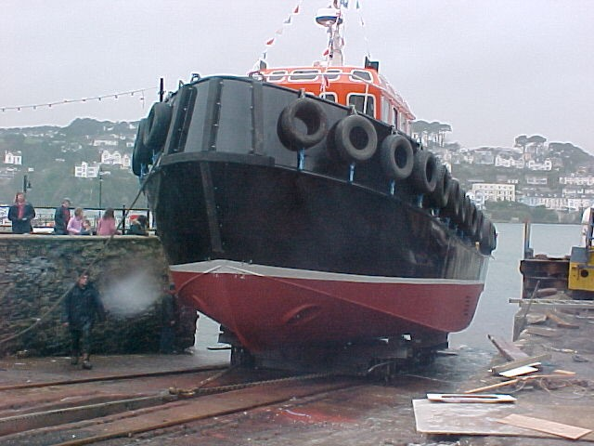 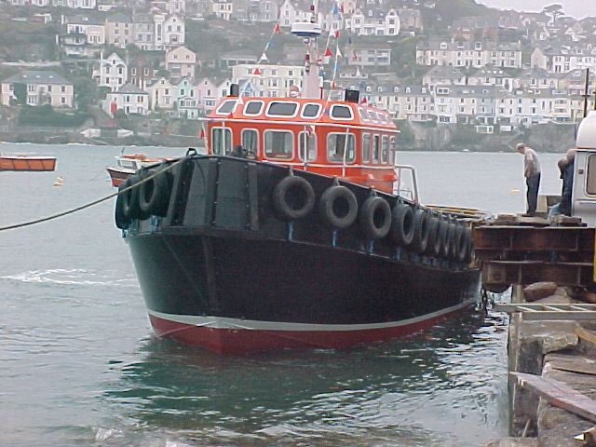

**On the slipway being launched Afloat for the first time**

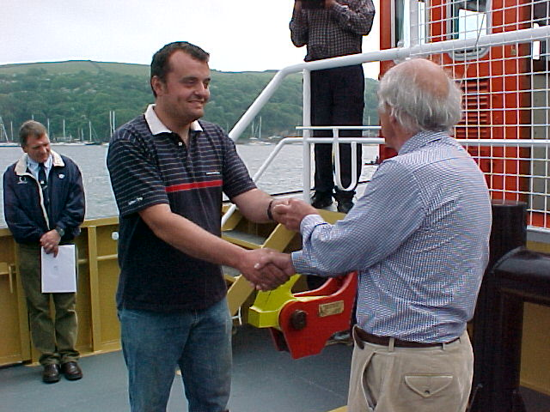

**Paul Toms handing the Polmear over the Gerry Williams, Chairman of the Fowey Harbour Commissioners**

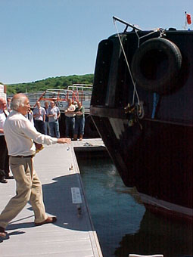 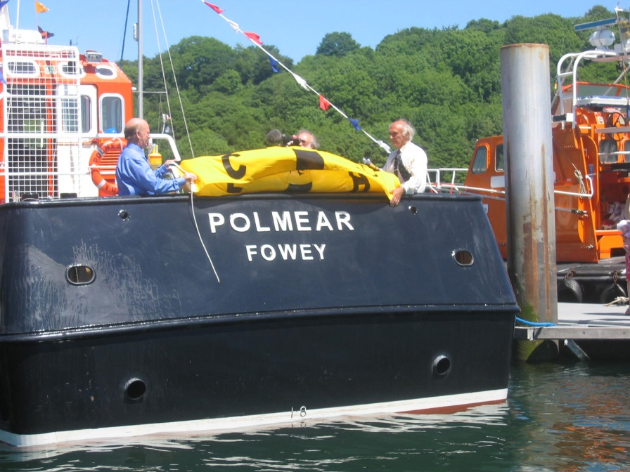

**Gerry Williams, Chairman of the Fowey Harbour Commissioners naming Polmear**

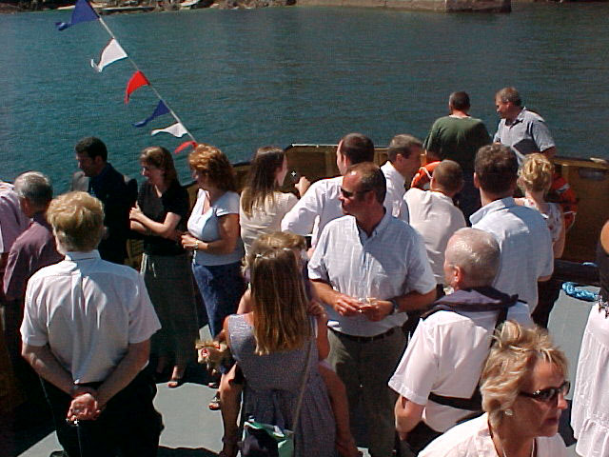 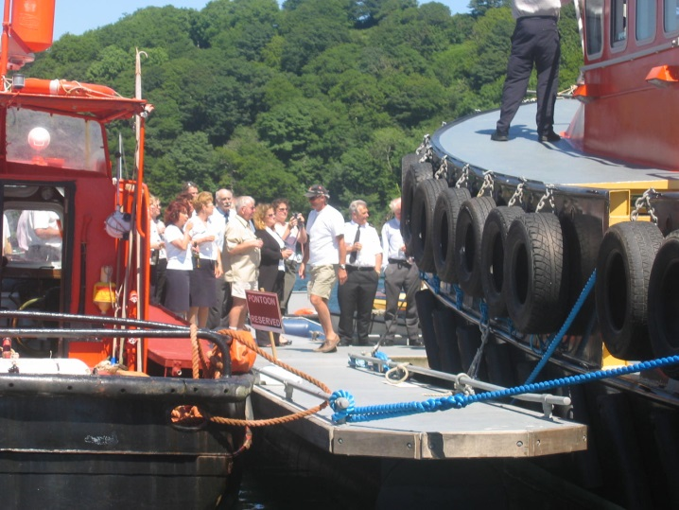

**The naming party on a sunny afternoon 2004**

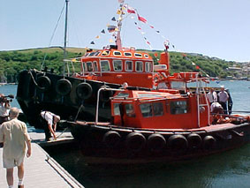 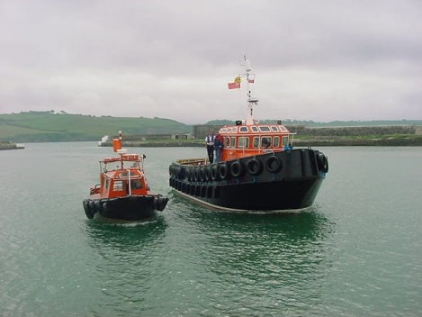

**Polmear and Par Pilot the vessel she was built to replace**

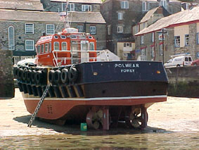 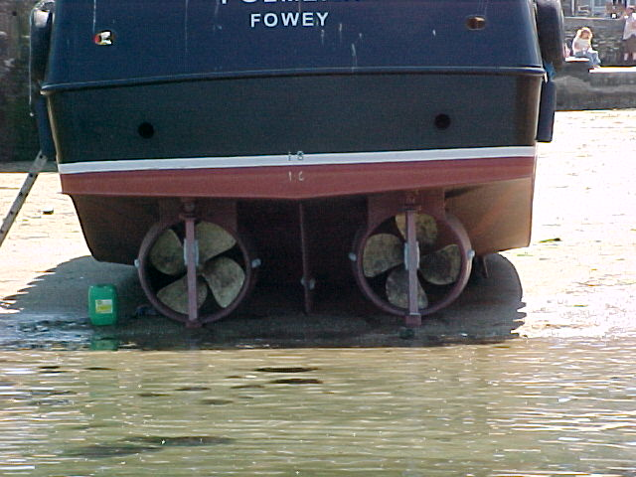

**Dried out on Beach at Polruan to check propellers**

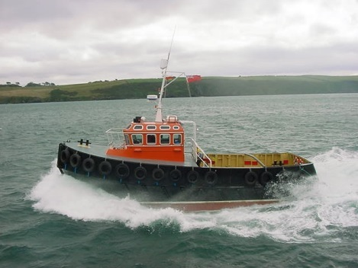 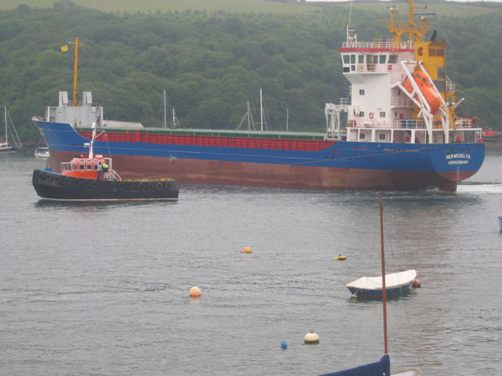

**Full speed trials Turning the m.v. Merwadelta in the lower harbour**

**This was the first new build towage vessel for the Commissioners and the first to be built by Toms Yard. Her role was dual purpose to provide boarding and landing as well as towage. She was designed for the shallow water operation necessary in Par with a 10 ton bollard pull. This was provided by twin Cummins NTA 14M engines giving 44O BHP at 1800 rpm. Initially primarily for Par duties, the build was to provide for reserve duties in Fowey as well. A substantially larger vessel than Par Pilot and Penleath she measured 14.65 metres in length with a draft of 1.67m. The twin propellers had fixed kort nozzles and twin rudders. She became the first vessel to operate in the port’s fleet fitted with a bow thruster. From time to time Polmear was used for towage duties in Fowey where early in 2006 she took over as reserve pilot boat as well. With the downturn in trade in Par, she was moved to be permanently based in Fowey later in the year.**

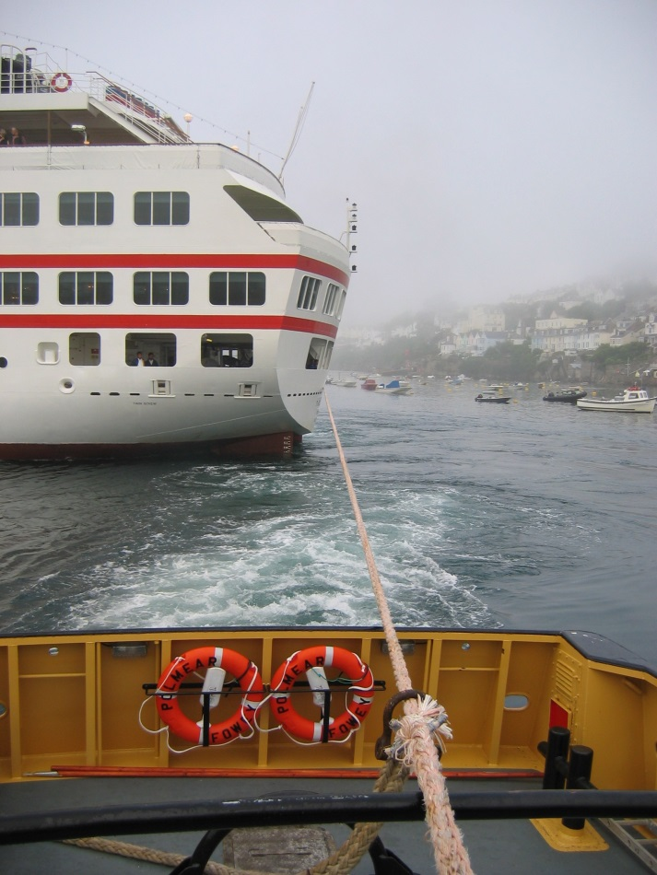 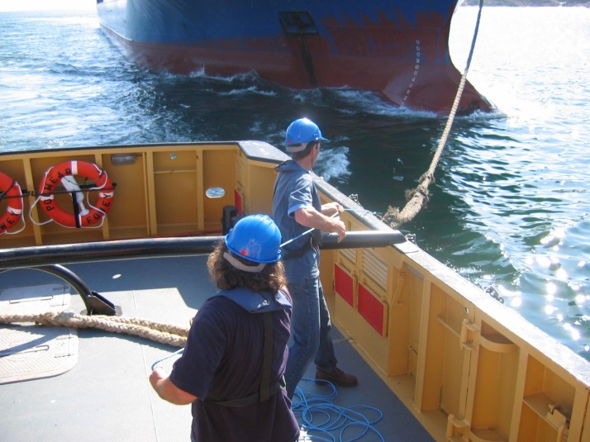

**Towing Cruise ship Hanseatic Taking a tow rope for’d**

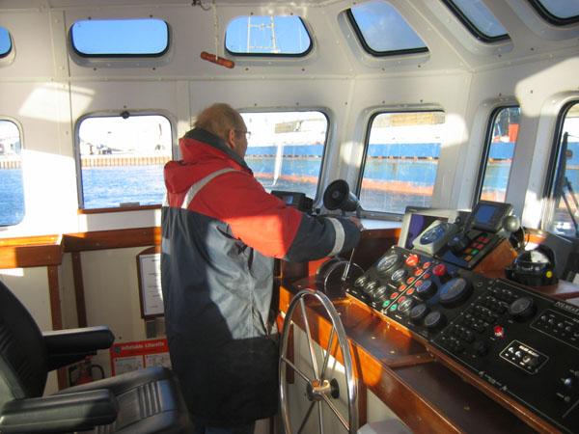 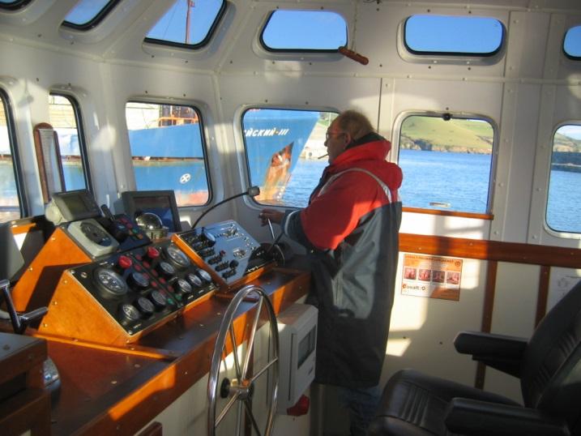

**John Avril at the controls in Par Harbour Inside the wheel house**

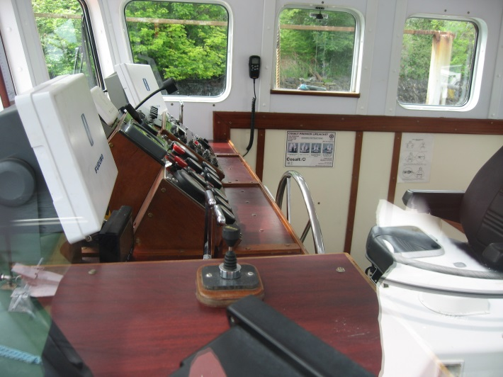 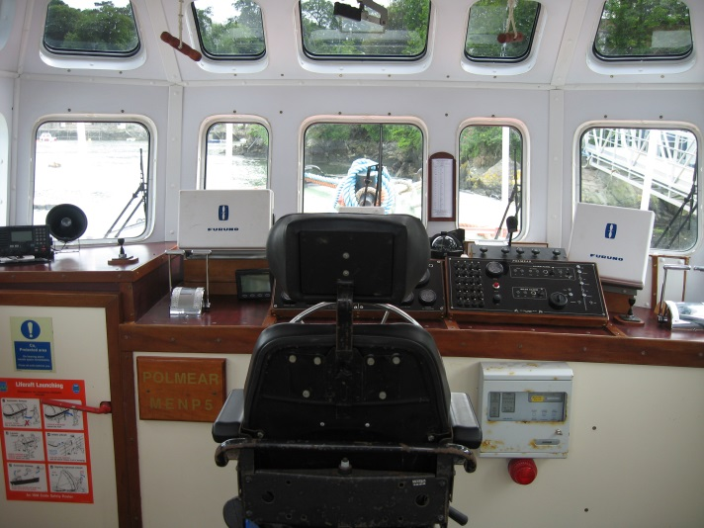

**The controls from the port side looking forward in the wheelhouse**

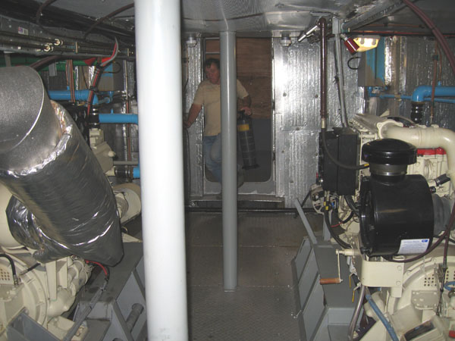 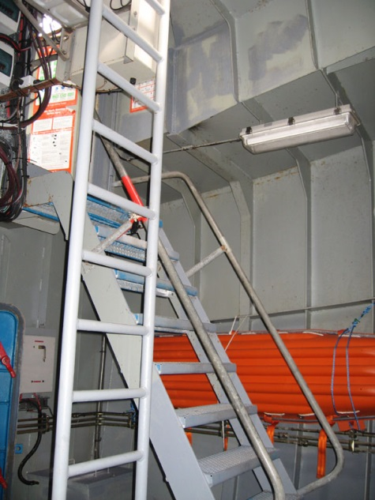

**The engine room for’d access to engine room**

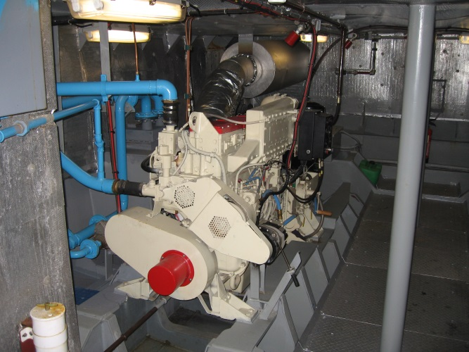 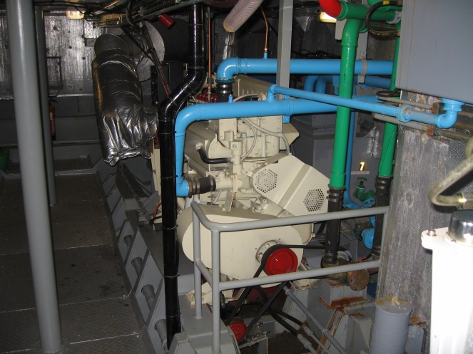

**Starboard engine Port engine**

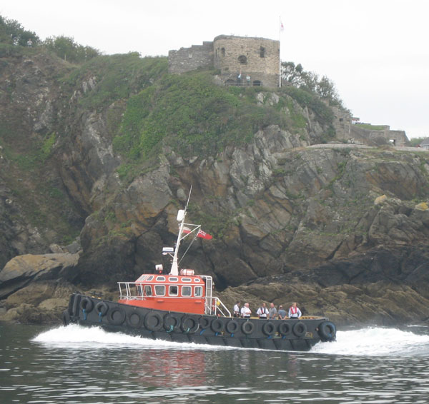

**Below St Catherine’s Castle**

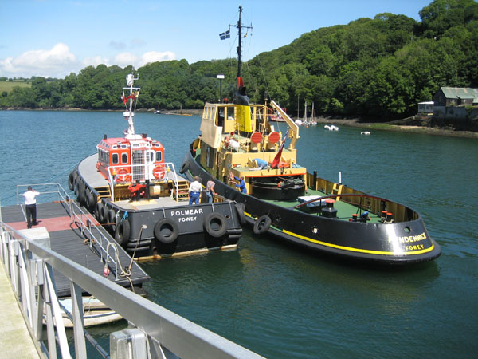

**Alongside the pilot pontoon with Pendennick**

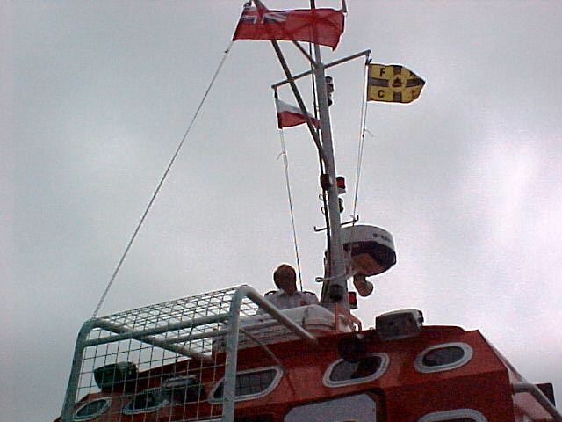 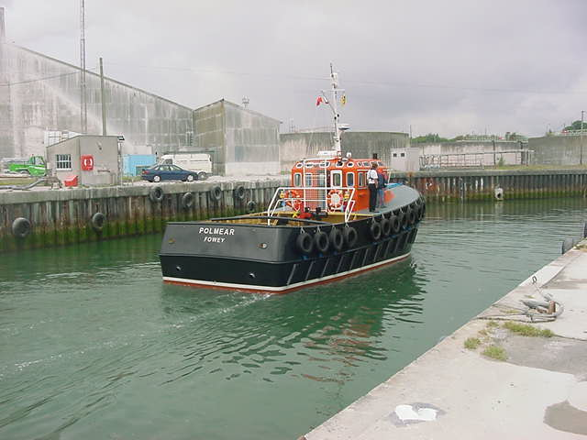

**Flying FHC and pilot flag operation in Par Harbour**

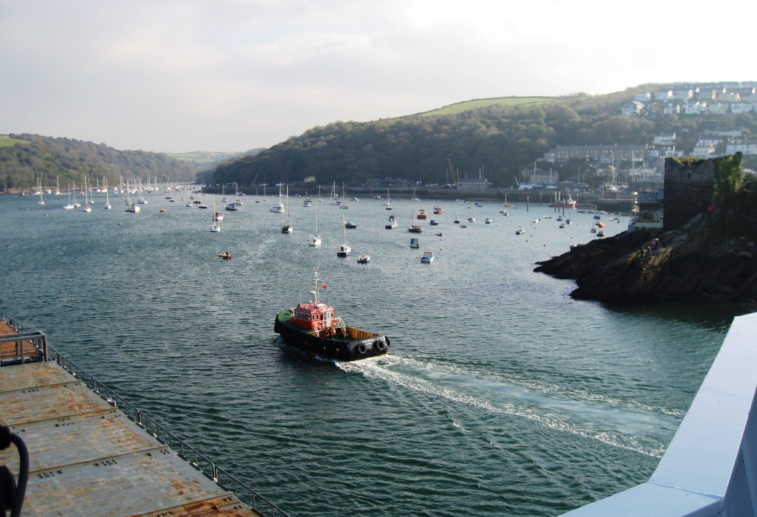

**Fowey Harbour Commissioners new multi-purpose launch Polmear at sea.**

**The new multi-purpose launch Polmear is now in service with the The Fowey Harbour Commissioners . Built principally to serve the nearby port of Par, the new vessel replaces an earlier dual-purpose pilot/workboat that has given good service since its introduction in 1977.**

**Fowey Harbour Commissioners are the pilotage authority for the port and provide all of the marine services to the privately owned Imerys Port of Par (formerly English China Clay). A new vessel was required to meet current regulatory standards and improve the ability to handle larger ships in the port. A decision was therefore taken to replace the older vessel with a larger and more powerful one capable of providing all of the pilotage, towage and berthing assistance necessary, not only for the port of Par but also to act as a relief during the handling of large ships at Fowey.**

**A contract for construction was awarded to the local yard of C Toms and Sons Limited, Polruan, where work started in mid 2003 to meet a planned delivery in the spring of this year.**

**Polmear was designed by Falmouth naval architect Dennis Swire and is a vessel of 14.65m in length overall with a beam of 5.5m and a working draft of 1.65m. The design criteria specified a vessel with a maximum speed of 9 to 10 knots with a bollard pull of 10 tonnes.**

**This was intended to give the boat the ability to carry out the pilotage duties off Par harbour in St Austell Bay and to assist vessels of up to 110m in length in the restricted confines of Par harbour.**

**Polmear meets all of the requirements of the Maritime & Coastguard Agency (MCA) codes of practice applicable to this size and type of vessel, carrying out the duties mentioned.**

**The hard chine hull is built largely from 8mm steel plate with the super structure and other plating at 6mm.**

**Twin Cummins NTA 14M 440bhp (269kW) main engines running at 1800rev/minute provide the necessary power.**

**The engines are turbo-charged and after cooled and have proved ideal for the purpose. Dry exhaust systems incorporate silencers located in the engine room and overboard outlets in the transom. Engines are cooled by Weka type 6P6-1000 box coolers, supplied by Causeway Marine Limited, located above the turn of the bilge, amidships, on both sides of the vessel. The choice of cooling system was determined by the need for the vessel to operate for long periods at less than 2 knots and to obviate the salt water cooling problems experienced with the previous boat while working close to a muddy bottom.**

**Power is transmitted to a pair of 1000mm diameter four blade propellers via Twin Disc MG 1554 gearboxes with a reduction ratio of 3.1 to 1. Virtually all of the stern gear and propulsion equipment was supplied by Kort Propulsion, the propellers rotate within Kort type 19A propulsion nozzles and are mounted on 90mm diameter stainless steel tail shafts. The latter run in water lubricated stern tubes complete with bearings and stuffing glands fore and aft. Kort high-lift rudders are also fitted and operated by a Wills Ridley hydraulic steering system supplied by Southern Cross Marine. The steering gear is equipped with an emergency backup and manual emergency steering systems.**

**Polmear is fitted with a Kort - model KT45DD bow thruster producing approximately 420kgs of transverse thrust. The bow thruster was installed to improve manoeuvrability in the narrow confines of Par Harbour and to assist in positioning the vessel during shiphandling operations and in particular when pushing on ships at alongside berths. This reduces the need for ships to use their own bow thrusters, which in turn reduces damage to quay facings and drying berths.**

**The hydraulic system aboard Polmear , supplied by Fowey Fluid Power of Lostwithiel, powers the steering gear and bow thruster. All of the piping is to MCA standards using zinc plated mild steel pipe work fabricated onboard and the number of connections kept to a minimum to reduce the possibility of leakage. Further additions are to be added to the system including the installation of a 5 tonne hydraulically powered bridle winch to control the gob rope whilst towing. The later will similarly be driven from the gearbox mounted load-sensing hydraulic pump.**

**A towing connection is made aboard Polmear by means of a Britannia Marine quick release tow hook, with a safe working load of 10 tonnes. The hook can be released from the steering position or on deck as required.**

**In the wheelhouse, a steering jog lever is provided on either side, in addition to a conventional centrally located wheel, allowing the coxswain to work from either side. Marine Electronics of Fowey and Falmouth provided the Furuno M1833 radar with colour plotter and a Furuno (GP32) GPS system. An Icom VHF radio system is installed and provided with microphones on either side of the wheelhouse.**

**The electronics outfit also includes an echo sounder and transducers, and a Jotron 40GPS EPIRB.**

**From time to time the vessel will be used to provide a backup for survey work in the approaches to Par Harbour and the system is designed to accommodate the necessary additional equipment.**

**Accommodation on the vessel is basic and intended only to meet the needs of short voyages to sea and normal onboard operations.**

**The wheelhouse has sufficient seating for all of those onboard and a large accommodation space in the forepeak houses a work-bench and an emergency generator capable of running all of the vessel's systems and charging batteries. There is also adequate space for the stowage of safety equipment, vessel stores.**

**Pilots are boarded from a raised deck forward with access at wheelhouse level. A safety harness rail is fitted around the wheelhouse. All of the safety equipment; life jackets, life rafts, and fire fighting equipment, including CO 2and fire detection systems were supplied and installed by Cosalt International through their Saltash based office. This arrangement complies with the Harbour Commissioner's policy of using a local, high standard, source of supply.**

**After extensive trials for the owners and the MCA the vessel was accepted into service at the beginning of July and has proved more than adequate for handling ships and boarding and landing the pilots off the Port of Par.**

**The vessel was named on 15 June and accepted by the Chairman of the Commissioners Mr A G Williams.**

**The Fowey Harbour Commissioners and Pilots are delighted with the vessel and the standard of construction.**

**Polmear meets all of the requirements set down in the replacement programme. During the trials the vessel was used to handle larger ships in Fowey Harbour and when the tugs servicing that port are in repair or maintenance the Polmear may be used as a relief ensuring 24-hour cover for both ports. A bollard pull test was carried out during the trials and Polmear achieved the 10 tonne bollard pull specified. The vessel will be maintained by the Harbour Commissioners in its own yard and the paint system has been designed for ease of maintenance, thus reducing the amount of down time necessary for planned maintenance.**

**In June 2008 it was decided that as part of the ports restructure to cope with the new china clay export regime and the need to upgrade the towage units Polmear could be disposed of together with the decision to sell both Tregeagle and Pendennick. Jenkins Marine of Poole purchased the Polmear in August 2008 and she left for a new life working in their operation along the south coast, based at Poole. Purchasers for the Pendennick were also found at the same time as the Polmear’s departure and it was then possible to purchase another tug.**

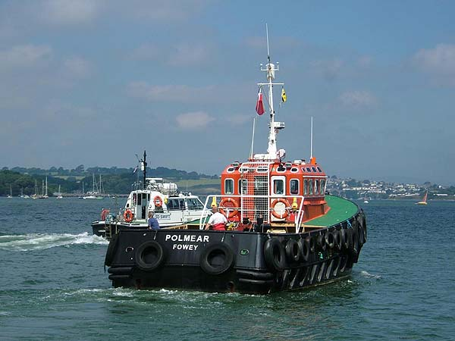

In Poole owned by Jenkins Marine

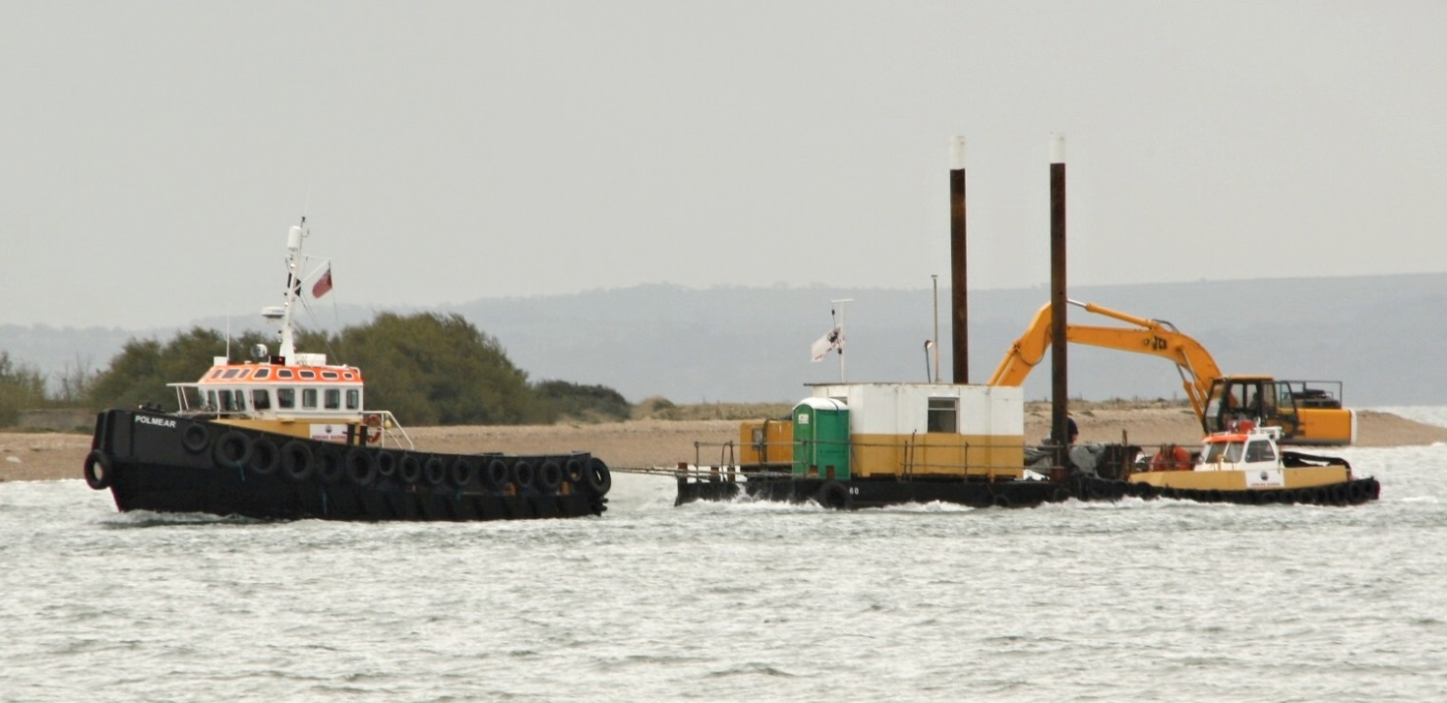

**At work for Jenkins Marine,Poole POLMEAR is a twin-screw motor tug, certificated under the MCA Workboat Code of Practice for operation up to 60 miles offshore. She is available for towage and survey works throughout the UK.**

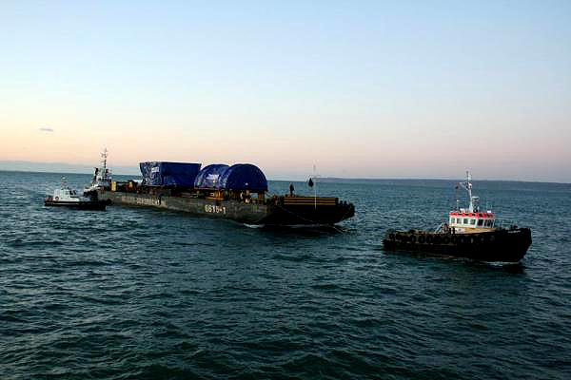

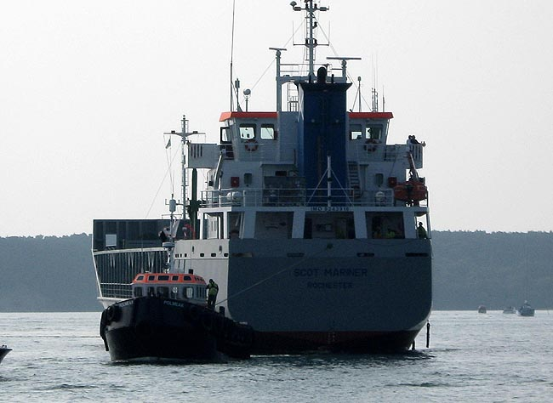

**Towing a ship in Poole harbour**

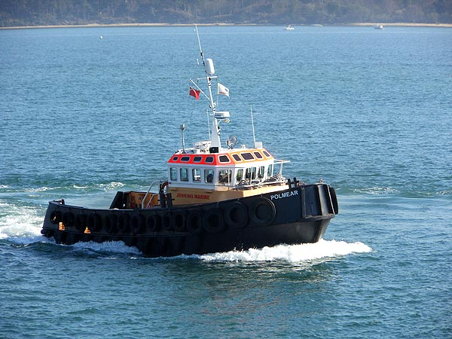

In 2015 /16 she was chartered to assist berthing during the St.Marys Isles of Scilly quay extension work

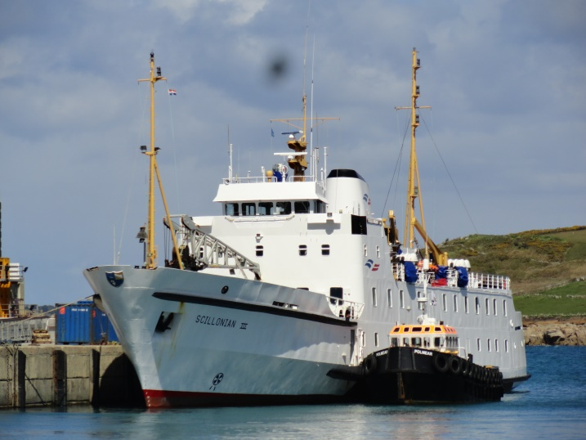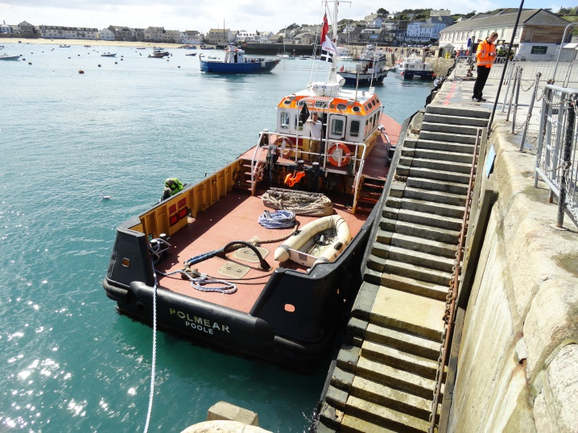

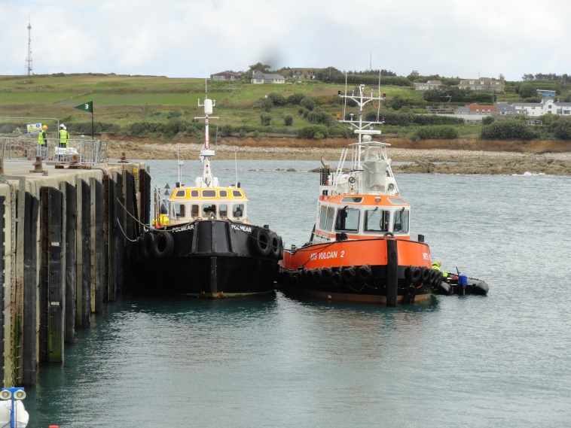

**Operates for Jenkins in and from Poole harbour**

**Operating in Plymouth**

|  |  |  |  |  |  |  |  |  |  |  |
| --- | --- | --- | --- | --- | --- | --- | --- | --- | --- | --- |
| **Name of Vessel**  **in Fowey** | | | | | **Polmear** | | | | | |
| **Year Built** | **2004** | | | **Official Number**  **Call sign** | | | **235018662**  **MENP5** | | **G.R.T.** |  |
| **Builders** | | | **Toms Yard, Polruan** | | | | | | | |
| **Dimensions** | | | | | | **Length** | | | **Beam** | **Draft** |
| **14.65 metres** | | | **5.5 m** | **1.67m** |
| **Engines** | | **Twin Cummins NTA 14M 44O BHP at 1800 rpm** | | | | | | **Bollard pull** | | **10 tons** |
| **Owners Built for** | | | | | **Fowey Harbour Commissioners** | | | | | |
| **Owners in Fowey** | | | | | | |  | **Fowey Harbour Commissioners** | | |
| **History on Leaving Fowey** | | | | | | |  | **In Commission**  **Jenkins Marine, Poole** | | |

**VOYAGES OF THE TUG POLMEAR**

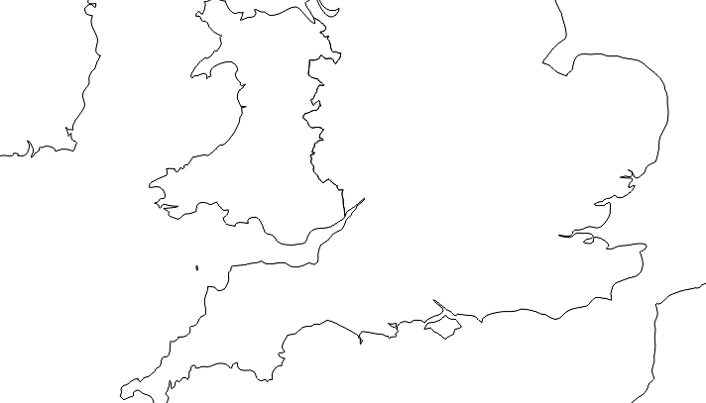

**St.Marys IOS**

**2015/16**

Jenkins Marine Poole

2008 to present

Fowey/Par

2004 to august 2008

Built Polruan

2004