Schooner Pride of the Channel
Vessel Name | Official Number |  | Signal letters | Rig /Type | Where built |  | Builder |  | Year built |  |  | Year end |  | reg tons
PRIDE OF THE CHANNEL | 63974 |  | LVNS | 3 masted Brigantine |  | Charlestown |  | Anthony Luke |  | 1873 |  |  | 1897 |  | 176
OWNERS/ MANAGERS/REGISTRATION DETAILS |  | Notes |  |  |  |  |  |  |  |  | MASTERS
registered in Fowey 12th May 1873. 1876 John Stephens, Charlestown,1879 Thomas Hitchens, St.Austell |  | LOA 109.6' x 24.4' x 12.8. Square stern female bust figure head. In March 1897 On passage from Martinique to Bordeaux with a cargo of 752 barrels of rum was driven ashore at Naujac in the Bay of Biscay. 6 crew were drowned one saved. |  |  |  |  |  |  |  |  | 1873-74 Piper 1875-90 R.W.Hollow 1894-97

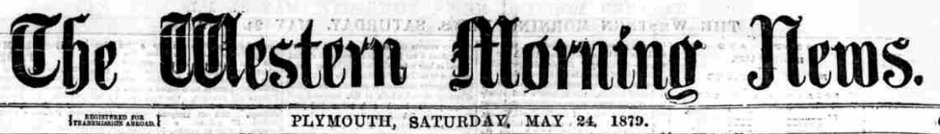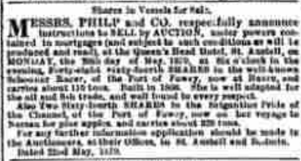
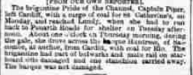

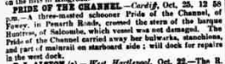
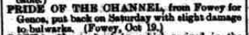
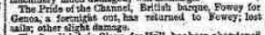
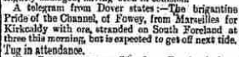
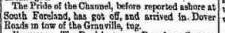
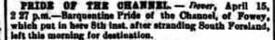
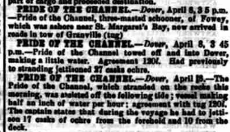
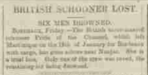

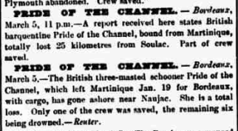
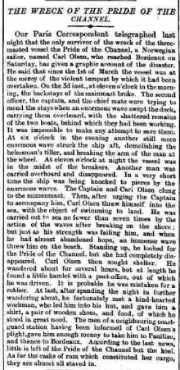
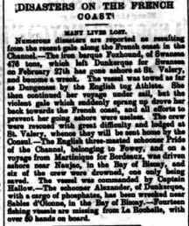
Ship: Pride of the Channel; Official number: 63974.
George Vincent Piper; rank/rating, Master; age, 45; place of birth, Cornwall; previous ship, same ship.
Alfred D Piper; rank/rating, Mate; age, 23; place of birth, Cornwall; previous ship, same ship.
James Hopwood; rank/rating, Boatswain; age, 30; place of birth, Goole; previous ship, same ship.
Alexander Hollons; rank/rating, Cook and Steward; age, 45; place of birth, Cornwall; previous ship, Narcissus, Hms.
James E Piper; rank/rating, Able Seaman; age, 17; place of birth, Cornwall; previous ship, Pride of the Channel of Fowey.
William Langmaid; rank/rating, Able Seaman; age, 21; place of birth, Cornwall; previous ship, Star of Peace of Brixham.
T H Hambley; rank/rating, Able Seaman; age, 23; place of birth, Cornwall; previous ship, E S Hocken of Fowey.
J H Lovering; rank/rating, Ordinary Seaman; age, 18; place of birth, Cornwall; previous ship, first ship.
Date: | 1881

