Schooner Rebecca

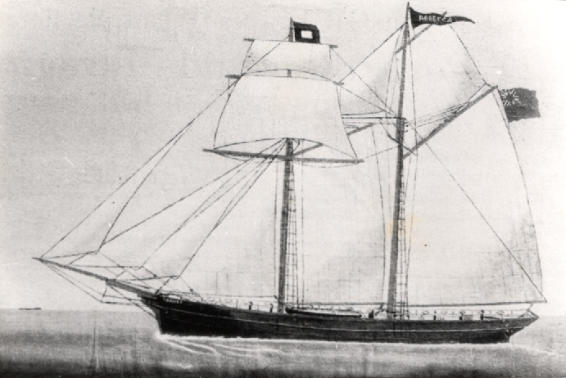

Vessel Name | Official Number |  | Signal letters | Rig /Type | Where built |  | Builder |  | Year built |  |  | Year end |  | reg tons
REBECCA | 44891 |  | VBCQ | schooner |  | Polruan |  | Nicholas Butson |  | 1862 |  |  | 1899 |  | 78
OWNERS/ MANAGERS/REGISTRATION DETAILS |  | Notes |  |  |  |  |  |  |  |  | MASTERS
registered in Fowey 14th April 1862. John Clements Junr, West Looe 1890 Thos. Halls Knight, Lostwithiel |  | Loa 80 x 19 x 10.5 ft Launched on Saturday 15th February 1862. On 25th February 1885 put into Penzance disabled after being in collision with schooner Joseph of Penzance off Lands End. Not registered in 1899 |  |  |  |  |  |  |  |  | J.Clements 1862-1872 Bowden 1873-1885

