Schooner Sabina
Vessel Name | Official Number |  | Signal letters | Rig /Type | Where built |  | Builder |  | Year built |  |  | Year end |  | reg tons
SABINA | 17664 |  | MHPN | schooner |  | Polruan/ Bodinnick |  | Nicholas Butson |  | 1841 |  |  | 1876 |  | 96
OWNERS/ MANAGERS/REGISTRATION DETAILS |  | Notes |  |  |  |  |  |  |  |  | MASTERS
Registered in Fowey 23rd June 1841. 1846 Peter Tadd, Polruan 1875 Mrs Grace Tadd, Fowey |  | LOA 65.7 X 18 X 11.2FT.12th October 1872 whilst on passage from Dublin for Middlesborough was abandoned 40 miles NE of Cromer in a sinking state off Lowestoft. She was carrying pig iron and old rails. Crew saved and landed in Lowestoft. The smack Florence May of Gorleston found her as a derelict and towed her into Lowestoft. She was later lost in 1876 on a voyage from Fowey to Newcastle for coal .she passed Deal on 9th April but was not seen or heard of again. |  |  |  |  |  |  |  |  | Peter Tadd 184 -59 J.Martyn 1859-1872 Barton 1869 Tucker 1873 Langmaid 1872-73 Buckingham 1876

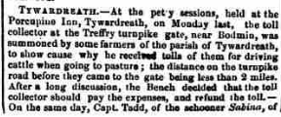
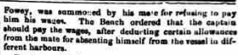
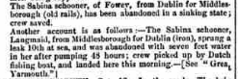
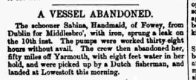
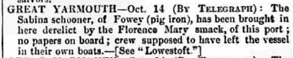
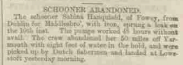
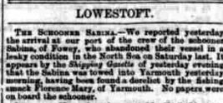

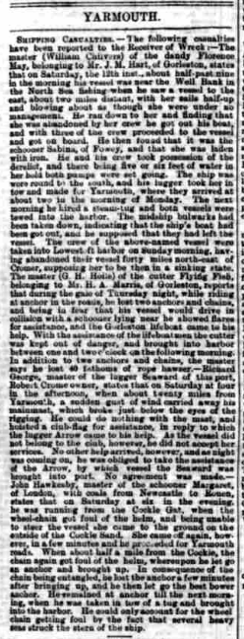

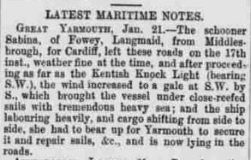
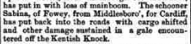

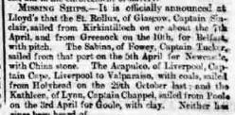
The Fowey schooner Sabina was last seen passing Deal on April 9th 1876 on voyage Fowey to Newcastle. Presumed lost off Yorkshire coast.
Read more at wrecksite: https://www.wrecksite.eu/wreck.aspx?265801

