Schooner Sarah
Vessel Name | Official Number |  | Signal letters | Rig /Type | Where built |  | Builder |  | Year built |  |  | Year end |  | reg tons
SARAH | 21344 |  | NFVT | 3 masted schooner |  | Kingsbridge |  | Date |  | 1858 |  |  | 1911 |  | 119
OWNERS/ MANAGERS/REGISTRATION DETAILS |  | Notes |  |  |  |  |  |  |  |  | MASTERS
1863 registered in Dartmouth to R H SLADEN. 1885 John Ennor Newquay |  | LOA 103.6 x 22.9 x 11.9ft. previously registered in Dartmouth 3rd July 1858. and London registered. On 26th January 1893 Sarah, of Fowey, was driven on to Clippern rocks near Holyhead, but the crew of five men were rescued and taken to Holyhead, where they were accommodated at the Sailors' Home. She was on passage for Runcorn from Fowey, the crew returned later and some the china clay was discharged and she was later got off badly damaged to the bottom. Went aground on Castle point Falmouth 1910. Pulled off by tug Not reg in Fowey after 1911. |  |  |  |  |  |  |  |  | Richard ARUNDEL 1863 Clark 1864 -71 J.Carter 1894-1909 Lightfoot 1890 Wilkinson 1907

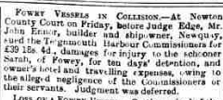

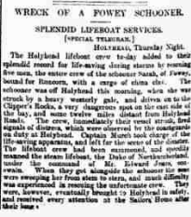
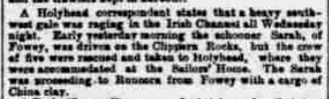

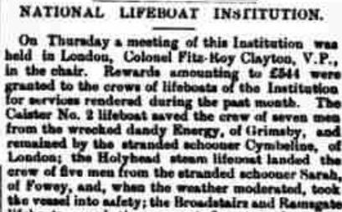
SARAH | Dates | 8/8/1863 to 18/12/1863
Official number | 21344 | List type | List C
Ownership | R H SLADEN | Registered | DARTMOUTH, 30/1858
 | SALCOMBE, DEVON | Tonnage | 156 net
Master | R ARUNDEL | Archives | Devon Archives and Local Studies
 | SALCOMBE | Archives reference | 1976/SARAH/21344
Crew names
Forename | Surname | Age/DOB | Birthplace | Capacity | Previous vessel
RICHARD | ARUNDEL | 42 | SALCOMBE | MASTER | REMAINS
JOHN | PUTT | 25 | SALCOMBE | MATE | SARAH, DARTMOUTH, 1863
THOMAS | HILSON | 25 | SUNDERLAND | BTSWN | A SCLAREDEN, SUNDERLAND, 1863
THOMAS | PEARSE | 26 | BRISTOL | AB | BETSEY HALL, L'POOL, 1863
JOHN | HOWTIE | 25 | MONTROSE | AB | LOCHIEL, ABERDEEN, 1863
GEORGE | BRAUCEY | 23 | HASTINGS | OS | ELIZABETH, GIBRALTAR, 1863
JENS | JENSEN | 22 | COPENHAGEN | AB | DORL[...], BRISTOL, 1863
JOHN | ROLS | 22 | SWEDEN | AB | JOHN DAVIS, L'POOL, 1863
WILLIAM | BUISH | 18 | EDINBURGH | OS | LOCHIEL, ABERDEEN, 1863
JOHN | ATWAY | 35 | L'POOL | COOK & STEWARD | EDITH, SHOREHAM, 1863
HENRY | FREEMAN | 17 | BOVEY | COOK & STEWARD | LADY ELLIOTT, FOWEY, 1863
WILLIAM | JACKSON | 26 | WHITEHAVEN | OS | OCTAVIA, WHITEHAVEN, 1863
C | HERG | 26 | SWEDEN | AB | M[...]ER, [...], 1863
BRUCE | C[...] | 26 | GLASGOW | AB | GLENG[...], [...], 1863

Vessel | SARAH | Dates | 24/3/1863 to 3/8/1863
Official number | 21344 | List type | AC
Ownership | R H SLADEN | Registered | DARTMOUTH, 30/1858
 | SALCOMBE | Tonnage | 156 gross,
Master | RICHARD ARUNDEL | Archives | Devon Archives and Local Studies
 | SALCOMBE | Archives reference | 1976/SARAH/21344

Crew names
Forename | Surname | Age/DOB | Birthplace | Capacity | Previous vessel
RICHARD | ARUNDEL | 41 | SALCOMBE | MASTER | SAME SHIP
JOHN | PUTT | 24 | SALCOMBE | MATE | ELIZABETH, SALCOMBE
JOHN | SMITH | 39 | BELGIUM | BSWAIN | MARY ANN, YOUGHAL
WILLIAM | LINTER | 20 | EXETER | COOK & STD | SALSBURY, LPOOL
JOHANARE | ROCO | 23 | ITALY | AB | BRITAINS PRIDE, SHOREHAM, 1863
HENRY | GRIFFITHS | 24 | LLANELLY | AB | ALERT, IPSWICH
RICHARD | LEVERING | 17 | ILFRACOMBE | OS | JOHN PARDEW, PLYMOUTH
THOMAS | SIRFIELD | 18 | BURNHAM | OS | R INGHAM, SHIELDS

