Schooner Silver Stream

Vessel Name | Official Number |  | Signal letters | Rig /Type | Where built |  | Builder |  | Year built |  |  | Year end |  | reg tons
SILVER STREAM | 58292 |  | RGNW | schooner |  | Polruan |  | Christopher Slade |  | 1868 |  |  | 1881 |  | 152
OWNERS/ MANAGERS/REGISTRATION DETAILS |  | Notes |  |  |  |  |  |  |  |  | MASTERS
registered 15th September 1868. William Geake,St.Columb , |  | LOA 100.2 x 22.7 x 12.7ft. Launched august 1868 by miss Slade.built for Mediterranean and Brazilian trades. Silver Stream, of Fowey, left Cadiz for St. John's, Newfoundland, with salt, Sept. 23, 1881; lost with all hands |  |  |  |  |  |  |  |  | Elias R.Tadd 1868 Phillip Tadd 1875-1881

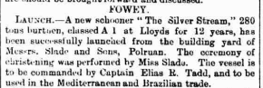Crew list
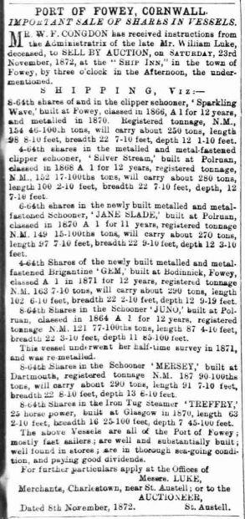

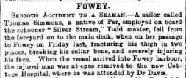

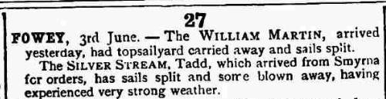 Silver Stream,

