**Schooner Spring**

|  |  |  |  |  |  |  |  |  |  |  |  |  |  |  |  |
| --- | --- | --- | --- | --- | --- | --- | --- | --- | --- | --- | --- | --- | --- | --- | --- |
| **Vessel Name** | **Official Number** | | **Signal letters** | **Rig /Type** | **Where built** | | **Builder** | | **Year built** | | | **Year end** | | **reg tons** | |
| **SPRING** | 55485 | | SPDG | Schooner | | Kingsbridge | | W.Date and Sons | | 1867 | | | 1916 | | 132 |
| **OWNERS/ MANAGERS/REGISTRATION DETAILS** | | **Notes** | | | | | | | | | **MASTERS** | | | | | |
| 1867 W H L.Yabsley Salcombe. 1887 - 1890 E dward Rillston, Dolphin House, Quay, Fowey (MO) | | registered in Salcombe on 18th June 1867. In 1899 she transferred to the London regisiter and renamed GRAVESEND. On 20th March 1915 morrings failed and she drifted onto goodwins. Crew rescued. Vessel towed in by tug and lifeboat .  register closed 1916 | | | | | | | | | BENJN BUSHELL 1867 Piper 1888-89 Rundell 1895 J.E.Court 1900- 1914 | | | | | |

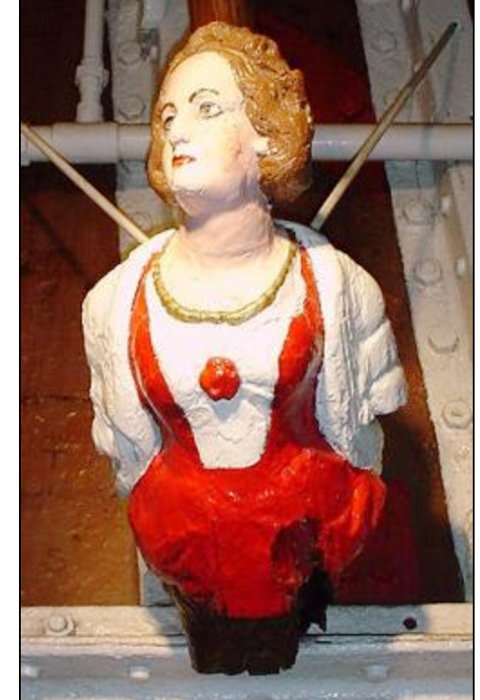

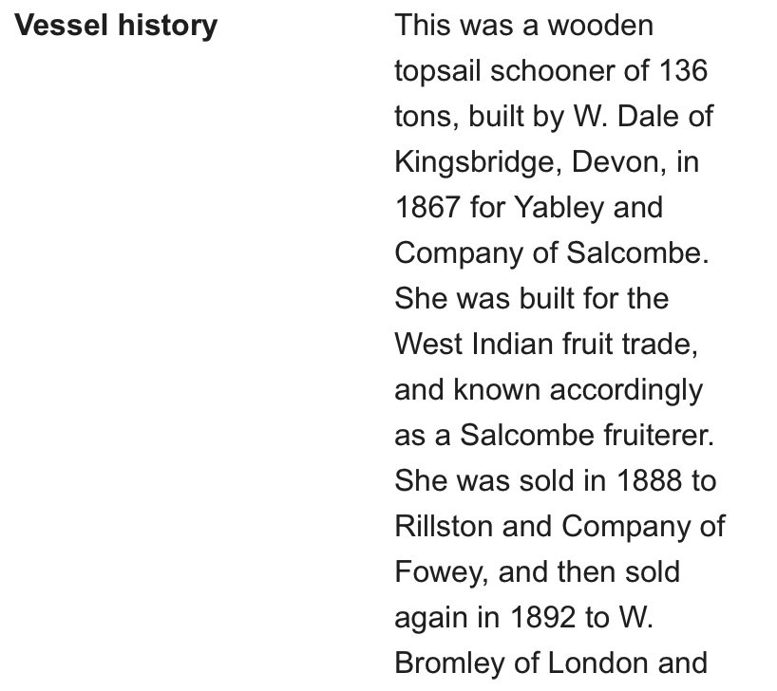

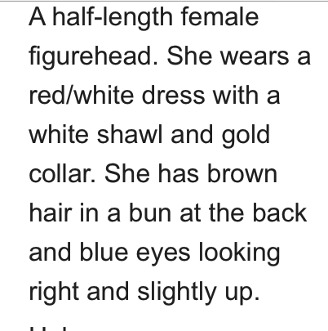

The figurehead of the Spring later known as Gravesend store on board the Cutty Sark.

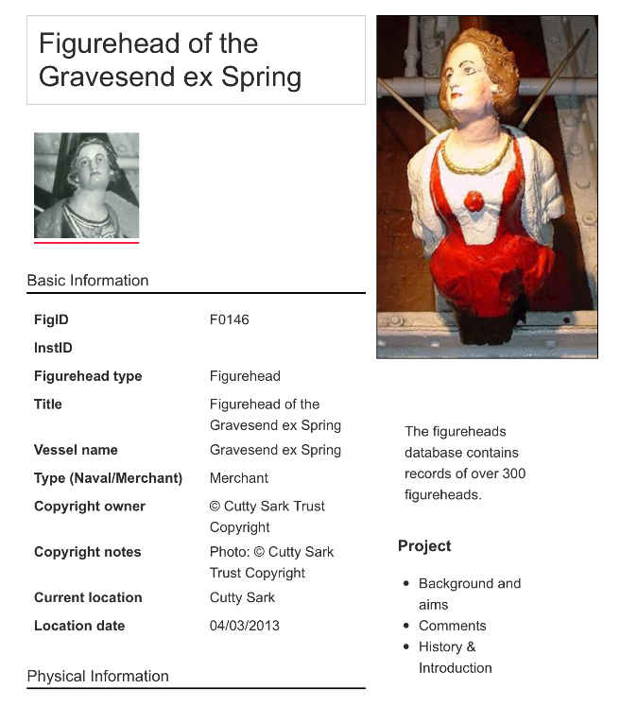

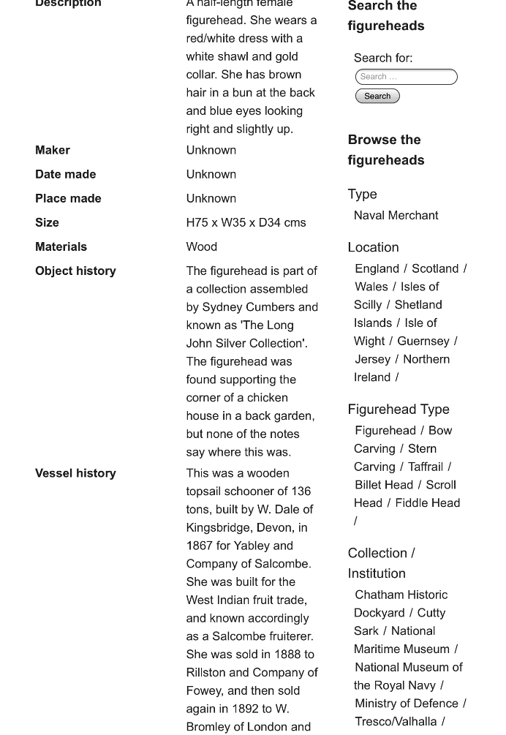





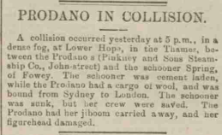

**As the schooner Gravesend**

