Schooner Standard
Vessel Name | Official Number |  | Signal letters | Rig /Type | Where built |  | Builder |  | Year built |  |  | Year end |  | reg tons
STANDARD | 11403 |  | KSMD | sloop ketch |  | Fowey |  | William Brokenshire |  | 1837 |  |  | 1917 |  | 51
OWNERS/ MANAGERS/REGISTRATION DETAILS |  | Notes |  |  |  |  |  |  |  |  | MASTERS
registered in Fowey 1st January 1838.Joseph Thomas treffry 1846 George B. Brokenshaw,Jnr, Fowey 1890 Alfred Nicholas, Watchet, Somerset 1915 Willie Nicholas, Gillam Trc, Watchet (MO) |  | LOA 54 x 16.5 x 8.6ft. altered to ketch in 1889 dismantled and hulked in 1917. |  |  |  |  |  |  |  |  | T.Harris1842-1846 Hocking 1845-46 T.Lean 1848-49 Thomas Lane 1851 James Hanson 1869-73 Burgess 1873 Button 1876 Mutton 1877 John Thos Harris 1879-1883 Rasmussen 1905-10

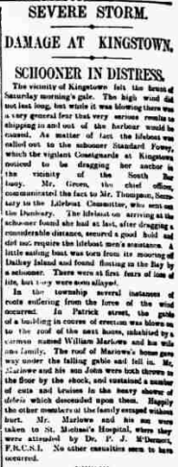
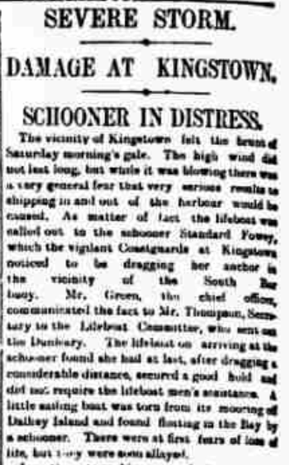
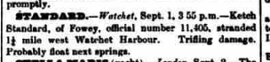

Name | rank | age | birthplace | previous vessel
WILLIE NICHOLAS | MASTER | 46 | WATCHET | SAME SHIP
WILLIAM MACORD | MATE | 48 | JERSEY
WILLIAM NORMAN | ABLE SEAMAN | 51 | WATCHET | SAME SHIP

