Schooner Sterling
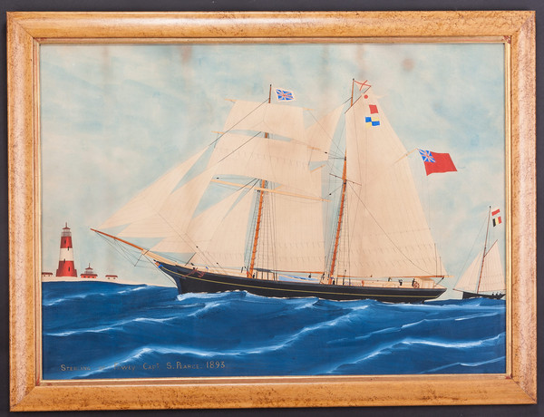
The Topsail Schooner Sterling of Fowey
c. 1893 Belgium
The Topsail Schooner Sterling of Fowey portrayed in the Scheldt estuary with an accompanying pilot cutter.
Painted in watercolour, gouache and ink on paper, with gum Arabic highlights, within a modern maple veneered frame. Dated 1893.by Aristidius Amatus Joannes De Clerck

Vessel Name | Official Number |  | Signal letters | Rig /Type | Where built |  | Builder |  | Year built |  |  | Year end |  | reg tons
STERLING | 45187 |  | VCHL | Schooner |  | Brixham |  | Dewdeny |  | 1863 |  |  | 1895 |  | 169
OWNERS/ MANAGERS/REGISTRATION DETAILS |  | Notes |  |  |  |  |  |  |  |  | MASTERS
1882 James Johns, Mevagissey 1896 WilliamV.Kellow, Pentewan (MO) |  | LOA 99.4 x 23.6 x 12.6ft registered in Dartmouth 28th July 1863.1880 registered in Brixham. March 1883 abandonened of Dover after a collision but later towed into Dover on 30th March 1883. She had been in a collision and the crew abandoned ship in their own boat. later landed at Margate. on 8th December 1895 having been in severe weather for 3 days and losing her foremast and becoming uncontrollable foundered 15 to 20 miles W x S of Norden lighthouse near Heligoland. The fishing Smack Columbus rescued the crew except for the captain who remained on board until just before she sank. He got off in the tender and was rescued by the Columbus. All were landed in Hull. Foundered in the North sea 8th December 1895 |  |  |  |  |  |  |  |  | Sprague 1871 Pearse 1881 T.Brooks 1883 Richard Johns 1883 Dingle 1887 J.Johns 1889-91 S.Pearce 1894-95

