Fowey Harbour Sewage Scheme
Under the “Clean Sweep” programme, South West Water after much discussion got down to upgrading the Fowey, Polruan and Bodinnick sewage systems and various projects were looked at. As all the sewage drained into the harbour and estuary system it was decided that was where the sewage should be collected and then pumped to a works at Penventinue treated .“Treated effluent” was then permitted to be discharged into the estuary from the various treatment works serving communities around the estuary.
After a lengthy consultation process the work on the scheme finally got under way in 1993. Due to the length of time needed to complete, work was restricted to winter working over the following two winters. This was a condition placed by the Harbour Commissioners who owned the harbour foreshore and fundus and controlled harbour operations together with the Town Council and Restormel Borough council as a planning condition. Others involved were the Polruan Town Trust, the Environment Agency, the Treffry and Boconnoc estates together with others. The scheme was to largely be built in the harbour for the collection tanks, pumping stations and the pipe work to collect the sewage and then pump it to the treatment works.
In the harbour it was going to require the lifting of the leisure moorings along the Fowey shore, in the southern part of Polruan pool and at Caffa Mill. There would also be major disruption to landing passengers at Fowey and Polruan quays with work at the other two landings of Whitehouse and Riverside. The Harbour Commissioners together with the councils and the environment agency had to therefore work closely with the contractors, Mowlem and South west water to ensure that the disruption was kept to a minimum and the communities and harbour operations could continue to function.
It was obvious that the works would cause major disruption to the communities around the estuary and it was agreed that the work would be carried out in the winter months. There would be four main sites of work on land and they were where the collecting /holding tanks and pumping stations would be located. These were to be at Polruan quay, Readymoney cove, Fowey town quay and Riverside slipway. At each of these locations a major construction was necessary involving either building an extension to the quays or building tanks in the existing local fabric. At each site, a watertight cofferdam needed to be constructed inside of which the constructions could take place throughout the tidal window. Large amounts of materials and plant would be necessary and it was agreed that the only way this could be achieved was by water borne delivery system and the large plant , concrete lorries and specialized cranes would come in on large pontoons.
All the sites would be connected by a series of collector and pumping mains and sewage would be pumped to the treatment works from the main site on town quay. All the discharges of which there were many from properties and public sources had to be connected to a series of collector mains and there began a huge task of locating them for this work to be carried out. Many of these discharges were in poor condition and often “open” on land and this had to be addressed as well.
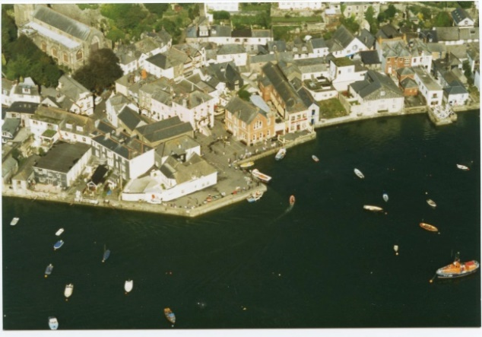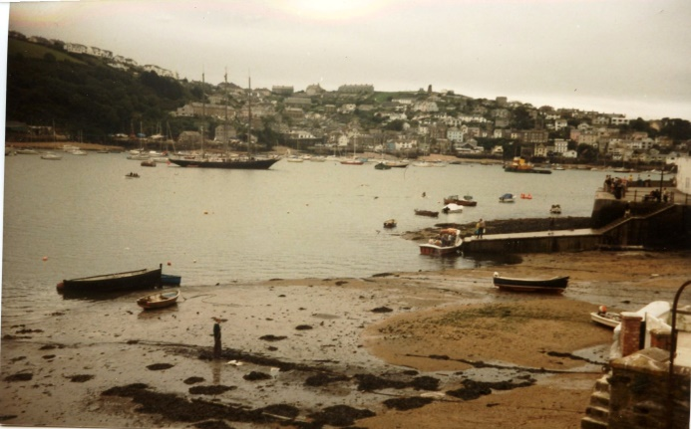
The town quay site before the quay extension where the main holding tank and pumping station was to be built
BUILDING THE TOWN QUAY FACILITY
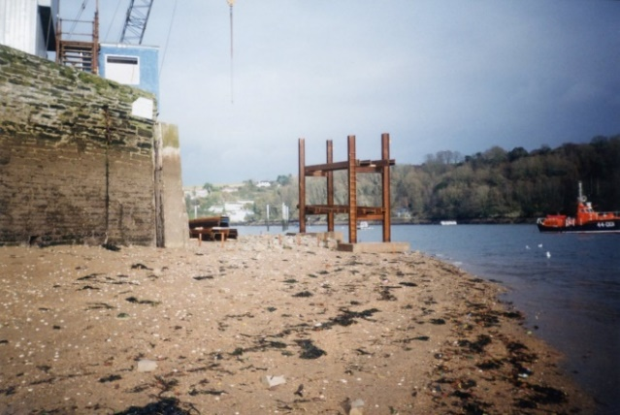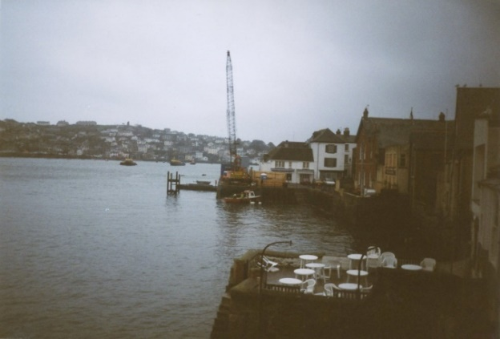
As all the sewage from Fowey and Poruan was to be collected at the Town Quay storage tank that had to start first.A large crane was brought down by water and a steel cofferdam had to be constructed first.The extension built out onto the foreshore had to be higher than the rest of the quay to prevent as much as possible the overtopping at high tides and in bad weather. Pumps were to be installed together with an emergency discharge .
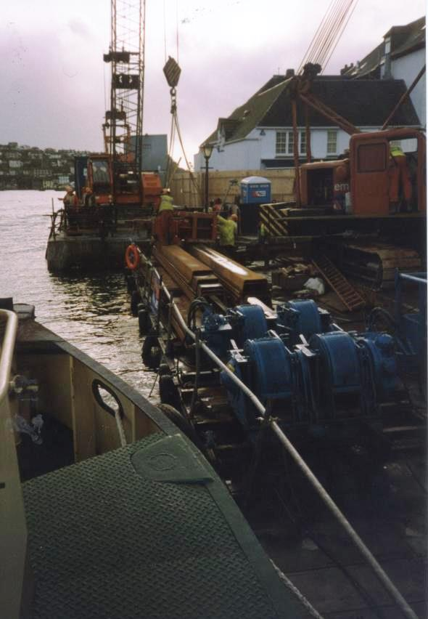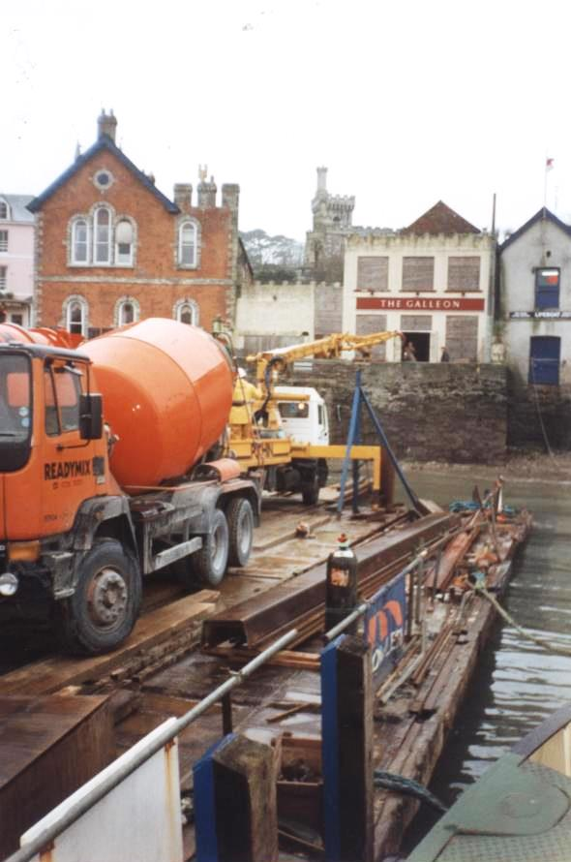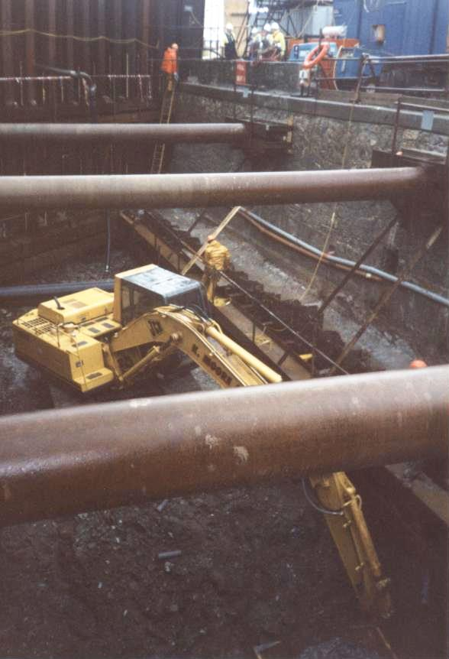
All the materials wer brought down from Caffa Mill or the docks together with the considerable quantities of concrete. Whilst this work went on in the winter of 1994 the ferry landed at Riverside Slipway.
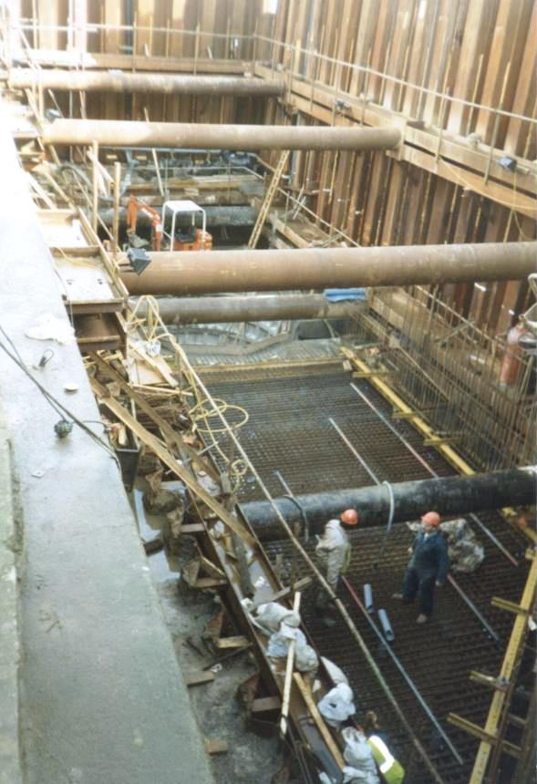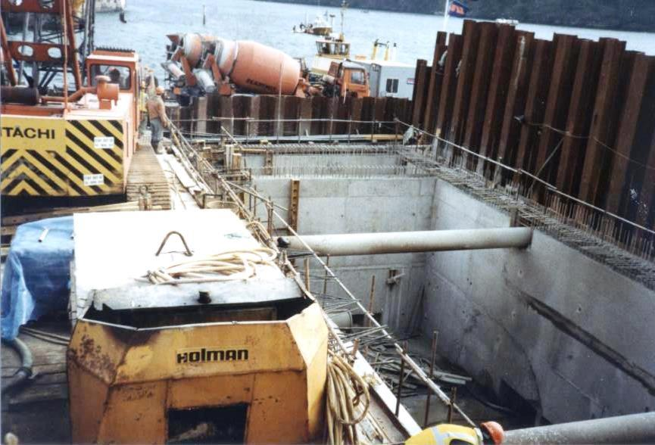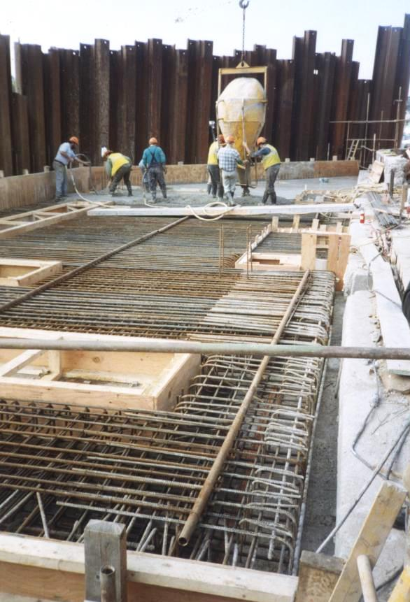
Inside the cofferdam was dug out and then shuttering and braces were built before concrete could be poured. With the sides of the tank constructed the top was built.

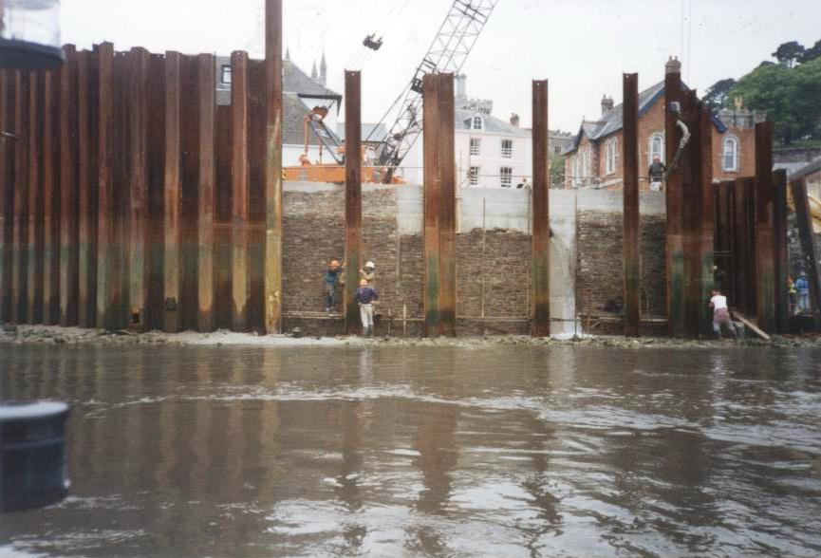
With the tank walls constructed and intakes in place and watertight the covering stonework was started then the shuttering removed to complete. A ladder was installed on the quay face.
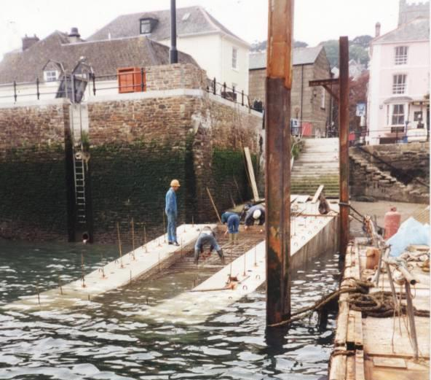
As the quay had been extended so was the slipway to provide landing at low water. The upstream side having been deepened.
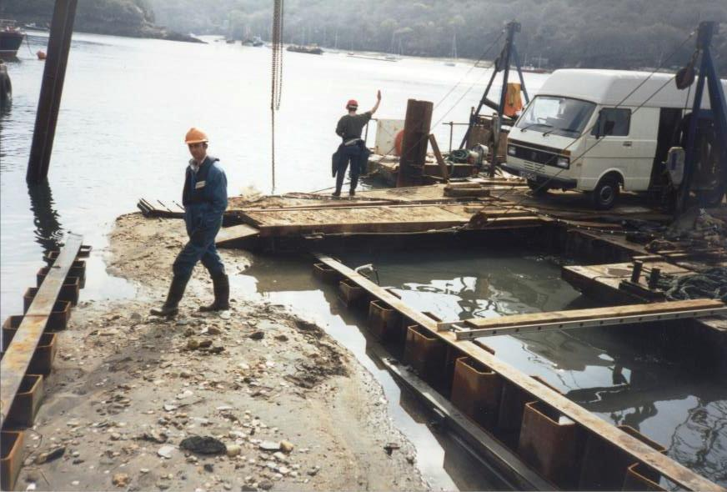
Work had to be completed on valve chambers and pipe work connecting the upstream pipes
PIPE WORK IN THE FORESHORE
The laying of pipe lines connecting the holding tand/ pumping stations was a major part of the operations and caused major disruption to the harbour operations.All leisure moorings were removed and stored at Brazen Island and a programme had to be planned so that not all areas of the harbour were dug at the same time.

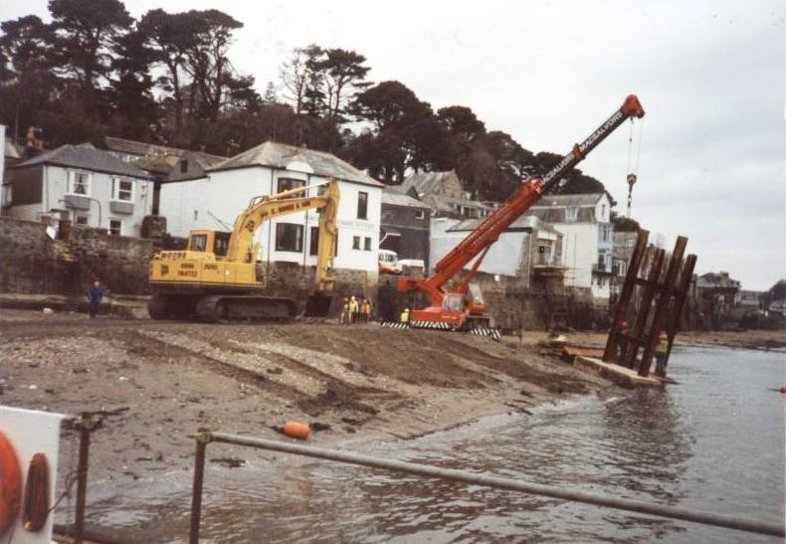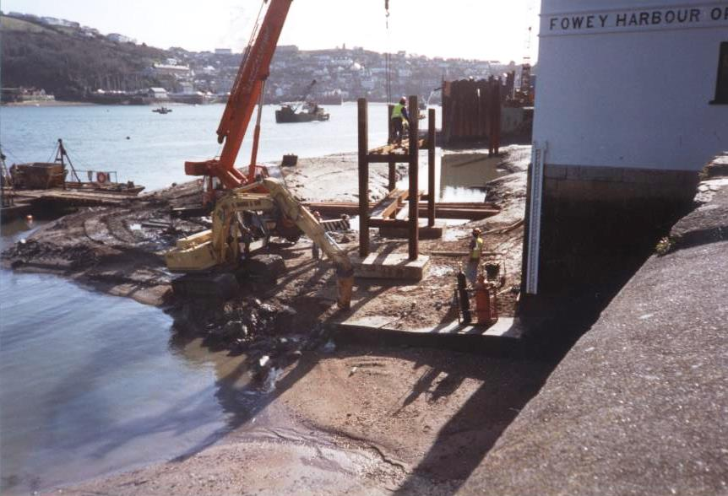
The pipe work was started heading along the foreshore past the Albert Quay where it had to go through the slipway close to the Harbour office clear of the pontoon landing.The trenches were dug with diggers landed from a pontoon as the tide went out. Specialist tracking diggers were used .
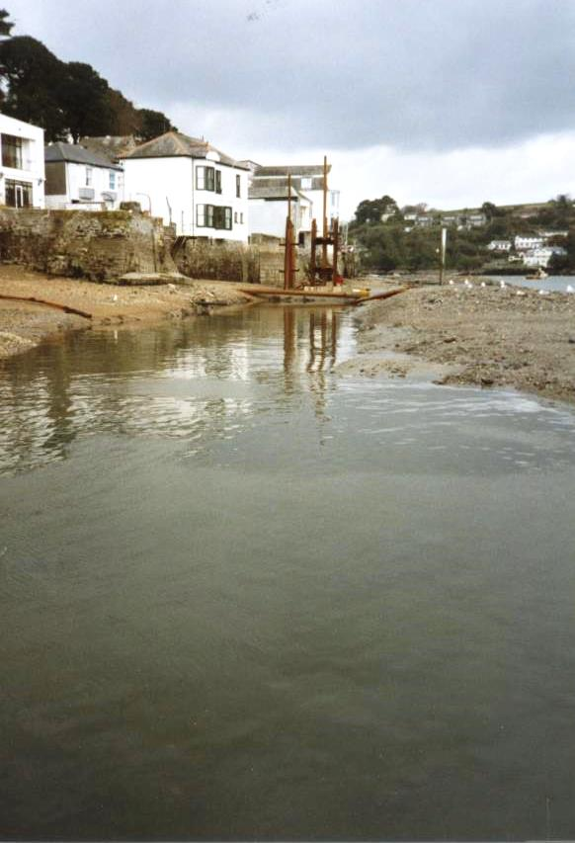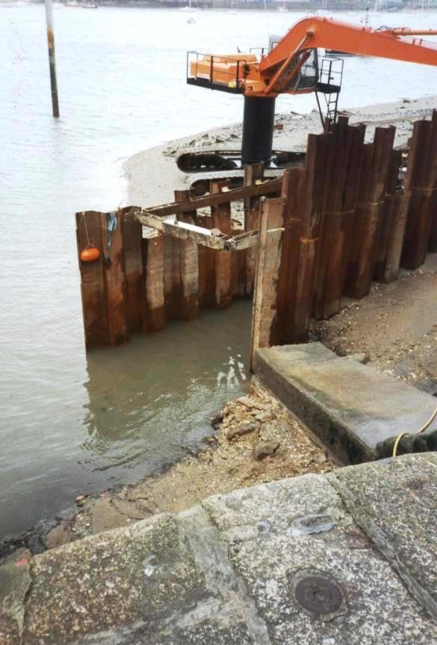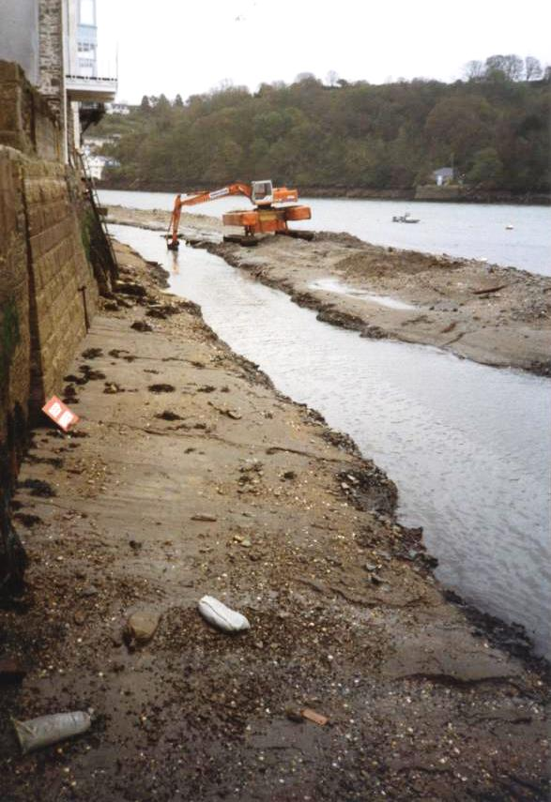
Shuttering was used to prevent the foreshore erroding and exposing sea wall foundations
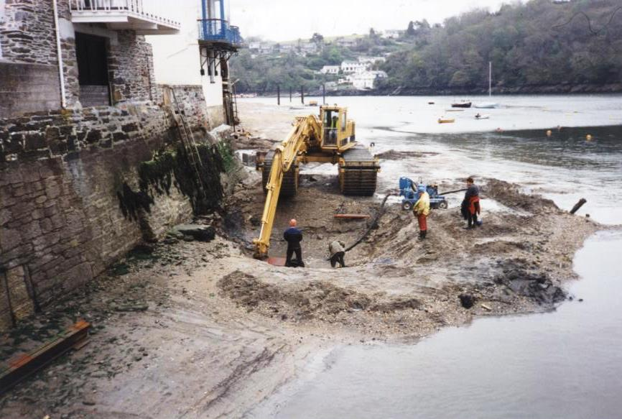
All along the foreshore a deep trench was dug to firstly lay the collector main attaching all the outfalls then outside this another pipe taking the sewage from town quay to Caffa Mill. All the moorings had to be removed to allow the digging and to get plant in and out and float in the pipeline
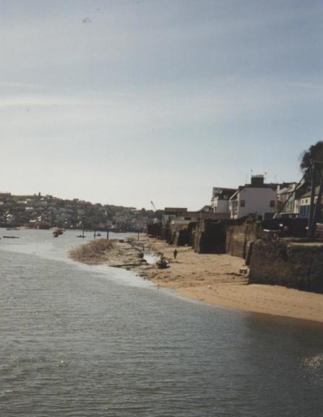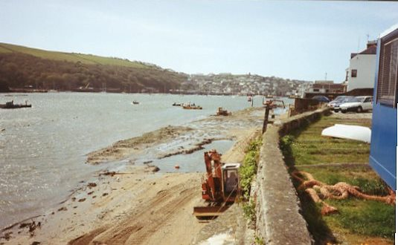
Work was commenced at Berrills yard foreshore in the spring and then a large section of pipe was floated in and sunk into the trench. Moored off is a similar length of pipe ready for the pumped main
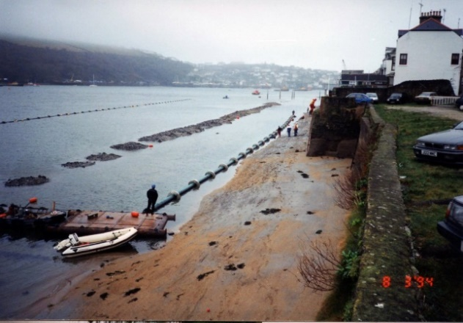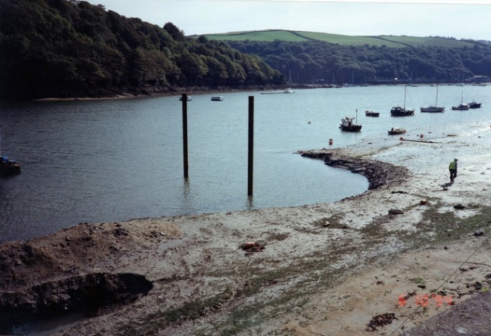
As there were plans for a landing pontoon and base for the RNLI this was dug out and piles put in ready at the same time.
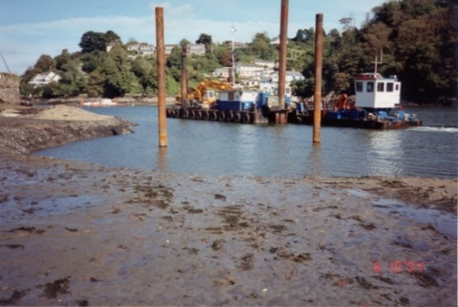
Putting in the piles and below the pontoon installation went ahead with the bank of the deepened area protected as well as stopping berosion of the pipe along the foreshore
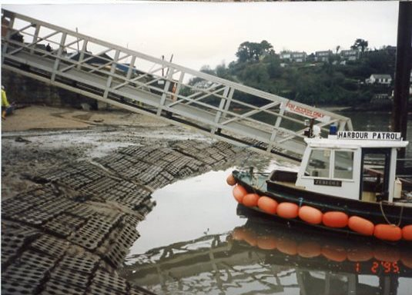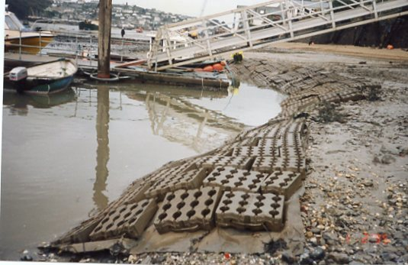
PIPE WORK AT WHITEHOUSE QUAY
Whilst there was no holding tank or pumping station at Whitehouse this was the point were the shore sewage system from Readymoney to Whitehous made its connection to the foreshore pipe line to Town Quay along with the pumped main from the Polruan quay works.The work involved considerable drilling and excavating a trench through the narrow access to the quay
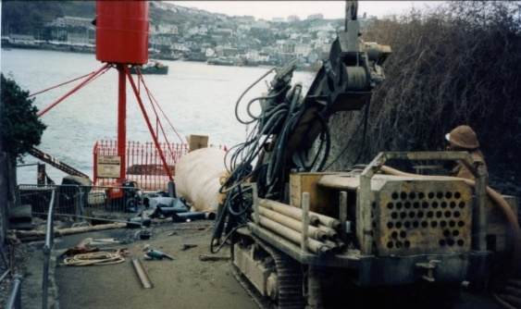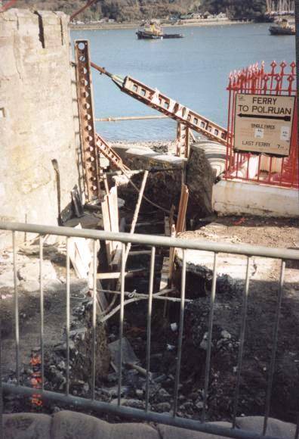
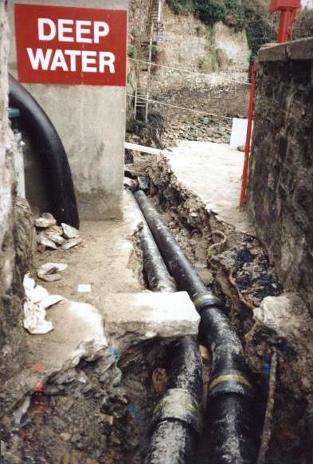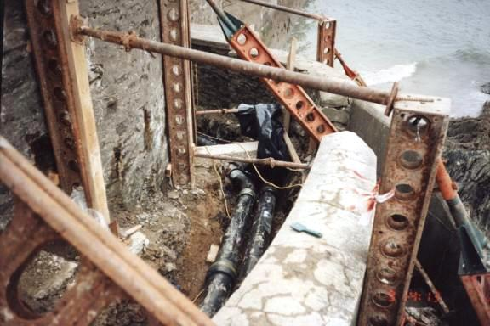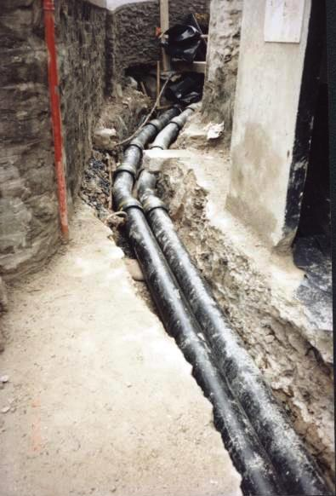
Walls had to be supported on both sides of the trench.
PIPE WORK FROM WHITEHOUSE QUAY
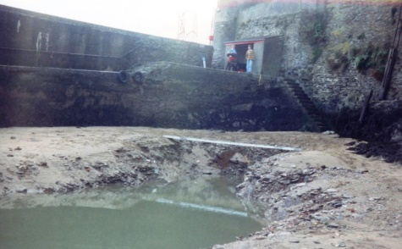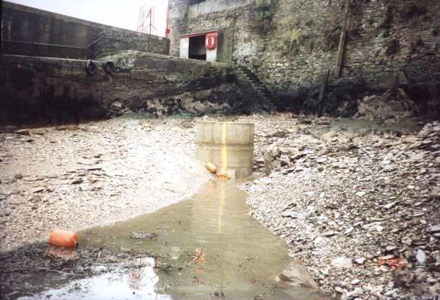
From Whitehouse the pipework had to drop down onto and join up wil the pipes in the foreshore towards Town Quay. A chamber was constructed fore maintenanance access.
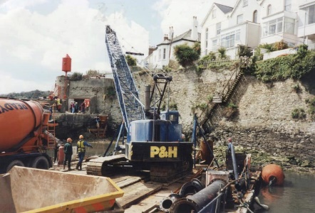

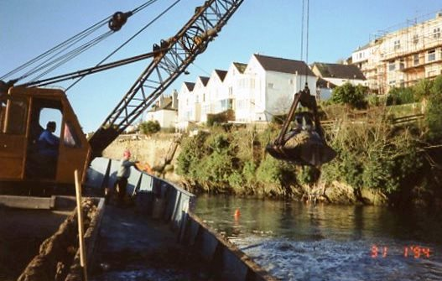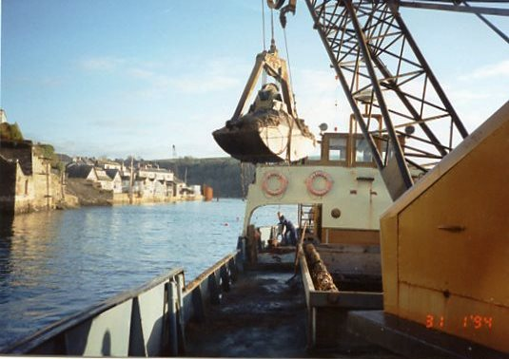
Material excavated from the trench dug by the foreshore based diggers had to be removed from the foreshore as it contained large quantaties of shale rock and hard material unsuitable for the pipe to be laid in or covered over with.The pipe had to be laid with a gradient on it down to the town quay
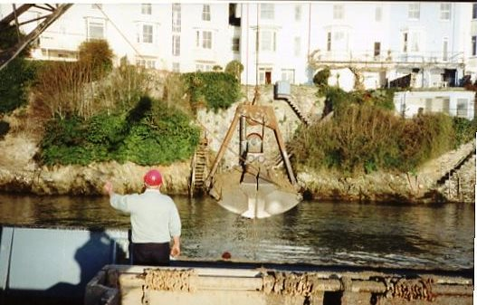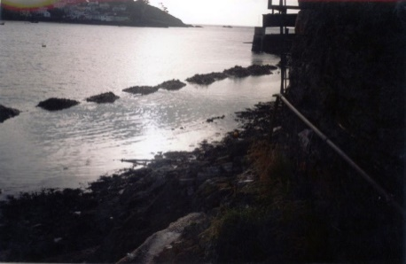
Ernie Libby master of the Lantic Bay directing operations. The material ready for removal
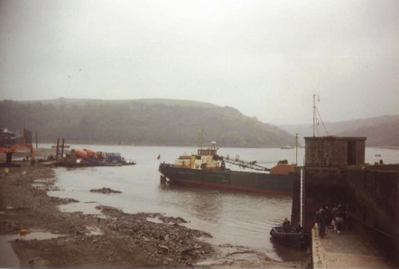
Lantic Bay caught out by the tide

PIPE WORK FROM POLRUAN TO WHITEHOUSE
This was done in two sections with the heavy duty near rigid bipe work along the foreshor on the polruan side connection into a flexible purpose made pipe to cross the harbour. A site had to be selected for the crossing and the decision to bury it close to the existing telephone and electricity cable was made. Anchoring in this part of the harbour was prohibited to protect the existing cables and this would afford the most protection. Whilst a trench was partially excavated the main part had to be air lifted in using divers.
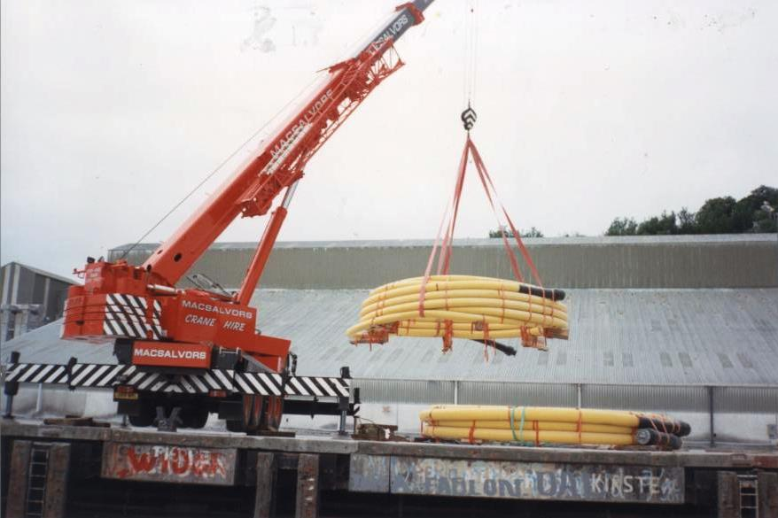
The pipe was made in Denmark at Copenhagen and transported by ship to Fowey docks where it was unloaded and made ready for loading on a barge for deployment
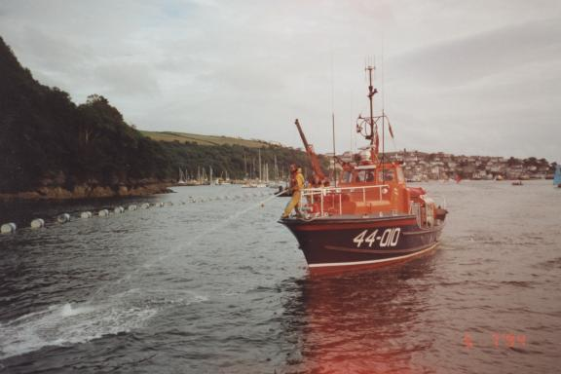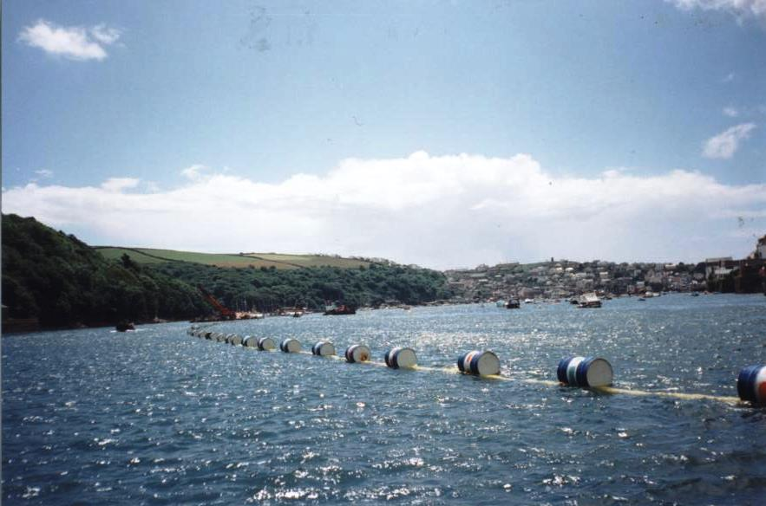
The floating pipe under tow or used as target for a lifeboat drill
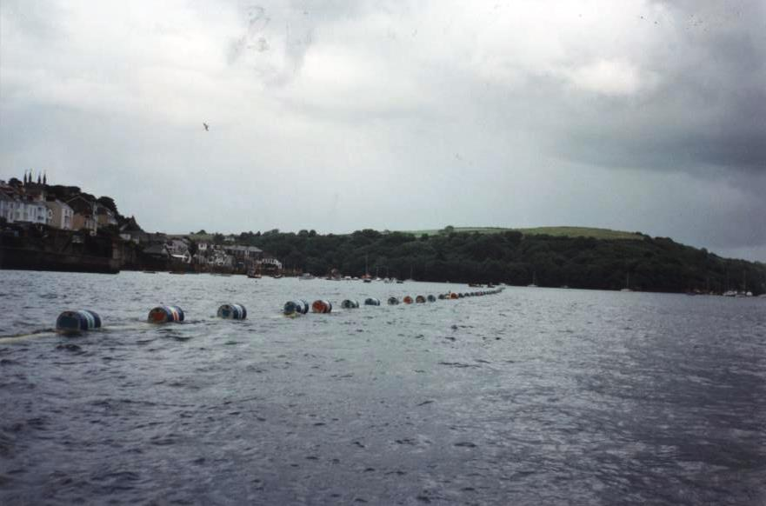
As the pipe was turned on a makeshift turntable 40 gallon oil drums were attached to make it float and it was moored between Prime Cellars and Bodinnick and the towed down the harbour to the crossing were the drums were cut off starting on the Polruan side by the Castle allowing the pipe to sink in place. This was done in June in-between shipping movements and in good weather.
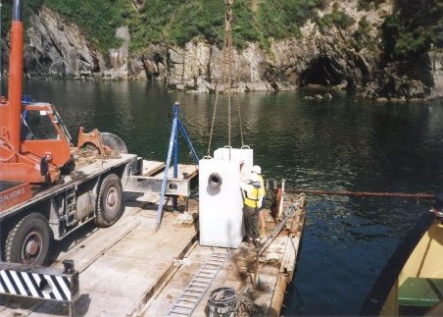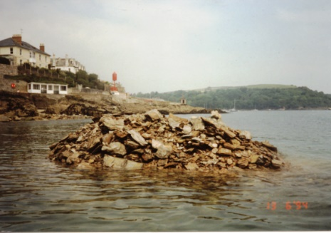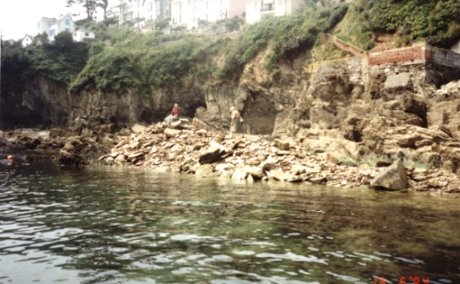
The pipe was in two sections and had to be joined just over half way across in this specially constructed chamber.There is largely sand and shingle in the mid channel but on each sude a trench had to be dug in the rocky seabed. Piles of rubble had to be removed and was used as infill at construction sites

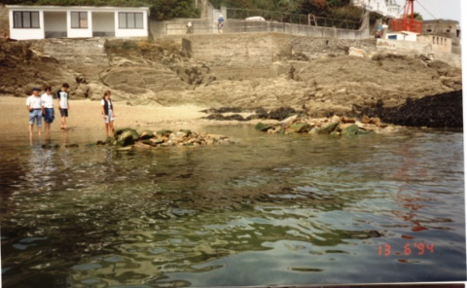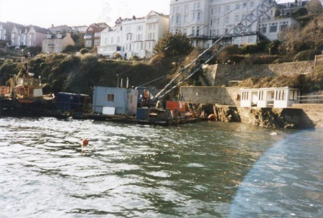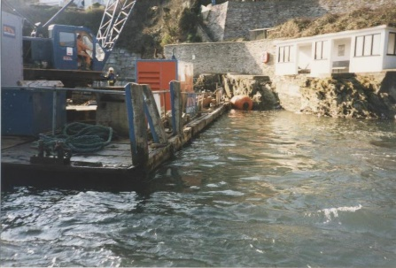
Although work in this section was permitted until the end of June the contractors still had to clear rubble from the whitehouse beach below low water. At High tide the big crane barge had to go right into the cove to access the pipe work and excavations
POLRUAN QUAY HOLDING TANK AND PUMP STATION
The second biggest construction site was at Polruan quay where the quay had to be extended out into the harbour and the steps for the ferry realigned, extended and rebuilt. The controls had to be situated in the newly built toilet and waiting room block and the associated pipe work collecting sewage from outlets and the pipe pumping the sewage across to Fowey had to be installed. As there was so much work on the quay and the steps were to be rebuilt an temporary landing had to be builtwith piles driven into the beach and a scaffolding structure and steps to allow ferry and other traffic to continue. The Polruan Town trust who owned and managed the quay had the task of agreeing all of this along with the Harbour Commissioners. Once agreed a steel cofferdam was built around the end of te quay and the steps and the water pumped out for work to commence.
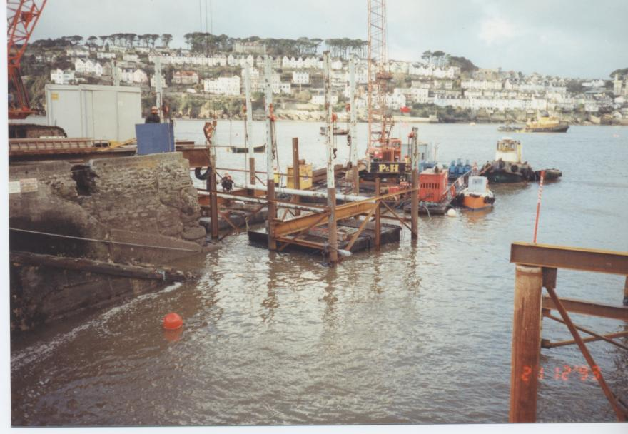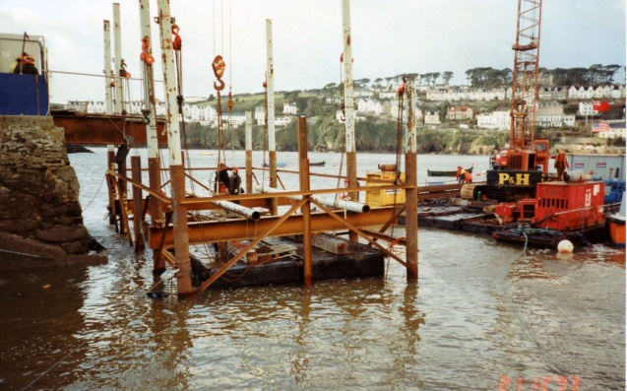
A steel frame was lowered into the position of the cofferdam to provide a frame work for the shuttering
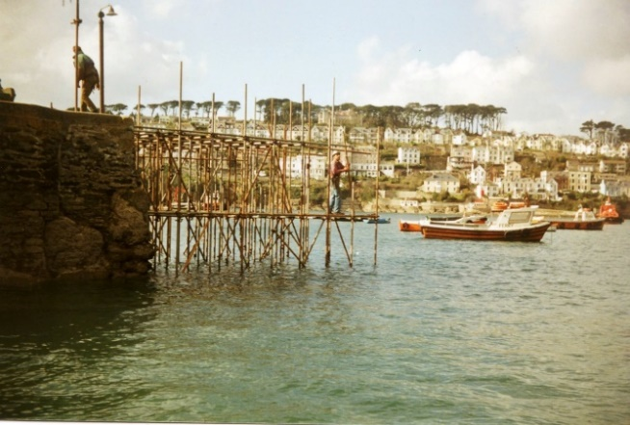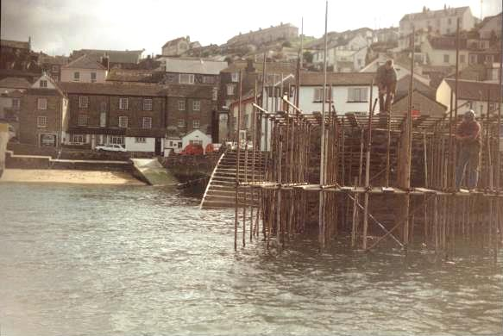
This was followed by a scaffolding structure to give support and to work from
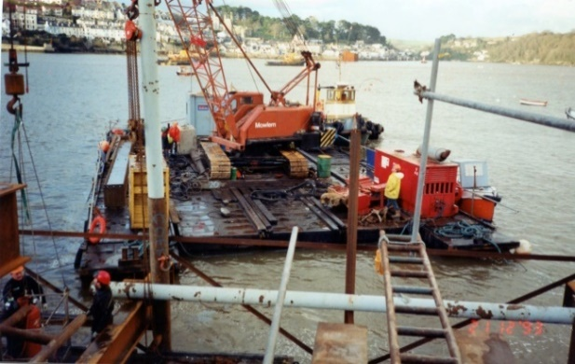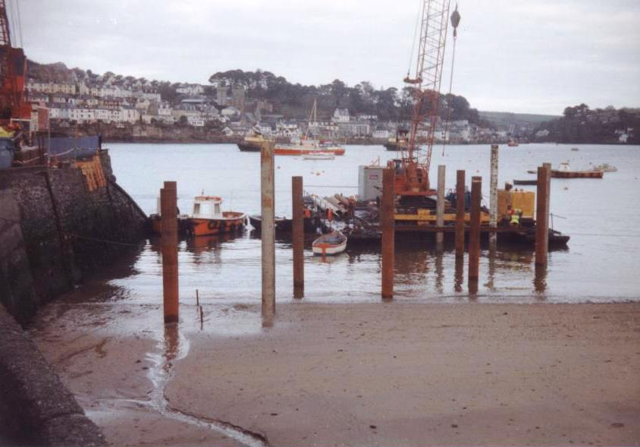
The load bearing pillons for the temporary landing were installed using a heavy lift crane on the barge
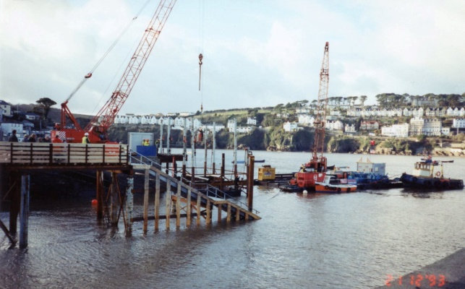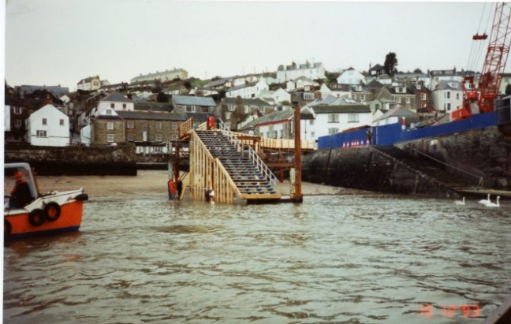
Once costrusted the work of building the cofferdam commenced. The ferry had to land on the upstream side where timbers wer placed to land against and hand rails were installed on the otherside for passenger safety
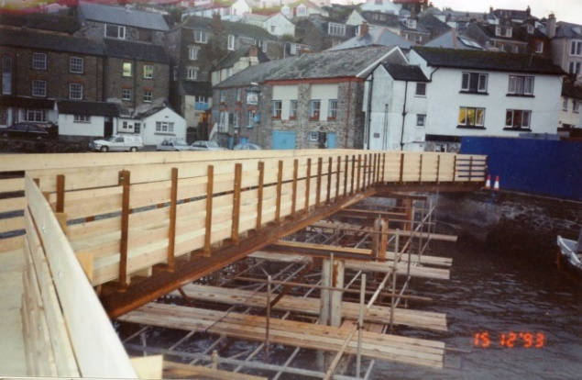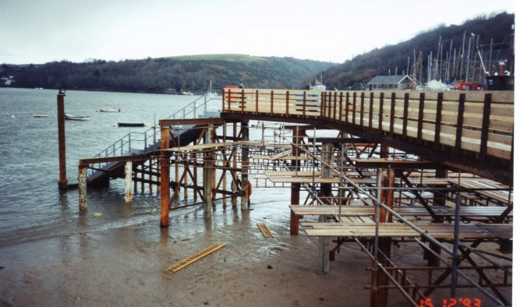
On the walkway leading to the steps safety barriers were constructed and the lifebuoy relocated.
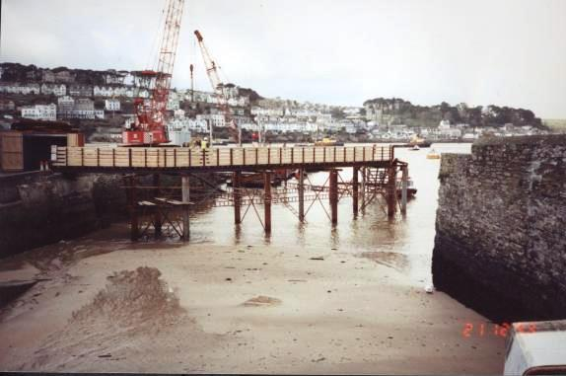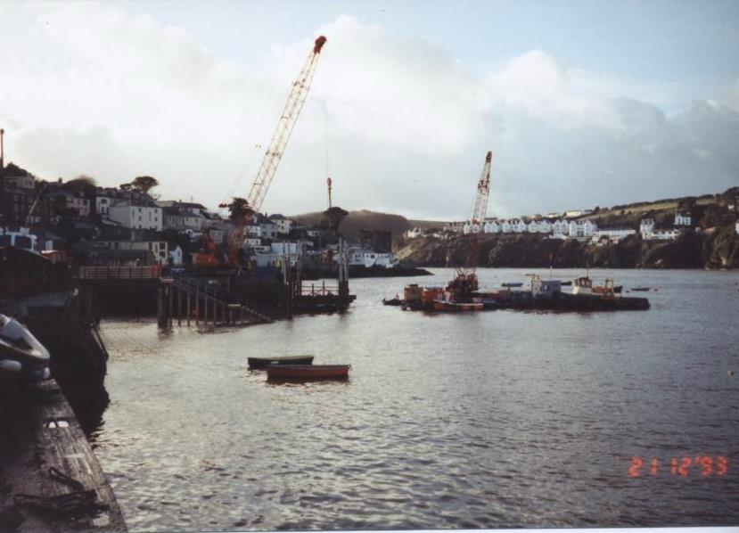
The Polruan ferry company were consulted through out ensuring the best facility could be provided.
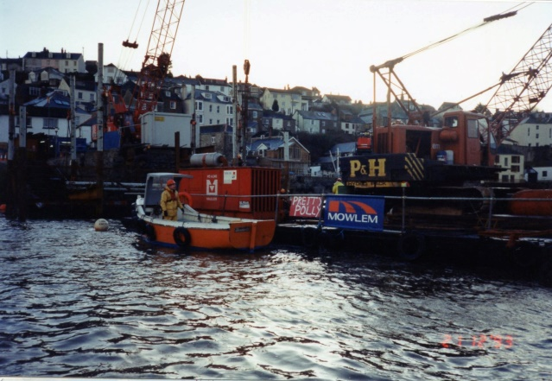
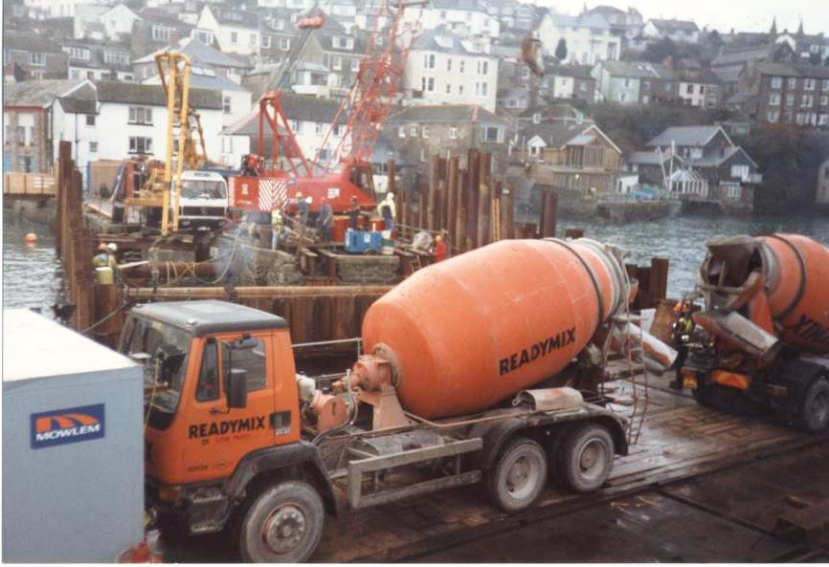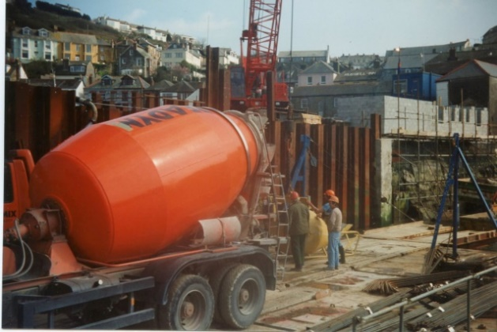

A large mobile crane was landed on the quay to do the pile driving and carry out all the many lifts. Concrete was brought in where possible at high tide but if not loaded into a special container which was then lifted in by crane.
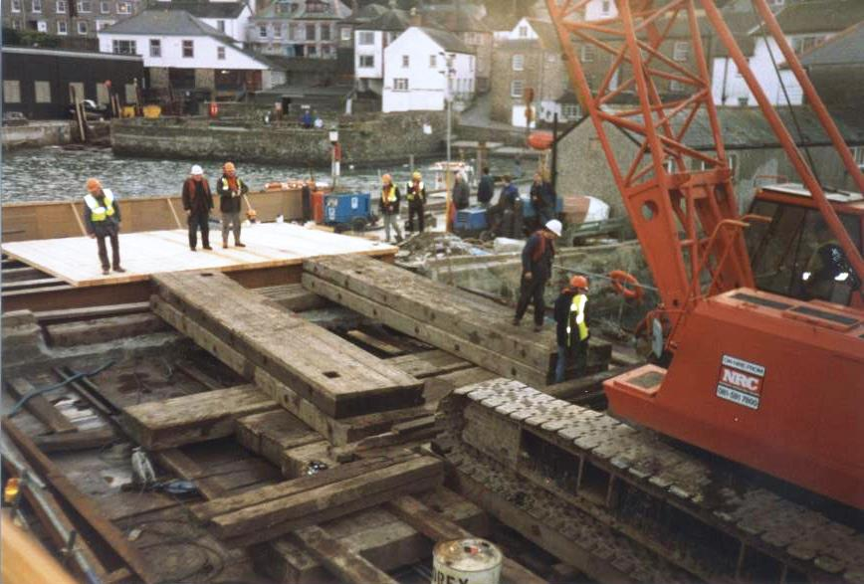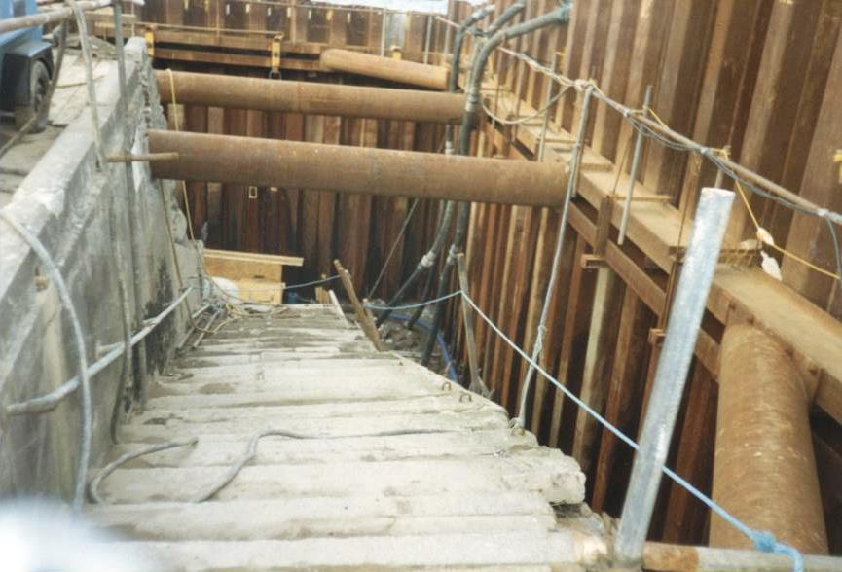
The crane had to be supported on large bulks of timber which spread the load. The steps were broken where necessary and rebuilt inside the cofferdam where large pipes were installed to prevent collapse at high tide.
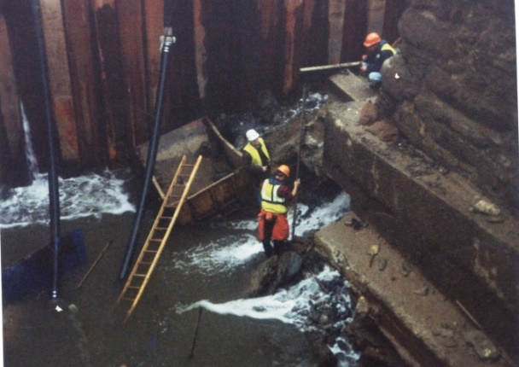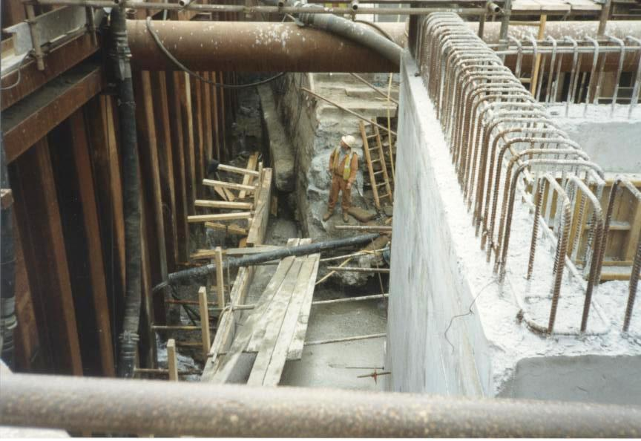
There was quite a bit of water ingress especially at high tide and pumps were used continuosly to keep levels down. The concrete holding tank was built inside with large quantities of reinforcing.
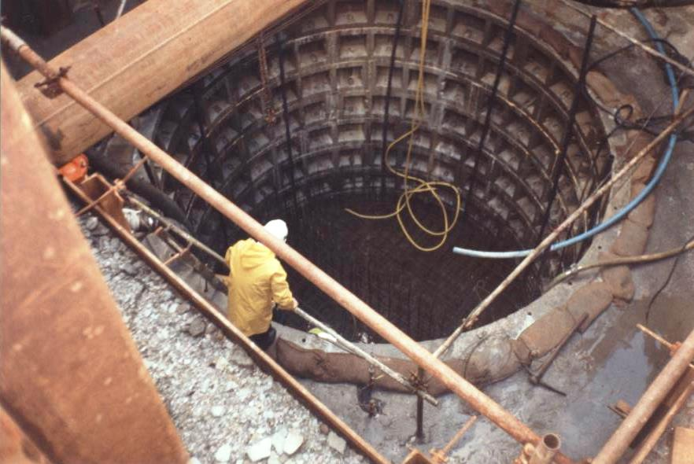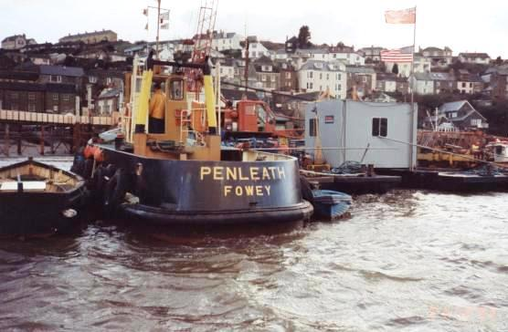
One of the tanks constructed and the construction barge with mess room and equipment needed delivered by Penleath
BERRILLS YARD RELIEF VALVE AND CHAMBER
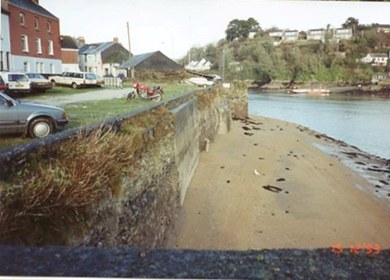
Berrills yard had been bought by the harbour commissioners in 1992 with plans to make it into another landing point plus providing a berth for the lifeboat and other harbour facilities.
In addition to having pipework connecting sewers in the are a relief valve was needed on the pumped main to Caffa Mill. The car parking area had not been surfaced by then and trenches were dug and a site for the valve chamber dug.
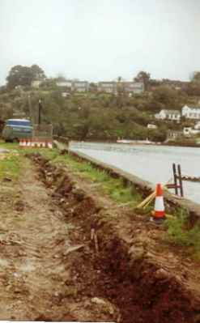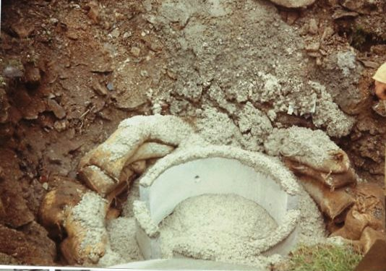
Trench and base for the chamber
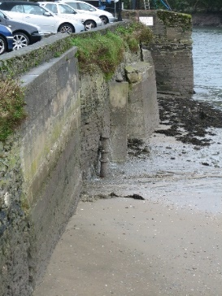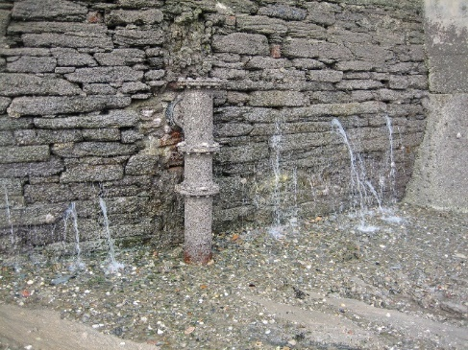

The exterior pipe connection and just to the north the collector pipe encased in concrete
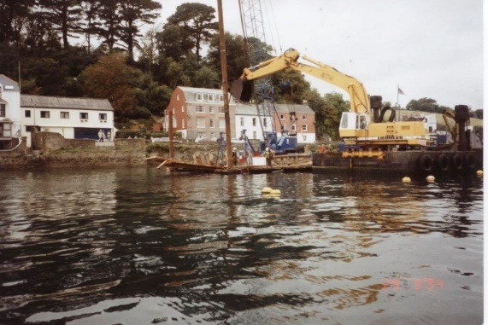

While the plant for piling was available the commissioners contracted for the pontoon piles to be driven .

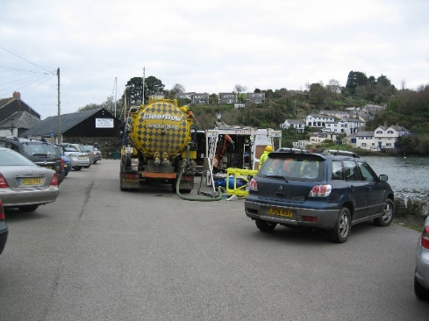
Subsequently in 2008 trouble began to arise at the site. The first sign of trouble was when sewage was noticed coming out from the seawall. After many investigations and pump out in 2009 a major failure occurred.

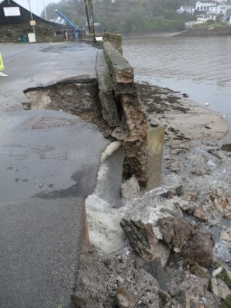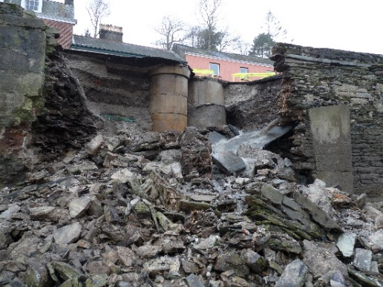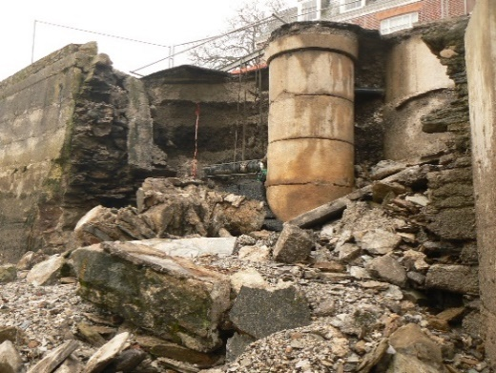

On 16th January 2010 the harbour master received a call that sewage was pouring out of the wall and 20 ft into the air. En route to investigate another call was received to say no rush as the seawall had blown out onto the beach leaving a gapping hole and raw sewage pouring out onto the beach. After an invesigation it was found the chamber had cracked and the pipe work connecting had come adrift possibly when the build up of pressure occurred although it had been leaking for some time.Luckily the were’nt any car actually over the chamber and the spaces that crumbled into the harbour

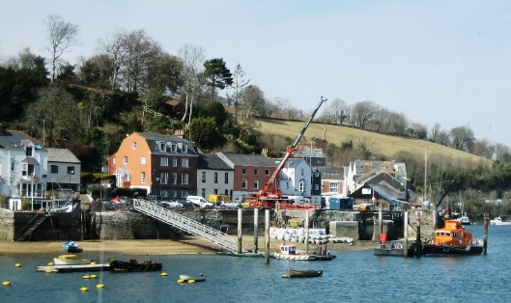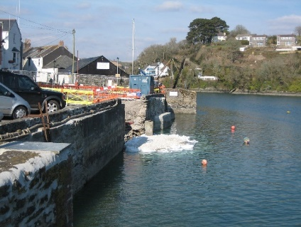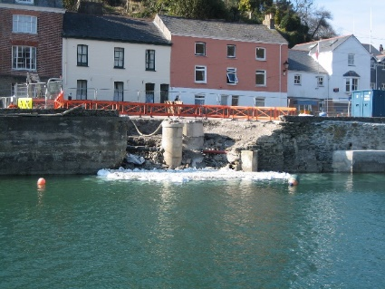
In April 2010 after much consultation, a bagged cofferdam was built on the beach and new chambers built and substantial pipe work installed before a reinforced concrete wall was built and concrete poured into the hole.A new pipe on the outside of the wll connected to the main and the beach restored.
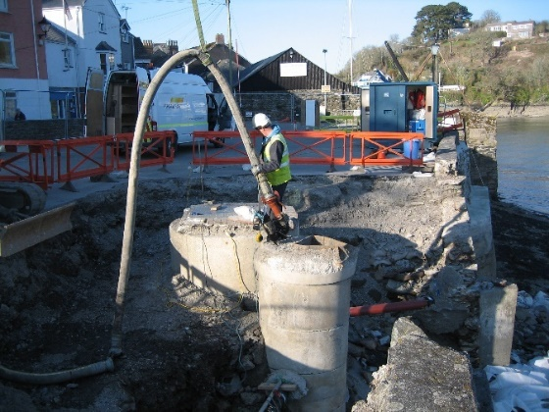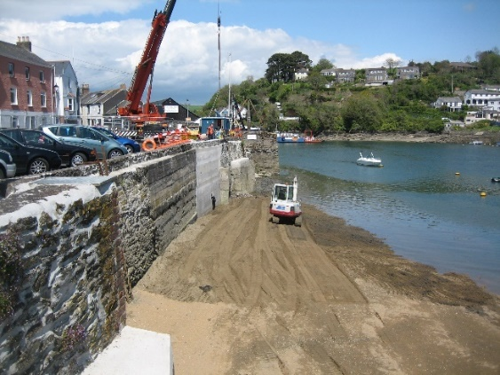
THE HOLDING TANK AT RIVER SIDE SLIPWAY

A holding tank was needed to collect the sewage from houses and businesses at the Caffa Mill end of Fowey and Riverside slipway the old ferry landing was chosen.The Restormel council owned the slip however the foreshore onto which the facility was partly owned by the Boconocc estate. As the ferry had to land at this site during the construction of the town quay works this work had to be done in the second phase during the second winters construction.

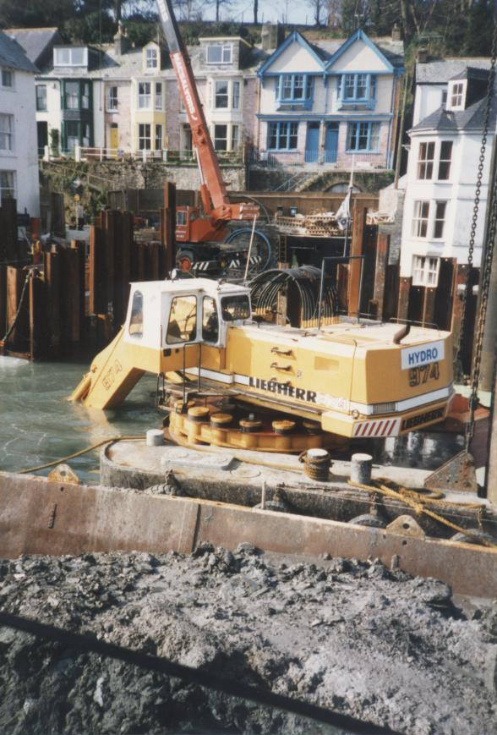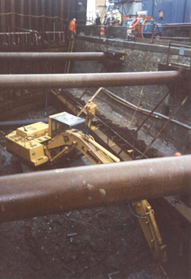
Some deepening had to be carried out and material removed from inside the cofferdam constructed
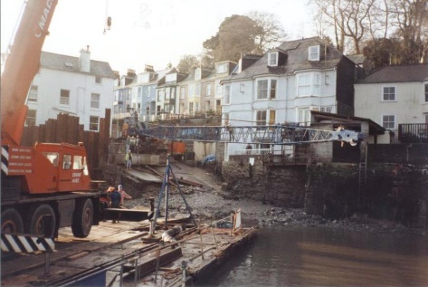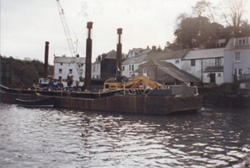
Like all the sites everything was brought in from the harbour ensuring traffic could get through town. Pipe work was installed close to the Caffa Mill properties before the pumped main was taken asher into and throgh the carpark and up the valley to Penventinue where a sewage works was being built. A second pipe was laid to just above the ferry landing where the treated sewage water was to be discharged into the estuary ant controled times. 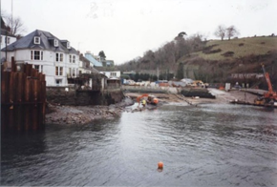
Whilst the works at Riverside were undertaken a temporary landing for the ferry and other craft was built at Albert quay using the existing pillons and some additional ones.

CONNECTING BRAZEN ISLAND

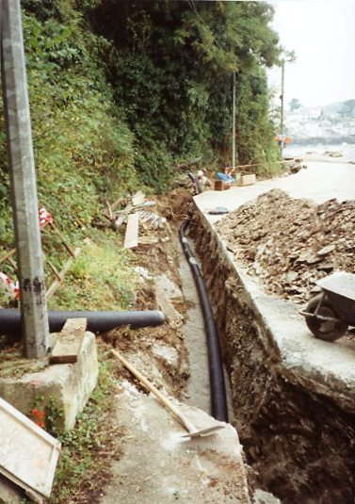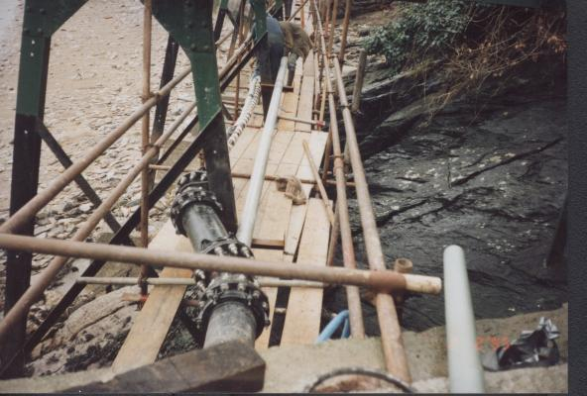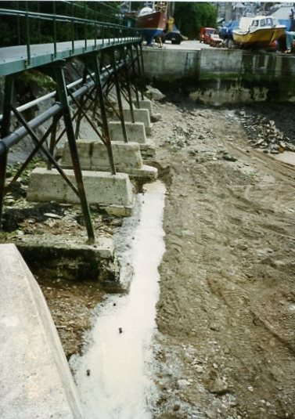
Pipes were laid in trenches dug through Toms Boatyard following the pathway then onto the beach and into Polruan quay.
The waste pipe was suspended under the jubilee bridge and encased when it was replaced behind a seawall infilled. Water and electricity were also delivered this way.
The Harbour Commissioners repair yard and slipway had to be connected to the sewage mains and it was agreed that South West Water would carry out this work as part of the agreement to use the site for constructing pipe work and the use of the harbour for the whole project.
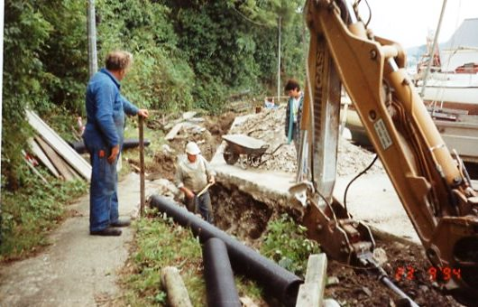

Up until this time Brazen island had no freshwater supply relying on spring water and electricity was generated on site. The site had been converted from DC to AC with all the equipment updated. Now was the opportunity to bring in both water and electricty and they were both laid in the trench and under the jubille bridge but at the commissioners cost.The Jubille was later to be replaced with a sea wall and and infill protecting the vulnerable facilities.( see history of Brazen Island for more details of the Jubilee Bridge)
BUILDING THE PIPEWORK FOR THE SCHEME
The scheme consisted of a large pumped main and a smaller collector main so large lengths of pipes had to be constructed. The pumped main 45cm in diameter went from Polruan Quay to Polruan castle where it joined a specially constructed section for crossing the harbour and then into Whitehouse and to town quay. Other sections ran from town quay to Caffa mill where it joined the land section to Penventilly and the sewage works.
A location to build and launch the pipe work was necessary and Brazen island was chosen because of the length of the slipway, the capability to receive and store pipes with an area to site equipment and works facitities and a relatively easy launch site.
The site had to remain a working slipway, so the build and launching structure were positioned to one side and the logistics required good liason between the contractors and the FHC staff.
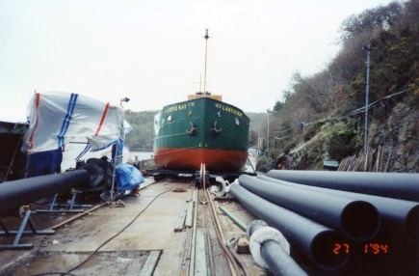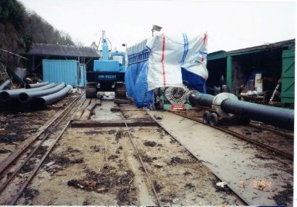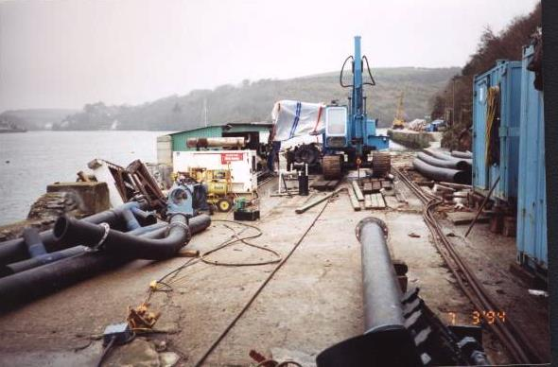
The “welding” site where pipes were heat welded together was located above high water in a coverd area . Once weld the pipes proceeded down the track with concrete weights used to sink the pipe were place on boggies which ran in a specially constructed runway close to the wall and adjacent to the maintenace cradle
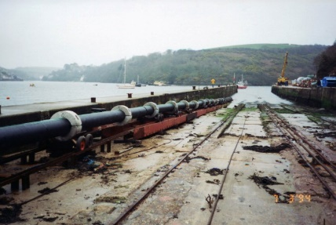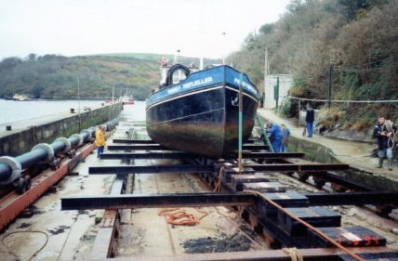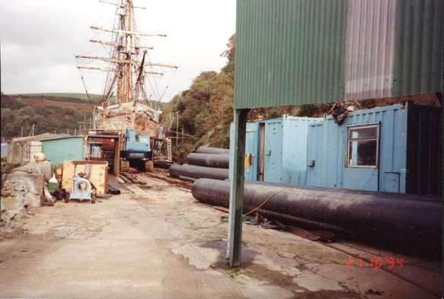
The pipe with weights on boggies running down the slipway with a view above the weld area with machinery and contractors mess facilities.Gear even stowed in the winch house.
The pipe was left open at the down end during construction to prevent it floating but was blanked off at both ends when lauching took place when the floating pipe was then towed out from the slipway and taken to a floating storage area in Mixtow Reach or under the hills .
The slipway was in use throughout and can be seen with theLantic Bay, the Fowey Refueller bunker barge and the square rigger Maria Assumpta (Later lost off Padstow) . Floating sections of the pumped and collector mains floating ready to be towed out.
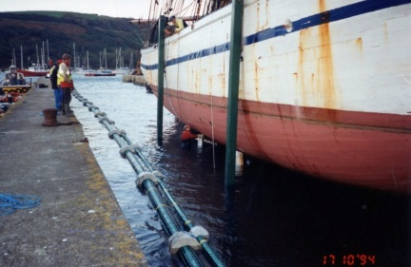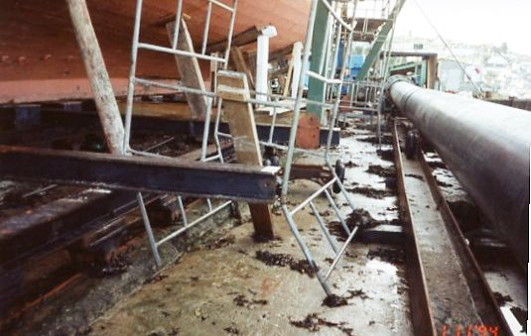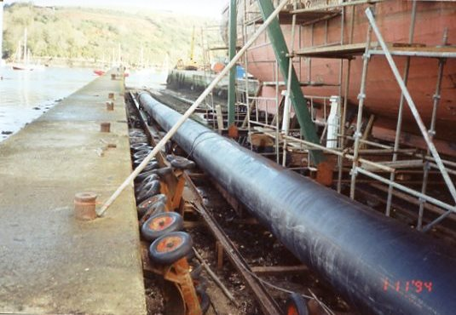
The Maria Assumpta being slipped with diver helping position bilge choaks . The runway and pipes.
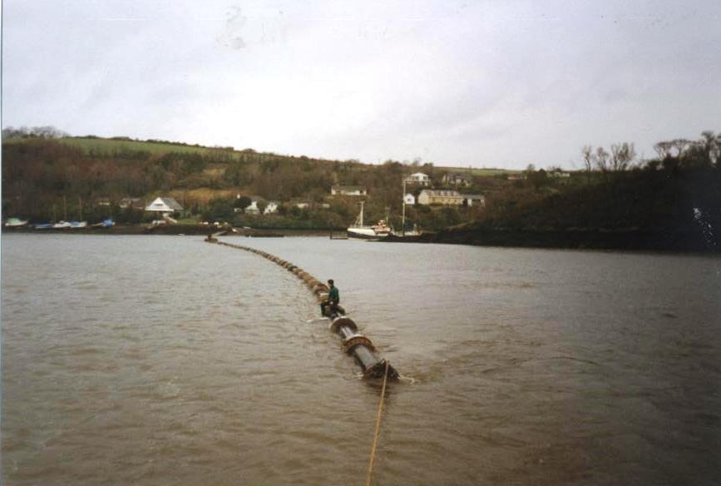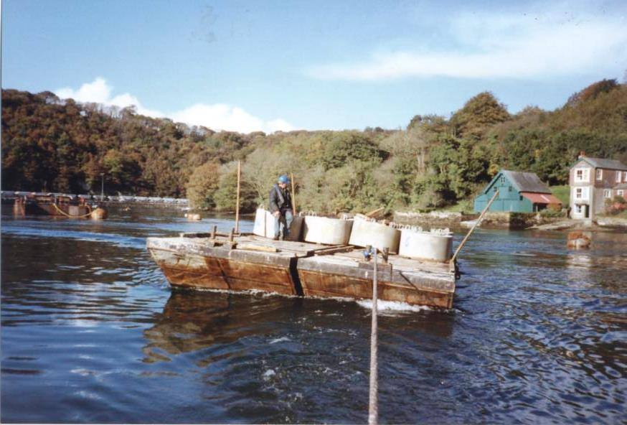
Pipe were towed to the location needed with a couple of divers on board .It was their job to gradually sink the pipe into the trench by letting water in to the pipe by a valve in ith blank offs ant each end. The concrete weights were unloaded at the jetties and transported to the constructon site.
READYMONEY BEACH
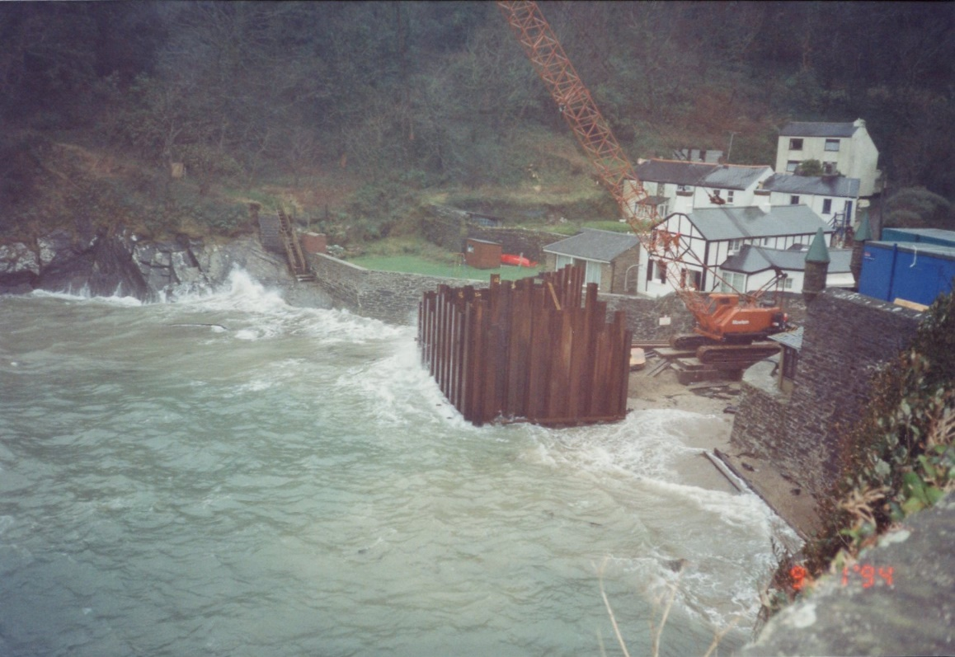
Sewage from the Readymoney end of town had to be collected into a holding tank so that it could be pumped to town quay via Whitehouse. The harbour commissioners who owned the beach but leased it to Restormel council agreed it could be built at the top of the beach under what would be a new slipway. This cove can be extremely rough especially in south easterly gales. Before a cofferdam could be built a large crawler, crane was brought in by barge and mounted on a purpose-built base above forecasted high waters. The cofferdam was a complete square which was dug out and the tank built. The pump equipment and vent were put in the old Readymoney lime kiln and now seated area and pipe work went by the road to Whitehouse slipway.
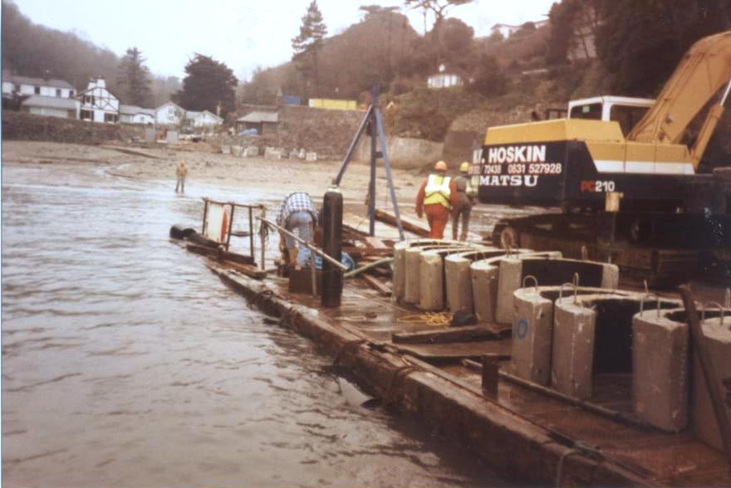
An overflow pipe was laid out clear of the bathing area and where the ebb tide could take any overflow out of the estuary. Weights were brought in to sink it. Sand was then brought in to give the beach a good covering when the works were completed.
DIGGING THE TRENCHES AND BACKFILLING THEM
Long lengths of pipe trenches had to be dug to lay the pipe work in. it had to be at the correct gradient and width and the material removed and either dumped at sea under the harbour commissioners dumping license at the Lantic Bay site , used as infill or removed ashore as in the case at Caffa Mill were some contamination existed.
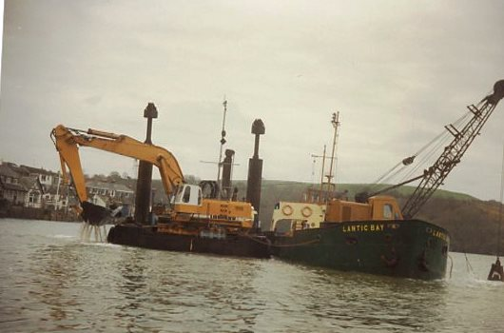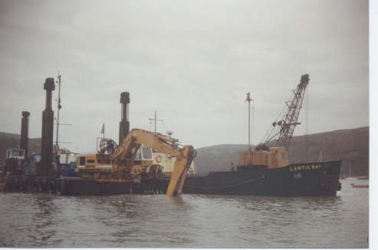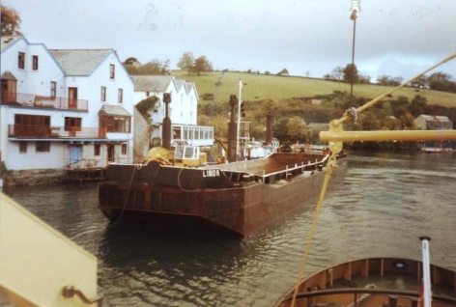
A backhoe digger on a pontoon was largely used to dig the trenches in deep water either loading Lantic Bay or latterly the barge Linda for dumping
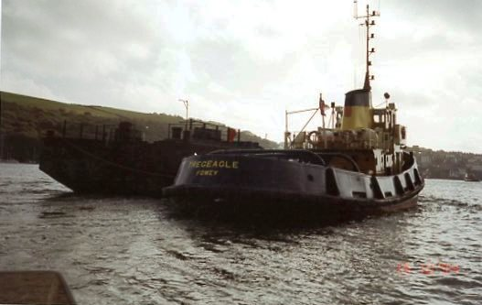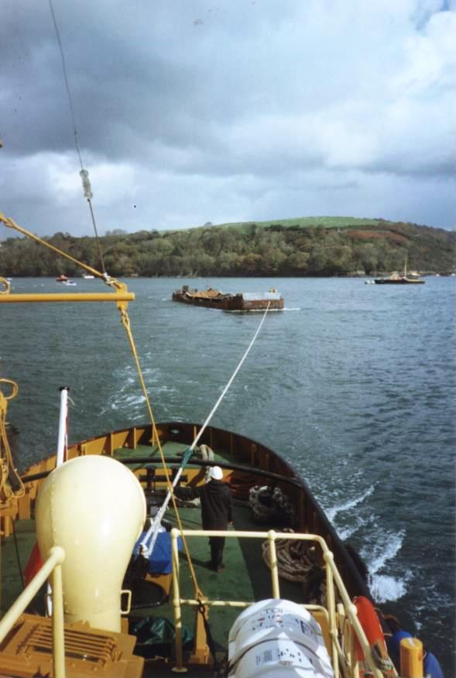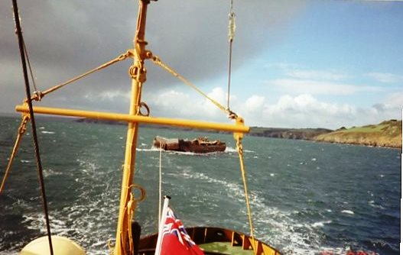
Both tugs Tregeagle and Pendennick were used to tow barges to the dump ground
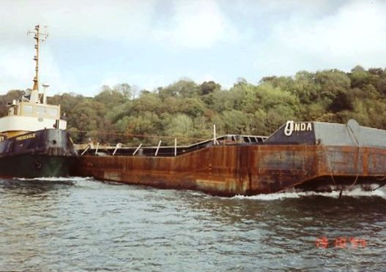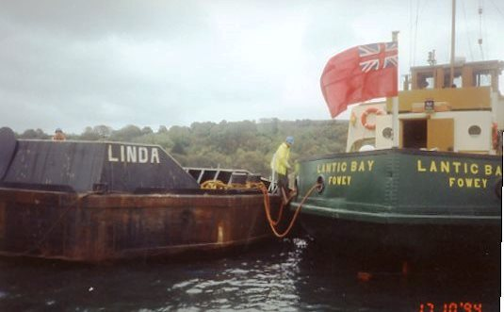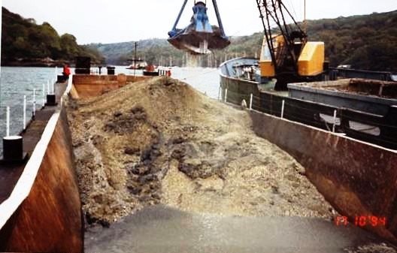
The barge was also used to transport fine shingle to cover the trenches and bed the pipes in. This was dug from the main channel and is found under the silt normally dredged this saved the contractor bringing it in from other sites.
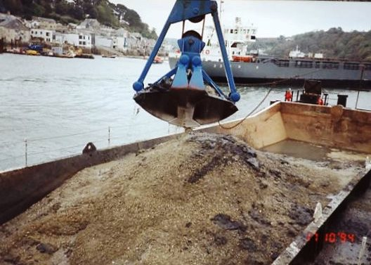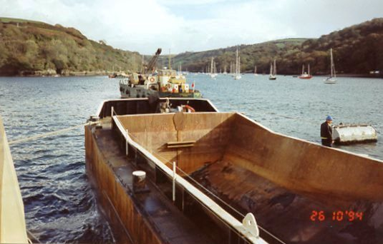
THE AFLOAT OPERATION
Because of the confines of Fowey and Polruan no land access to the many sites could be achieved so it was necessary to set up an afloat operation.The harbour commissioners had the craft expertise and staff to carry this out. The contractors brought in the floating pontoons, cranes and all their specialised equipment as did the pipe work contractors. Work was quite often tidal and went on until late at night as required for all the winter months for two years.The harbour had to remain fully operational and harbours services had to continue
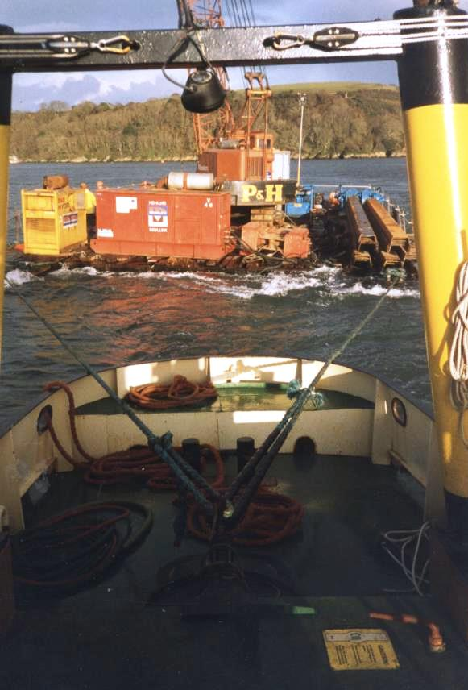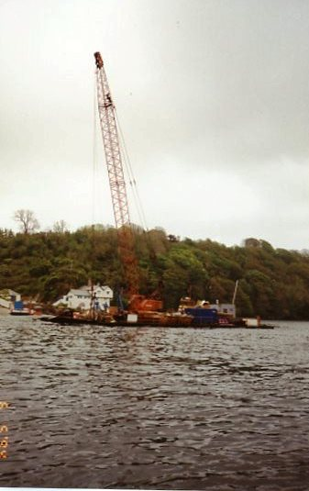
The Penleath was a big work horse moving large loads on the pontoons including the massive cranes
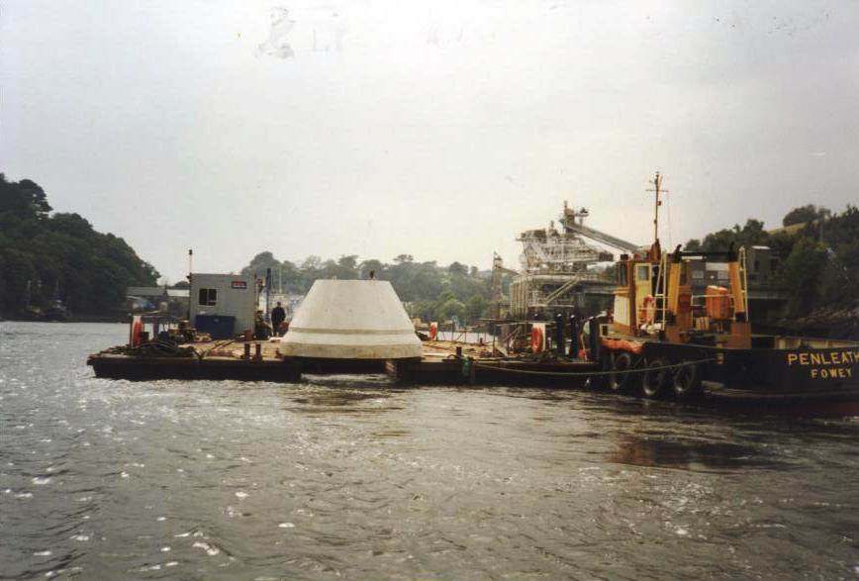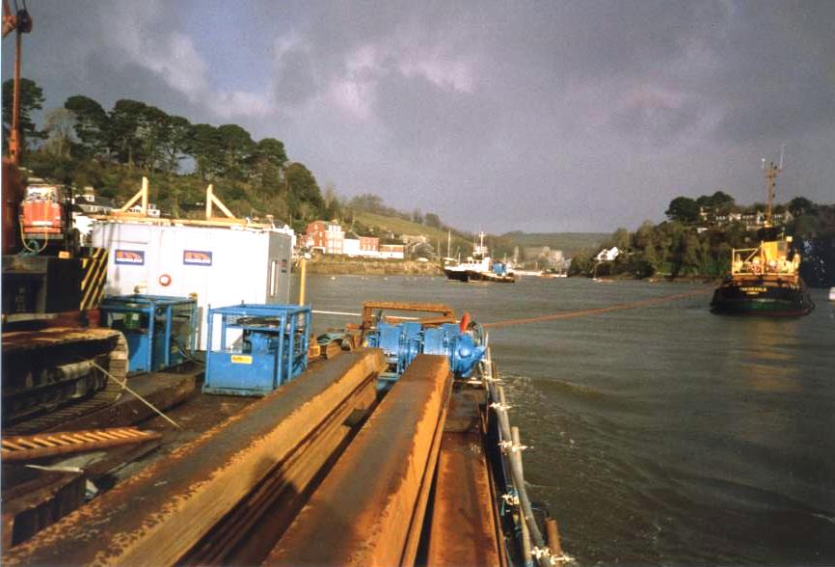
Various concrete structures were needed along with all the shuttering steel work pumps and compressers

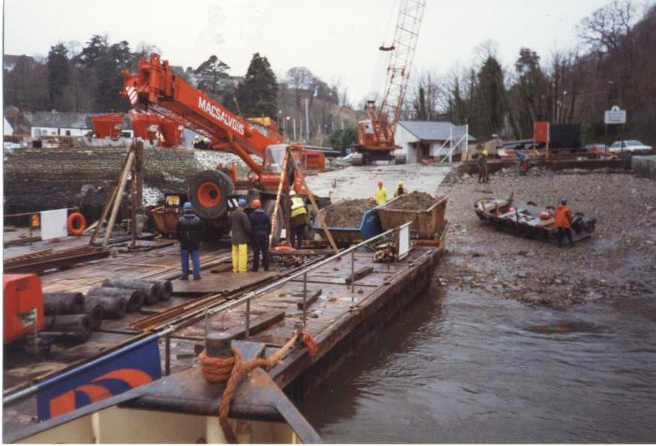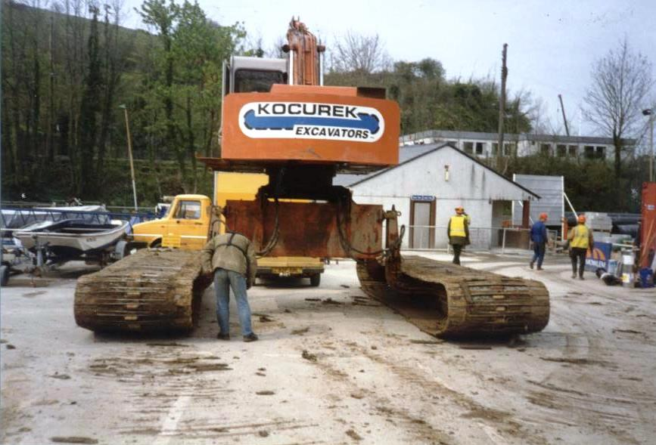
The main access point was at Caffa Mill where the contractors had a large compound and all their various plant arrived and was taken back to.This included specialised diggers for the foreshore work.The Fowey jetties were also used aound the shipping requiremnts.
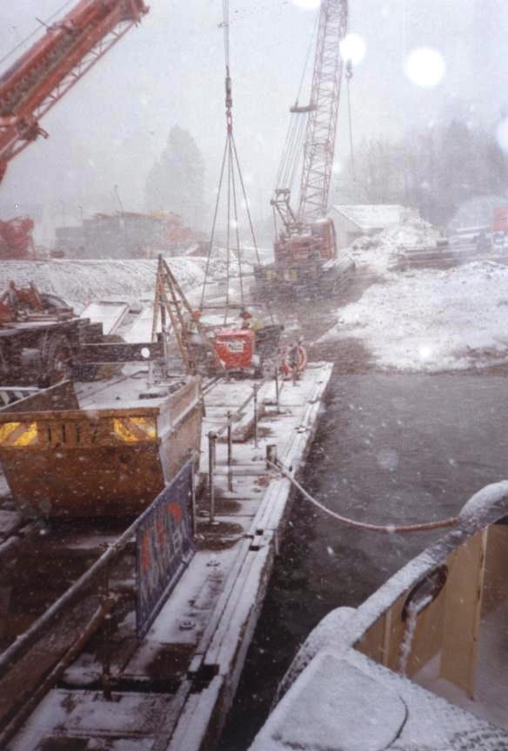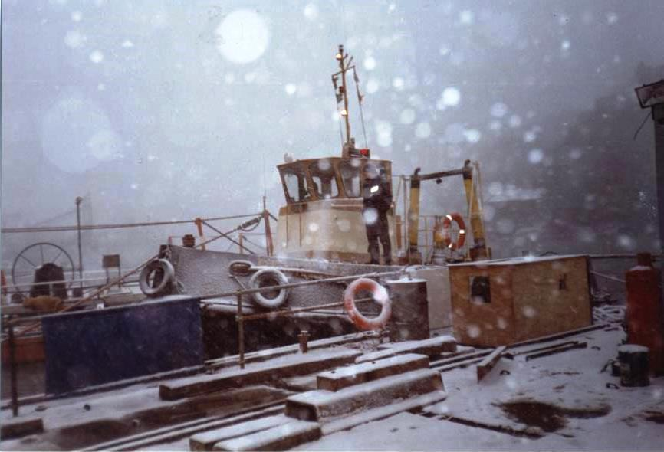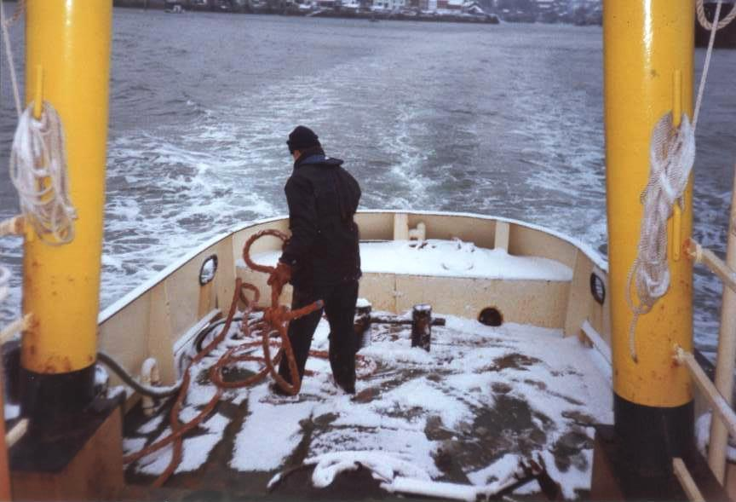
Work continued in all sorts of winter weather and the harbour commissioners staff made everything go smoothly along with pilots and their boatmen ,the ferries , lifeboat and many others that had a hand in the successful work.
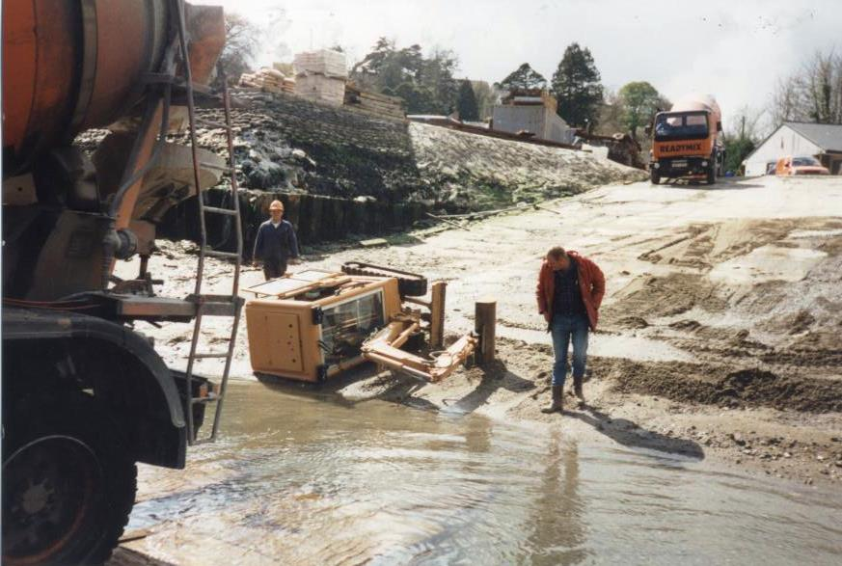
There were occassional mishaps!
Under the planning agreement the contractors were to give Caffa Mill slipway a face lift a however this never happened.
PLANNING THE OPERATIONS
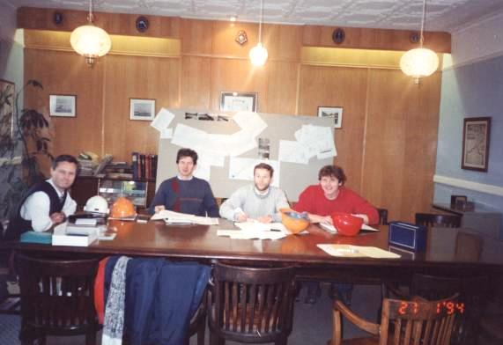
With so many different parts of the operation going on there had to be good liaison and understanding of the plans not only long term but weekly and daily. South West water would brief the harbour commissioners and the town council together with the Lanteglos council and Polruan Town Trust. The contractors would have their meetings and every Friday a weeks’ planning meeting would be held in the harbour office so that all parties knew what had been achieved and what the next steps and requirements were.
Pictured are the Pell Frischmann consultant engineer, Ivor Thomas the Mowlem in charge engineer and his deputy and Roy Kissick charge engineer for the pipework company.
The contractors took over the old station masters building at Caffa Mill as their offices together with Pell Frischman and they had separate site offices at all the various construction sites. There were large numbers of contactors staff involved and many companies were involved in the supply chain. A huge logistical and technical operation.
Bringing Bodinnick into the scheme followed with an under the harbour pipe in a tunnel drilled from Bodinnick to Caffa Mill. Later Golant was dealt with in a separate standalone scheme as was Lerryn. The aim was to make the water quality in the estuary meet the standards laid at the time and that was achieved although since there have been hiccups in the operations.
Not only were there benefits to water quality but improvements were made to the various sites. Town Quay and Polruan Quay and the landing were improved and enlarged, Riverside slipway was enlarged and a better slip at Readymoney achieved. Opportunity to use the specialised plant on site was also made with Berrills yard pontoon piling and the same at the pilot’s pontoon piled ready for their installation.
The estuary communities breathed a sigh of relief when it was all over it was however one of the biggest events in the harbour’s history.
Christmas 1994 brought an unusual arrival for Father Christmas. As usual he was to arrive at Town Quay escorted by the town crier Mike Penprase on board the Harbour Commissioners tug Tregeagle but this was a construction site so a special arrangement and a surprise for them was in hand. Tregeagle edged in as close as possible and the pair were invited into the cage swung aboard by the giant Mowlem crane. Once aboard, they were whisked up into the night sky and over the awaiting children in the safe zone on the quay where they soon distributed the traditional sweets. Both Mike and Father Christmas had an experience they would not forget.
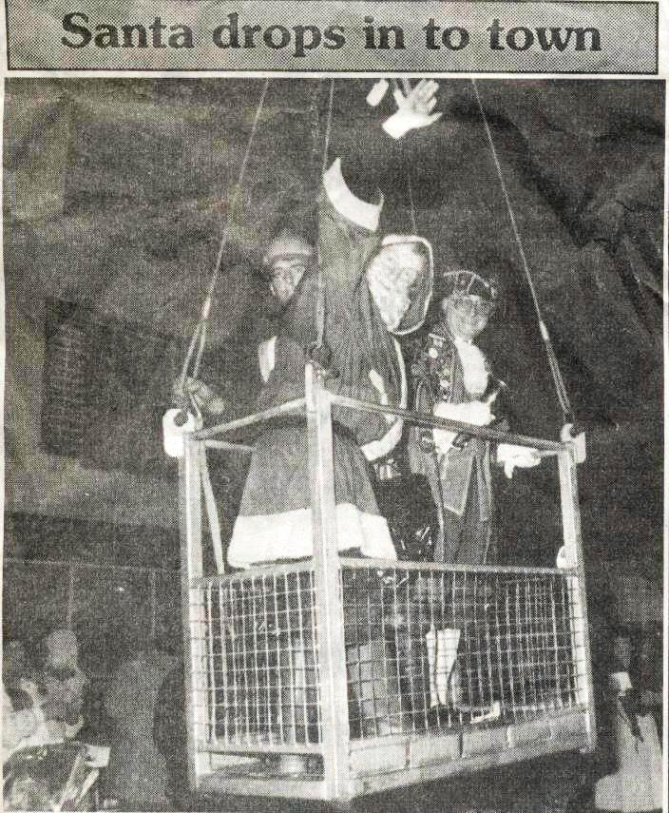
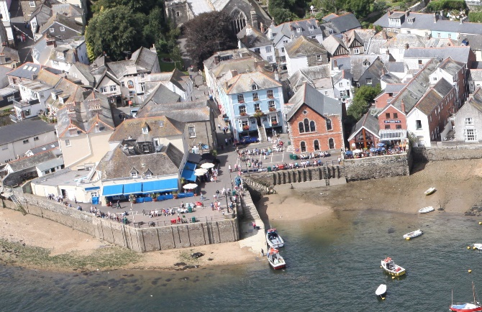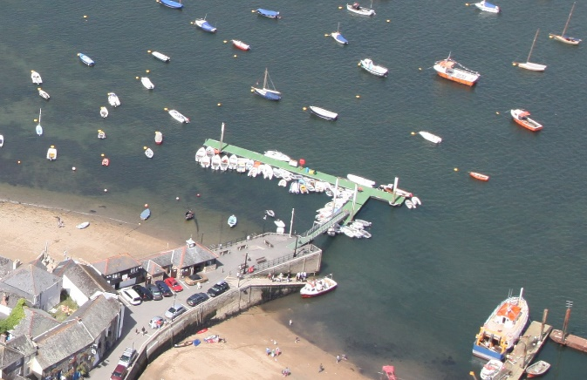
The new section of Fowey Town Quay and slipway. The extended Polruan quay and waiting room and toilets
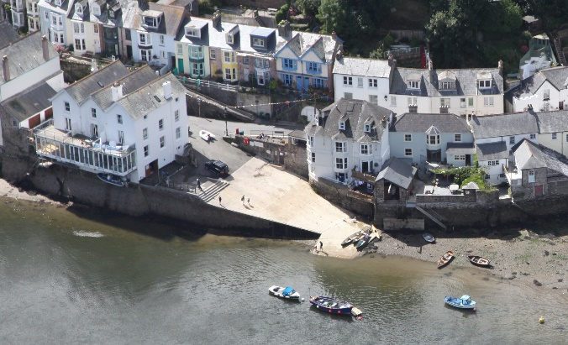
The hugely widened Riverside slipway and tank
MAP OF THE SCHEME

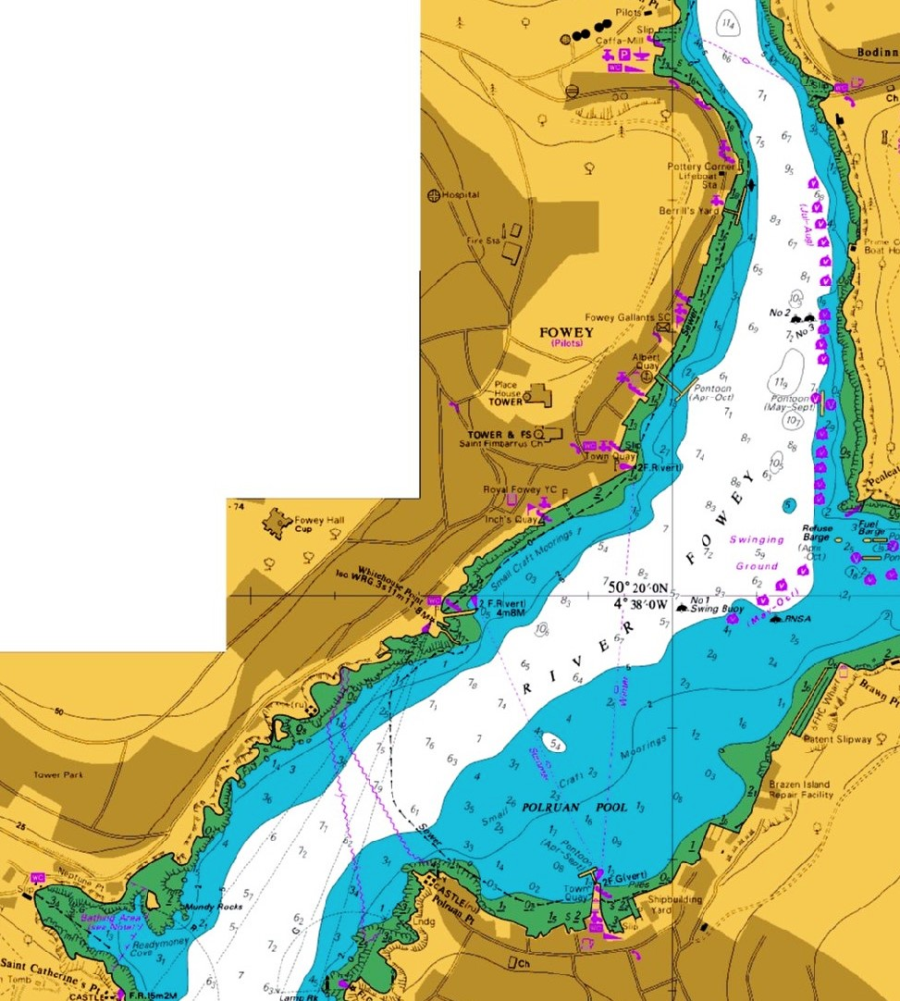
THE SEWAGE SCHEME IN FOWEY HARBOUR
Polruan quay extended and collection tank and pumping station built
Readymoney collection tank built under slipway and pumping station built in viewing area
Town quay collection tank and pumping station. The quay was extended as was the slipway
Berrills yard relief valve and pipe work
Pipe work collecting the sewage from outfallS taking it to Town Quay and then a pumped main taking the sewage to Caffa Mill
Riverside collection tank and pumping station

