The story of No 8 Jetty at Fowey
Before No 8 jetty was built there had been 7 ” T “shaped jetties built largely of timber between 1874 and 1895.The railways had come to the jetties with the first shipment from that source going out in 1869. After the railways took over the jetties the first three erected in 1874 were used principally for the export of iron ore which had been the principal trade. The china clay boom arriving and decline in the iron ore trade altered Fowey’s trade completely.
Initially the clay in bulk was handled via tipping shuts at the jetty head whilst casks or bags were loaded using steam cranes on rails. Vessels taking up to 300 tons were handled and cargoes for trans-ocean shipment were taken to other ports for trans shipping into larger vessel. With the arrival of steam ships, bigger in size the existing loading facilities soon became inadequate and at high tide the tipping became impossible and was often suspended.
Before the first world war Great Western Railways decided it was time to build a new jetty and to equip it with an electrically powered conveyor. Number 4 jetty had already been provided with one and it had proved successful. Carne point was selected where a deep-water berth was available on the outer bend in the river. It was to be 500 ft in length with a straight frontage of 300 ft.The idea being for the first time ships would lie alongside their length mooring fore and aft. Dolphins would not be needed as on other berths.
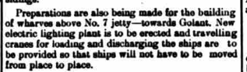
The plans were for the jetty to be 50ft wide and to be constructed of steel girders with a filling of brick arches and cement concrete. These were supported on 23 steel cylinders 6 ft in diameter driven down to the rock bed and filled with concrete. However, the war came along and construction was delayed until afterwards and that that was built commandeered by the Admiralty.
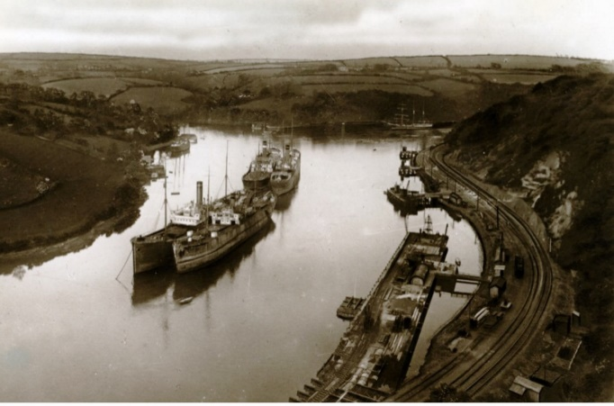
Work resumed after the war somewhat delayed initially by the shortage of material. The piling of the cylinders proved difficult with depths of 85ft down being made to get solid rock bottom. The berth would provide depths of water in excess of 12ft at low water spring tides. The face of the jetty was made with timber fendering protecting both jetty and ship alongside.
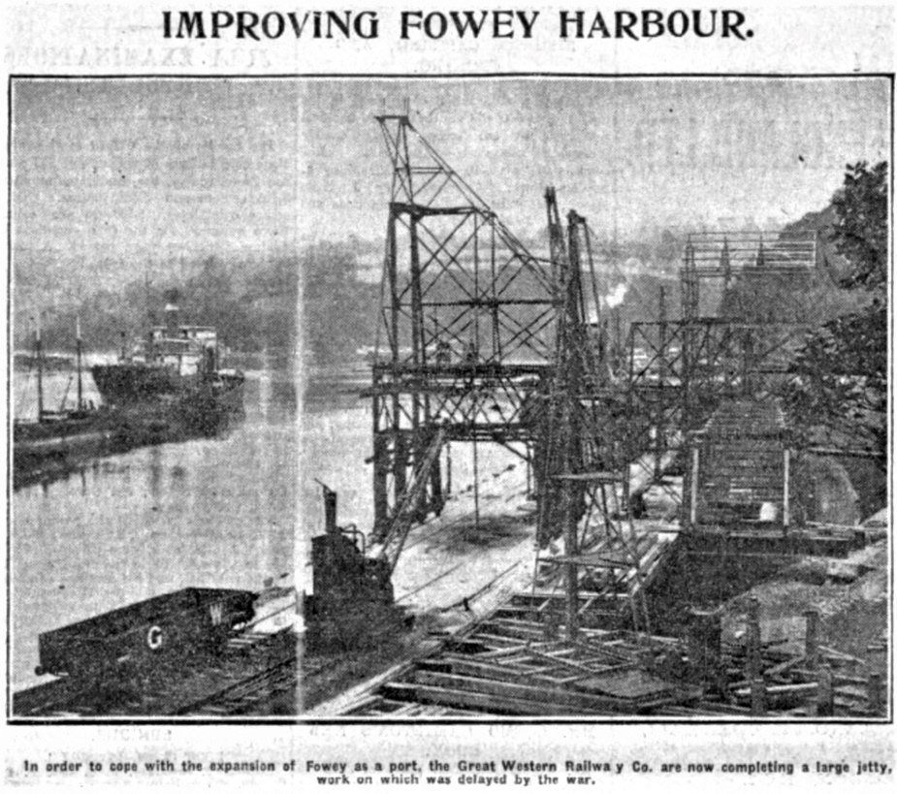
The movable tower being built
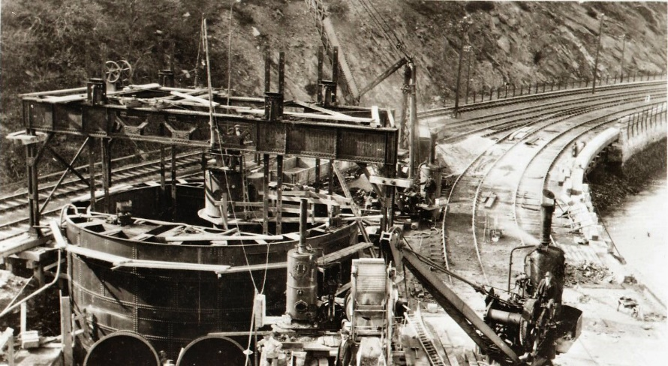
40 ft silo with internal width of 34 ft 6 inches and 23 ft from rails to floor.
The conveyor had a capacity of 240 tons per hour and the electricity to power it came from the electricity generating station that had already been built but had been made bigger and had more capacity.
The railway trucks containing the loose china clay having been shunted into a siding were hauled on to a table, secured and the table and truck tipped until its load was tipped into a hopper constructed within a silo. The clay then goes onto an endless belt traveling at about 125 ft per minute conveying it to a height of 35 ft above the jetty. The next step is onto a transverse belt and onto an adjustable belt working in conjunction with a movable portal tower and into a shute which allows it to fall into the ship where it is to be loaded. The shute has a trimming nose allowing a wide spread of the cargo reducing trimming.
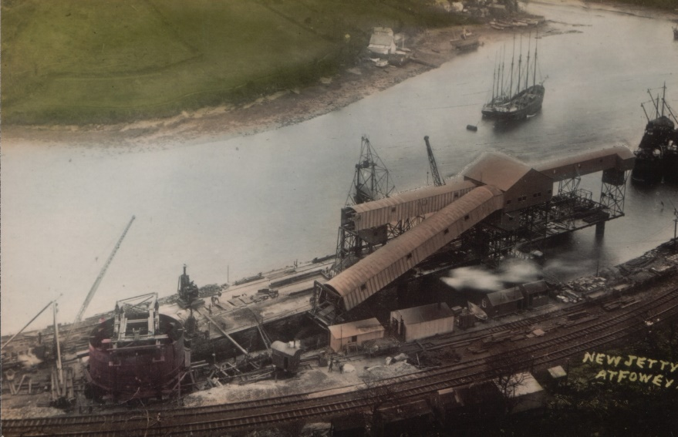
The tower transversed the main part of the length of the jetty thus it was not necessary for the vessel to be moved under the chute as at the other jetties. This saved on the time lost whilst the vessel was moved.
The silo was constructed of two steel skins strongly braced together and filled with concrete and founded on four cylinders sunk to the rock.it was 40ft externally and 34ft 62 internal diameter.
There was also a 3 ton portal electric crane on two rail sidings for clay in casks and or bags to be loaded. The movement of trucks was enabled by electric capstans eliminating the use of horses. Sidings to hold 200 additional trucks with clay were laid ensuring a continuous supply. This involved the purchase of land an cutting away the hillside behind the jetty. Before the jetties were commandeered by the Admiralty work had progressed well at a cost of £200000.
Construction was carried out by Cleveland Bridge & Engineering of Darlingtonand designed by Mr W.W.Gierson GWR’s Chief Engineer. Spencer and Co of Melksham built the conveyers designed by Mr Roger T.Smith GWR’s electrical engineer with Laurence Scott & co supplying the electrical equipment.
In the presence of a large gathering of the china-clay industry, The Fowey Harbour Commissioner and the Great Western Railway co the facility was opened on Thursday 27th September 1923.
To complete the opening a truck of clay was upended and emptied into the silo.Lord Mildmay of Fleet then started the belts and the clay was by the belts and deposited into the ship, s.s.Erden alongside. A trip on the steam tug Cruden Bay to see the facility from the water and lunch at the Fowey Hotel followed.
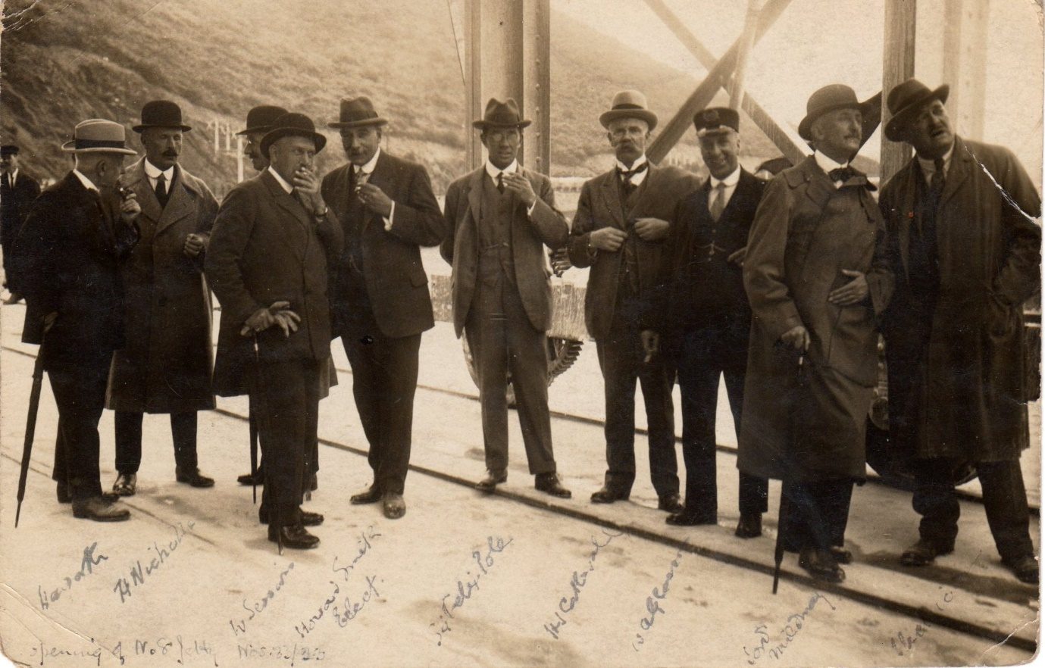
The directors and senior guests
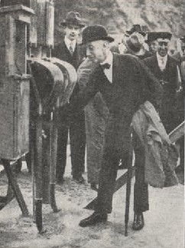
Lord Mildmay of Fleet, a director of Great Western Railways starting the belts working
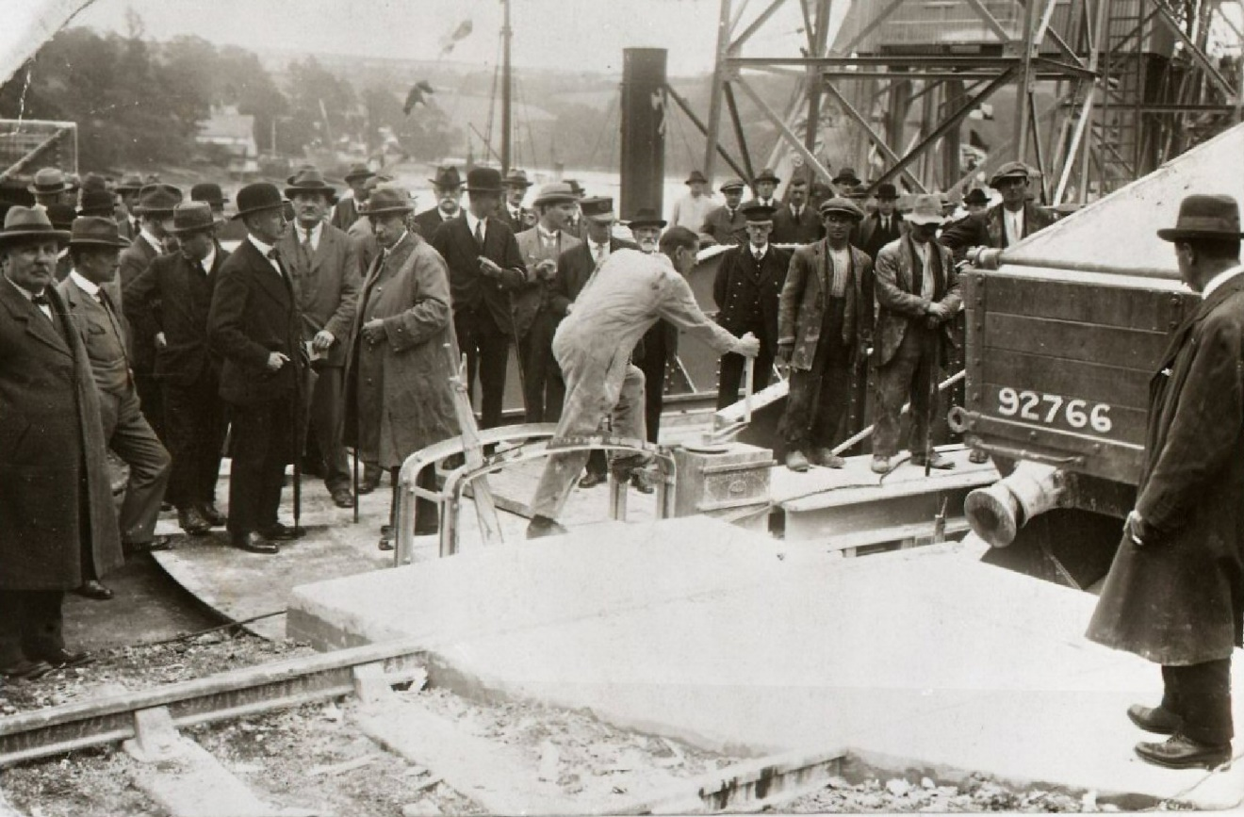
Tipping the first railway truck
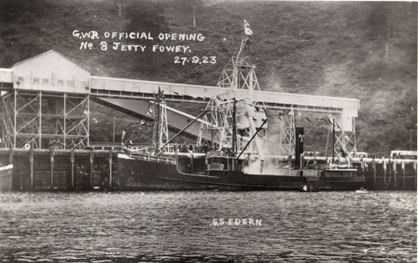
The clay being deposited in the ship.
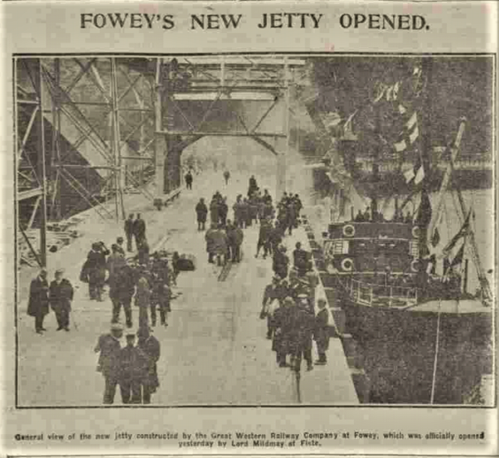
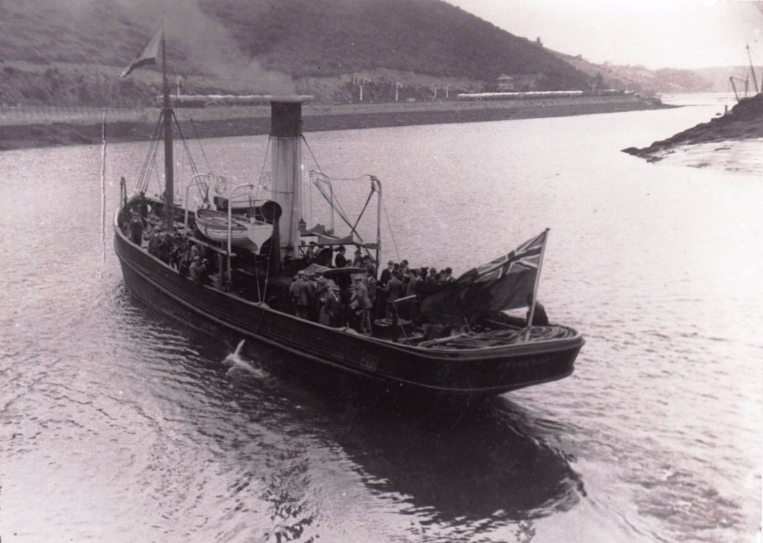
The Cruden Bay with guests on board inspecting from the water before being taken down the harbour and disembarking at Whitehouse Quay.
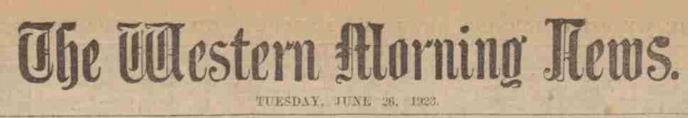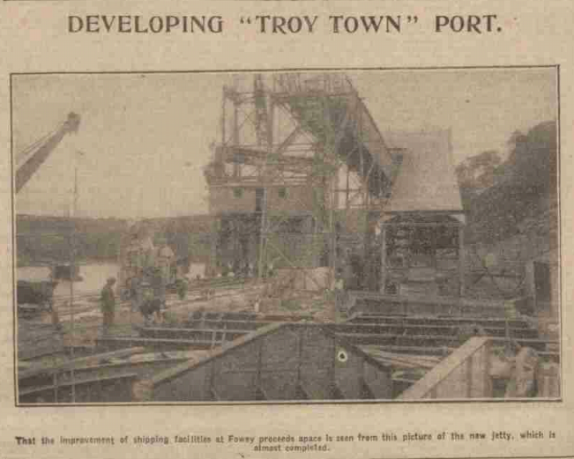
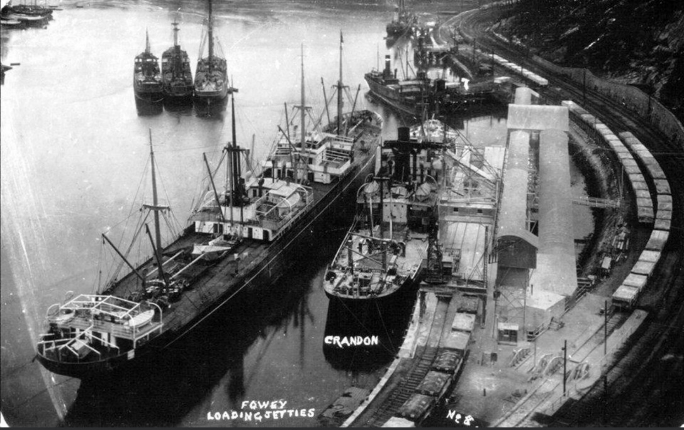
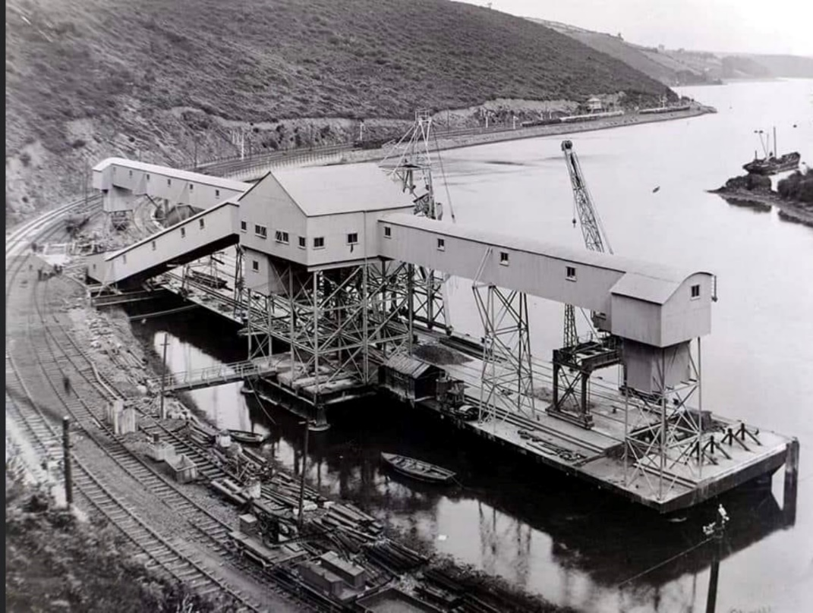

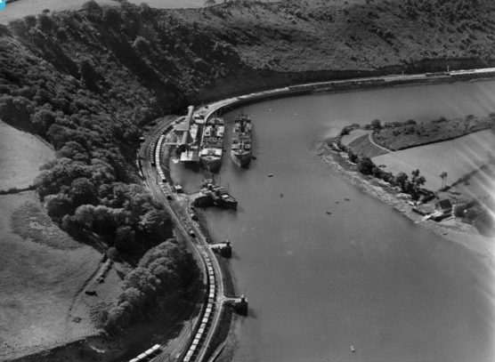
1928
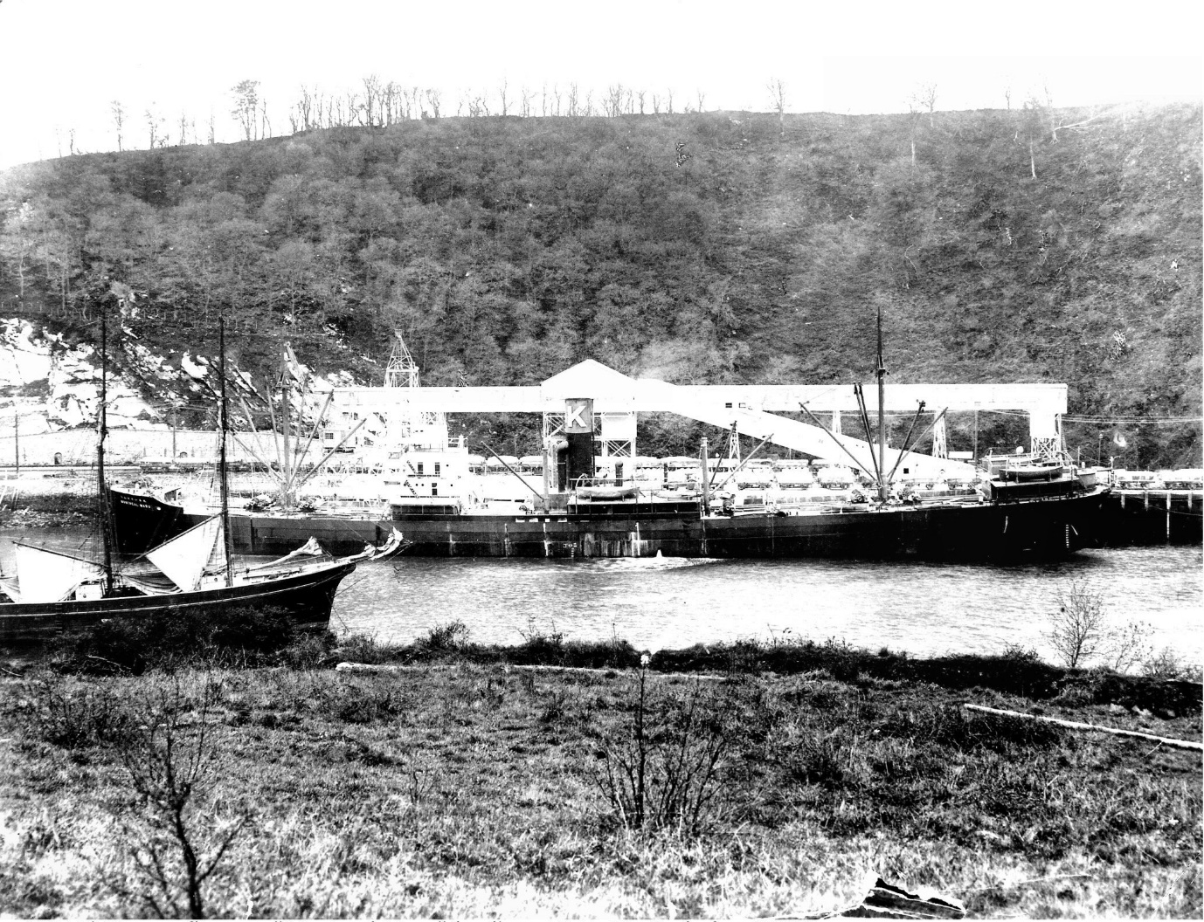
Teiko Maru on No 8 jetty not long after the opening.
