The steam bucket dredger Tregeagle
The Tregeagle was built in Holland in 1918 by it is believed L.Smit and Zoon.
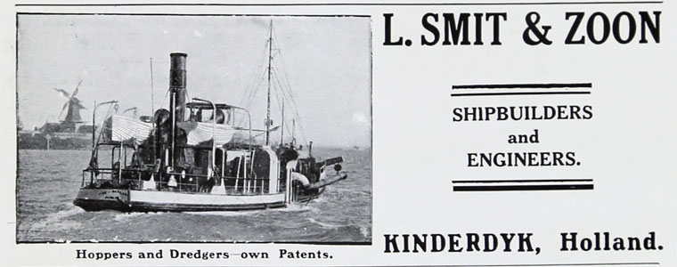
She was 114 GRT
From the time the railways opened up to connect Fowey to the China Clay companies there was pressure on the Commissioners to dredge the harbour, deepening it for larger ships necessary especially to go across the Atlantic. Dredging had been carried out using Falmouth’s dredger the Briton before, however with the enlarging of no 8 berth more work was needed.

The Commissioners were quick to play their part in improving the port. In 1922 they acquired a central ladder steam bucket dredger from Holland for £6,000 and put it to work to deepen the harbour from the mouth of the estuary to the jetties, so that it would not be less than 20 feet deep in its shallowest part at low water at ordinary spring tides, as against 13 feet previously. The dredger was capable of reaching a depth of 45 feet and had an output of 300 to 400 tons per hour. She was towed to Fowey with a barge by a Dutch tug and on 20th September 1922 was named Tregeagle .To buy the dredger the commissioner had to seek a loan. Lloyds would not facilitate and one was arranged with Barclays Bank. This had to be increase a year later to pay for the work. GWR was responsible for their berths and hire Tregeagle and plant to deepen the berths. No 8 was formally opened to traffic on 29th September 1923 at noon.

Once in operation the dredger was put to work deepening the channel to No 8 jetty to allow access for deeper steamships. Following this a gradual deepening of the harbour took place and Tregeagle was kept busy in the harbour.

In 1928 it was recorded for the first time she was used outside the port having been towed to Poole to work on the bar there.

Whilst continuous maintenance took place Tregeagle required substantial repair early in 1934.Following this a substantial deepening of berths 3 and 4 took place when she encountered large boulders.

With the arrival of the WWII dredging in the harbour was restricted and for a while stopped altogether. Tregeagle dredged in Newlyn in 1940 .She was there again in 1941 when bombs were dropped but she was not damaged.

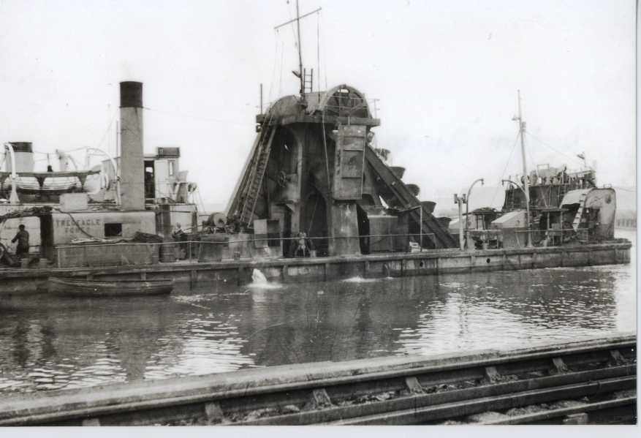
Working near the railway lines with either Lerryn or Lantyan alonside
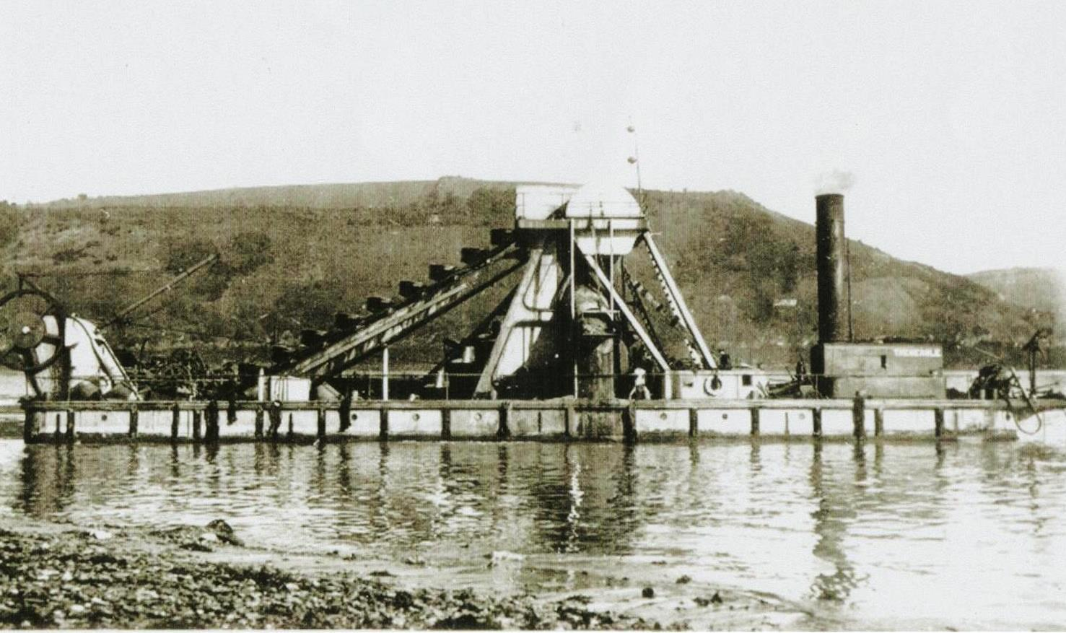
Tregeagle working off town quay
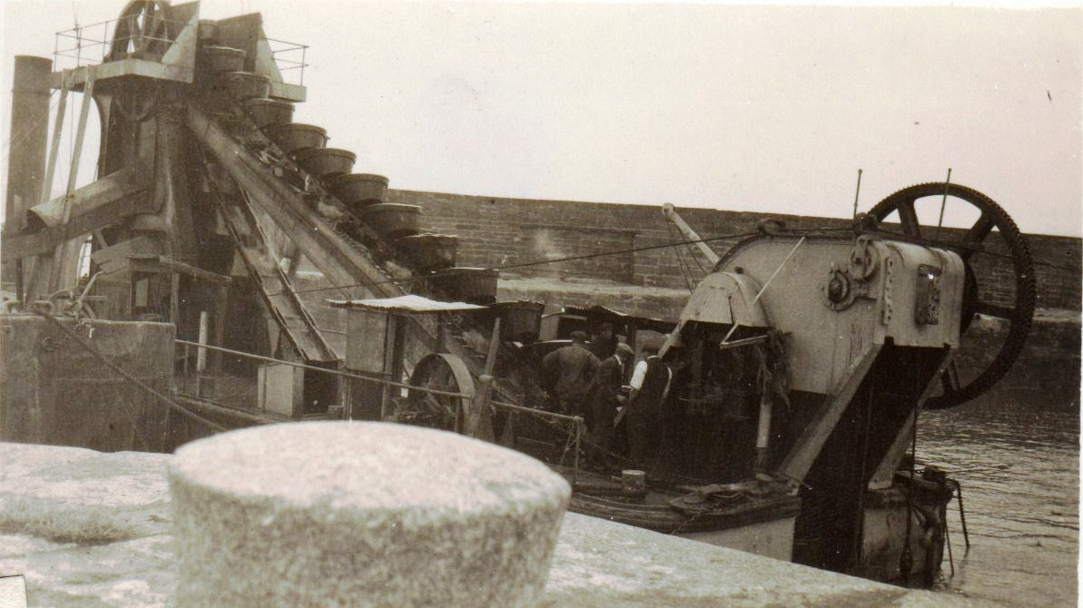
Tregeagle in Par having repairs alongside
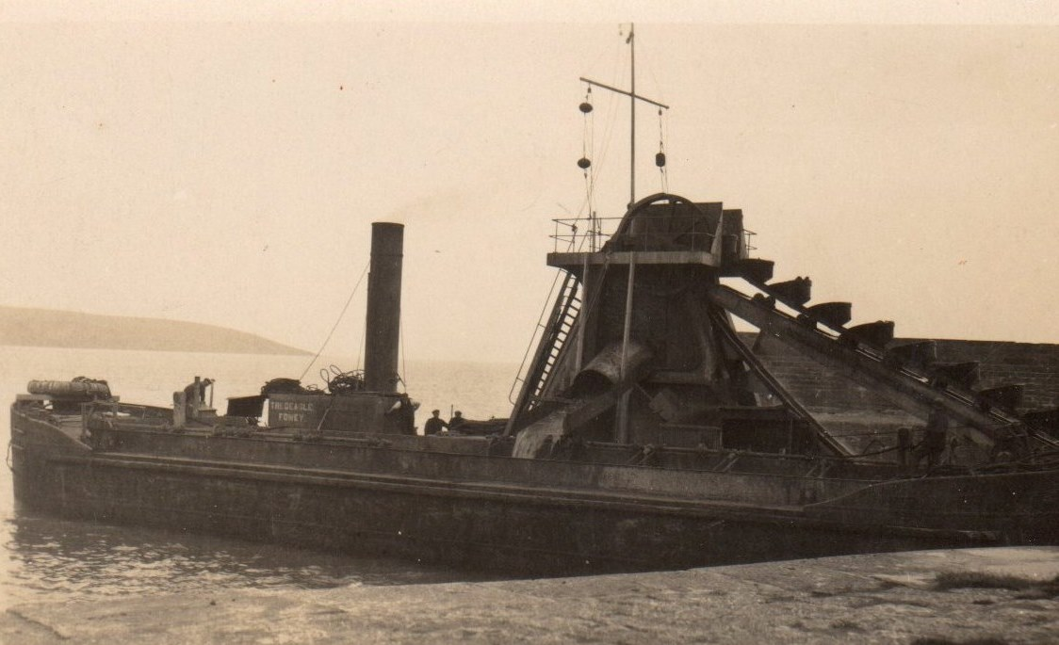
Tregeagle in the entrance to Par Harbour loading a barge
In May 1945 there were enquires for Tregeagle to go to Antwerp but after some deliberation the commissioners decided their policy to keep to Plymouth or Cornish ports. l
On 26th June 1946 Tregeagle headed back down to Newlyn to urgently dredge the entrance as debris was being washed in.
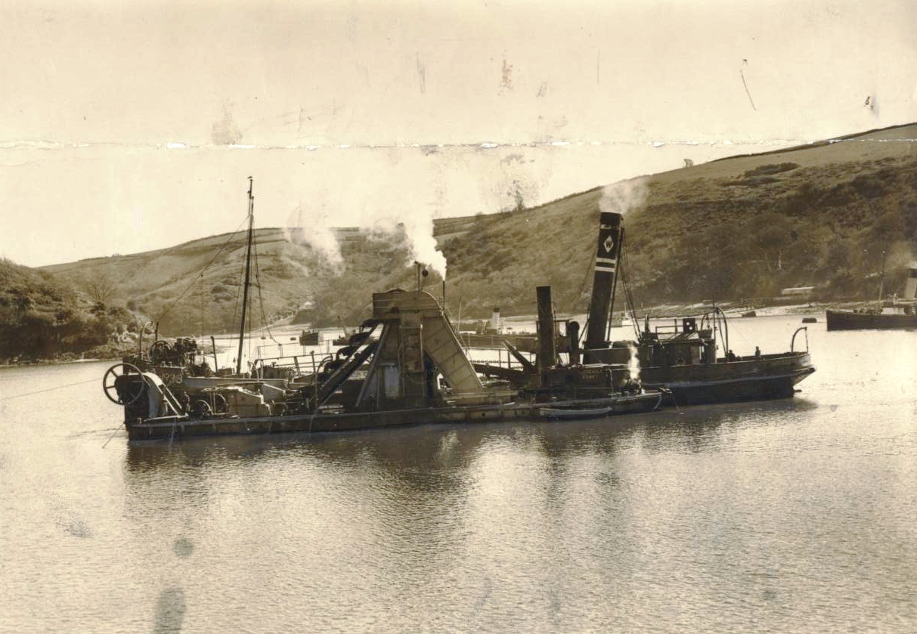
Tregeagle dredging the channel off Penleath Point loading hopper W38 offered ex admiralty to Fowey Harbour Commissioner after the war.
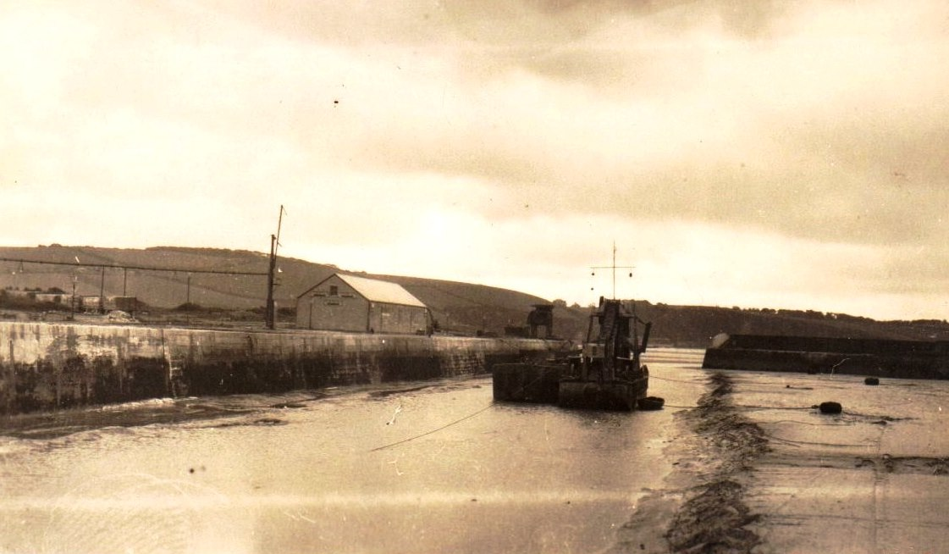
In Par Harbour with barge alongside
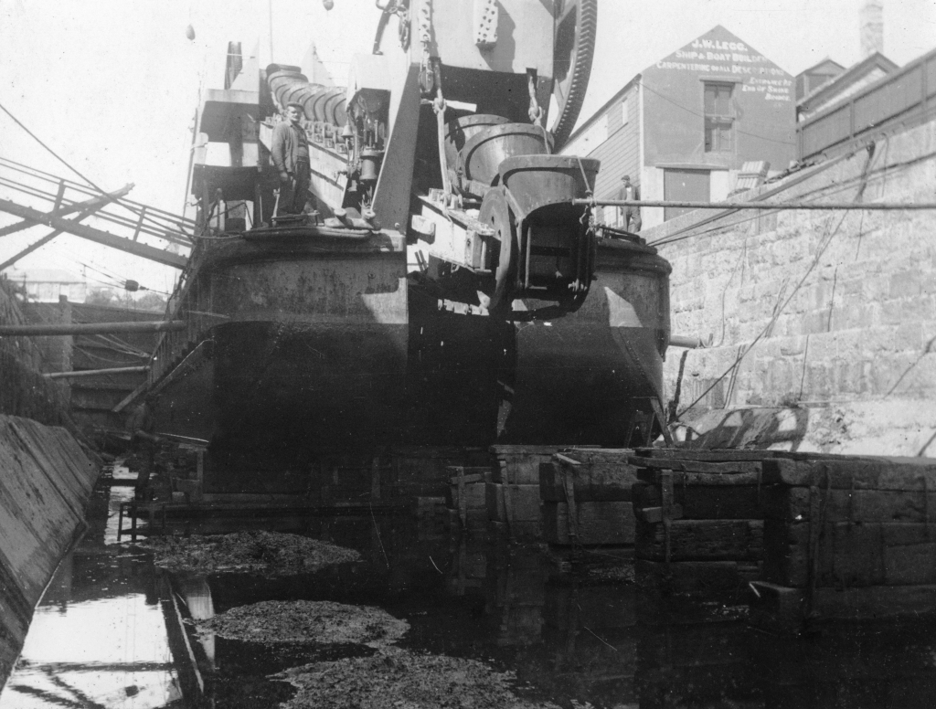
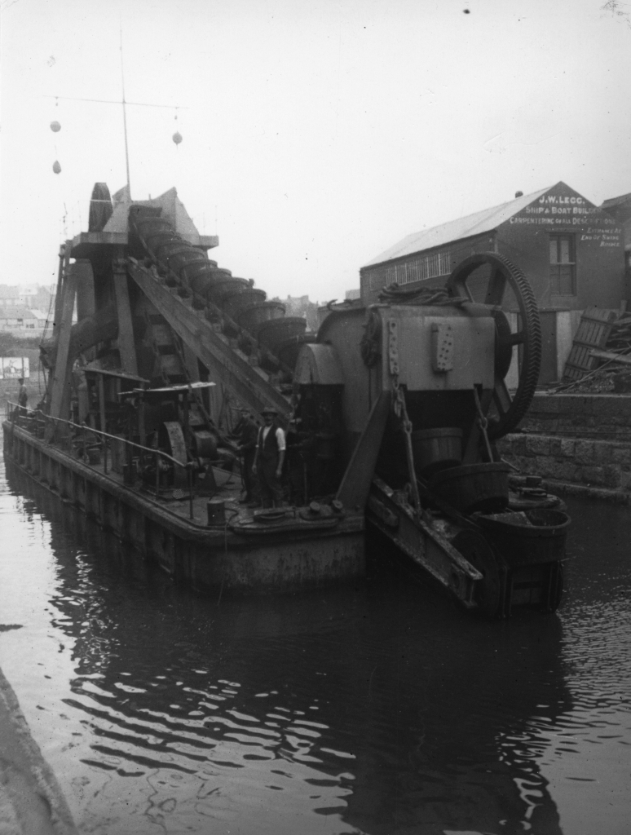
Pictured in Penzance Dry dock on one of her times working either in Penzance or Newlyn
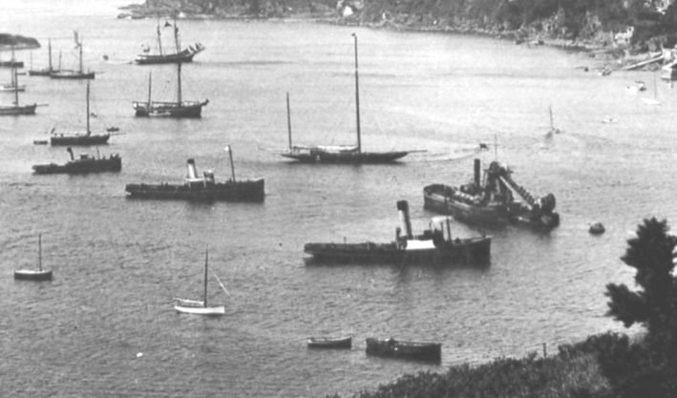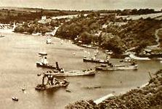
Tregeagle moored in the pool with tugs and in entrance to Pont with hoppers
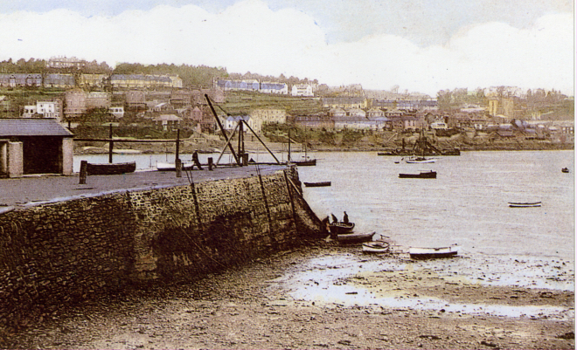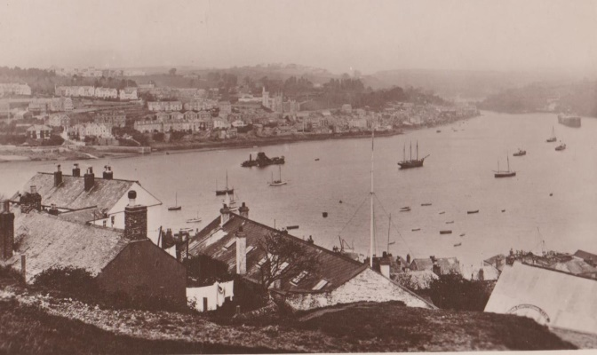
Off Whitehouse in the main channel ensuring it was kept at 20 ft below datum
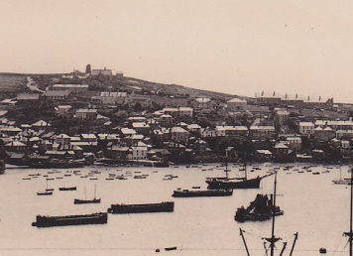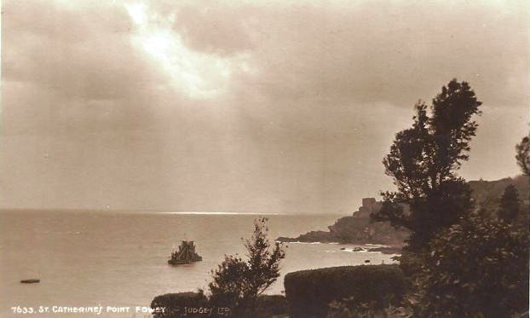
Moored just off swing ground with barges and working in the mouth of the harbour
In 1952 Tregeagle went to Rosslare in Ireland along with other plant completing a contract there in July. They moved to Wexford next and then back to Rosslare.In November having returned to Fowey she went to Plymouth to dredge off Sutton harbour. This was completed late in January the following year. At the end of March 1953 there was a return to Newlyn to dredge outside the breakwaters. The work in Newlyn was completed on 27th August

She remained in Fowey until February 1954 when she headed to south Wales and dredged Port Talbot. The work took over a year being completed in March the following year.
1956 saw the dredger and plant return to Mounts bay to work in Newlyn and Penzance with a return to Fowey in September for a short break before heading to Portland harbour to dredge Castletown Pier..In March the following year this work was completed and then there was a short move to Weymouth harbour to dredge the entrance. This didn’t take long and on her return Tregeagle was sold to Lord Craigmyle of London .
The plant had become old and the boilers needed continuous maintenance so the Harbour Commissioners agreed to sell and build their own dredger.
The Tregeagle along with other dredging plant was taken to Milford Haven and handed over on 26th June 1957.This coincided with the construction work at the Esso refinery in the port.

Below an extract from the 1940 Lloyds register for some reason under sailing vessels

