Schooner Thetis

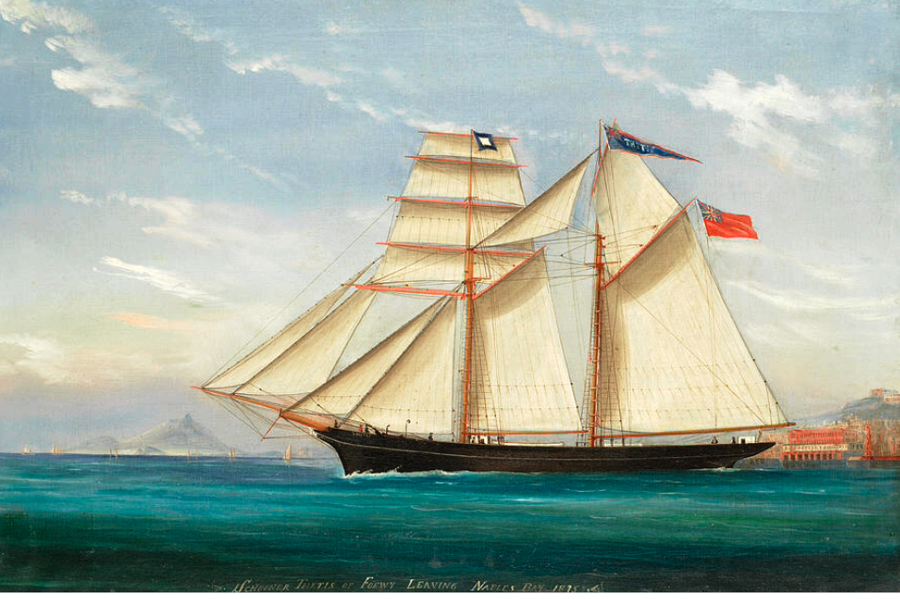

Naples Bay 1875 by Tommaso De Simone
Vessel Name | Official Number |  | Signal letters | Rig /Type | Where built |  | Builder |  | Year built |  |  | Year end |  | reg tons
THETIS | 63972 |  | MPHQ | Schooner |  | Polruan Brazen Island |  | Nicholas Butson |  | 1873 |  |  | 1877 |  | 173
OWNERS/ MANAGERS/REGISTRATION DETAILS |  | Notes |  |  |  |  |  |  |  |  | MASTERS
Registered 13th May 1873. Thomas Pearce,Trenovissick, St. Blazey and Capt Beale. |  | LOA 103.9 x 23.6 x 12ft.Launched on 15th March 1873 and christened by Miss Miss Pearce of Trenovissick, Par Station. she was built for the Mediterranean trade. She was stranded on coast of Sardinia at Aquebella .she was on passage to Palermo. Crew were saved. Total loss in 20th February 1877 |  |  |  |  |  |  |  |  | W.N.Beale 1872 and 1877 William Henry 1873-76

