Brigantine Undine

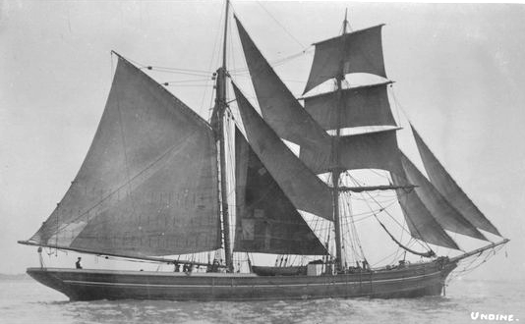

The Undine a Brigantine O.N 69850 was built at Brazen Island, Polruan by Thomas Butson in 1875 and had a gross tonnage of 174 tons and was 104 ft in length she was the Butsons last vessel and sailed like a “Witch”. Initially owned and later managed by Thomas H.Knight a timber merchant and importer of Lostwithiel. She was transferred to the Faversham register in 1896 and remained on the register until 1917 being lost on 25th February 1917.
She was owned by the Nicholls family, Osborne being her master. She was one of the fastest ships out of Whitstable as she was built specifically to transport pineapples from America in the shortest possible time. Her length of boom made her difficult to handle in coastal waters, so in later days when she worked nearer home, she was modified to cope. She lasted until the 27th February 1917 when, whilst drifting in fog in the Wash, she was run down and sunk by the steamer 'Emlyn'.

Vessel Name | Official Number |  | Signal letters | Rig /Type | Where built |  | Builder |  | Year built |  |  | Year end |  | reg tons
UNDINE | 69850 |  | NVGR | clipper Brigantine |  | Polruan,Brazen Island |  | Nicholas Butson |  | 1875 |  |  | 1917 |  | 174
OWNERS/ MANAGERS/REGISTRATION DETAILS |  | Notes |  |  |  |  |  |  |  |  | MASTERS
registered in Fowey13th May 1875 Thomas H. Knight, Lostwithiel Thomas Sherwill, Lostwithiel.1890 Thomas Knight, Lostwithiel. (MO) 1894 A.Nichols |  | LOA 104.1 x 24 x 13.2ft launched 2nd April 1875 and christened by Miss Hicks the niece of her master. Had new decks in 1893. March 1894 put up for sale by auction in Fowey. 1896 Transferred to Faversham register. She was run down by steamer off Flamborough Head 1917.register closed 1917 |  |  |  |  |  |  |  |  | Wm Hicks 1875 W. Beale 1875-90 Piper 1892 O.Nichols 1894 Puckey 1894 Eves 1901 Rasmussen 1903 Edwin Blaxland 1915 W.H.Wilmott 1915

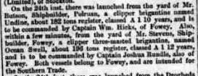

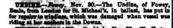

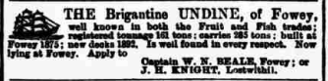

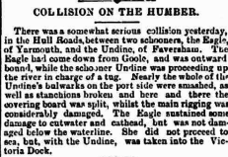

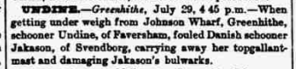

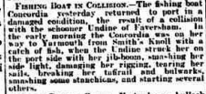

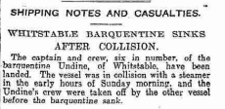
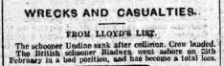

crew List 1915

Edwin Blaxland; rank/rating, Master; age, 58; place of birth, Whitstable; previous ship, Undine.
G Gisley; rank/rating, Mate; age, 65; place of birth, Herne Bay; previous ship, Undine of Faversham.
James Alfred Philpott; rank/rating, Able Seaman; age, 60; place of birth, Whitstable; previous ship, Undine of Faversham.
Richard Lansborn; rank/rating, Able Seaman; age, 61; place of birth, Gravesend; previous ship, Undine of Faversham.
John Newman; rank/rating, Able Seaman; age, 62; place of birth, Sweden; previous ship, Tweed of Faversham.
Frederick Brown; rank/rating, Cook; age, 43; place of birth,?; previous ship, Nil.
William Horridge; rank/rating, Cook; age, 23; place of birth, Pembroke, Wales; previous ship, Empress of Ireland.
G Gisley; rank/rating, Captain; age, 65; place of birth, Herne Bay; previous ship, Undine of Faversham.
Thomas Pitcher; rank/rating, Mate; age, 68; place of birth, Herne Bay; previous ship, Sally Vardon of Faversham.
Frank Holness; rank/rating, Able Seaman; age, 28; place of birth, Herne Bay; previous ship, (not stated).
John Newman; rank/rating, Able Seaman; age, 62; place of birth, Sweden; previous ship, Undine of Faversham.
W Hudson; rank/rating, Able Seaman; age, 36; place of birth, Whitby; previous ship, Sharwood of Middlesborough.
J Morgan; rank/rating, Cook; age, 18; place of birth, London; previous ship, (not stated).

1915

Ship: Undine; Official number: 69850.
W H Willmott; rank/rating, Master; age, 73; place of birth, Whitstable, Kent; previous ship, same ship.
J H Ramden; rank/rating, Mate; age, 54; place of birth, Whitstable, Kent; previous ship, same ship.
H F Bartlett; rank/rating, Able Seaman; age, 32; place of birth, Whitstable, Kent; previous ship, Tweed of Faversham.
Edwin Knight; rank/rating, Able Seaman; age, 47; place of birth, London; previous ship, Triton of London.
J Nieuman; rank/rating, Able Seaman; age, 56; place of birth, Res?, Kent; previous ship, Tweed of Faversham.
G Gisly; rank/rating, Master; age, 62; place of birth, Whitstable, Kent; previous ship, Lord March of Faversham.
J A Philpott; rank/rating, Mate; age, 60; place of birth, Whitstable, Kent; previous ship, Herbert of Faversham.
W Byhurst; rank/rating, Ordinary Seaman; age, 19; place of birth, Whitstable, Kent; previous ship, Brenda of Faversham.
S Brenchley; rank/rating, Ordinary Seaman; age, 19; place of birth, Whitstable, Kent; previous ship, first ship.
J Dove; rank/rating, Ordinary Seaman; age, 19; place of birth, Whitstable, Kent; previous ship, first ship.
F Pitcher; rank/rating, Ordinary Seaman; age, 40; place of birth, Whitstable, Kent; previous ship, first ship.
R Lamburn; rank/rating, Able Seaman; age, 60; place of birth, Whitstable, Kent; previous ship,?.
Date: 1915

